Lesson 8: Moves in Parallel
Let’s transform some lines.

8.1: Line Moves
For each diagram, describe a translation, rotation, or reflection that takes line $ℓ$ to line $ℓ^{′}$. Then plot and label $A^{′}$ and $B^{′}$, the images of $A$ and $B$.
- 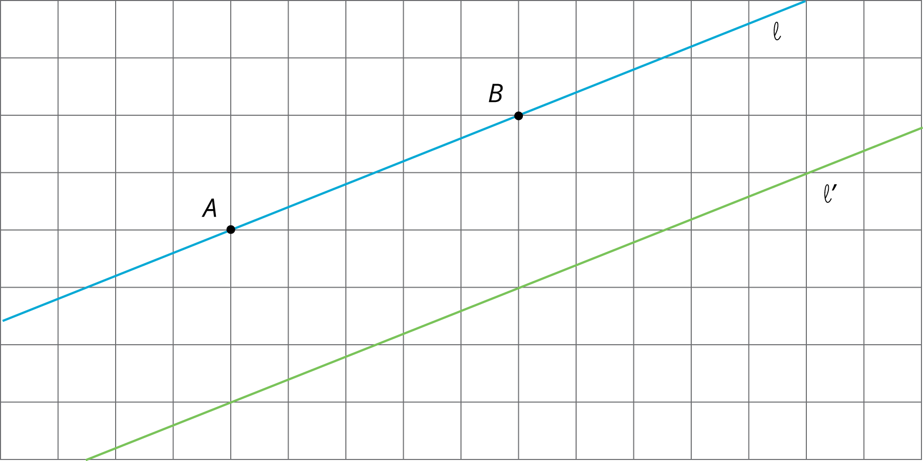
- 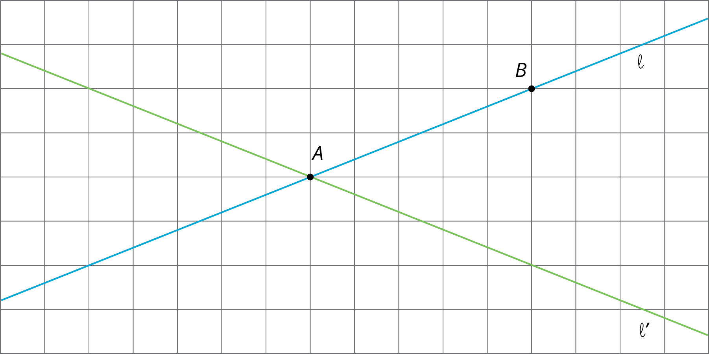

8.2: Parallel Lines
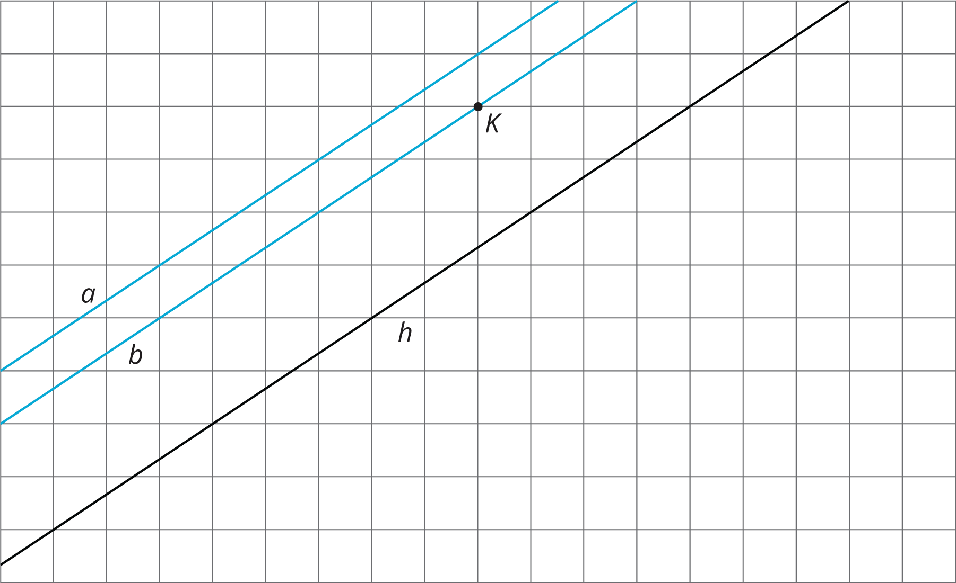
Use a piece of tracing paper to trace lines $a$ and $b$ and point $K$. Then use that tracing paper to draw the images of the lines under the three different transformations listed.
As you perform each transformation, think about the question:
What is the image of two parallel lines under a rigid transformation?
- Translate lines $a$ and $b$ 3 units up and 2 units to the right.
  - What do you notice about the changes that occur to lines $a$ and $b$ after the translation?
  - What is the same in the original and the image?
- Rotate lines $a$ and $b$ counterclockwise 180 degrees using $K$ as the center of rotation.
  - What do you notice about the changes that occur to lines $a$ and $b$ after the rotation?
  - What is the same in the original and the image?
- Reflect lines $a$ and $b$ across line $h$.
  - What do you notice about the changes that occur to lines $a$ and $b$ after the reflection?
  - What is the same in the original and the image?

Are you ready for more?
When you rotate two parallel lines, sometimes the two original lines intersect their images and form a quadrilateral. What is the most specific thing you can say about this quadrilateral? Can it be a square? A rhombus? A rectangle that isn’t a square? Explain your reasoning.

8.3: Let’s Do Some 180’s
- The diagram shows a line with points labeled $A$, $C$, $D$, and $B$.
  - On the diagram, draw the image of the line and points $A$, $C$, and $B$ after the line has been rotated 180 degrees around point $D$.
  - Label the images of the points $A^{′}$, $B^{′}$, and $C^{′}$.
  - What is the order of all seven points? Explain or show your reasoning.
- The diagram shows a line with points $A$ and $C$ on the line and a segment $AD$ where $D$ is not on the line.
  - Rotate the figure 180 degrees about point $C$. Label the image of $A$ as $A^{′}$ and the image of $D$ as $D^{′}$.
  - What do you know about the relationship between angle $CAD$ and angle $CA^{′}D^{′}$? Explain or show your reasoning.
- 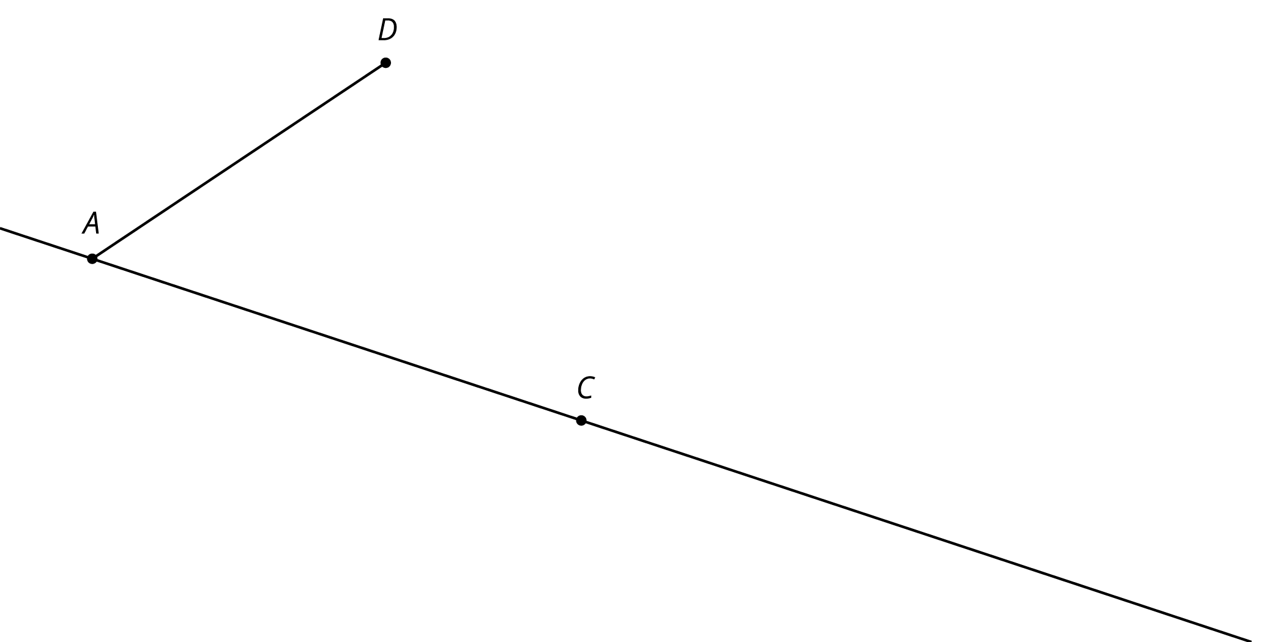
- The diagram shows two lines $ℓ$ and $m$ that intersect at a point $O$ with point $A$ on $ℓ$ and point $D$ on $m$.
  - Rotate the figure 180 degrees around $O$. Label the image of $A$ as $A^{′}$ and the image of $D$ as $D^{′}$.
  - What do you know about the relationship between the angles in the figure? Explain or show your reasoning.
- 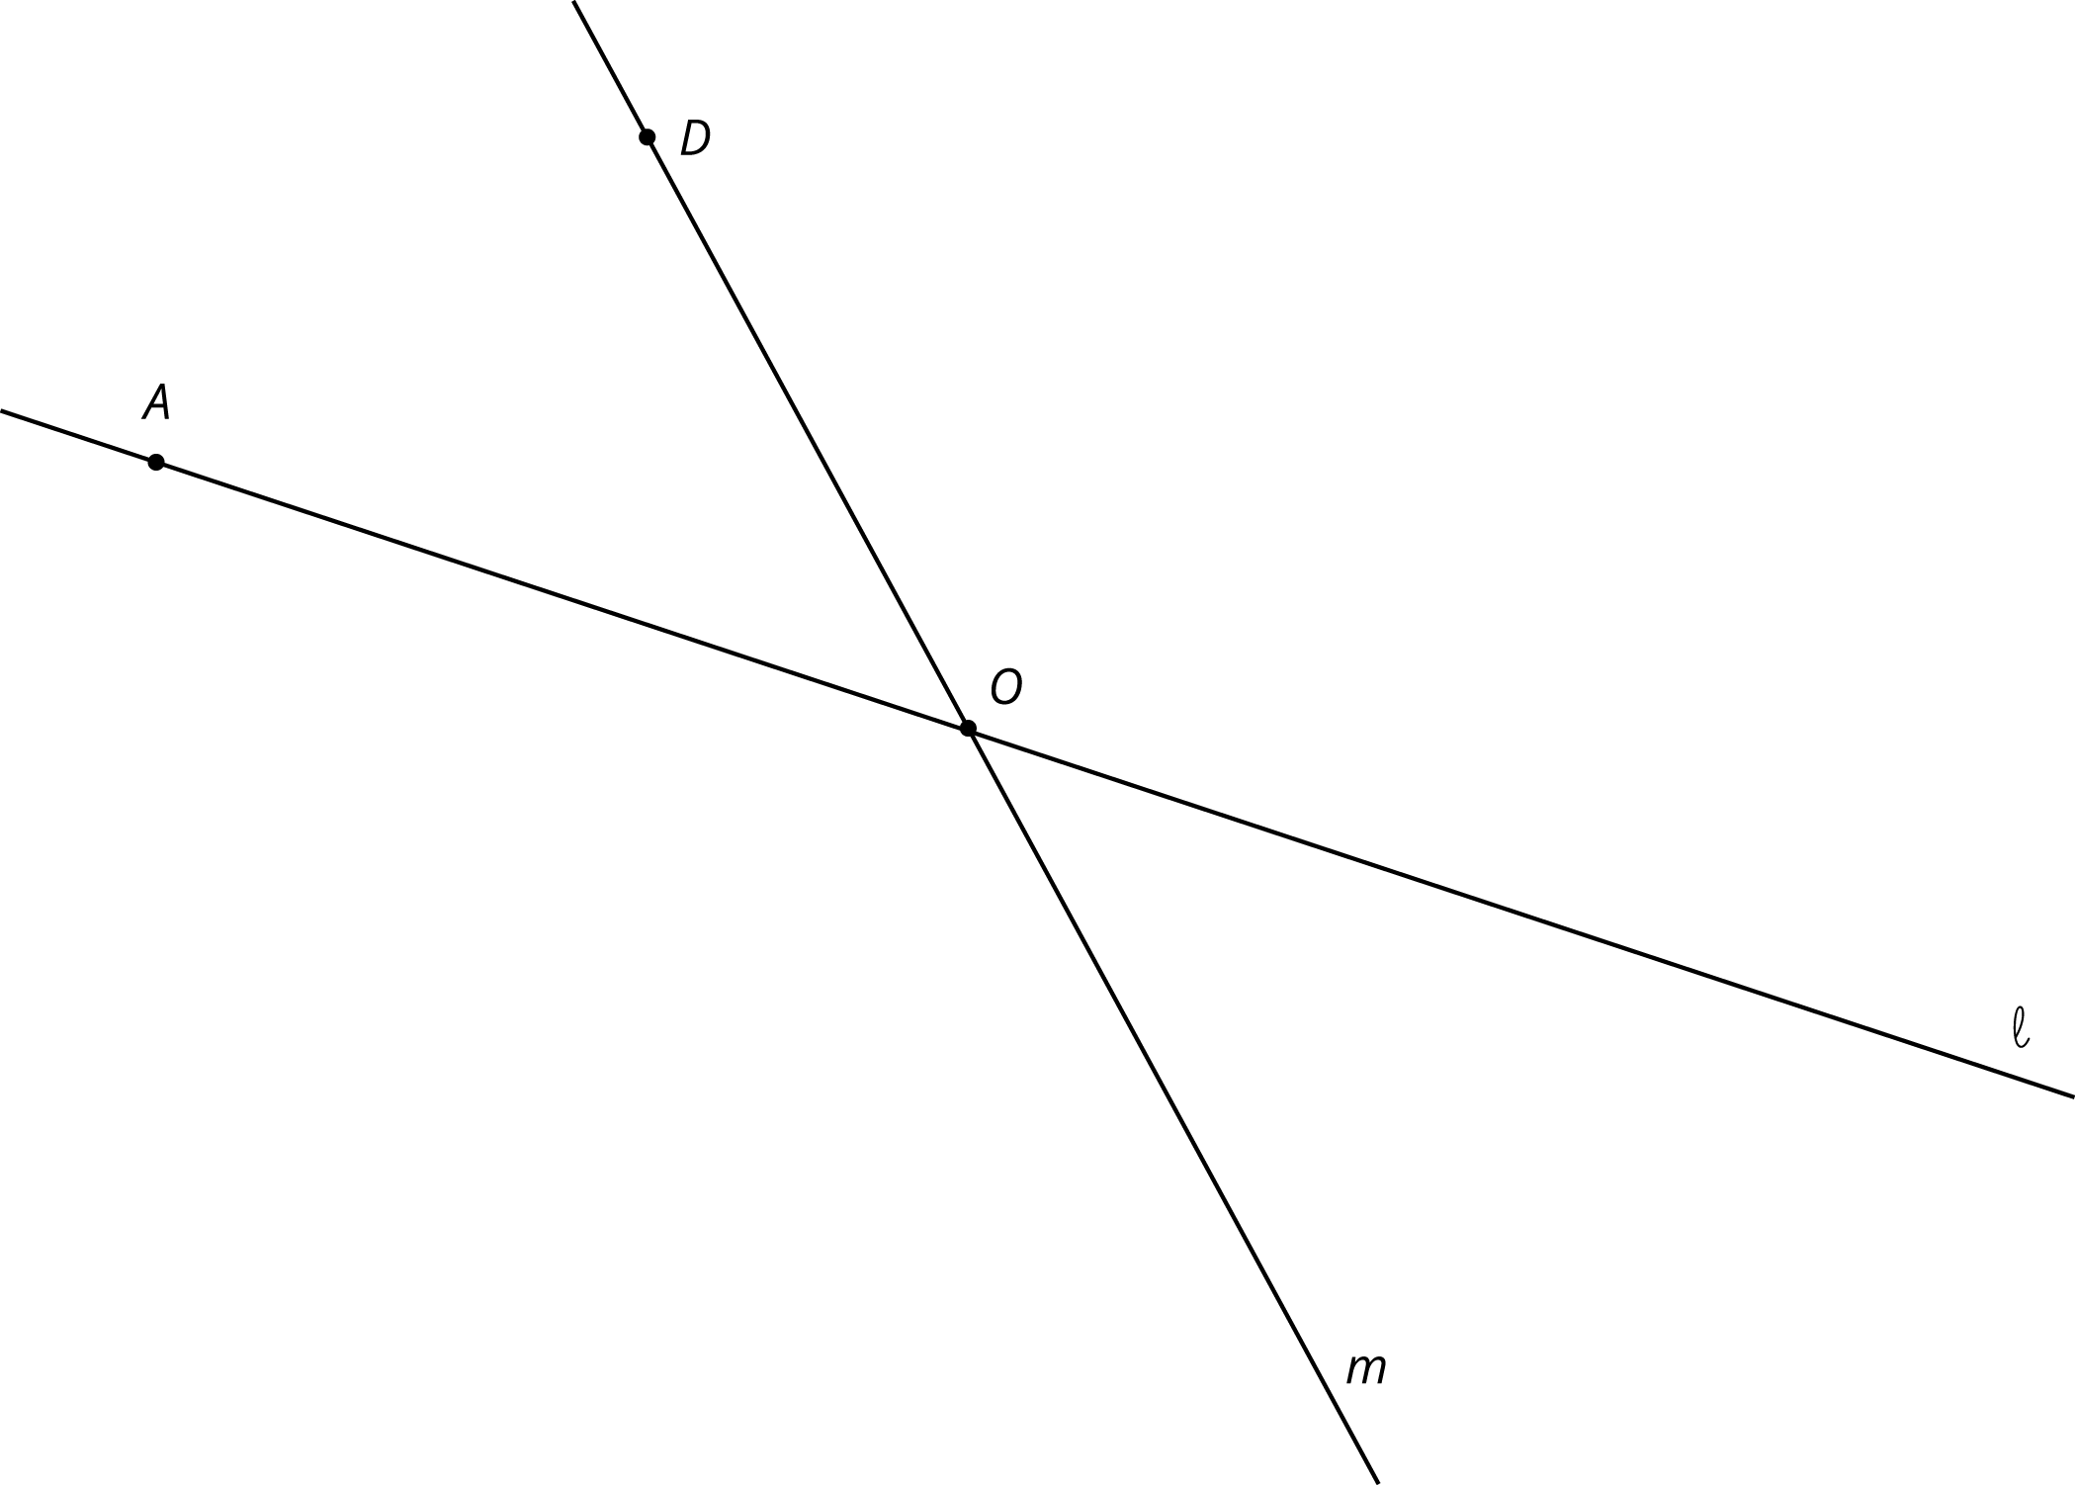

Lesson 8 Summary
Rigid transformations have the following properties:
- A rigid transformation of a line is a line.
- A rigid transformation of two parallel lines results in two parallel lines that are the same distance apart as the original two lines.
- Sometimes, a rigid transformation takes a line to itself. For example:
- 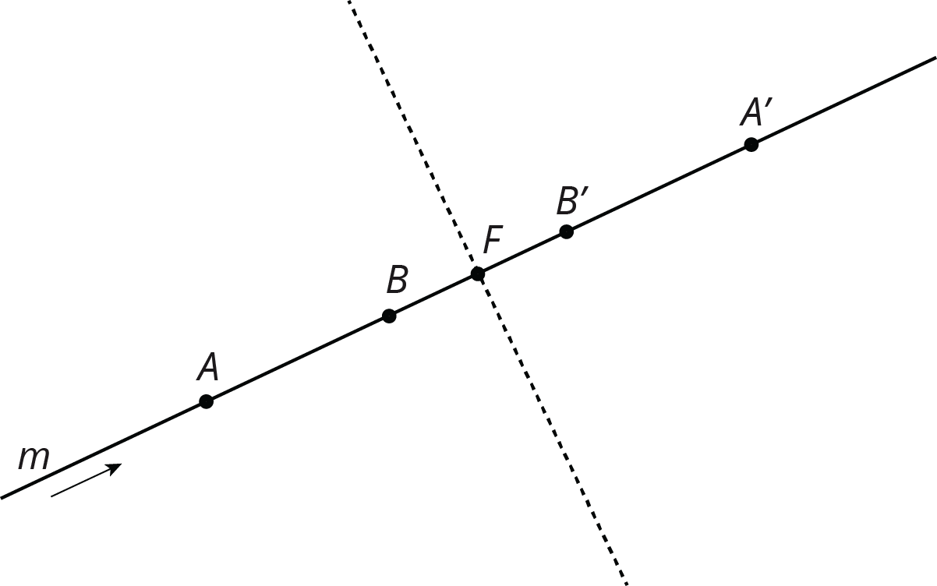
  - A translation parallel to the line. The arrow shows a translation of line $m$ that will take $m$ to itself.
  - A rotation by ${180}^{∘}$ around any point on the line. A ${180}^{∘}$ rotation of line $m$ around point $F$ will take $m$ to itself.
  - A reflection across any line perpendicular to the line. A reflection of line $m$ across the dashed line will take $m$ to itself.
These facts let us make an important conclusion. If two lines intersect at a point, which we’ll call $O$, then a ${180}^{∘}$ rotation of the lines with center $O$ shows that vertical angles are congruent. Here is an example:
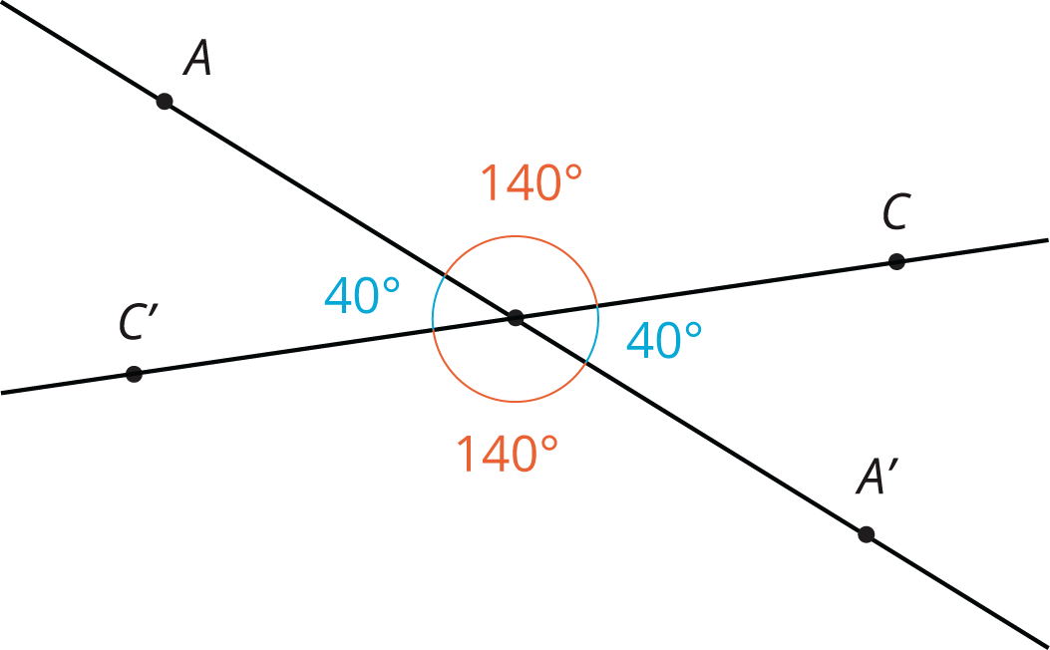
Rotating both lines by ${180}^{∘}$ around $O$ sends angle $AOC$ to angle $A^{′}OC^{′}$, proving that they have the same measure. The rotation also sends angle $AOC^{′}$ to angle $A^{′}OC$.
© CC BY Open Up Resources. Adaptations CC BY IM.

