Lesson 9: Shapes Are Everywhere
- Let’s find shapes in our world.

Warm-up: Which One Doesn’t Belong: Rectangles, Squares, and Triangles
Which one doesn’t belong?
A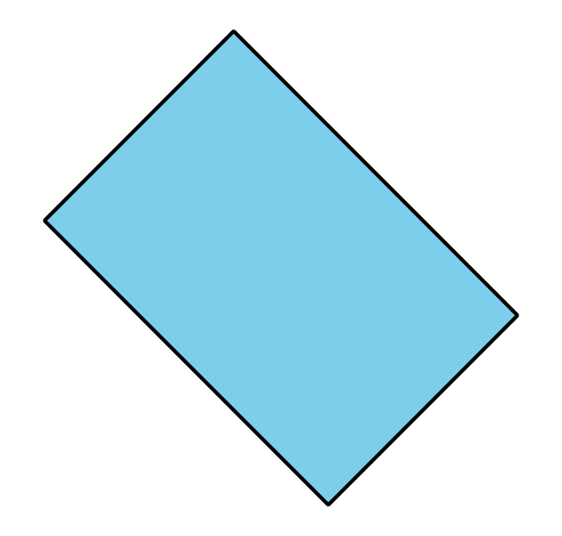
B
C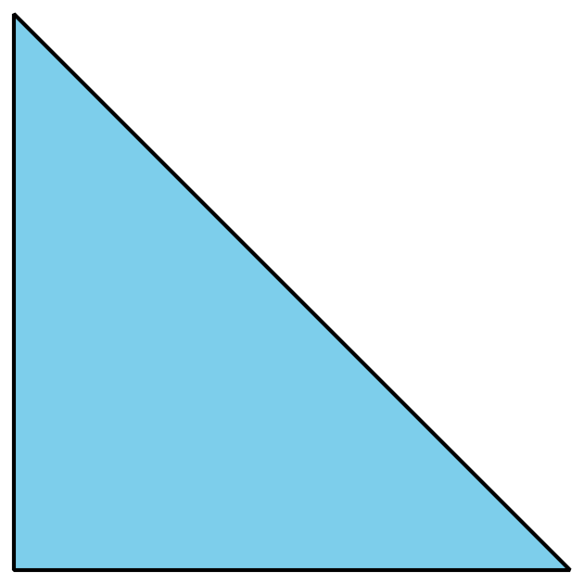
D

9.1: School Shape Walk
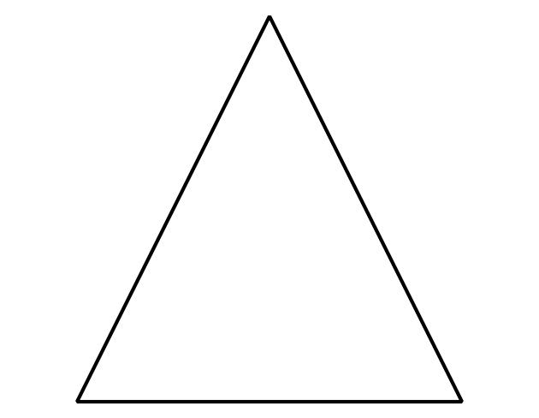
Synthesis:
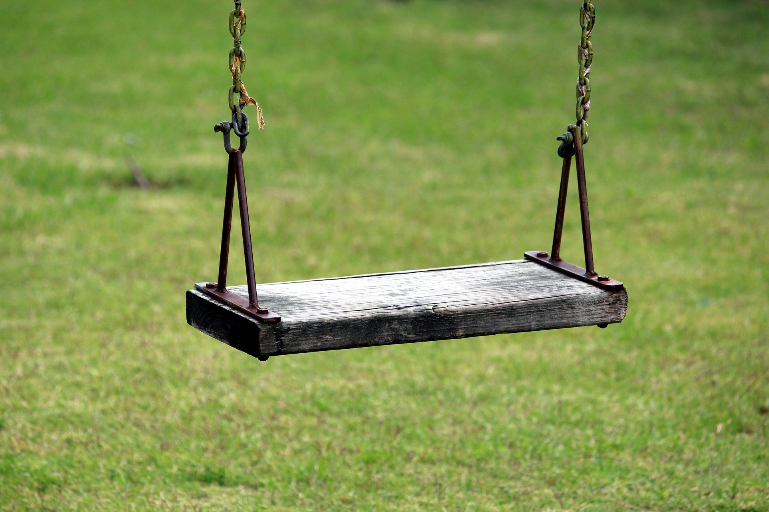

9.2: Create the Shape

9.3: Centers: Choice Time
Choose a center.
Build Shapes
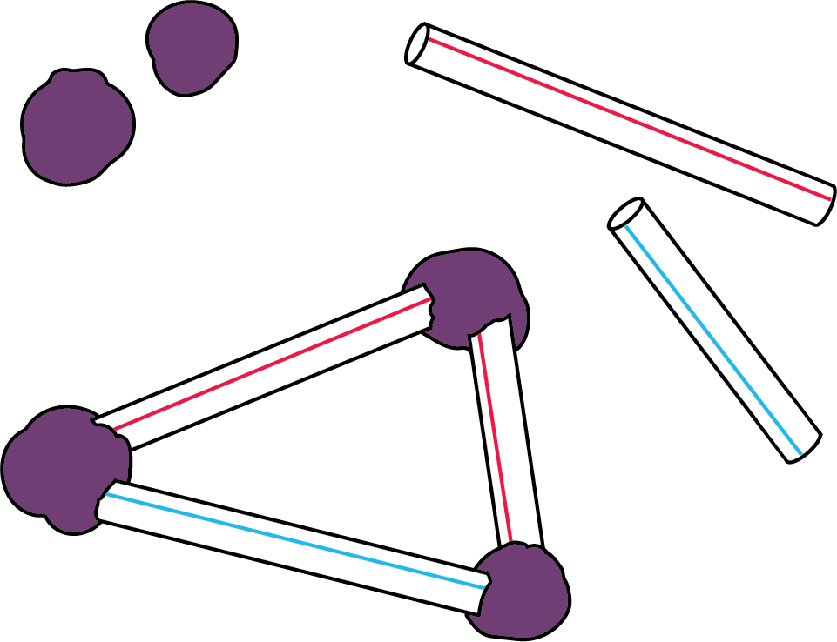
Counting Collections
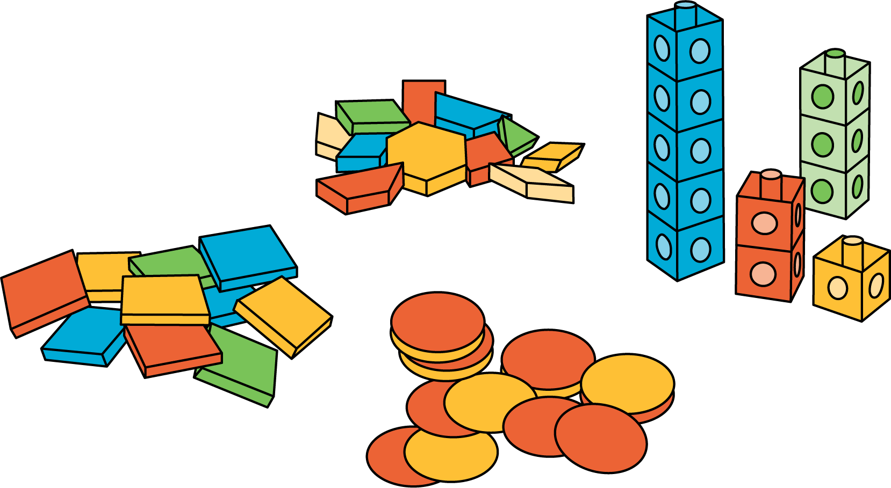
Which One
Picture Books
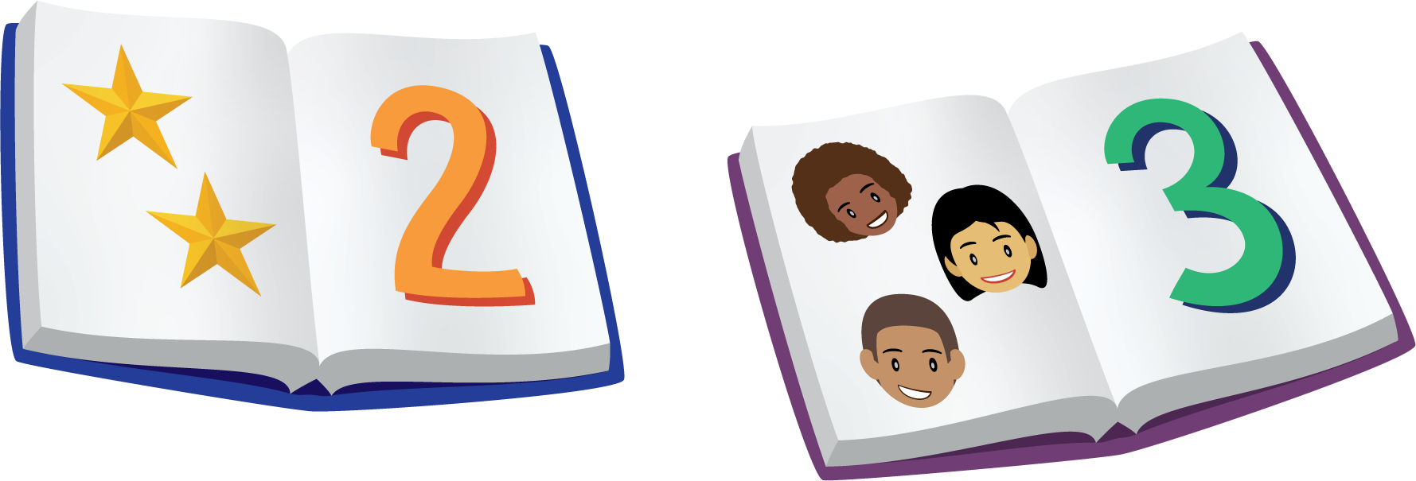
Bingo
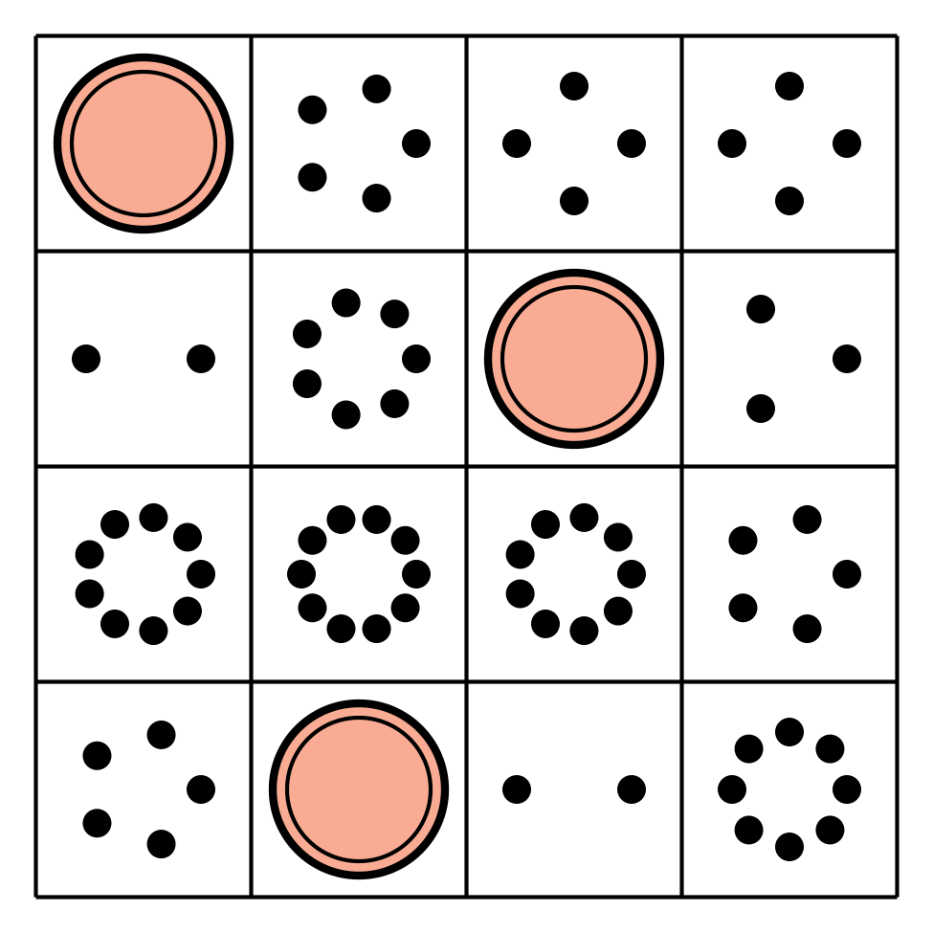
Shake and Spill
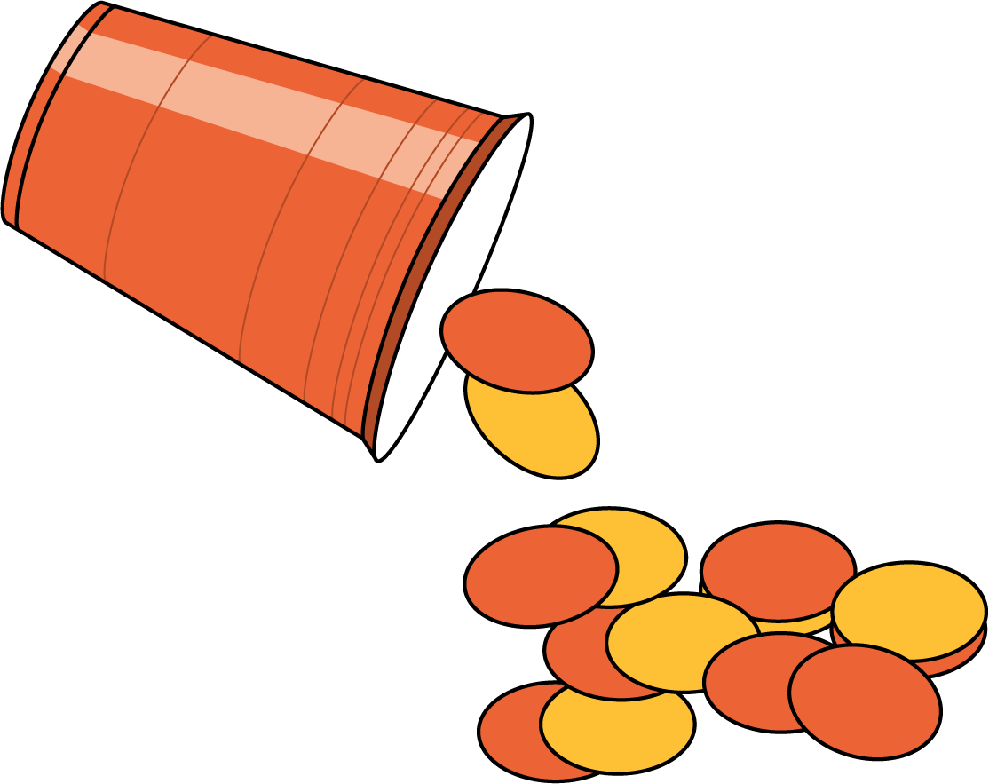

Section Summary
Section Summary
In this section, we noticed shapes in the world around us.
We described and compared shapes.
This shape looks like a door that is crooked.
It has 4 corners.
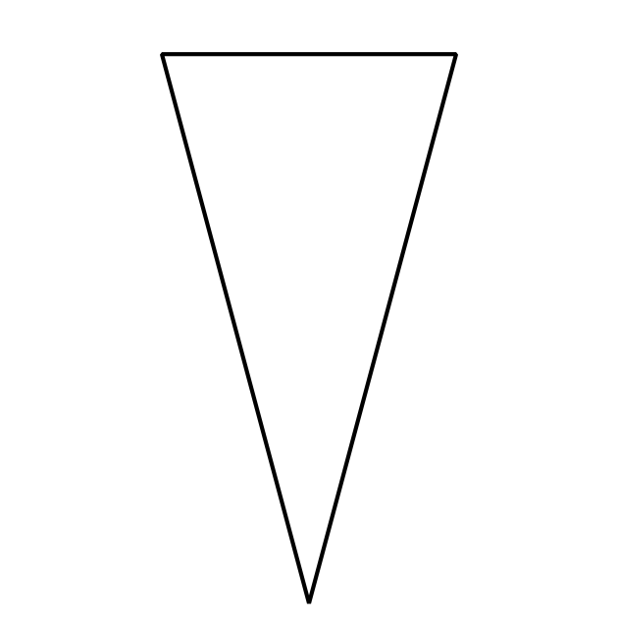
This shape has 2 long sides and 1 shorter side.
The shapes are alike because they have straight sides.
The shapes are different because one has 4 sides and one has 3 sides.
We learned the names of these shapes:
circle
triangle
rectangle
square
© CC BY 2021 Illustrative Mathematics®

