Lesson 8 Practice Problems
- The number of hours worked, $x$, and the total dollars earned, $y$, have a strong positive relationship.
- Explain what it means to have a strong positive relationship in this situation.
- The number of minutes on the phone and the customer satisfaction rating have a weak negative relationship.
- Explain what it means to have a weak negative relationship in this context.
- Technology required. Use a graphing calculator to answer the questions.
- $x$ | - $y$
- 5 | - 2
- 6 | - 4.6
- 7.5 | - 7.2
- 8 | - 8.4
- 8.3 | - 8.2
- 9 | - 9.1
- 10.2 | - 10.3
- 11.4 | - 9.9
- 11.4 | - 11
- 12 | - 12.5
  - What is an equation of the line of best fit?
  - What is the value of the correlation coefficient?
- Elena collects data to investigate the relationship between the number of bananas she buys at the store, $x$, and the total cost of the bananas, $y$. Which value for the correlation coefficient is most likely to match a line of best fit of the form $y=mx+b$ for this situation?
  - -0.9
  - -0.4
  - 0.4
  - 0.9
- A researcher creates a scatter plot that displays the relationship between the number of years in business, $x$, and the percentage of company business that is fair trade, $y$. The researcher creates a line of best fit, $y=0.091x+0.060$, and wants to find the residuals for the companies that have been in business for 3 years.
  - Find the residuals for the two points representing companies that have been in business for 3 years, $\left(3,0.42\right)$ and $\left(3,0.3\right)$.
  - Compare the residuals for the two companies who have been in business for 3 years. How are they different? How are they similar? What does the information about the residuals for the two companies tell you about their fair trade business?
- (From Unit 3, Lesson 6.)
- The correlation coefficient, $r$, is given for several different data sets. Which value for $r$ indicates the weakest correlation?
  - 0.01
  - 0.5
  - -0.99
  - 1
- (From Unit 3, Lesson 7.)
- Which of the following is the best estimate of the correlation coefficient for the data shown in the scatter plot?
- 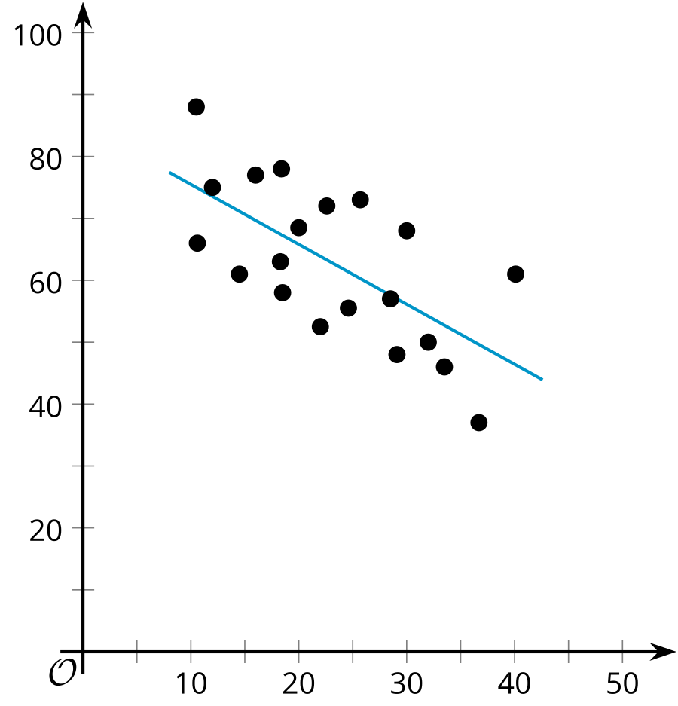
  - -0.9
  - -0.4
  - 0.4
  - 0.9
- (From Unit 3, Lesson 7.)
© CC BY 2019 by Illustrative Mathematics®

