Lesson 7: Using Graphs to Find Average Rate of Change
Let’s measure how quickly the output of a function changes.

7.1: Temperature Drop
Here are the recorded temperatures at three different times on a winter evening.
time | 4 p.m. | 6 p.m. | 10 p.m.
temperature | ${25}^{∘}F$ | ${17}^{∘}F$ | $8^{∘}F$
- Tyler says the temperature dropped faster between 4 p.m. and 6 p.m.
- Mai says the temperature dropped faster between 6 p.m. and 10 p.m.
Who do you agree with? Explain your reasoning.

7.2: Drop Some More
The table and graphs show a more complete picture of the temperature changes on the same winter day. The function $T$ gives the temperature in degrees Fahrenheit, $h$ hours since noon.
$h$
$T(h)$
0
18
1
19
2
20
3
20
4
25
5
23
6
17
7
15
8
11
9
11
10
8
11
6
12
7
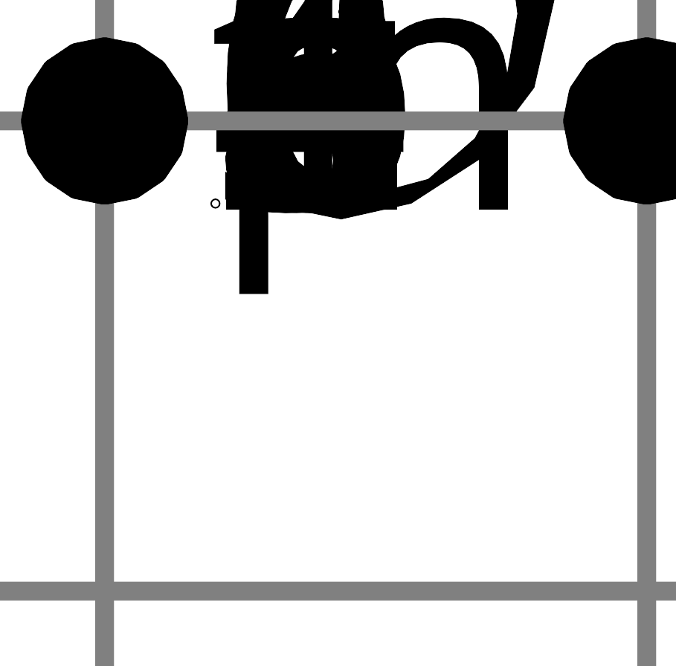
- Find the average rate of change for the following intervals. Explain or show your reasoning.
  - between noon and 1 p.m.
  - between noon and 4 p.m.
  - between noon and midnight
- Remember Mai and Tyler’s disagreement? Use average rate of change to show which time period—4 p.m. to 6 p.m. or 6 p.m. to 10 p.m.—experienced a faster temperature drop.

Are you ready for more?
- Over what interval did the temperature decrease the most rapidly?
- Over what interval did the temperature increase the most rapidly?

7.3: Populations of Two States
The graphs show the populations of California and Texas over time.
  - Estimate the average rate of change in the population in each state between 1970 and 2010. Show your reasoning.
  - In this situation, what does each rate of change mean?
- Which state’s population grew more quickly between 1900 and 2000? Show your reasoning.

Lesson 7 Summary
Here is a graph of one day’s temperature as a function of time.
The temperature was ${35}^{∘}F$ at 9 a.m. and ${45}^{∘}F$ at 2 p.m., an increase of ${10}^{∘}F$ over those 5 hours.
The increase wasn't constant, however. The temperature rose from 9 a.m. and 10 a.m., stayed steady for an hour, then rose again.
- On average, how fast was the temperature rising between 9 a.m. and 2 p.m.?
- Let's calculate the average rate of change and measure the temperature change per hour. We do that by finding the difference in the temperature between 9 a.m. and 2 p.m. and dividing it by the number of hours in that interval.
- $\text{average rate of change}=\frac{45−35}{5}=\frac{10}{5}=2$
- On average, the temperature between 9 a.m. and 2 p.m. increased $2^{∘}F$ per hour.
- How quickly was the temperature falling between 2 p.m. and 8 p.m.?
- $\text{average rate of change}=\frac{30−45}{6}=\frac{\text{-}15}{6}=\text{-}2.5$
- On average, the temperature between 2 p.m. and 8 p.m. dropped by ${2.5}^{∘}F$ per hour.
In general, we can calculate the average rate of change of a function $f$, between input values $a$ and $b$, by dividing the difference in the outputs by the difference in the inputs.
$\text{average rate of change}=\frac{f(b)−f(a)}{b−a}$
If the two points on the graph of the function are $(a,f(a))$ and $(b,f(b))$, the average rate of change is the slope of the line that connects the two points.
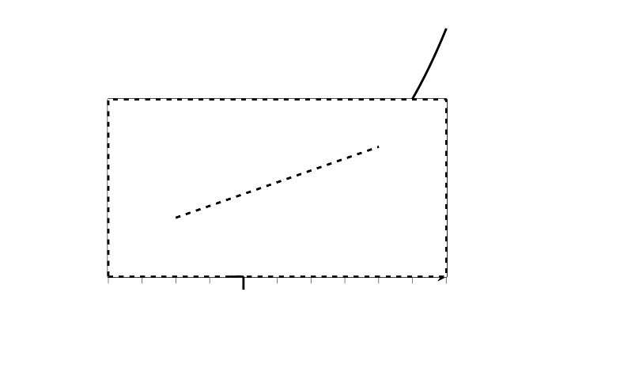
© CC BY 2019 by Illustrative Mathematics®

