Lesson 17 Practice Problems
- Jada is planning a kayak trip. She finds an expression for the time, $T(s)$, in hours it takes her to paddle 10 kilometers upstream in terms of $s$, the speed of the current in kilometers per hour. This is the graph Jada gets if she allows $s$ to take on any value between 0 and 7.5.
  - What would be a more appropriate domain for Jada to use instead?
  - What is the approximate speed of the current if her trip takes 6 hours?
- A cylindrical can needs to have a volume of 6 cubic inches. A label is to go around the side of the can. The function $S(r)=\frac{12}{r}$ gives the area of the label in square inches where $r$ is the radius of the can in inches.
  - As $r$ gets closer and closer to 0, what does the behavior of the function tell you about the situation?
  - As $r$ gets larger and larger, what does the end behavior of the function tell you about the situation?
- What is the equation of the vertical asymptote for the graph of the rational function $g(x)=\frac{6}{x−1}$?
  - $x=1$
  - $x=\text{-}1$
  - $x=6$
  - $x=\frac{1}{6}$
- A geometric sequence $h$ starts at 16 and has a growth factor of 1.75. Sketch a graph of $h$ showing the first 5 terms.
- (From Unit 1, Lesson 7.)
- Is this the graph of $g(x)=\text{-}x^{2}(x−2)$ or $h(x)=x^{2}(x−2)$? Explain how you know.
- 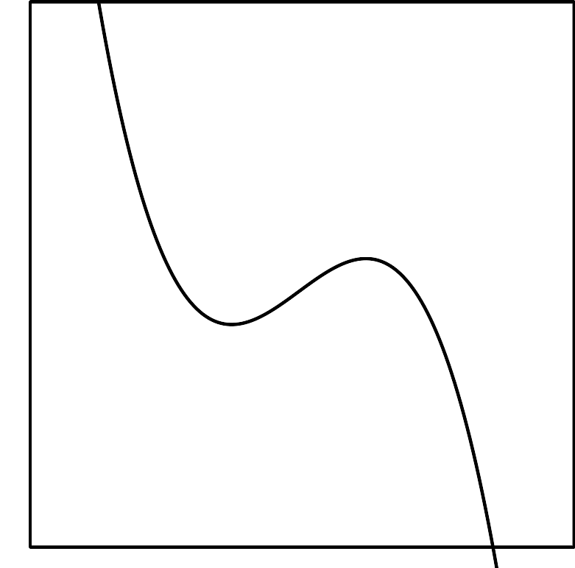
- (From Unit 2, Lesson 10.)
- Technology required. A 6 oz cylindrical can of tomato paste needs to have a volume of 178 cm³. The current can design uses a radius of 2.75 cm and a height of 7.5 cm. Use graphing technology to find a cylindrical design that would have less surface area so each can uses less metal.
- (From Unit 2, Lesson 16.)
- The surface area $S(r)$ in square units of a cylinder with a volume of 20 cubic units is a function of its radius $r$ in units where $S(r)=2πr^{2}+\frac{40}{r}$. What is the surface area of a cylinder with a volume of 20 cubic units and a radius of 4 units?
- (From Unit 2, Lesson 16.)
© CC BY 2019 by Illustrative Mathematics®

