Lesson 6: Represent Numbers in Different Ways
- Let’s represent numbers in different ways.

Warm-up: Which One Doesn’t Belong: Numbers in Different Ways
Which one doesn’t belong?
A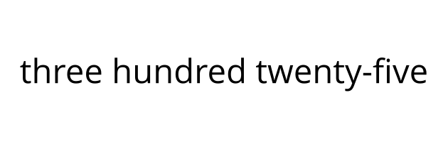
B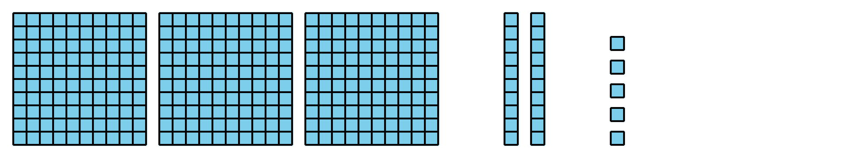
C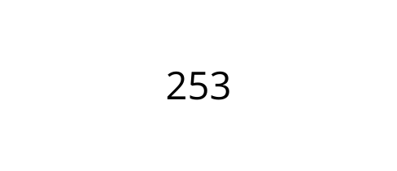
D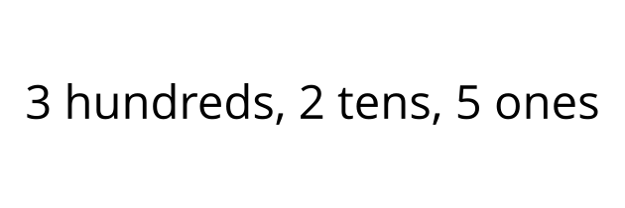

6.1: Numbers as Words
- Fill in the blanks to represent 248 with words.
- two ___________________ forty-________________
- Fill in the blanks to represent 562 with words.
- ______________ hundred _____________- _______
- Represent this number with words.
- 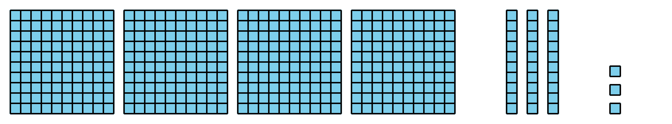
- Represent 627 with words.
- Represent $900+50+1$ with words.
- Represent three hundred eighteen in two different ways.

6.2: Represent the Numbers
Represent the number on your poster. Be sure to represent the number using:
- a three-digit number
- a base-ten diagram
- expanded form
- words
If you have time: Represent the number using only tens and ones. Represent the number composed in a different way.

Section Summary
Section Summary
In this section of the unit, we learned different ways to represent numbers that are greater than 99. We represented hundreds with base-ten blocks and diagrams. We represented numbers by describing the number of hundreds, tens, and ones that make up the number. We learned to read and write numbers as three-digit numbers, as a sum of the value of each of the digits, and using words.
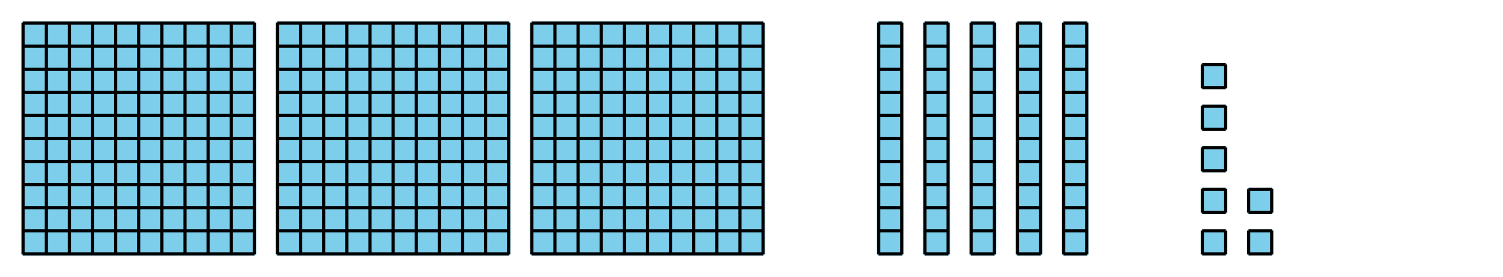
3 hundreds 5 tens 7 ones
357
$300+50+7$
three hundred fifty-seven
© CC BY 2021 Illustrative Mathematics®

