Unit 6 Lesson 9: You Ate the Whole Thing

WU Number Talk: What's the Sum? (Warm up)

Student Task Statement
Find the value of each expression mentally.
- $20+10+10+5$
- $30+25$
- $35+15$
- $15+25+15$

1 Pizza to Share

Student Task Statement
Clare’s friends were going to share a pizza. The image shows how they cut the pizza.
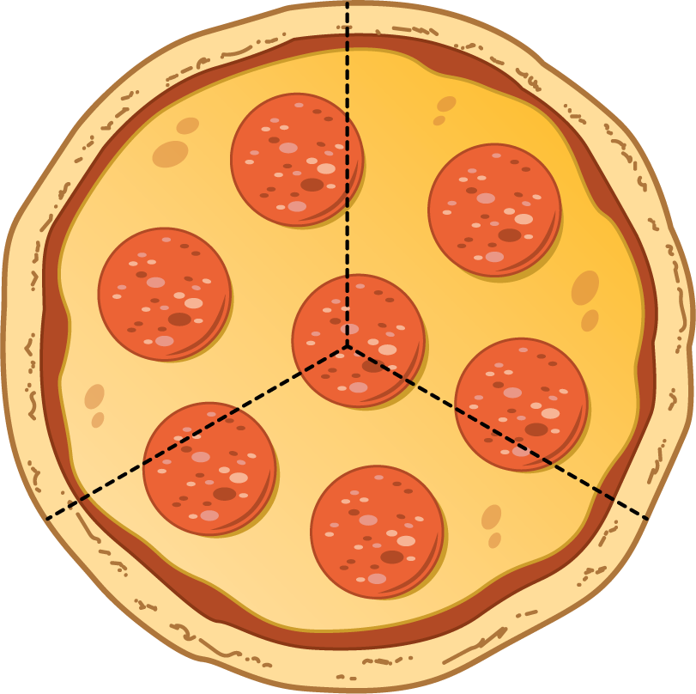
- Clare ate 3 slices and her friends got upset with her.
  - Why are her friends upset?
  - How many thirds did Clare eat?
  - How much of the pizza was left?
- Pizza Parts
- Group
- Priya
- Han
- Diego
  - Priya will eat ________________________ of the pizza.
  - Together they will eat ________________________ of the pizza.
- Pizza Parts
- 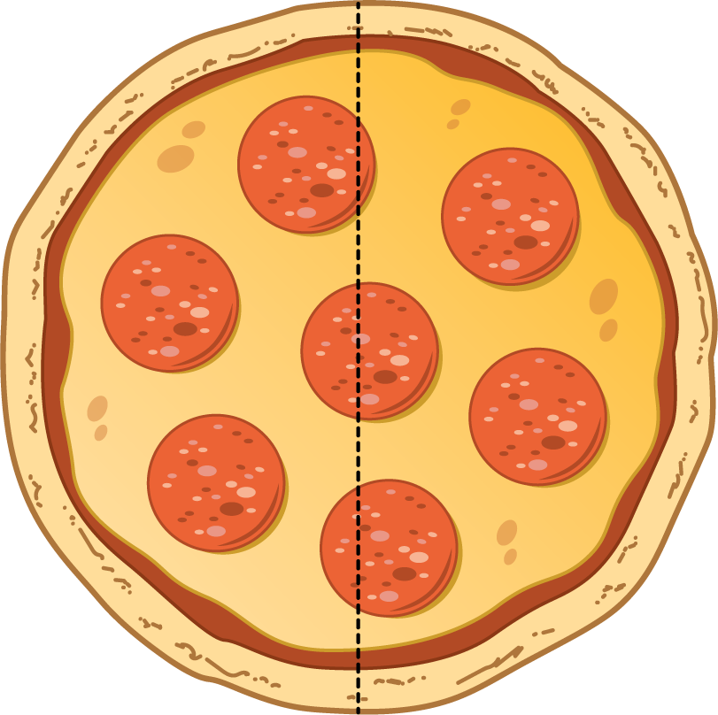
- Group
- Jada
- Mai
  - Each girl will eat ______________________ of the pizza.
  - Together they will eat ________________________ of the pizza.
- Pizza Parts
- 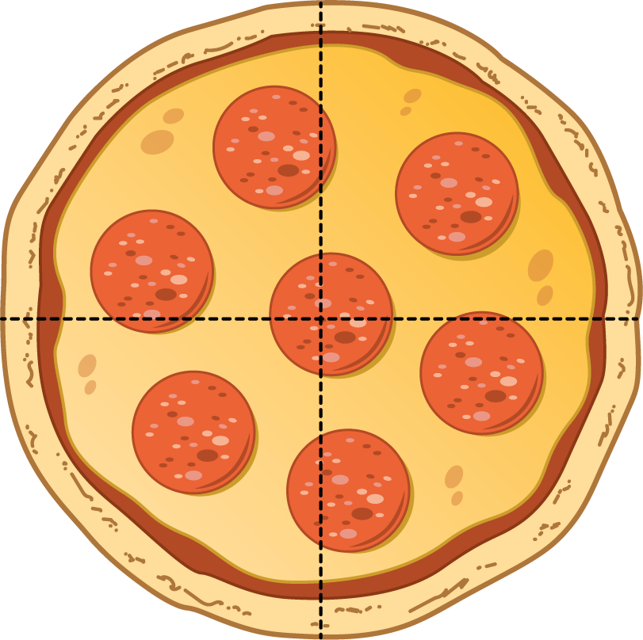
- Group
- Elena
- Tyler
- Lin
- Kiran
  - How much pizza will each child eat? ________________________
  - How much pizza will they eat in all? ________________________

2 Equal Shares of the Pie

Student Task Statement
Write the letter of each image next to the matching story.
A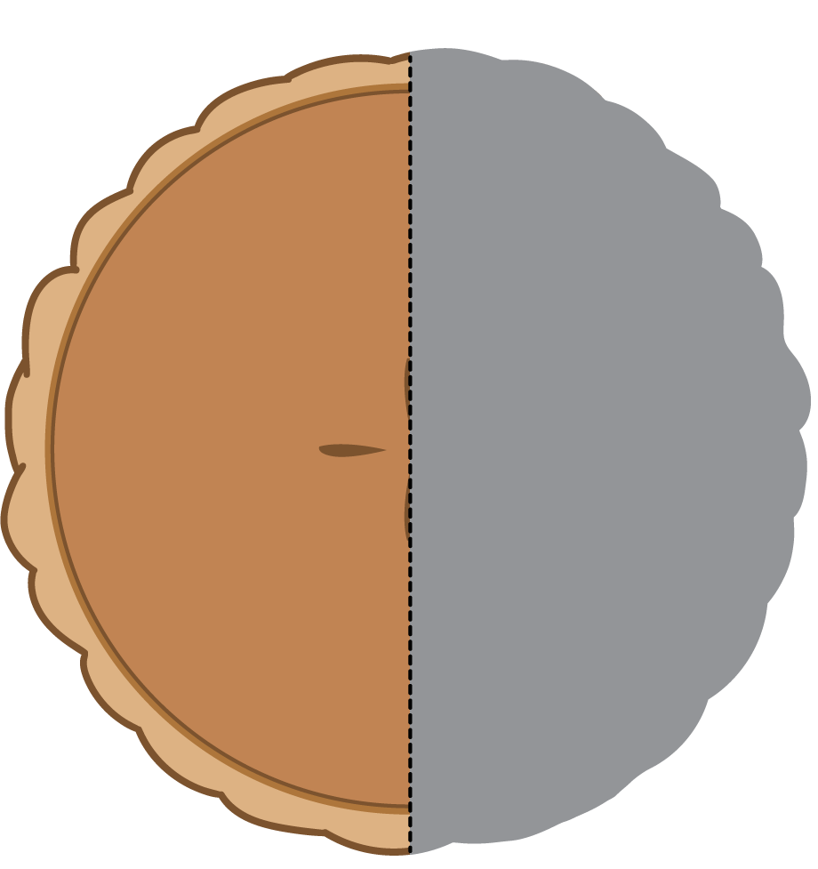
B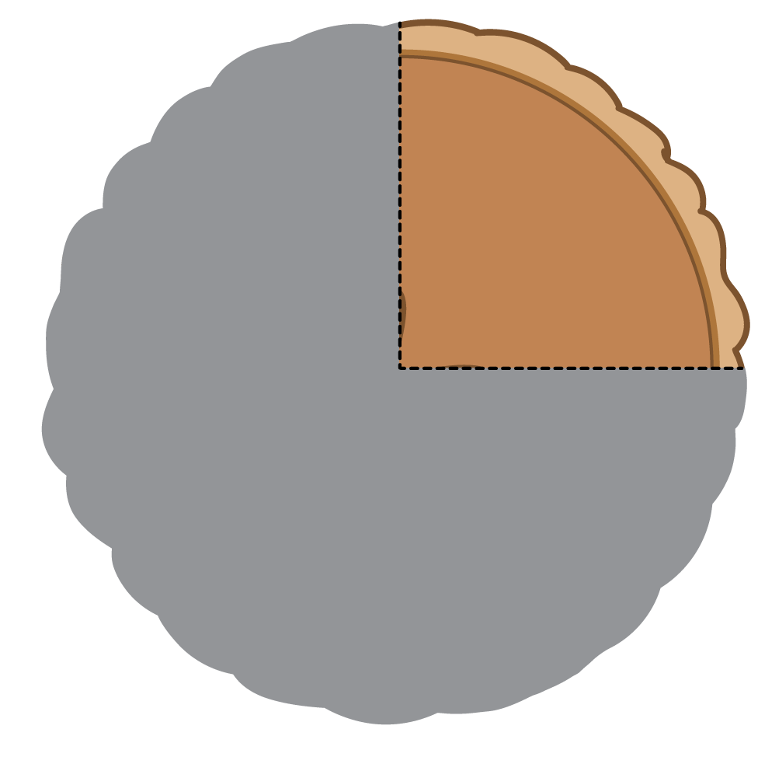
C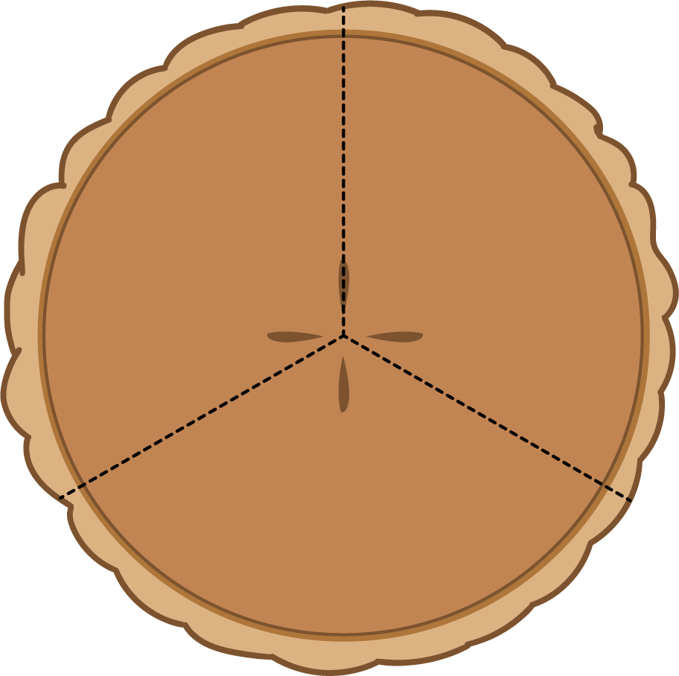
D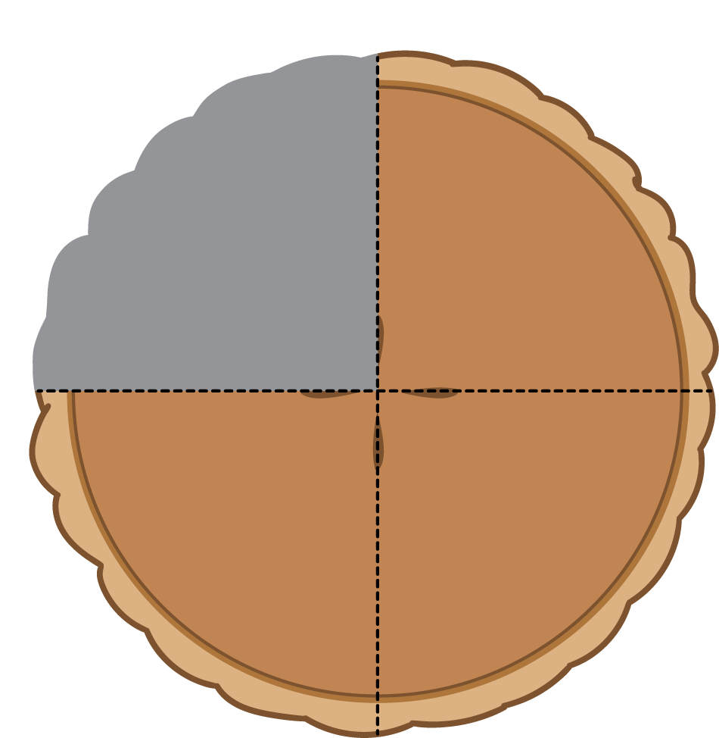
- Noah ate most of the pie. He left a quarter of the pie for Diego. __________
- Lin gave away a half of her pie and kept a half of the pie for herself. __________
- Tyler cut a pie into four equal pieces. He ate a quarter of the pie. __________
- Mai sliced the pie to share it equally with Clare and Priya. __________
  - How much of the pie will they each get? a _________________
  - How much of the pie will they eat in all? _________________
- Now you try.
  - Partition the circle into four equal pieces.
  - Shade in a quarter of the circle red.
  - Shade in the rest of the circle blue.
- How much of the circle is shaded? _____________________________

  - Partition the circle into 2 equal pieces.
  - Shade one half of the circle blue.
  - Color the other piece yellow.
- How much of the circle is yellow? ________________________
- How much of the circle is shaded? ________________________

Images for Activity Synthesis
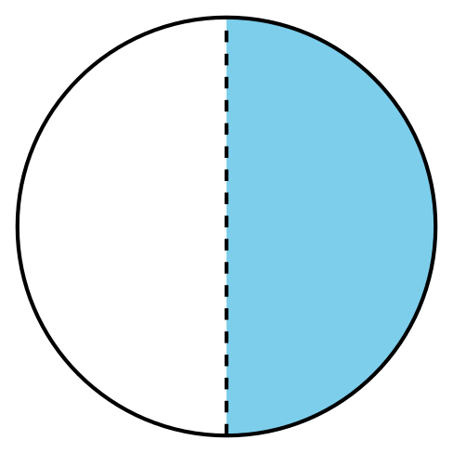
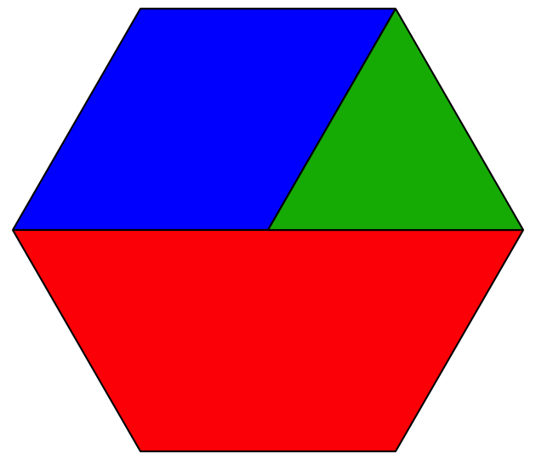
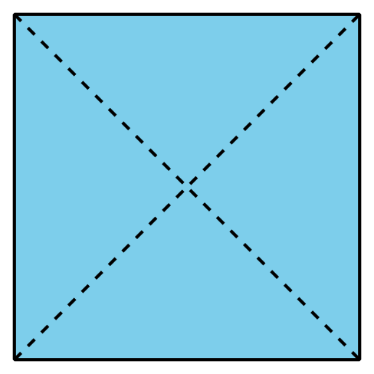
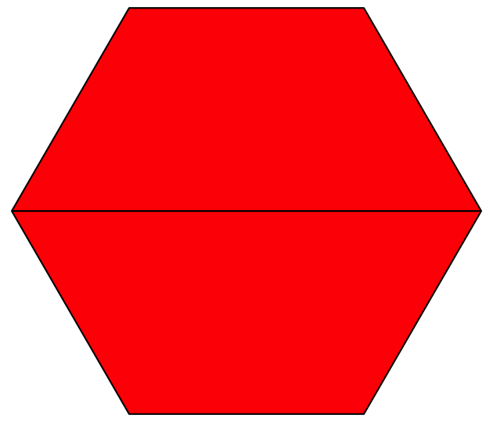
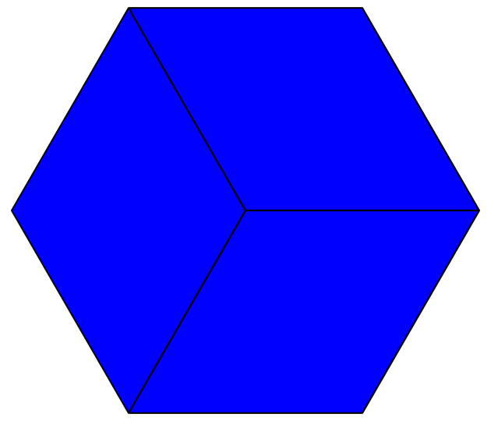
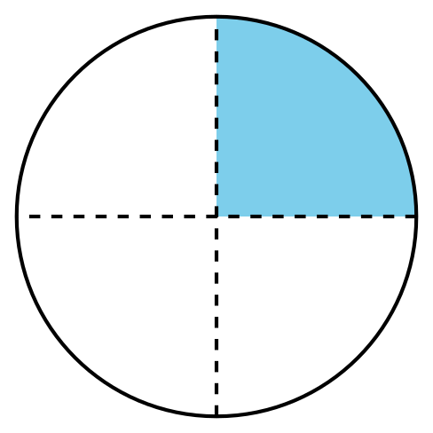
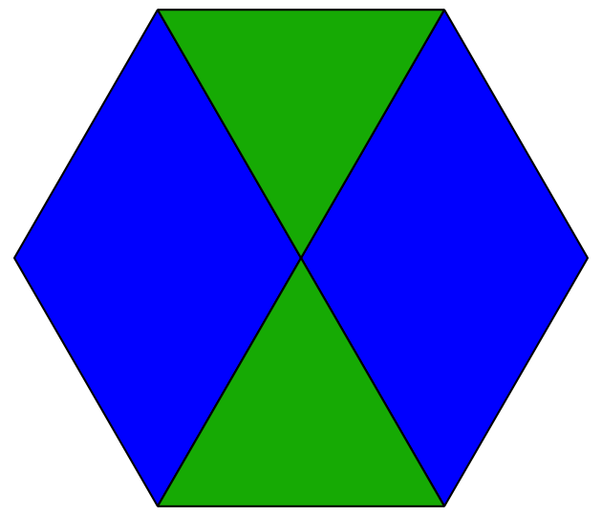
© CC BY 2021 Illustrative Mathematics®

