Unit 2 Lesson 20: What’s the Story?

WU How Many Do You See: 10-Frames (Warm up)

Student Task Statement
How many do you see?
How do you see them?
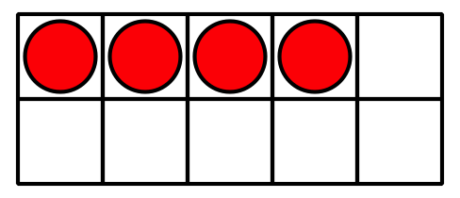
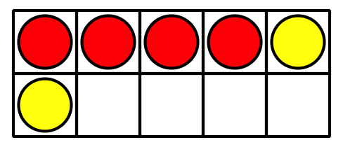
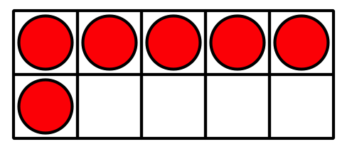
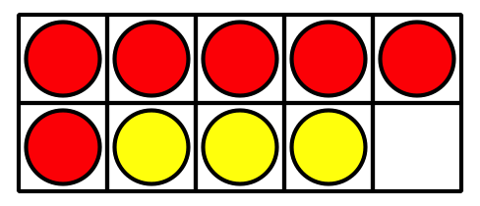

1 Write Story Problems

Student Task Statement
Choose 2 equations. Write a story problem for each equation.
- 3+5=8
- 4+3=7
- 10−5=5
- 9=5+4
- 3+7=10
- 6+3=9
- 8=2+6
- Equation: ________________________________
- Story Problem:
- Equation: ________________________________
- Story Problem:

2 I've Got the Answer

Student Task Statement
Circle a number that represents your answer.
2
3
4
5
6
7
8
9
10
Write an equation that includes the number you chose.
Put a box around the number.
Equation: ________________________________
Write a story problem that matches your equation.
Share your story problem with a partner.
Solve your partner’s story problem.
Write the equation that matches the story problem.
Equation: ________________________________
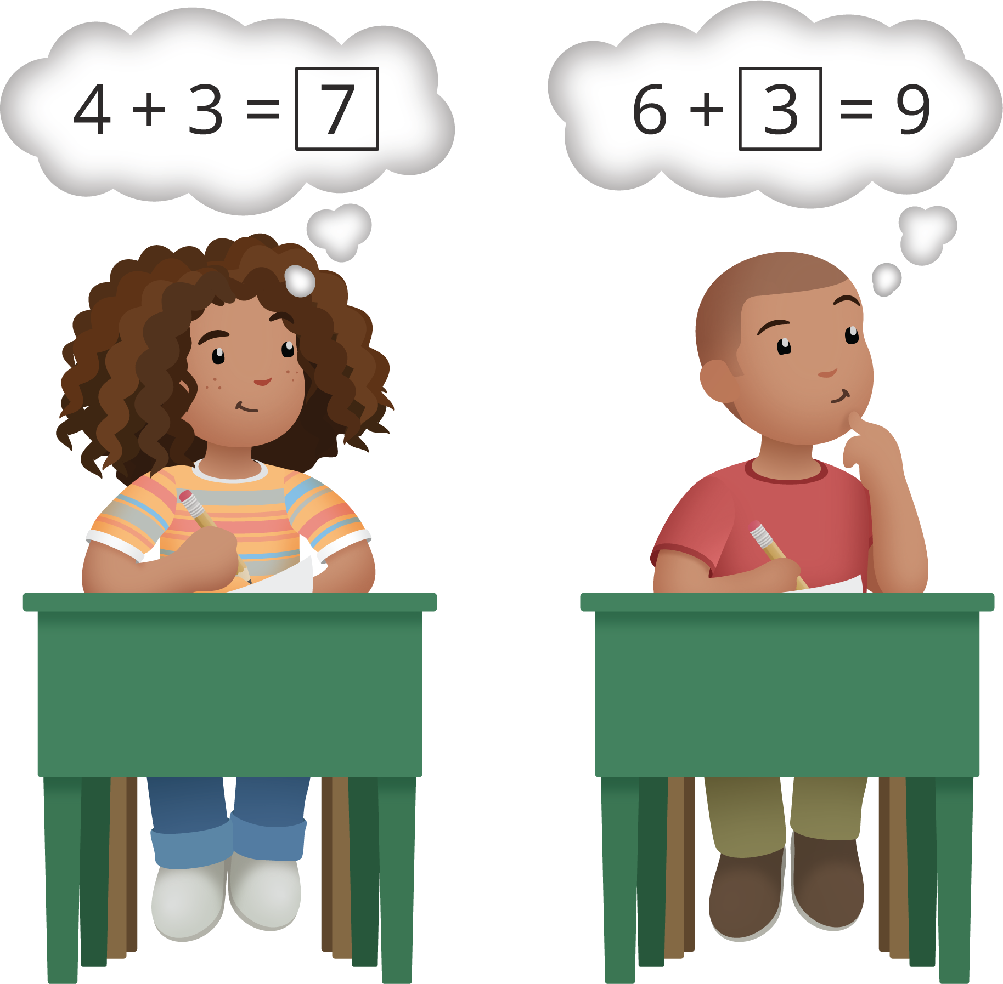

3 Centers: Choice Time

Student Task Statement
Choose a center.
Capture Squares
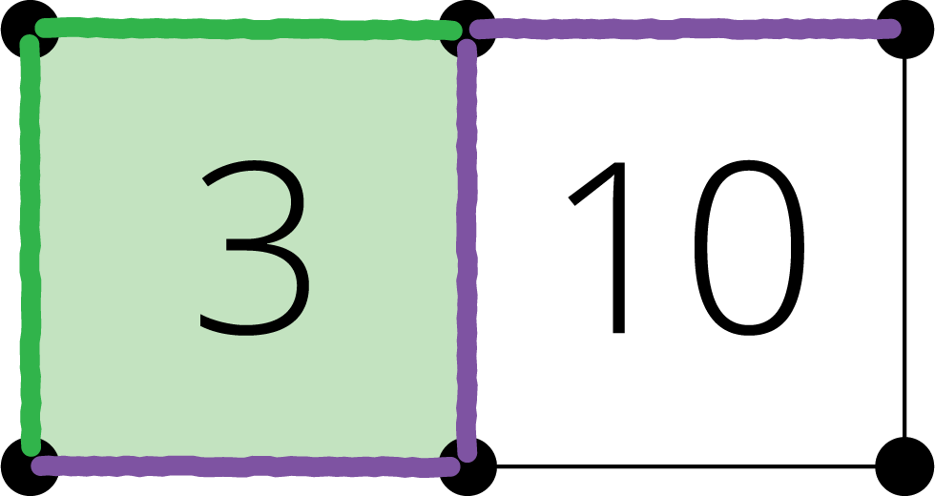
Shake and Spill
What's Behind My Back
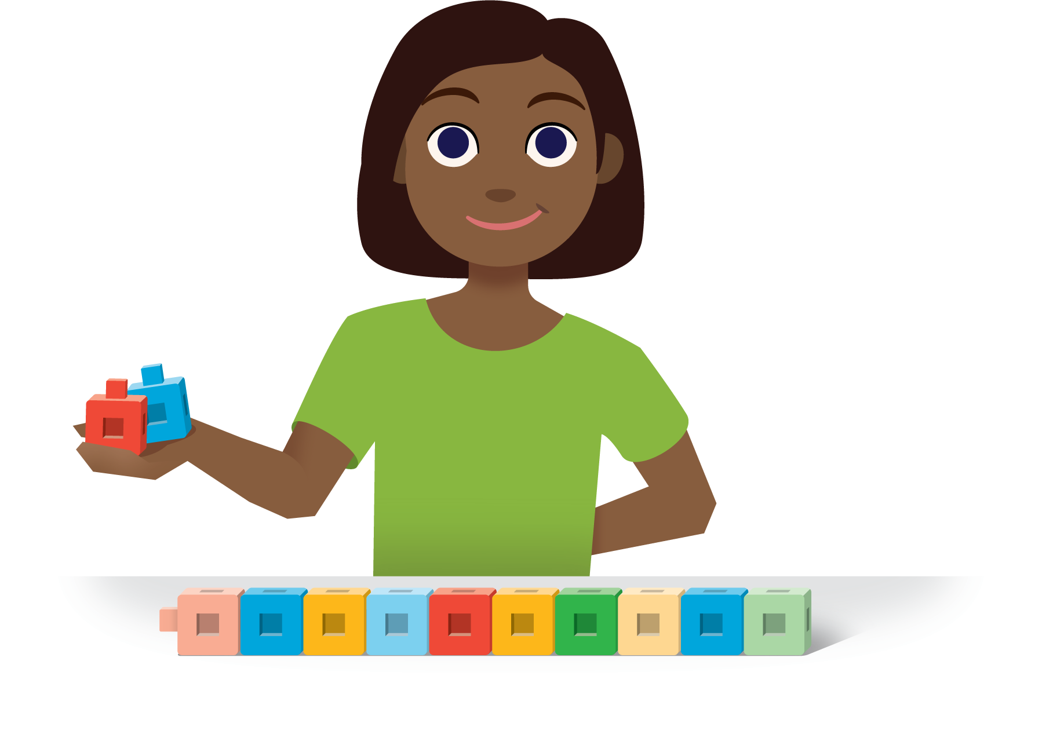
© CC BY 2021 Illustrative Mathematics®

