Lesson 7: The Size of Angles on a Clock
- Let’s describe angles using the hands of a clock.

Warm-up: Notice and Wonder: Two Sets of Angles
What do you notice? What do you wonder?
Set 1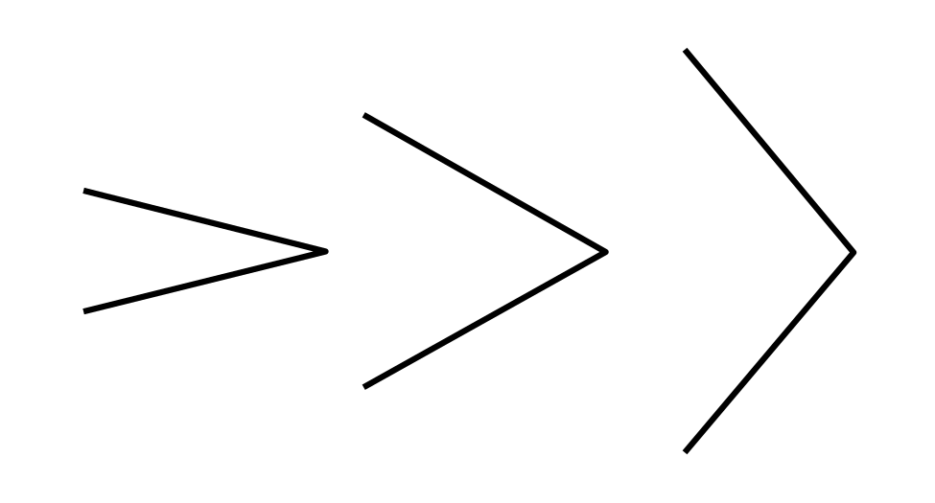
Set 2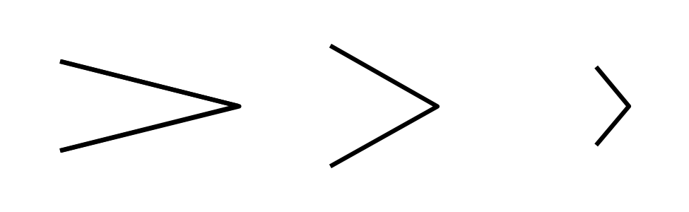

7.1: Draw Angles Andre’s Way
Andre used the hands of a clock to explain how to draw an angle to his partner.
“Imagine both hands are pointing at the 12. Turn the minute hand so it's pointing at the 3.”
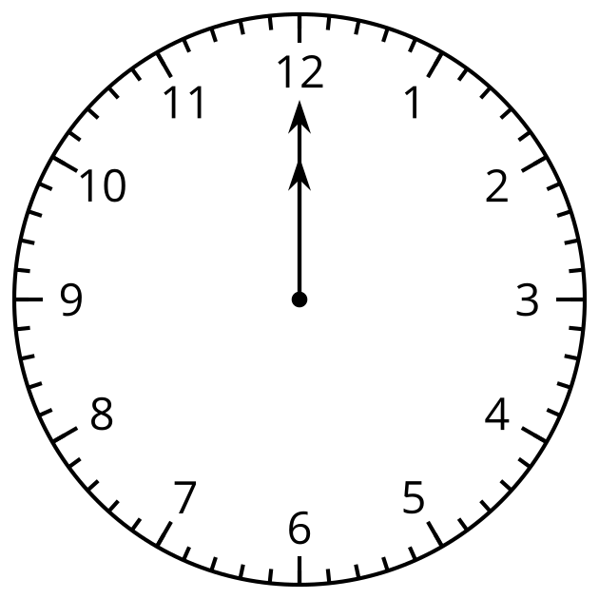
- Draw Andre’s angle.
- What is another way to describe how to draw the same angle using the clock?
- Use Andre’s way to explain how to draw these angles:

  - 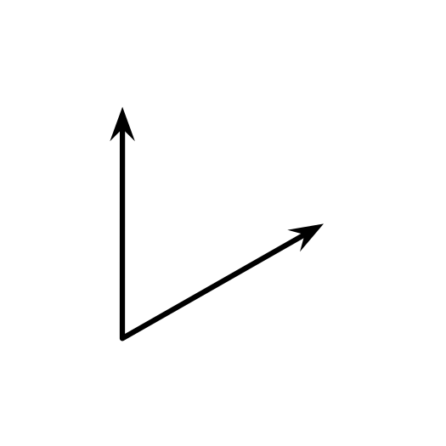

  - 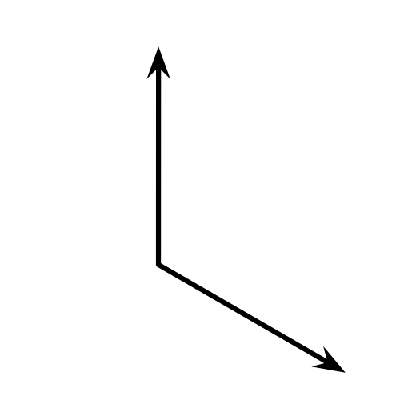

  - 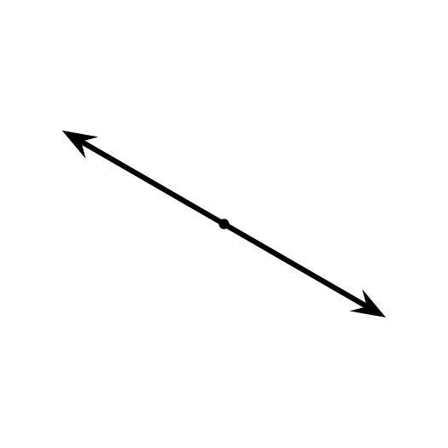

7.2: Compare Angles on the Clock
- Here are some angles formed by the two hands of a clock.
- In each pair of angles, which angle is larger? Explain or show your reasoning.

  - 5:00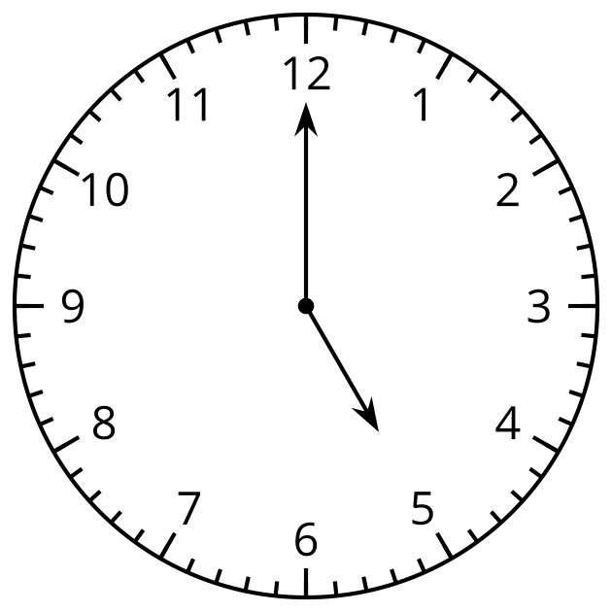
  - 3:00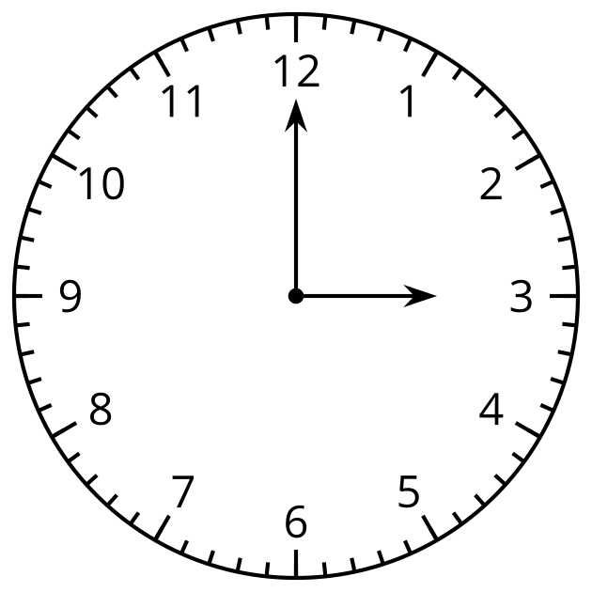

  - 1:15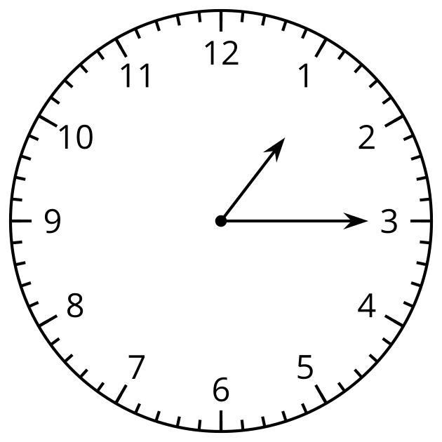
  - 1:20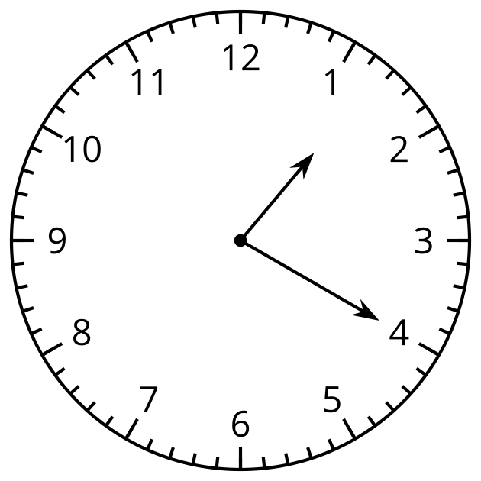

  - 2:50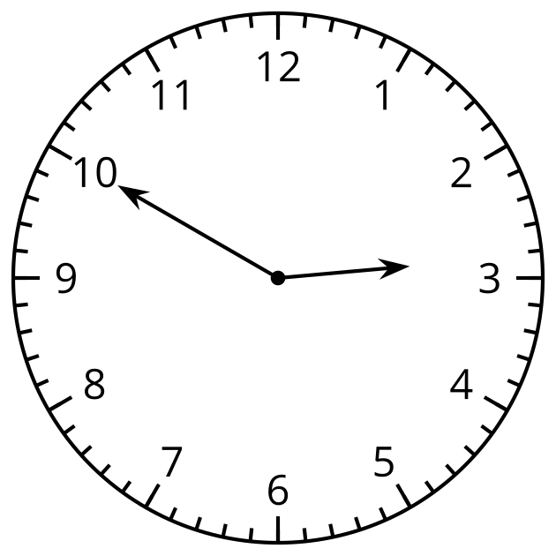
  - 11:20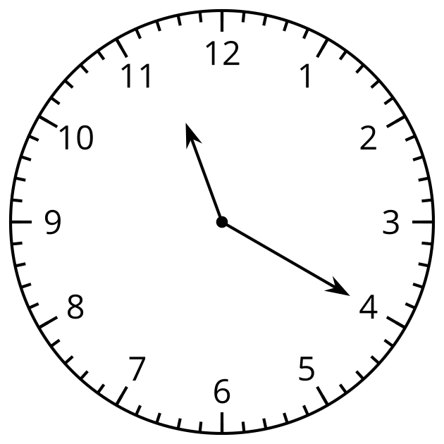

  - 8:58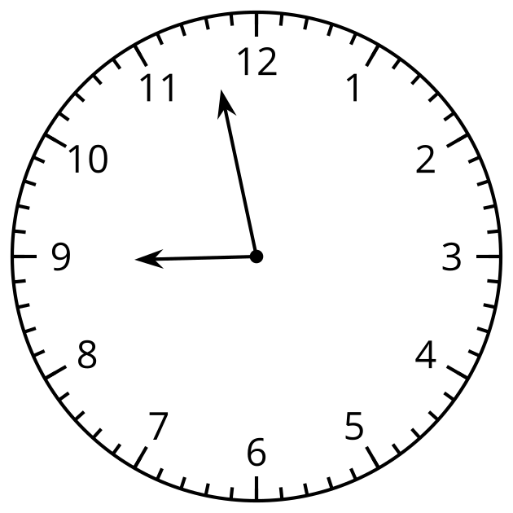
  - 9:35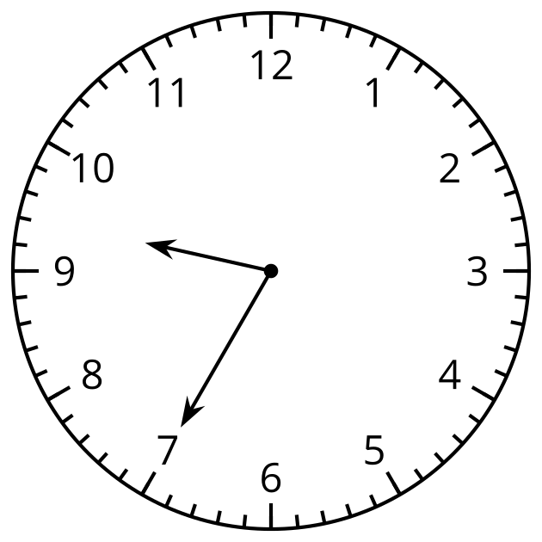
- How large is this angle?
- Describe its size in as many ways as you can.
- 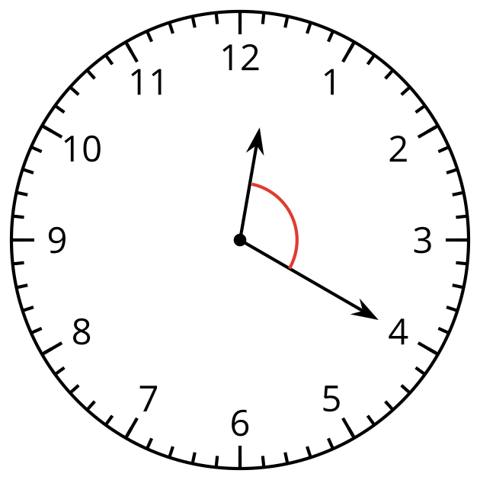
© CC BY 2021 Illustrative Mathematics®

