Unit 5 Lesson 10 Cumulative Practice Problems
- Kiran is using long division to find $696÷12$.
- 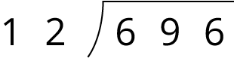
- He starts by dividing 69 by 12. In which decimal place should Kiran place the first digit of the quotient (5)?
  - Hundreds
  - Tens
  - Ones
  - Tenths
- Here is a long-division calculation of $917÷7$.
- 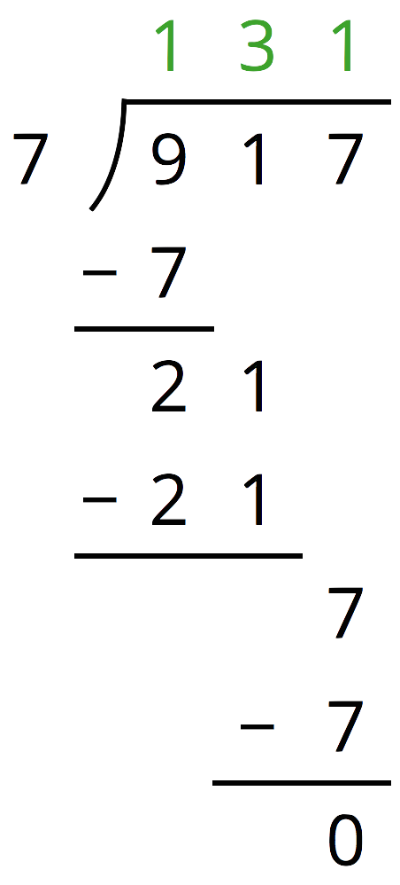
  - There is a 7 under the 9 of 917. What does this 7 represent?
  - What does the subtraction of 7 from 9 mean?
  - Why is a 1 written next to the 2 from $9−7$?
- Han's calculation of $972÷9$ is shown here.
- 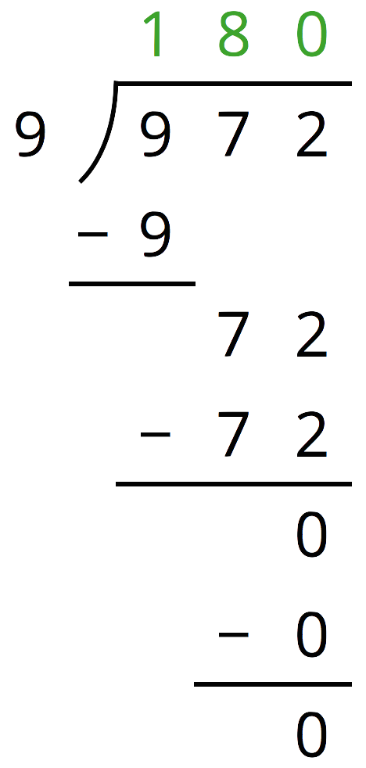
  - Find $180⋅9$.
  - Use your calculation of $180⋅9$ to explain how you know Han has made a mistake.
  - Identify and correct Han’s mistake.
- Find each quotient.
- 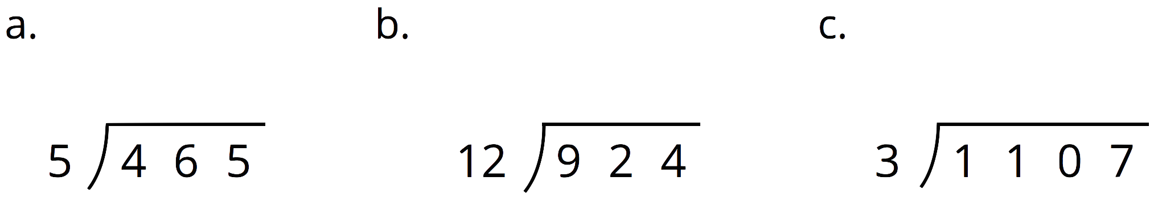

- One ounce of a yogurt contains of 1.2 grams of sugar. How many grams of sugar are in 14.25 ounces of yogurt?
  - 0.171 grams
  - 1.71 grams
  - 17.1 grams
  - 171 grams
- (From Unit 5, Lesson 7.)
- The mass of one coin is 16.718 grams. The mass of a second coin is 27.22 grams. How much greater is the mass of the second coin than the first? Show your reasoning.
- (From Unit 5, Lesson 4.)
© CC BY Open Up Resources. Adaptations CC BY IM.

