Unit 2 Lesson 13: Two Graphs for Each Relationship

1 True or False: Fractions and Decimals (Warm up)

Student Task Statement
Decide whether each equation is true or false. Be prepared to explain your reasoning.
- $\frac{3}{2}⋅16=3⋅8$
- $\frac{3}{4}÷\frac{1}{2}=\frac{6}{4}÷\frac{1}{4}$
- $\left(2.8\right)⋅\left(13\right)=\left(0.7\right)⋅\left(52\right)$

2 Tables, Graphs, and Equations

Student Task Statement
Your teacher will assign you one of these three points:
$A=\left(10,4\right)$, $B=\left(4,5\right)$, $C=\left(8,5\right)$.
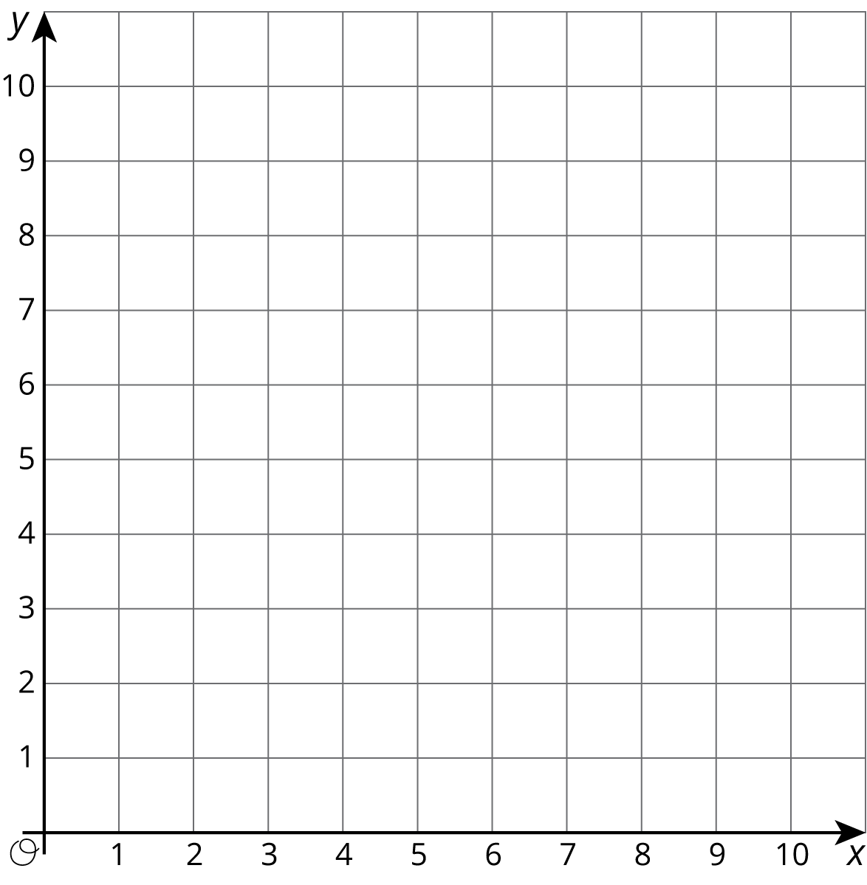
$x$ | $y$ | $\frac{y}{x}$
0 |  | NA
1
2
3
4
5
6
7
8
9
10
- On the graph, plot and label only your assigned point.
- Use a ruler to line up your point with the origin, $\left(0,0\right)$. Draw a line that starts at the origin, goes through your point, and continues to the edge of the graph.
- Complete the table with the coordinates of points on your graph. Use a fraction to represent any value that is not a whole number.
- Write an equation that represents the relationship between $x$ and $y$ defined by your point.
- Compare your graph and table with the rest of your group. What is the same and what is different about:
  - your tables?
  - your equations?
  - your graphs?
- What is the $y$-coordinate of your graph when the $x$-coordinate is 1? Plot and label this point on your graph. Where do you see this value in the table? Where do you see this value in your equation?
- Describe any connections you see between the table, characteristics of the graph, and the equation.

3 Hot Dog Eating Contest

Student Task Statement
Andre and Jada were in a hot dog eating contest. Andre ate 10 hot dogs in 3 minutes. Jada ate 12 hot dogs in 5 minutes.
Here are two different graphs that both represent this situation.
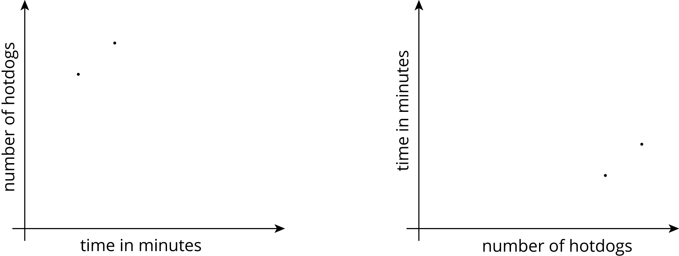
- On the first graph, which point shows Andre’s consumption and which shows Jada’s consumption? Label them.
- Draw two lines: one through the origin and Andre’s point, and one through the origin and Jada’s point.
- Write an equation for each line. Use $t$ to represent time in minutes and $h$ to represent number of hot dogs.
  - Andre:
  - Jada:
- For each equation, what does the constant of proportionality tell you?
- Repeat the previous steps for the second graph.
  - Andre:
  - Jada:
© CC BY Open Up Resources. Adaptations CC BY IM.

