Unit 7 Lesson 17 Cumulative Practice Problems
  - A green light blinks every 4 seconds and a yellow light blinks every 5 seconds. When will both lights blink at the same time?
  - A red light blinks every 12 seconds and a blue light blinks every 9 seconds. When will both lights blink at the same time?
  - Explain how to determine when 2 lights blink together.
  - List all multiples of 10 up to 100.
  - List all multiples of 15 up to 100.
  - What is the least common multiple of 10 and 15?
- Cups are sold in packages of 8. Napkins are sold in packages of 12.
  - What is the fewest number of packages of cups and the fewest number of packages of napkins that can be purchased so there will be the same number of cups as napkins?
  - How many sets of cups and napkins will there be?
  - Plot and connect these points to form a polygon.
  - $(\text{-}5,3),(3,3),(1,\text{-}2),(\text{-}3,\text{-}2)$
  - 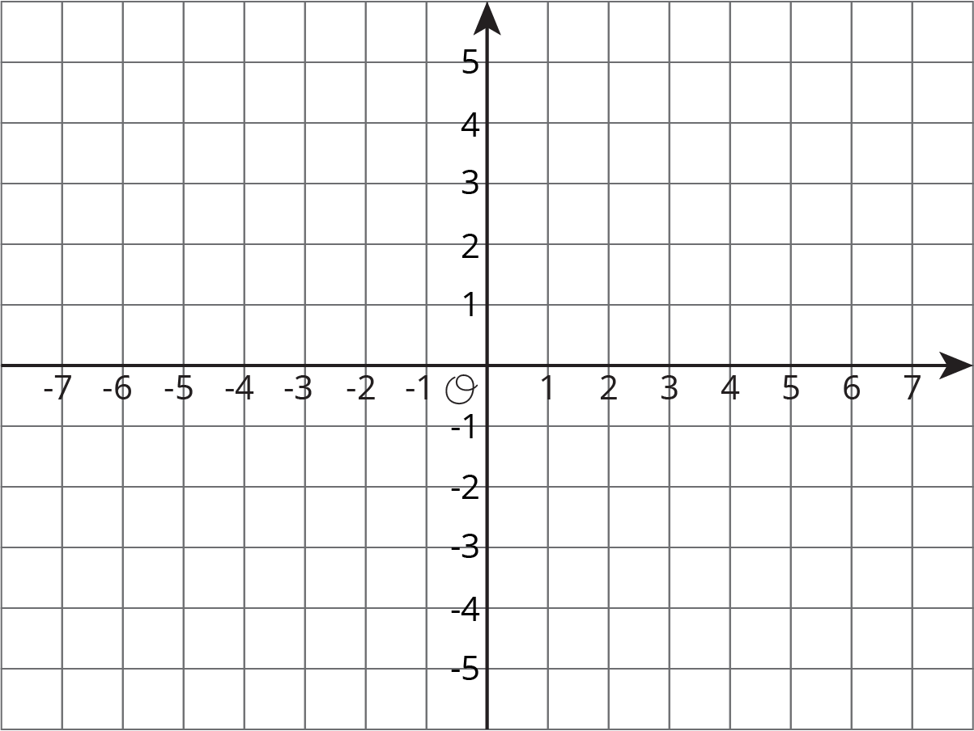
  - Find the lengths of the two horizontal sides of the polygon.
- (From Unit 7, Lesson 15.)
- Rectangle ABCD is drawn on a coordinate plane. A = $(\text{-}6,9)$ and B = $(5,9)$. What could be the locations of points C and D?
- (From Unit 7, Lesson 14.)
- A school wants to raise $2,500 to support its music program.
  - If it has met 20% of its goal so far, how much money has it raised?
  - If it raises 175% of its goal, how much money will the music program receive? Show your reasoning.
- (From Unit 3, Lesson 14.)
© CC BY Open Up Resources. Adaptations CC BY IM.

