Lesson 15: Using Graphs and Logarithms to Solve Problems (Part 1)
- Let’s use graphs and logarithms to solve problems.

15.1: Using a Graph to Estimate
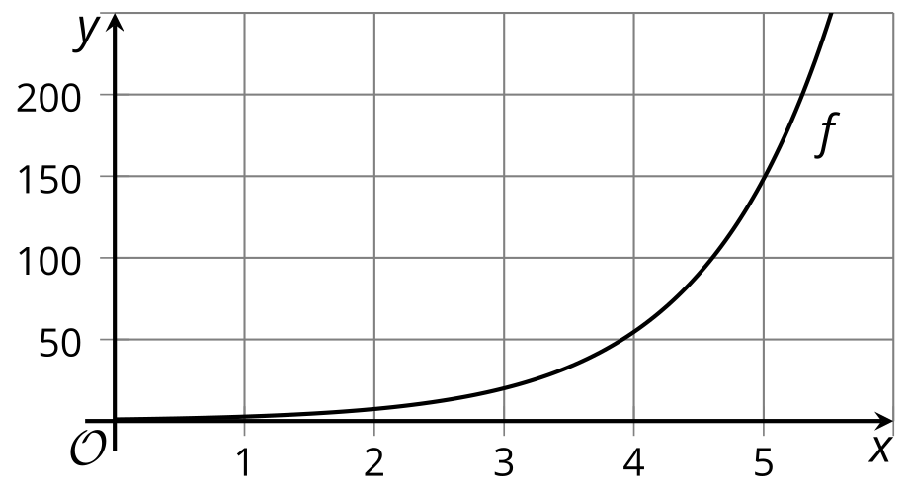
Here is a graph that represents an exponential function with base $e$, defined by $f\left(x\right)=e^{x}$.
- Explain how to use the graph to estimate logarithms such as $ln100$.
- Use the graph to estimate $ln100$.
- How can you use a calculator to check your estimate? What would you enter into the calculator?

15.2: Retire A Millionaire?
The expression $1⋅e^{\left(0.06t\right)}$ models the balance, in thousands of dollars, of an account $t$ years after the account was opened.
- What is the account balance:
  - when the account is opened?
  - after 1 year?
  - after 2 years?
- Diego says that the expression $ln5$ represents the time, in years, when the account will have 5 thousand dollars. Do you agree? Explain your reasoning.
- Suppose you opened this account at the beginning of this year. Assume that you deposit no additional money and withdraw nothing from the account. Will the account balance reach $1,000,000 and make you a millionaire by the time you reach retirement? Show your reasoning.

Are you ready for more?
Noah is 15 years old and wants to retire a millionaire when he is 60. If he invests $1,000 today, what interest rate would he need to achieve this goal?

15.3: Cicada Population
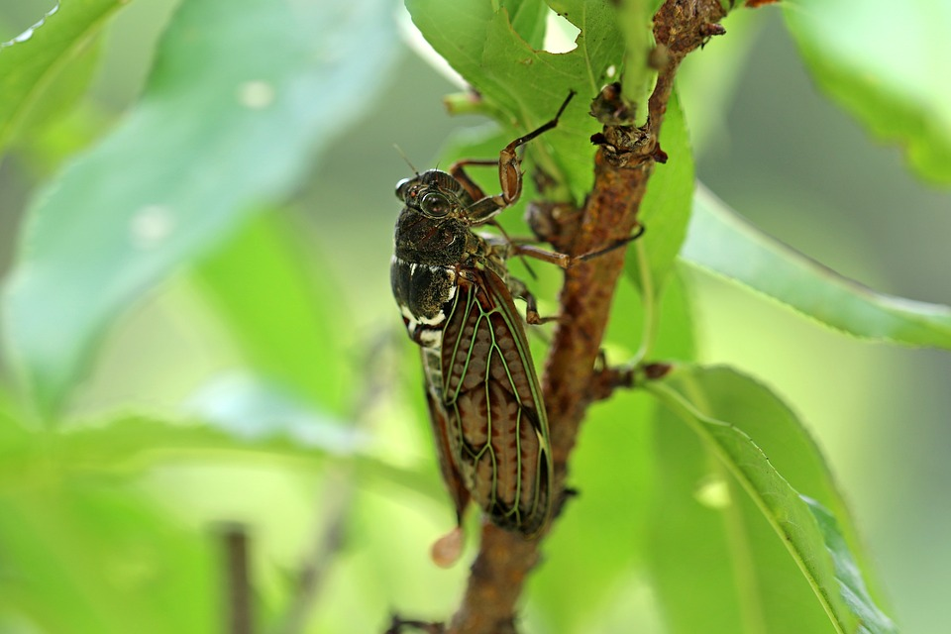
A population of cicadas is modeled by a function defined by $f\left(w\right)=250⋅e^{\left(0.5w\right)}$ where $w$ is the number of weeks since the population was first measured.
- Explain why solving the equation $500=250⋅e^{\left(0.5w\right)}$ gives the number of weeks it takes for the cicada population to double.
- How many weeks does it take the cicada population to double? Show your reasoning.
- Use graphing technology to graph $y=f\left(w\right)$ and $y=100,​000$ on the same axes. Explain why we can use the intersection of the two graphs to estimate when the cicada population will reach 100,000.

Lesson 15 Summary
We can use the natural logarithm to solve exponential equations that are expressed with the base $e$.
Suppose a bacteria population is modeled by the equation $f\left(h\right)=1,​000⋅e^{\left(0.5h\right)}$, where $h$ is the number of hours since the population was first measured. When will the population reach 500,000?
One way to answer this is to solve the equation $1,​000⋅e^{\left(0.5h\right)}=500,​000$, which is when $e^{\left(0.5h\right)}=500$.
The natural logarithm tells us the exponent to which we raise $e$ to get a given number, so $0.5h=ln500$. This means $h=\frac{ln500}{0.5}$ or about 12.4, so it takes 12.4 hours (or 12 hours and 24 minutes) for the population to reach 500,000.
We can also use a graph to solve an exponential equation. To solve $1,​000⋅e^{\left(0.5h\right)}=500,​000$, we can graph $y=1,​000⋅e^{\left(0.5h\right)}$ and $y=500,​000$ on the same coordinate plane and find the point of intersection.
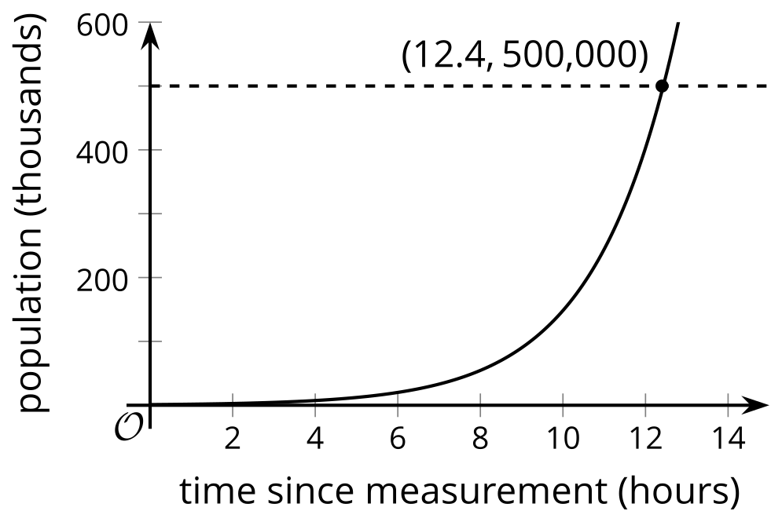
The graph shows us that the bacteria population reaches 500,000 when the input value is a little over 12, or about 12 hours after the population was first measured.
© CC BY 2019 by Illustrative Mathematics®

