Lesson 10 Practice Problems
- A random sampling of people are asked whether they like comedies or dramatic movies, and whether they prefer to watch them in the theater or at home. The results are in the table.
 | - comedy | - drama
- theater | - 57 | - 36
- home | - 78 | - 53
- Create a relative frequency table that shows the percentage of comedy lovers that prefer each location and the percentage of drama lovers that prefer each location.
- (From Unit 3, Lesson 2.)
- Two types of soil are used to grow corn to see if there is an association between the type of soil and the time it takes to reach harvest readiness. Due to the difficulty in making soil B, there were only 100 corn plants grown in that soil type. Complete the table so that it suggests no association between soil type and time to reach harvest readiness. Explain your reasoning.
 | - soil A | - soil B
- less than 80 days | - 279
- 80 days or more | - 131

- (From Unit 3, Lesson 3.)
- A recent survey investigated the relationship between the number of traffic tickets a person received and the cost of the person's car insurance. The scatter plot displays the relationship.
- 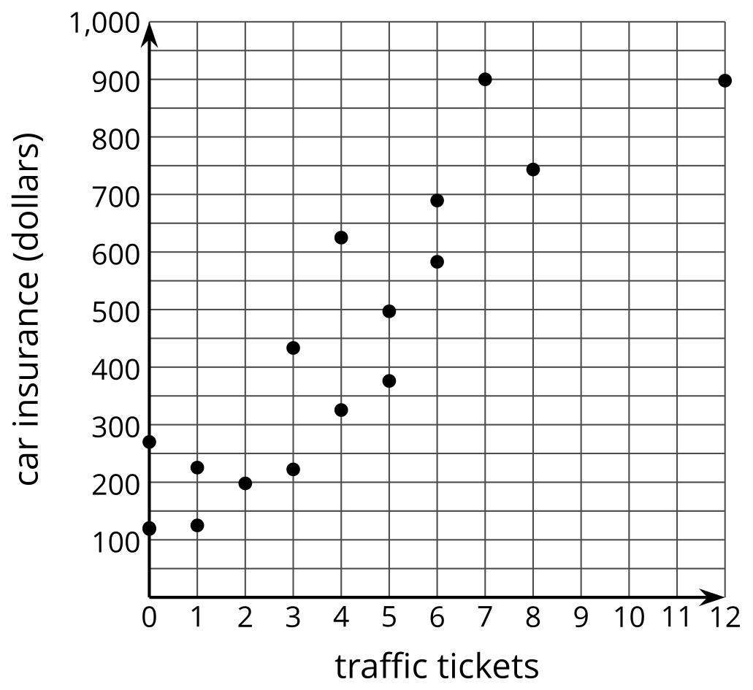
- The line that models the data is given by the equation $y=73x+146.53$, where $x$ represents the number of traffic tickets, and $y$ represents the cost of car insurance.
  - The slope of the line is 73. What does this mean in this situation? Is it realistic?
  - The $y$-intercept is $\left(0,146.53\right)$. What does this mean in this situation?
- (From Unit 3, Lesson 4.)
- Technology required.
- A survey wanted to determine if there was a relationship between the number of joggers who used a local park for exercise and the temperature outside. The data in the table display their findings.
- temperature in Fahrenheit, $x$ | - number of joggers, $y$
- 15 | - 4
- 30 | - 8
- 30 | - 8
- 41 | - 4
- 42 | - 16
- 49 | - 20
- 49 | - 14
- 55 | - 16
- 66 | - 34
- 72 | - 44
- 85 | - 40
- 94 | - 15
- Use graphing technology to create a scatter plot of the data.
  - Is a linear model appropriate for this data? Explain your reasoning.
  - If the data seems appropriate, create the line of best fit. Round to two decimal places.
  - What is the slope of the line of best fit and what does it mean in this context? Is it realistic?
  - What is the $y$-intercept of the line of best fit and what does it mean in this context? Is it realistic?
- (From Unit 3, Lesson 5.)
- Data for a local hospital is displayed in the scatter plot. The graph shows the relationship between the length of a person's stay in the hospital in days, $x$, and the amount owed for the hospital bill. The line of best fit for the data is $y=1,​899.66x+852.81$.
  - Find the residuals for the three patients who were in the hospital for 6 days, $\left(6,14320\right)$, $\left(6,7900\right)$, and $\left(6,13998\right)$.
  - Compare the residuals for the three patients. How are they similar? How are they different? What does the information about the residuals for the three patients tell you about their hospital bills?
- (From Unit 3, Lesson 6.)
- Select all the values for $r$ that indicate a strong, negative relationship for the line of best fit.
  - 1
  - -0.97
  - -0.45
  - 0.53
  - 0.9
  - -0.8
  - -1
- (From Unit 3, Lesson 7.)
- Noah collects data to investigate the relationship between the number of runs scored by his favorite baseball team, $x$, and the number of runs scored by his high school baseball team, $y$. Which value for the correlation coefficient is most likely to match a line of best fit of the form $y=mx+b$ for this situation?
  - -1
  - 0
  - 0.7
  - 1
- (From Unit 3, Lesson 8.)
- Noah creates a scatter plot showing the relationship between number of free throws made in a basketball game and the number of points scored. The correlation coefficient for the line of best fit is 0.76.
  - Are they correlated? Explain your reasoning.
  - Do either of the variables cause the other to change? Explain your reasoning.
- (From Unit 3, Lesson 9.)
- A news headline claims that “Essential Oils Cause Hormone Levels to Drop.” They show a scatter plot displaying a weak negative relationship ($r=\text{-}0.13$) between essential oil use and hormone levels.
  - What is wrong with this claim?
  - What is a better headline for this information?
- (From Unit 3, Lesson 9.)
- Technology required.
- Data in the table shows the relationship between average number of social network notifications a student receives during one class, $x$, and average test scores, $y$.
- average number of social network notifications, $x$ | - average test score, $y$
- 12 | - 92
- 26 | - 84
- 17 | - 87
- 43 | - 65
- 51 | - 57
- 29 | - 75
- 13 | - 83
- 4 | - 100
- 16 | - 86
- 12 | - 73
- 25 | - 67
- 22 | - 77
- 12 | - 89
- 8 | - 91
- 34 | - 98
  - What conclusions, if any, can you draw from the information provided? Justify your thinking with mathematics learned from this unit.
  - What conclusions can you not draw from the information provided? Justify your thinking with mathematics learned from this unit.
© CC BY 2019 by Illustrative Mathematics®

