Lesson 22 Practice Problems
- This design began from the construction of a regular hexagon. Name 2 pairs of congruent figures.
- 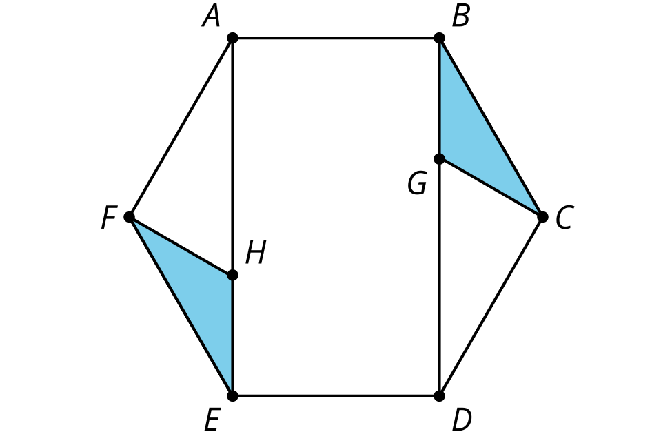
- This design began from the construction of a regular hexagon. Describe a rigid motion that will take the figure to itself.
- 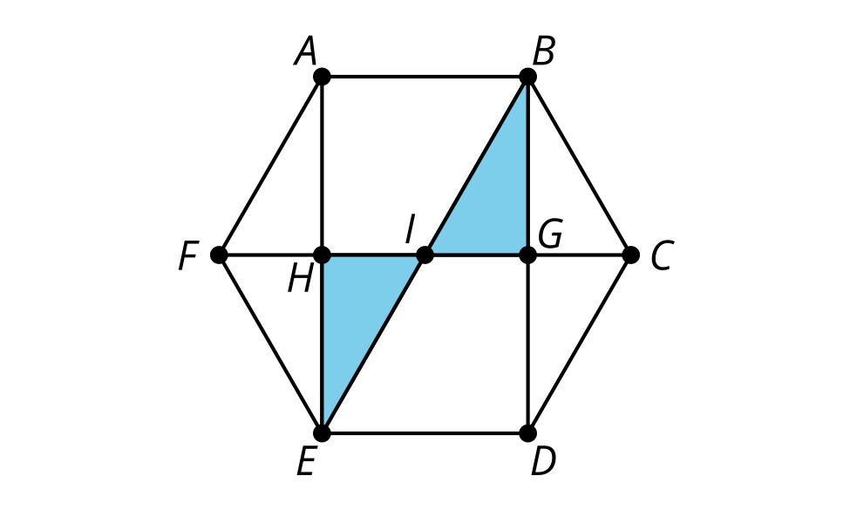
- Noah starts with triangle $ABC$ and makes 2 new triangles by translating $B$ to $A$ and by translating $B$ to $C$. Noah thinks that triangle $DCA$ is congruent to triangle $BAC$. Do you agree with Noah? Explain your reasoning.
- 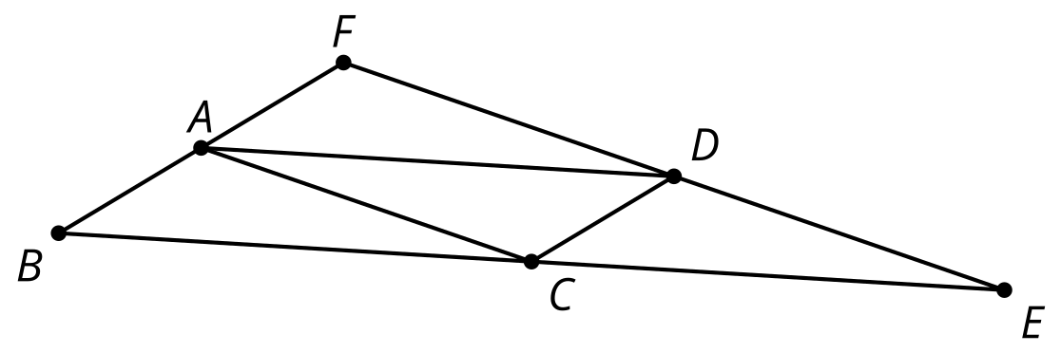

- (From Unit 1, Lesson 21.)
- In the image, triangle $ABC$ is congruent to triangle $BAD$ and triangle $CEA$. What are the measures of the 3 angles in triangle $CEA$? Show or explain your reasoning.
- 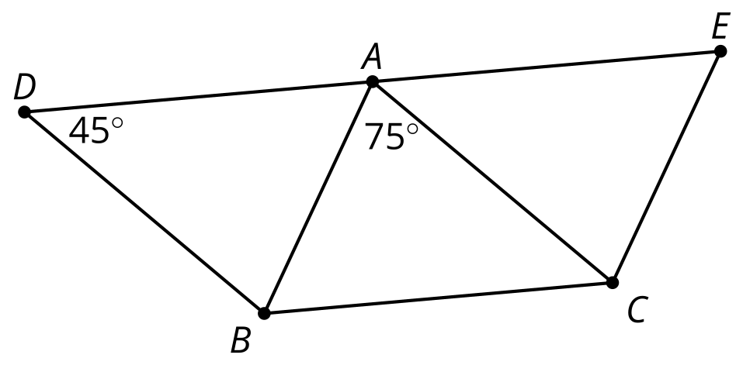
- (From Unit 1, Lesson 21.)
- In the figure shown, angle 3 is congrent to angle 6. Select all statements that must be true.
- 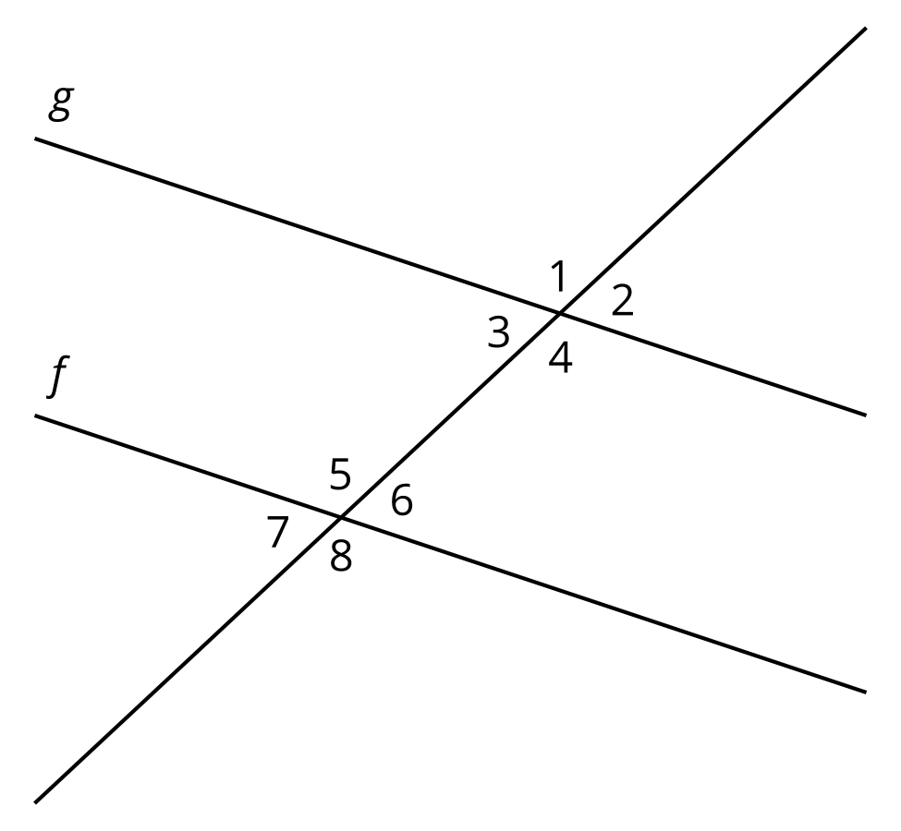
  - Lines $f$ and $g$ are parallel.
  - Angle 2 is congruent to angle 6
  - Angle 2 and angle 5 are supplementary
  - Angle 1 is congruent to angle 7
  - Angle 4 is congruent to angle 6
- (From Unit 1, Lesson 20.)
- In this diagram, point $M$ is the midpoint of segment $AC$ and $B^{′}$ is the image of $B$ by a rotation of ${180}^{∘}$ around $M$.
  - Explain why rotating ${180}^{∘}$ using center $M$ takes $A$ to $C$.
  - Explain why angles $BAC$ and $B^{′}CA$ have the same measure.
- 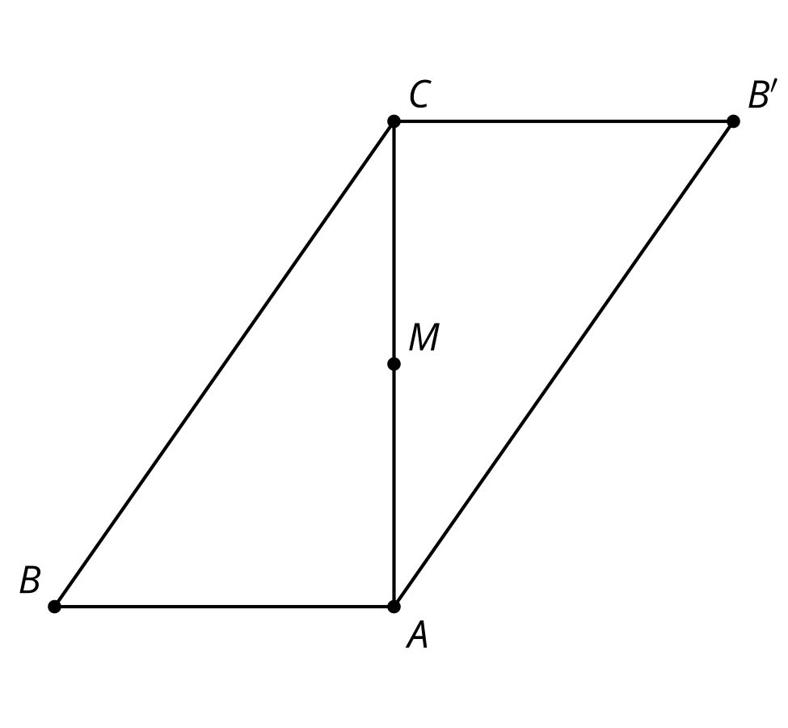
- (From Unit 1, Lesson 20.)
- Lines $AB$ and $BC$ are perpendicular. The dashed rays bisect angles $ABD$ and $CBD$.
- Select all statements that must be true:
- 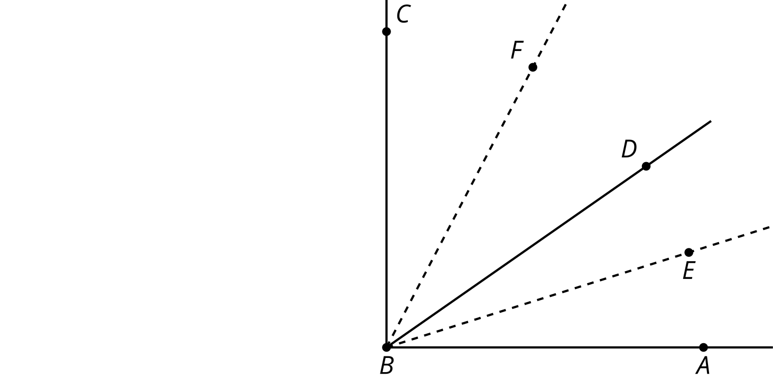
  - Angle $CBF$ is congruent to angle $DBF$
  - Angle $CBE$ is obtuse
  - Angle $ABC$ is congruent to angle $EBF$
  - Angle $DBC$ is congruent to angle $EBF$
  - Angle $EBF$ is 45 degrees
- (From Unit 1, Lesson 19.)
- Lines $AD$ and $EC$ meet at point $B$.
- Give an example of a rotation using an angle greater than 0 degrees and less than 360 degrees, that takes both lines to themselves. Explain why your rotation works.
- 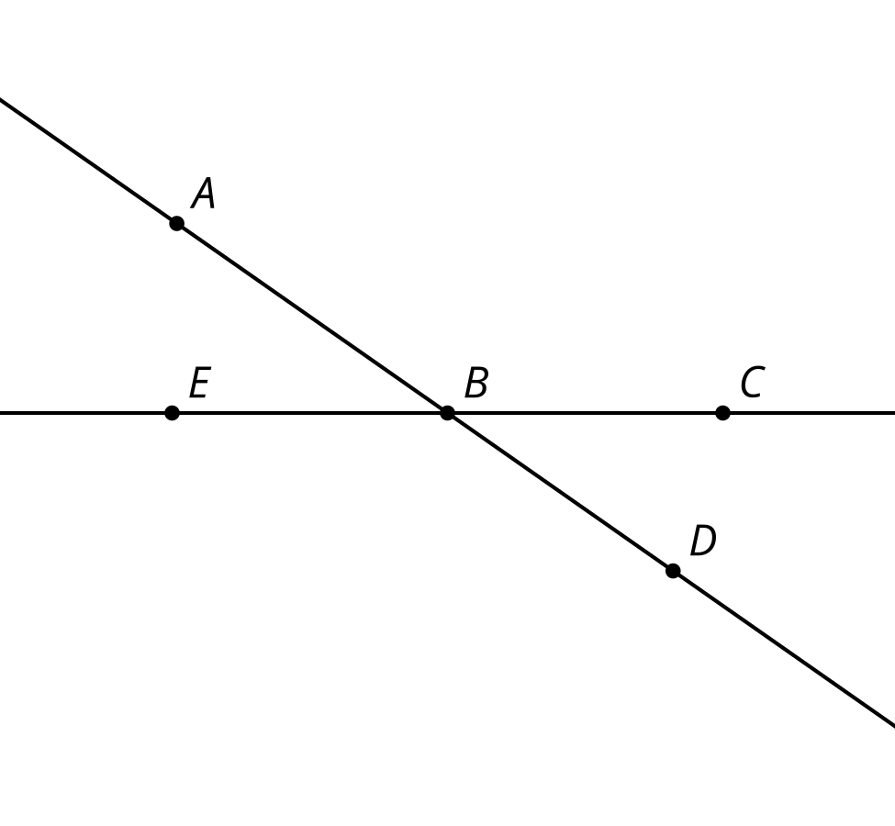
- (From Unit 1, Lesson 19.)
- Draw the image of triangle $ABC$ after this sequence of rigid transformations.
  - Reflect across line segment $AB$.
  - Translate by directed line segment $u$.
- 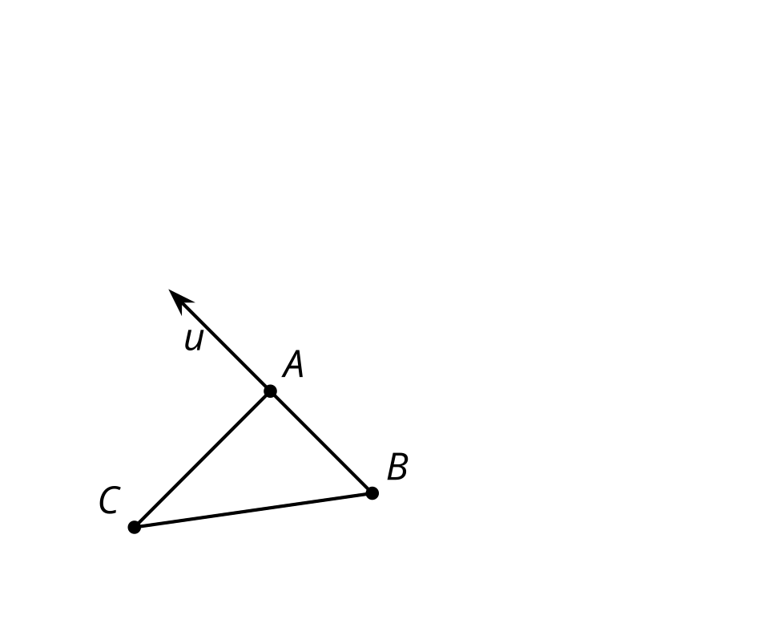
- (From Unit 1, Lesson 18.)

  - Draw the image of figure $CAST$ after a clockwise rotation around point $T$ using angle $CAS$ and then a translation by directed line segment $AS$.
  - Describe another sequence of transformations that will result in the same image.
- 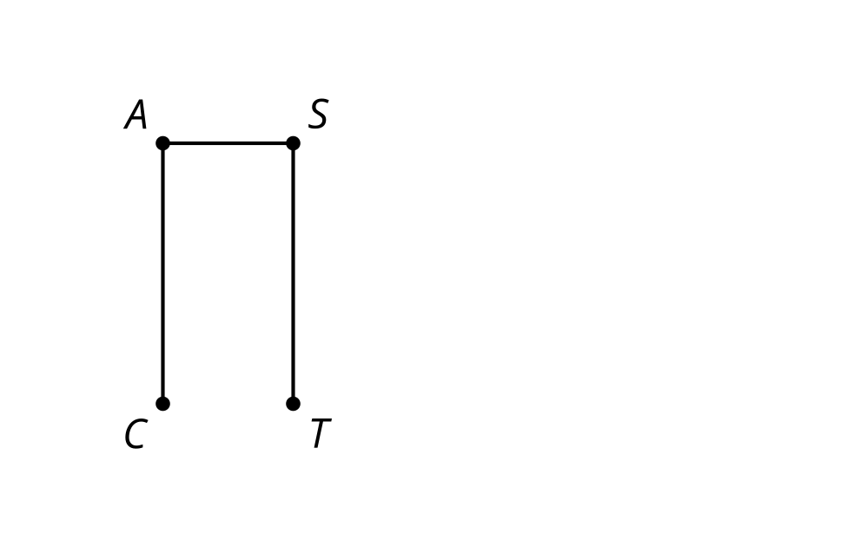
- (From Unit 1, Lesson 18.)
© CC BY 2019 by Illustrative Mathematics®

