Lesson 7: Divide to Multiply Unit Fractions

Standards Alignments
Addressing | 5.NF.B.3, 5.NF.B.4.a
Building Towards | 5.NF.B.4

Teacher-facing Learning Goals
- Connect division to multiplication of a whole number by a unit fraction.

Student-facing Learning Goals
- Let’s solve problems about multiplying whole numbers by unit fractions.

Lesson Purpose
The purpose of this lesson is for students to solve problems involving multiplication of whole numbers by unit fractions and represent the problems with equations and diagrams.
In this lesson students interpret situations and solve problems that involve products of a whole number and a fraction. Students solve story problems in a way that makes sense to them and match stories with diagrams and expressions. They work with expressions and flexibly interpret a diagram to extend their understanding of the relationship between fractions and multiplication and division. For example, consider this image:
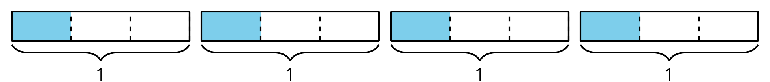
It shows $4÷3$ because there are 4 whole squares divided into 3 equal parts with 1 of those parts shaded. It also shows $\frac{4}{3}$ as there are 4 pieces shaded and each is $\frac{1}{3}$ of a unit rectangle. It shows the multiplication expression $4×\frac{1}{3}$ because there are 4 groups of $\frac{1}{3}$ shaded. It shows the multiplication expression $\frac{1}{3}×4$ since there is a total of 4, and $\frac{1}{3}$ of that is shaded.

Access for:

Students with Disabilities
- Engagement (Activity 2)

English Learners
- MLR8 (Activity 2)

Instructional Routines
Estimation Exploration (Warm-up), MLR7 Compare and Connect (Activity 1)

Materials to Copy
- Match the Situation (groups of 2): Activity 2

Lesson Timeline
Warm-up | 10 min
Activity 1 | 20 min
Activity 2 | 15 min
Lesson Synthesis | 10 min
Cool-down | 5 min

Teacher Reflection Question
Which student responses did you anticipate from today’s lesson? Which student responses surprised you in today’s lesson?

Cool-down
(to be completed at the end of the lesson) 5min
Another Race

Standards Alignments
Addressing | 5.NF.B.4.a

Student-facing Task Statement
Together, 6 children run a 5 mile relay race. They each run the same distance.
Select all the expressions that represent this situation.
- $\frac{1}{6}×5$
- $\frac{1}{5}×6$
- $5÷6$
- $\frac{5}{6}$

Student Responses
A, C, D

