Lesson 8: Three-digit Numbers on the Number Line
- Let’s locate and represent three-digit numbers on the number line.
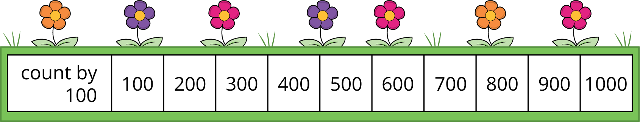

8.1: Label Three-digit Numbers
What do you notice? What do you wonder?
Locate and label 30, 300, and 3 on a number line.
Label each point with a number it represents.

8.2: Represent Three-digit Numbers on a Number Line
Locate and label each number on the number line. Label the tick marks with the numbers they represent if it helps.
- 700
- 472
- 940
- 356
- 590
© CC BY 2021 Illustrative Mathematics®

