Unit 6 Lesson 11: Tell Time with Halves and Quarters

WU What Do You Know About Ways to Tell Time? (Warm up)

Student Task Statement
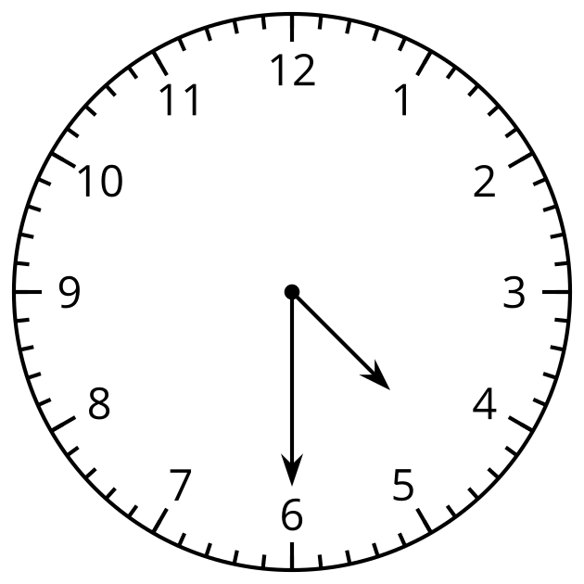
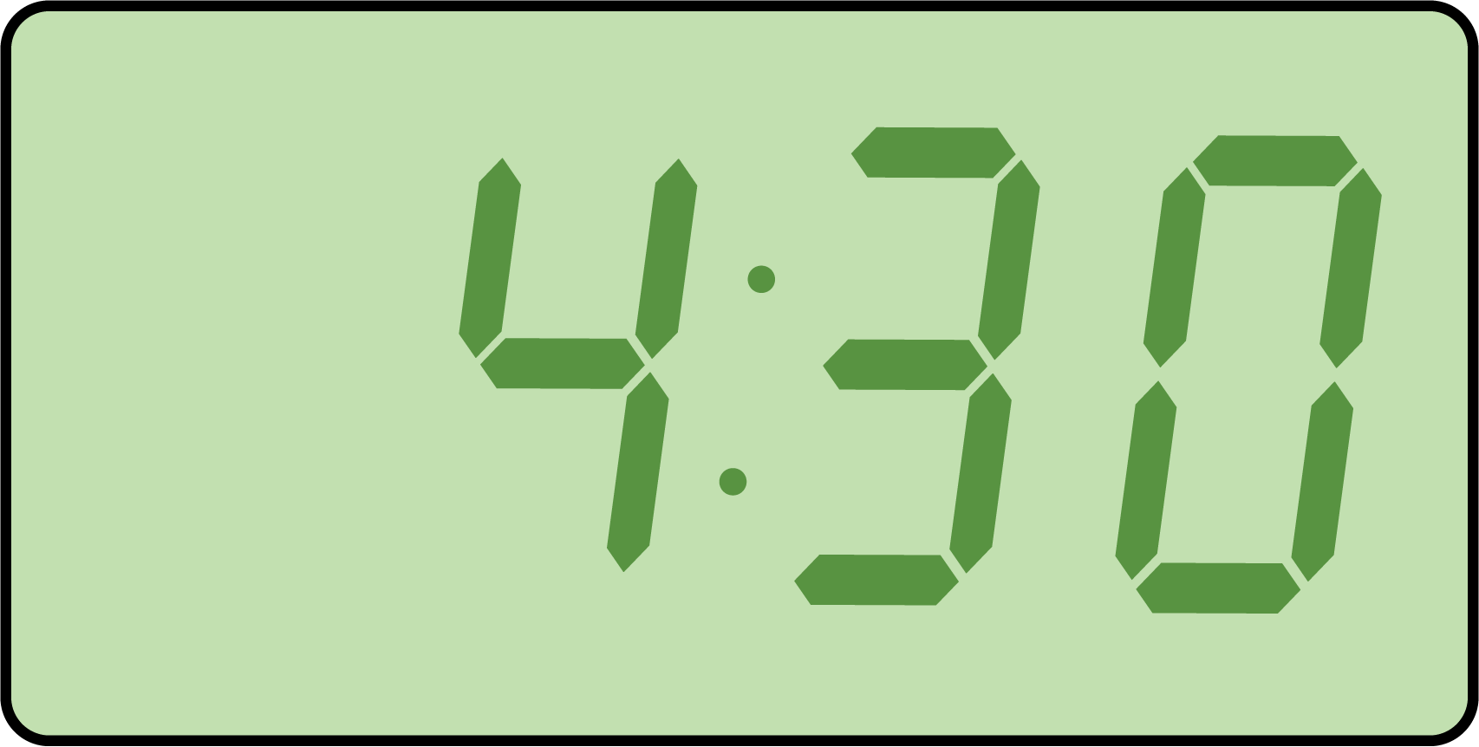
What do you know about ways to tell time? What words do you use to talk about time?

1 Tell Time to the Hour and Half-hour

Student Task Statement
- Circle the clock that shows 4 o’clock.
- 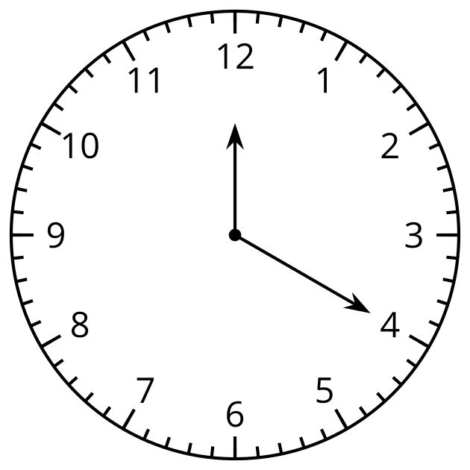
- 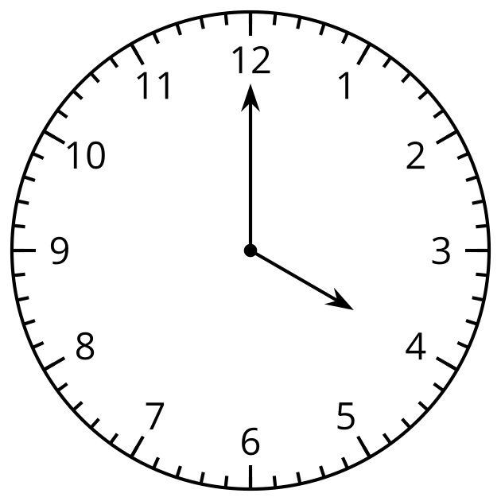
- Why doesn’t the other clock show 4 o’clock?
- Circle the clock that shows half past 7.
- 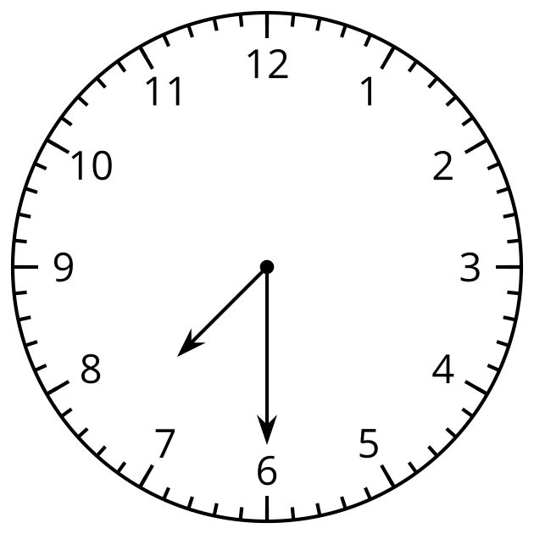
- 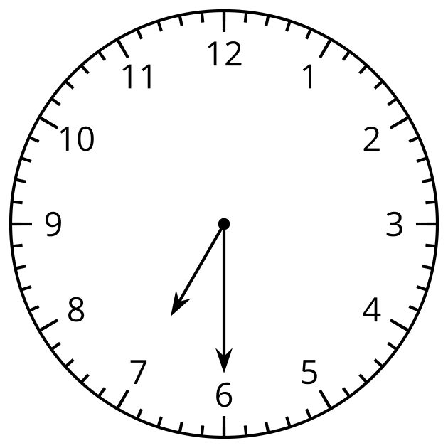
- Why doesn’t the other clock show half past 7?
- Draw the hands on the clock to show 10:00.
- 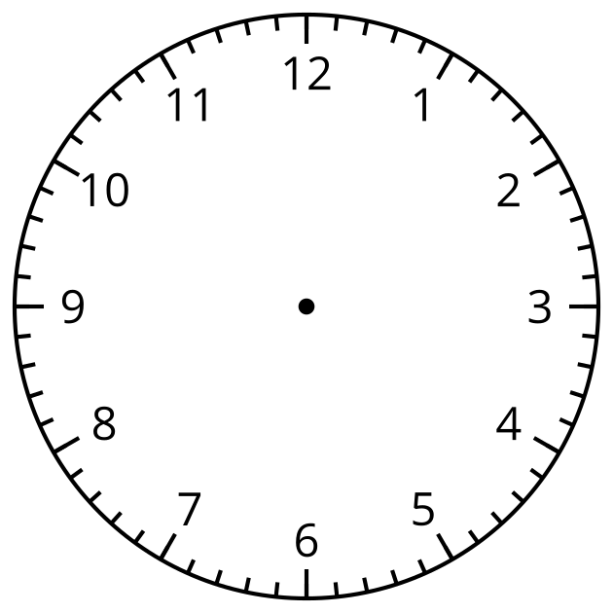
- Draw the hands on the clock to show 1:30.

Activity Synthesis
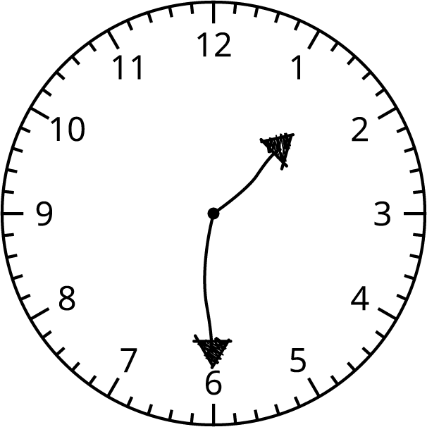
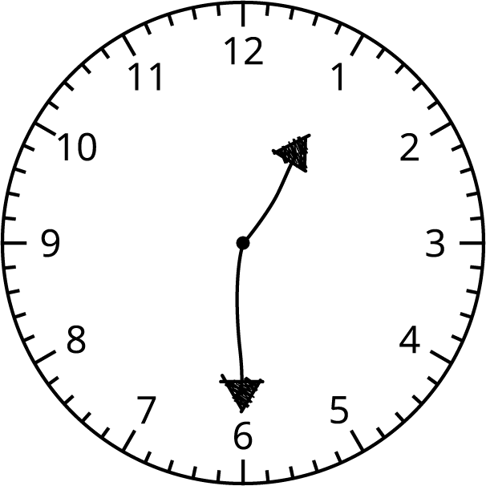

2 Card Sort: Halves and Quarters

Student Task Statement
- Find matching sets of cards. Each set should have 3 cards. Be prepared to explain why they match.
- Write the time shown on each clock using the words half past, quarter past, or quarter till.

  - 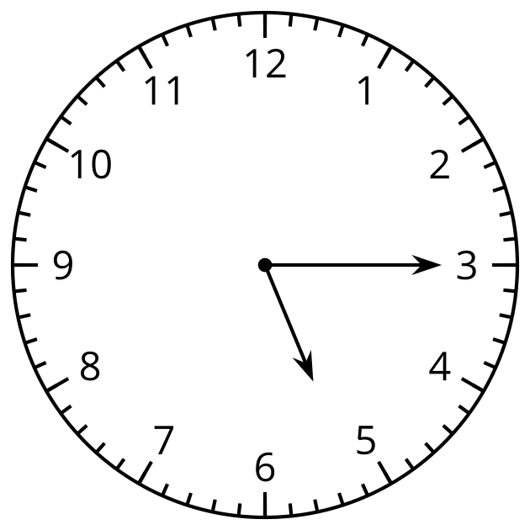

  - 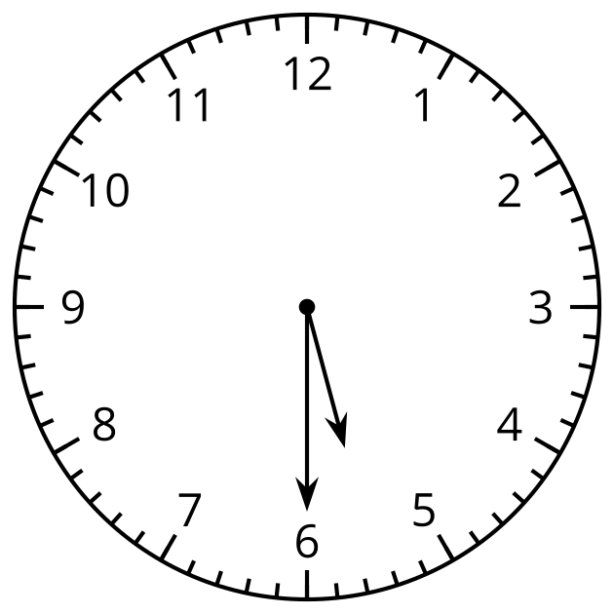

  - 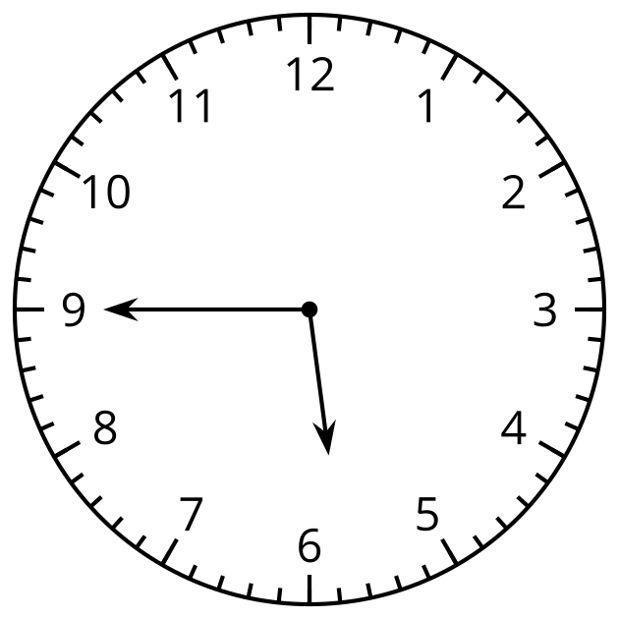

  - 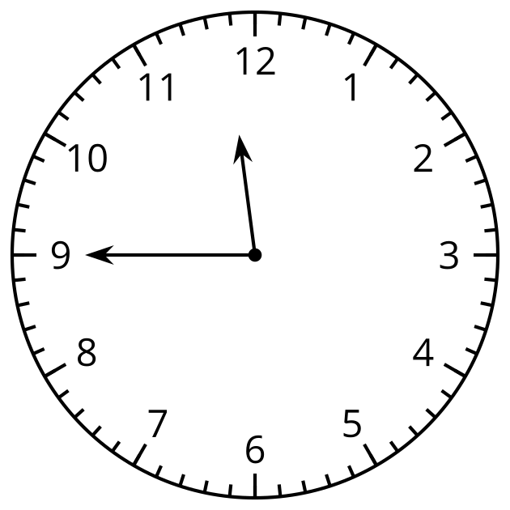

  - 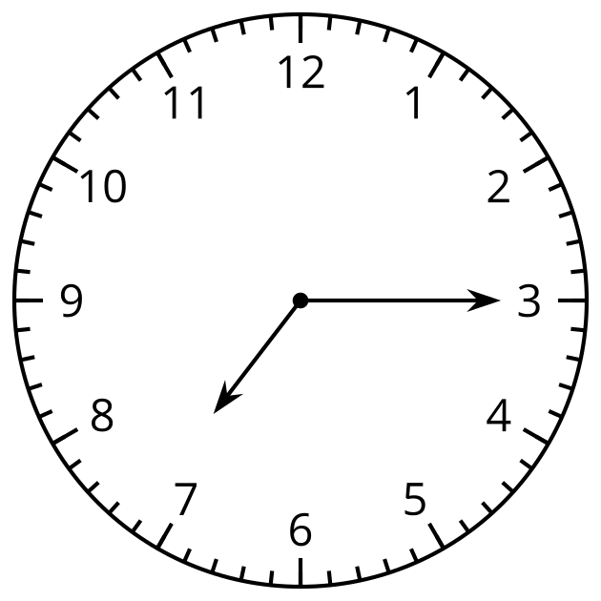
© CC BY 2021 Illustrative Mathematics®

