Lesson 12: Ways to Represent Measurement Situations
- Let’s make sense of and represent measurement situations at the fair.

Warm-up: Notice and Wonder: The Fair
What do you notice? What do you wonder?
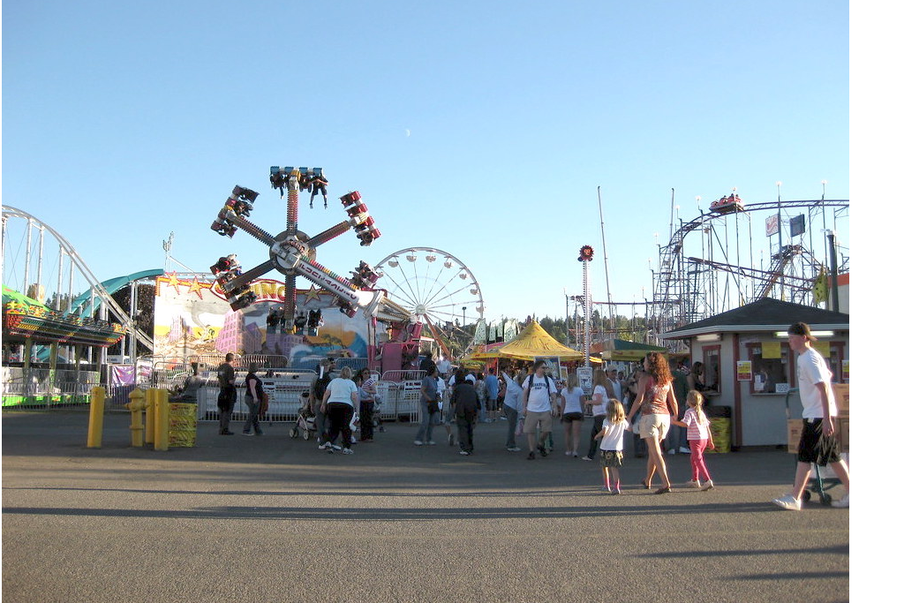
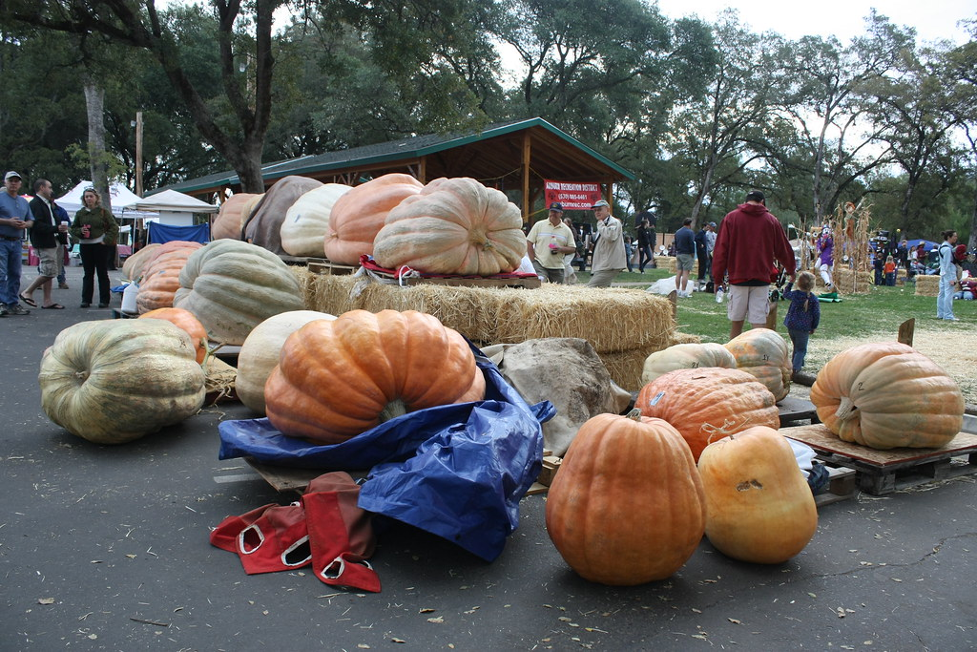
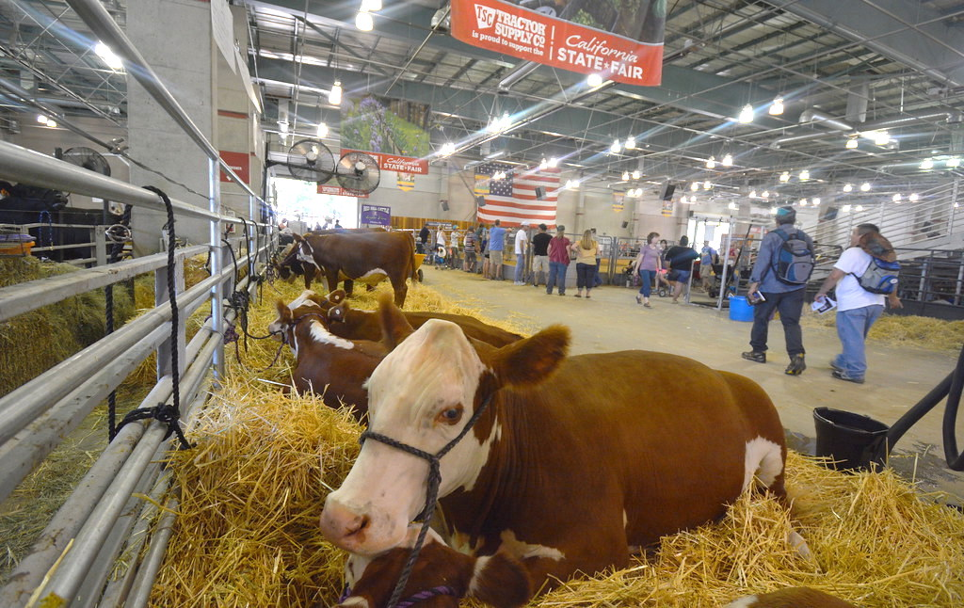

12.1: Giant Pumpkin Event
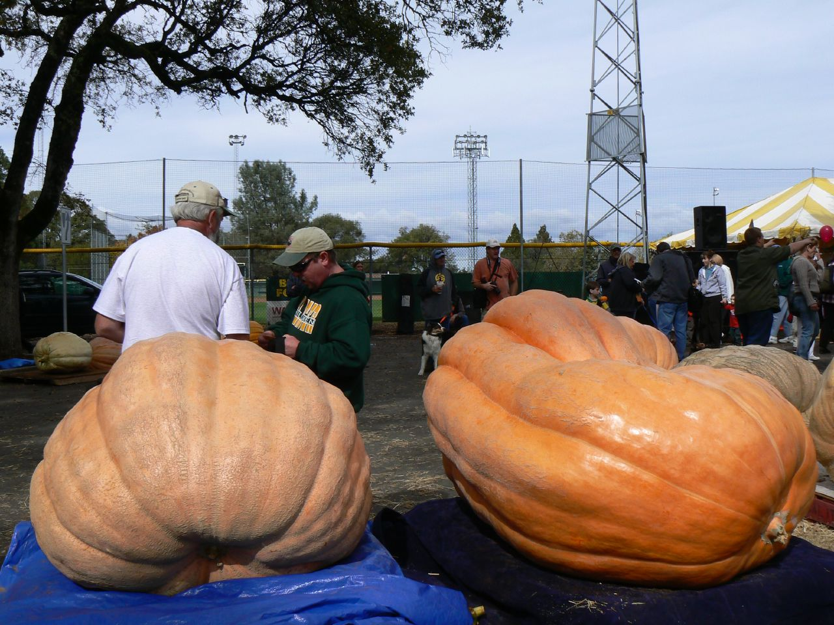
- Write a list of mathematical questions that could be asked about this image.
- Work with your partner to solve the problem you were given by your teacher and show your thinking on a poster. Be sure to write down on your poster the problem you are solving.

12.2: Card Sort: Giant Pumpkins
Your teacher will give you a set of cards with descriptions and diagrams.
Match each description with a diagram that represents the same situation.
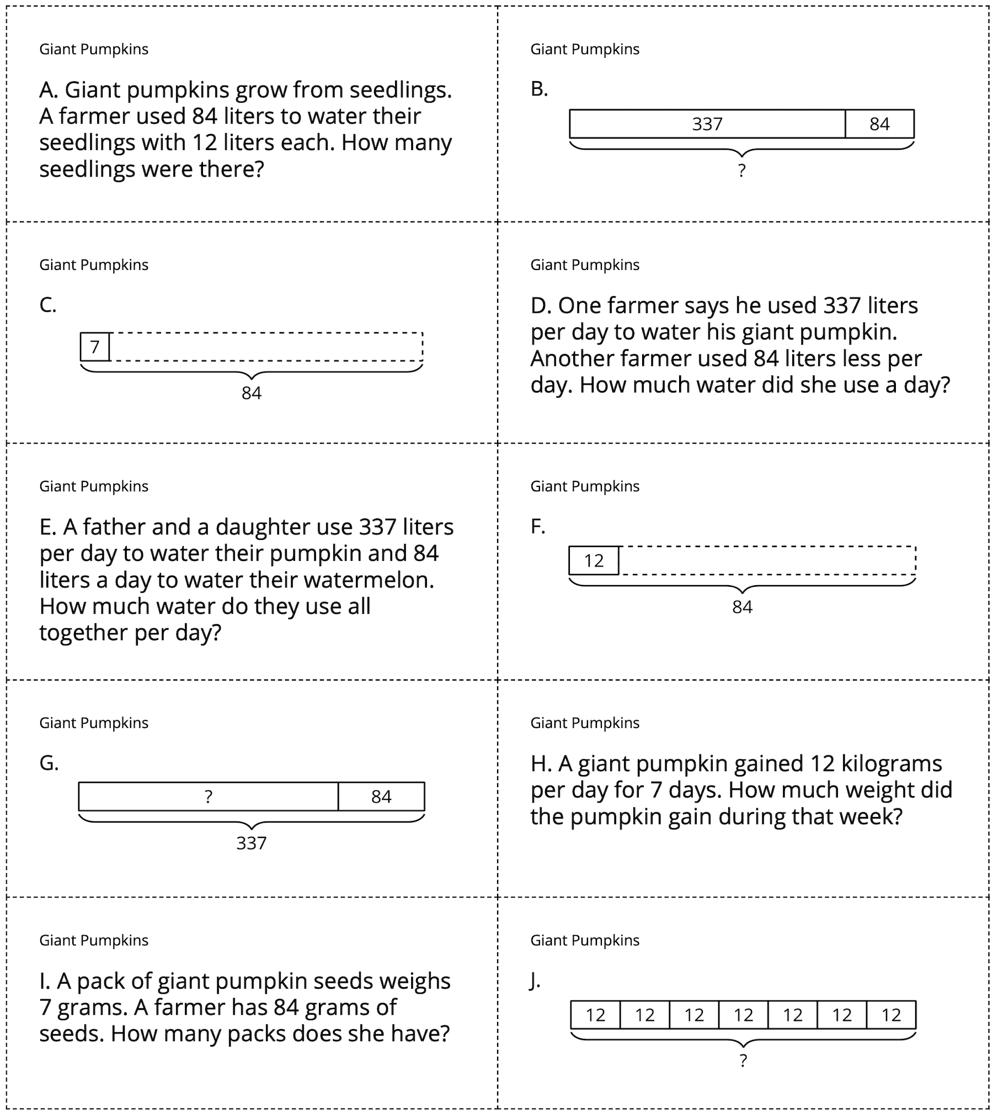
© CC BY 2021 Illustrative Mathematics®

