Unit 7 Lesson 2 Cumulative Practice Problems
- Angles $A$ and $C$ are supplementary. Find the measure of angle $C$.
- 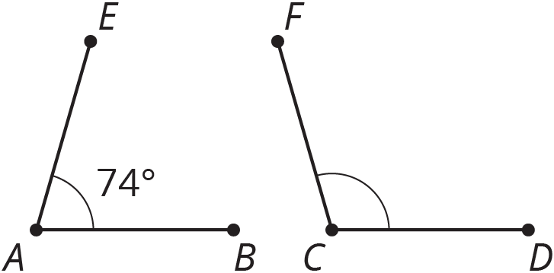

  - List two pairs of angles in square $CDFG$ that are complementary.
  - Name three angles that sum to ${180}^{∘}$.
- 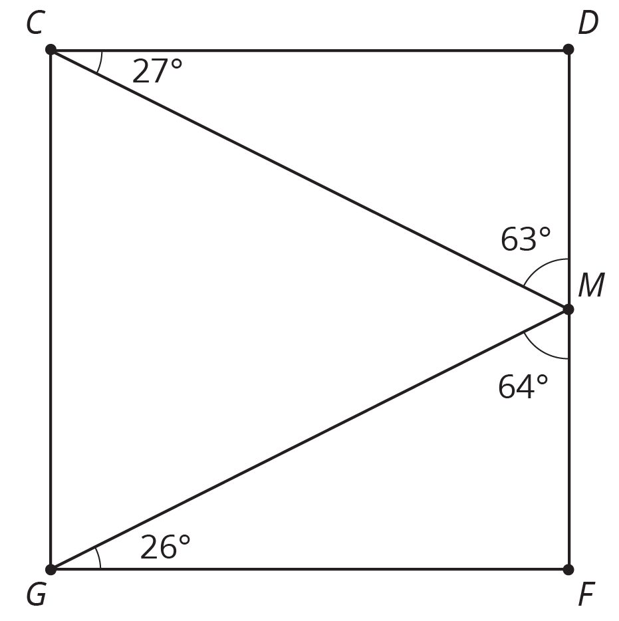
- Complete the equation with a number that makes the expression on the right side of the equal sign equivalent to the expression on the left side.
- $5x−2.5+6x−3=\underset{_}{}(2x−1)$
- (From Unit 6, Lesson 22.)
- Match each table with the equation that represents the same proportional relationship.
- $x$ | - $y$
- 2 | - 8
- 3 | - 12
- 4 | - 16
- 5 | - 20
- $x$ | - $y$
- 3 | - 4.5
- 6 | - 9
- 7 | - 10.5
- 10 | - 15
- $x$ | - $y$
- 2 | - $\frac{5}{2}$
- 4 | - 5
- 6 | - $\frac{15}{2}$
- 12 | - 15
  - $y=1.5x$
  - $y=1.25x$
  - $y=4x$
- (From Unit 2, Lesson 4.)
© CC BY Open Up Resources. Adaptations CC BY IM.

