## Unit 5 Lesson 8: Scaling the Outputs

### 1 Notice and Wonder: Arch You Glad to See Me? (Warm up)

#### Student Task Statement

What do you notice? What do you wonder?

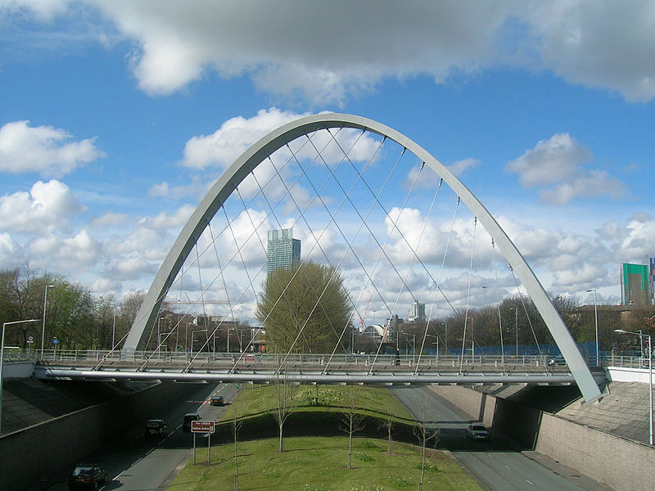

### 2 The Hulme Arch Bridge

#### Student Task Statement

The Hulme Arch Bridge in Manchester, England is shaped like a parabola. The ends of the arch are 52 meters apart, and it is 25 meters high.

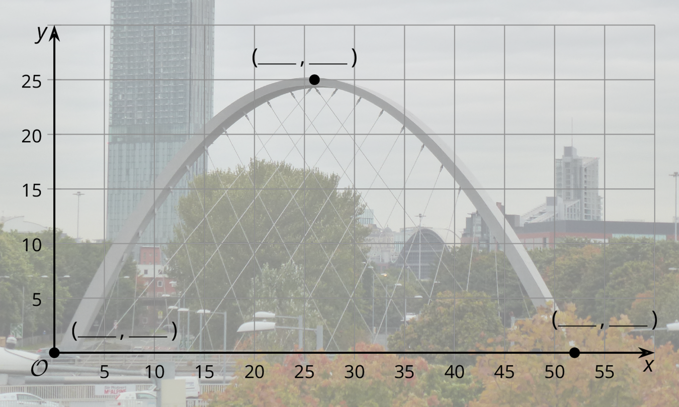

1. Use the description to help you label the 3 coordinates on the graph.
2. Han wants to model the shape of the arch with the graph of a function, and he chooses , where is the height in meters above a point meters along the base of the arch from the left end.
   1. For the -coordinates of the three points, what are the corresponding points on the graph of ?
   2. What aspects of the shape does Han’s function model well, and what parts does it not model well?
   3. Compare the height of Han’s graph with the height of the Hulme Arch Bridge. How can you change the outputs of to make it fit better? What would the revised version of be?

### 3 Feed the Dog

#### Student Task Statement

A certain brand of dog food gives the minimum daily amount of food a dog needs depending on its weight. We want to model the relationship between the amount of food and the dog’s weight with a function , where is the amount of food, in grams, needed by a dog weighing pounds.

| weight (pounds) | food (grams) |
| --- | --- |
| 5 | 50 |
| 10 | 75 |
| 20 | 130 |
| 40 | 230 |
| 60 | 305 |
| 80 | 375 |
| 100 | 435 |

1. Use graphing technology to find a linear function, , that fits the data.
2. What aspects of the data does your function model well and what aspects does it not model well?
3. The graph of has a general shape that fits the data. Use graphing technology to find a scale factor so that fits the data.



© CC BY 2019 by Illustrative Mathematics®