Lesson 6 Practice Problems
- Select all true statements:
- 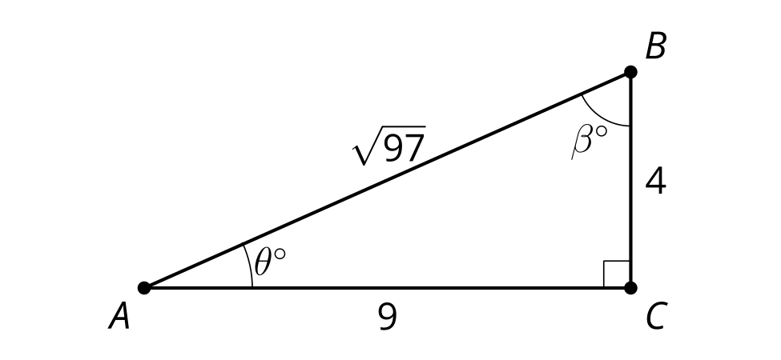
  - $sin\left(θ\right)=\frac{4}{\sqrt{97}}$
  - $tan\left(β\right)=\frac{9}{4}$
  - $tan\left(β\right)=\frac{4}{9}$
  - $cos\left(β\right)=\frac{4}{\sqrt{97}}$
  - $4^{2}+9^{2}=97$
- Write an expression that can be used to find the length of $JH$ and an expression that can be used to find the length of $GJ$.
- 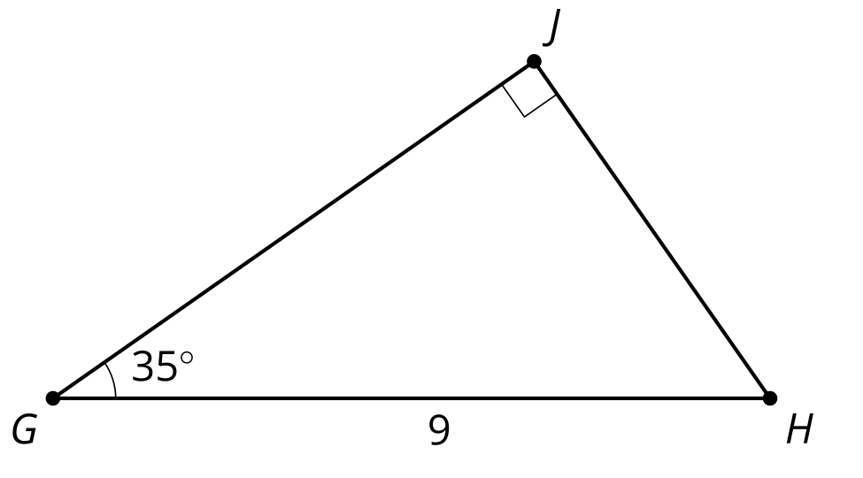
- Andre and Clare are discussing triangle $ABC$ that has a right angle at $C$ and a hypotenuse of length 15 units. Andre thinks the triangle could have legs that are 9 and 12 units long. Clare thinks angle $B$ could be 20 degrees and then side $BC$ would be 14.1 units long. Do you agree with either of them? Explain or show your reasoning.
- (From Unit 4, Lesson 5.)
- A triangle has sides with lengths 5, 12, and 13.
  - Verify this is a Pythagorean triple.
  - Approximate the acute angles in this triangle.
- (From Unit 4, Lesson 5.)
- Approximate the angles that have the following quotients:
  - adjacent leg $÷$ hypotenuse = 0.966
  - opposite leg $÷$ hypotenuse = 0.469
  - adjacent leg $÷$ hypotenuse = 0.309
  - opposite leg $÷$ adjacent leg = 1.036
- (From Unit 4, Lesson 4.)
- Lin missed class and Tyler is helping her use the table to approximate the angle measures that have the ratios listed. Tyler says, “You can use the right triangle table to figure this out.” Lin notices that some of the ratios are the same in each row. Estimate the angles and explain why some of the values are repeated.
- angle | - adjacent leg $÷$ hypotenuse | - opposite leg $÷$ hypotenuse | - opposite leg $÷$ adjacent leg
 | - 0.573 | - 0.819 | - 1.428
 | - 0.819 | - 0.573 | - 0.700
- (From Unit 4, Lesson 4.)
- Find the length of each leg.
- 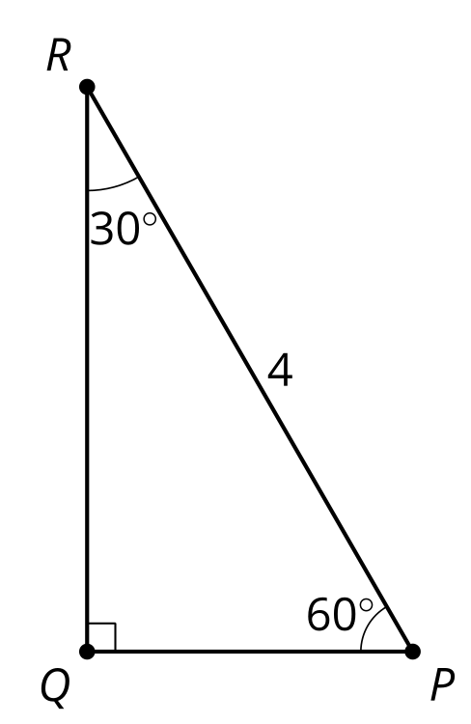
- (From Unit 4, Lesson 3.)
- Elena is proving the Pythagorean Theorem. She knows the goal is to prove that $a^{2}+b^{2}=c^{2}$ in a right triangle. So far she has:
- 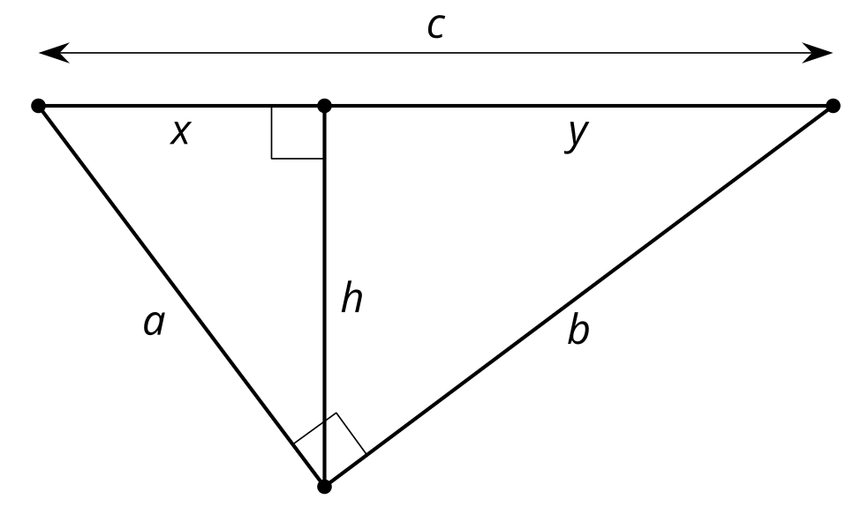
- In a right triangle the altitude that intersects the hypotenuse decomposes the triangle into 2 smaller right triangles. These triangles are similar to the large triangle by the Angle-Angle Triangle Similarity Theorem since each smaller triangle shares one angle with the larger triangle and has a right angle. Similar triangles have proportional side lengths, so $\underset{_}{1}$ and $\underset{_}{2}$. I can rewrite those equations to get $a^{2}=xc$ and $b^{2}=yc$. Therefore $a^{2}+b^{2}=$ . . .
- Fill in the blanks and finish the proof Elena started.
- (From Unit 3, Lesson 14.)
© CC BY 2019 by Illustrative Mathematics®

