Lesson 9: Measure Figures Made From Prisms
- Let’s find the volume of more figures.

Warm-up: Number Talk: Times Ten
Find the value of each expression mentally.
- $6×2$
- $6×2×10$
- $6×20×10$
- $60×20×10$
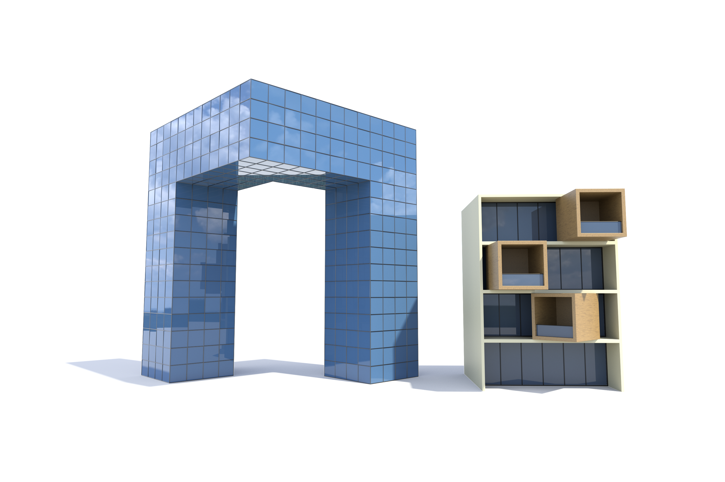

9.1: Find the Volume of Figures
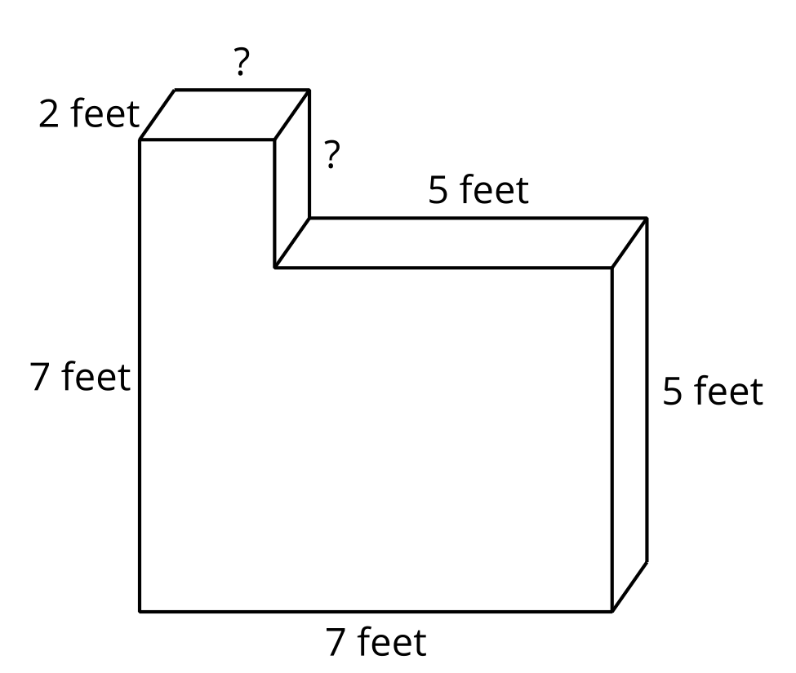
Partner A: Find the volume of Figure 1.
Partner B: Find the volume of Figure 2.
Figure 1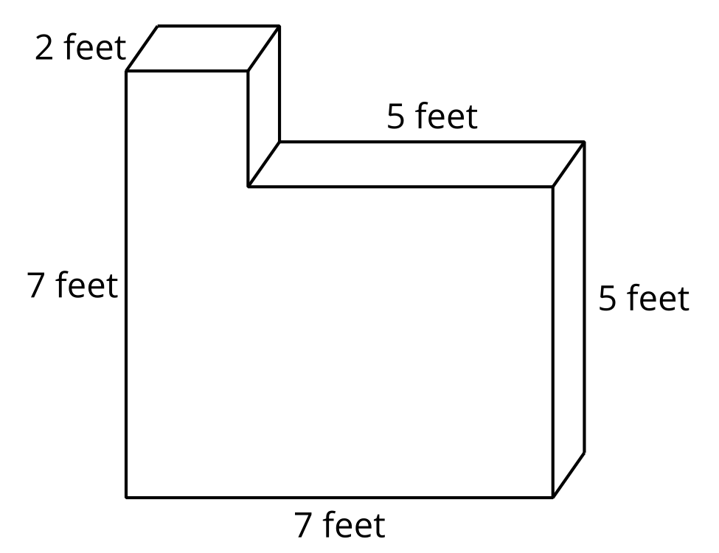
Figure 2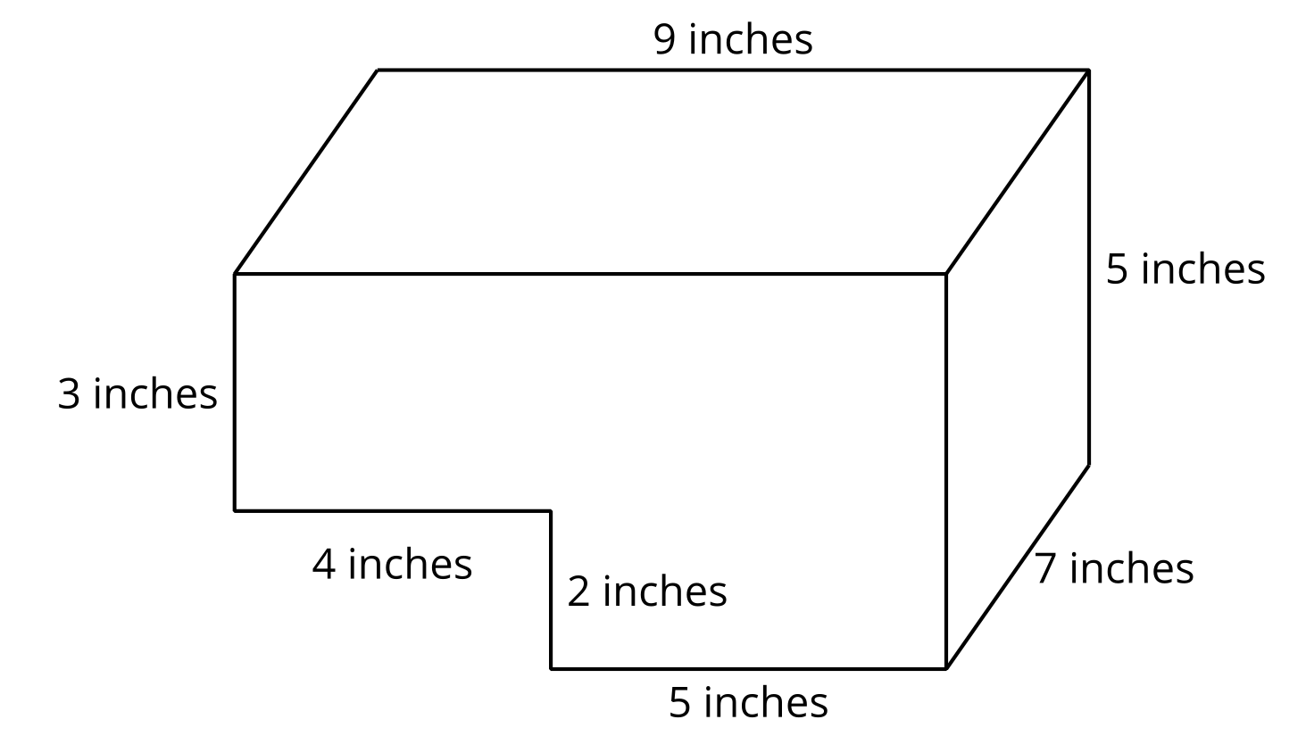

9.2: Expressions for the Volume of Figures
- Explain how each expression represents the volume of the figure. Show your thinking. Organize it so it can be followed by others.
  - $\left(\left(2×3\right)×4\right)+\left(\left(3×3\right)×2\right)$
  - $\left(5×6\right)+\left(3×4\right)$
- 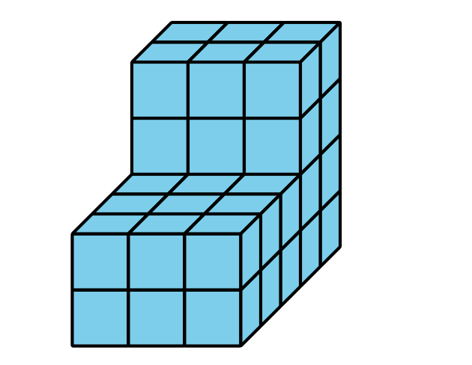
- How does each expression represent the volume of the prism? Explain or show your thinking. Organize it so it can be followed by others.
  - $\left(5×8×6\right)+\left(5×4×9\right)$ cubic inches
  - $\left(5×4×3\right)+\left(5×12×6\right)$ cubic inches
- 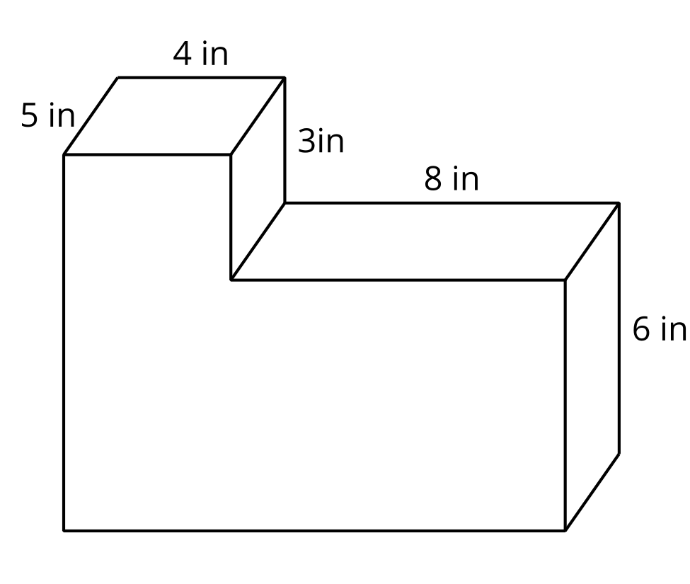
© CC BY 2021 Illustrative Mathematics®

