Unit 6 Lesson 12: Count by 5 to Tell Time

WU Notice and Wonder: Number Line and Clock (Warm up)

Student Task Statement
What do you notice? What do you wonder?
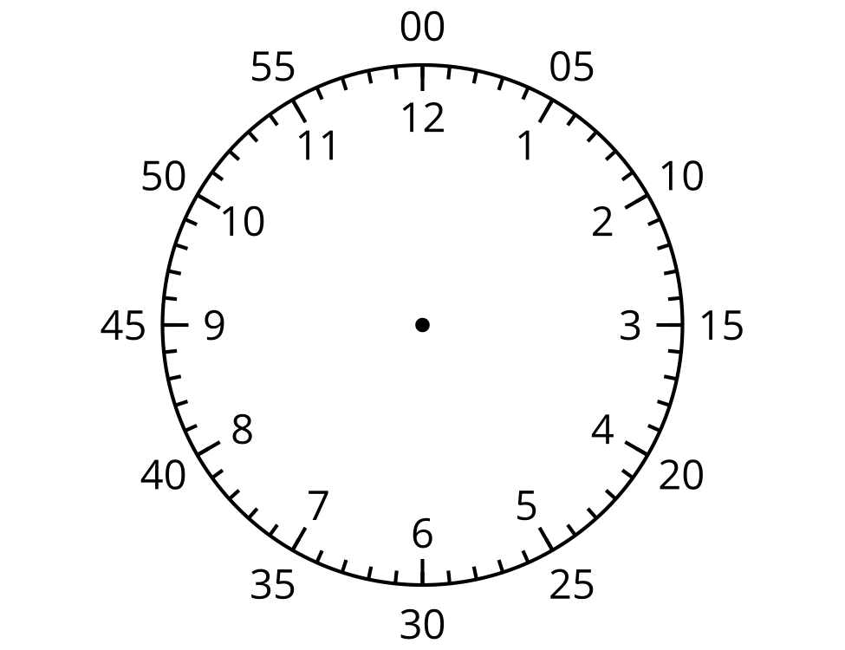

1 Count by 5 on the Clock

Student Task Statement
- Discuss 2 ways to read the time on this clock.
- 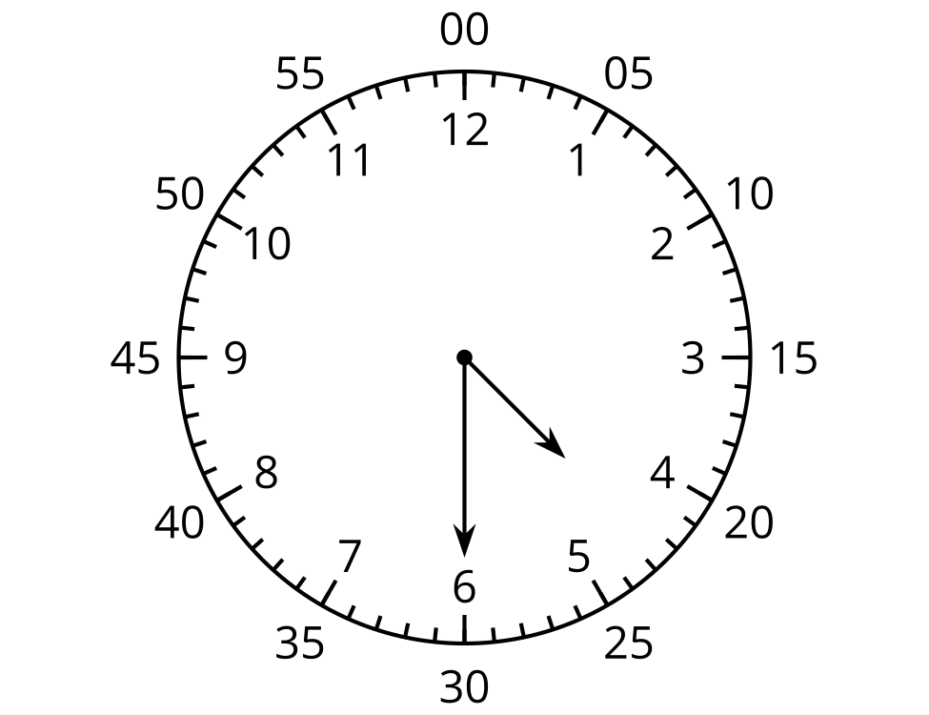
- What time does this clock show?
- 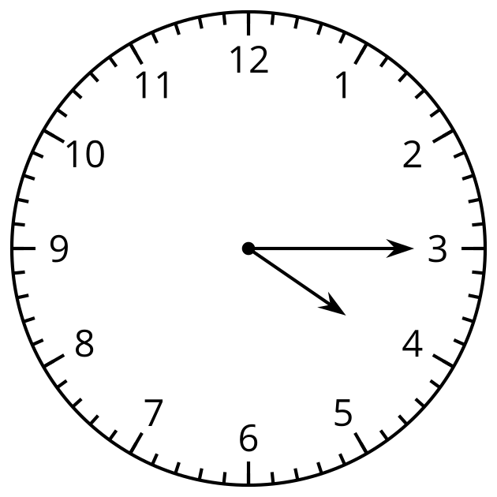
- Read the time on each clock card with your partner. Put the clocks in order based on the times they show.

2 Write the Time

Student Task Statement
Write the time shown on each clock.
- 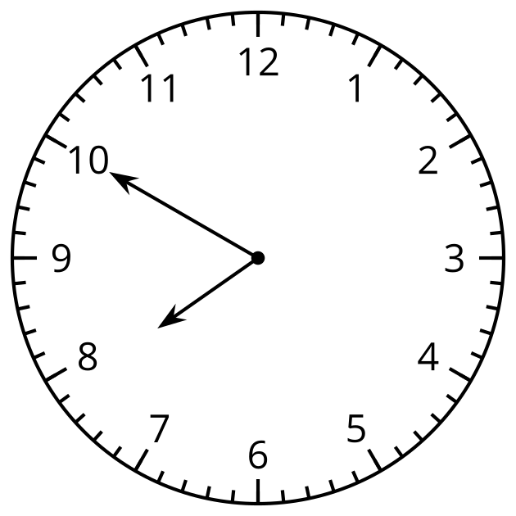
- 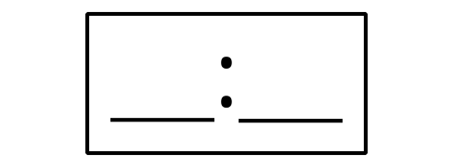

- 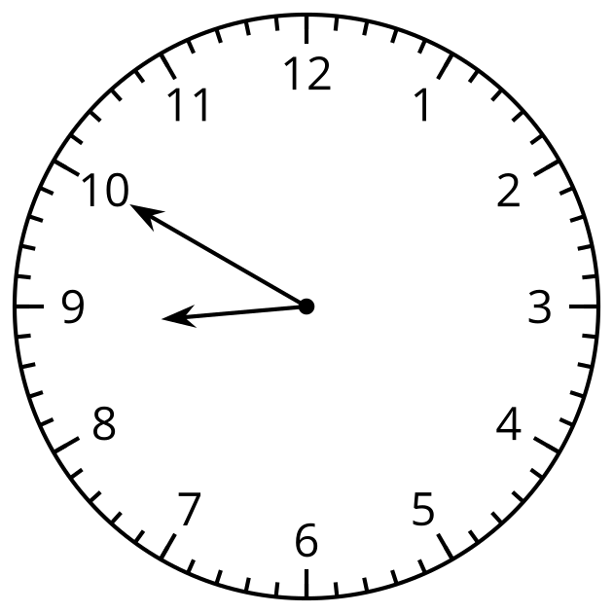
- 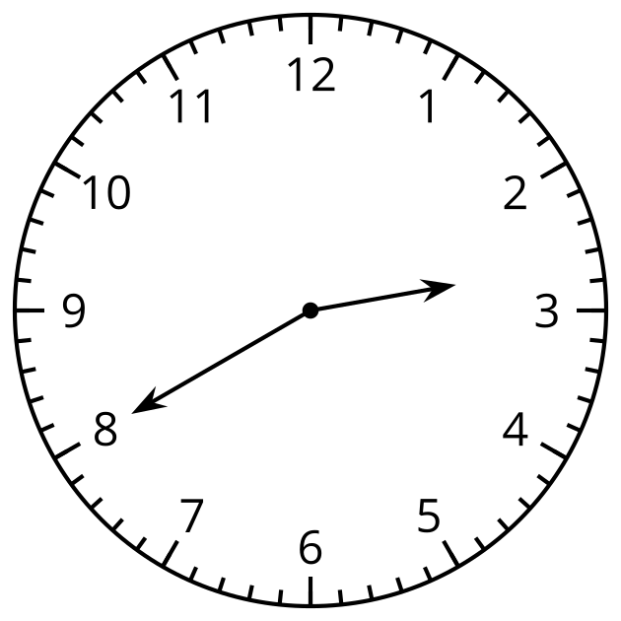

- 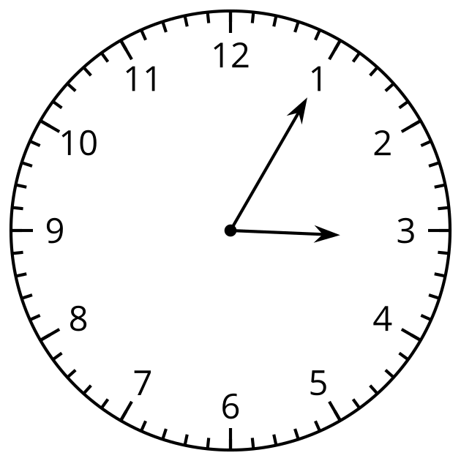
- 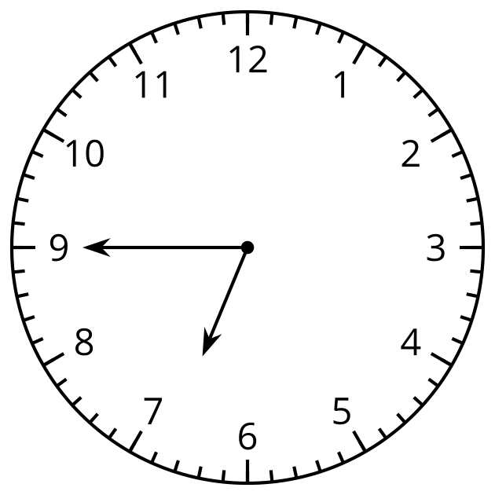

- 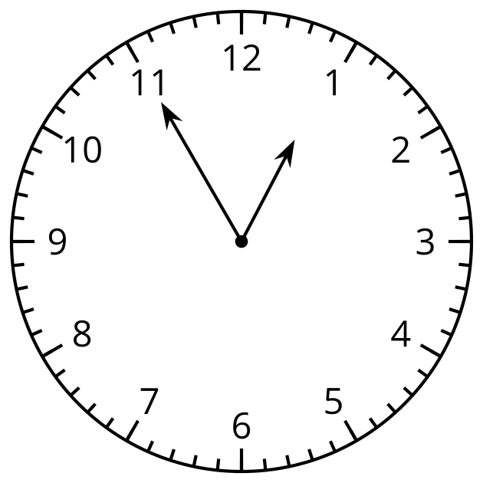

Activity Synthesis

Images for Activity Synthesis
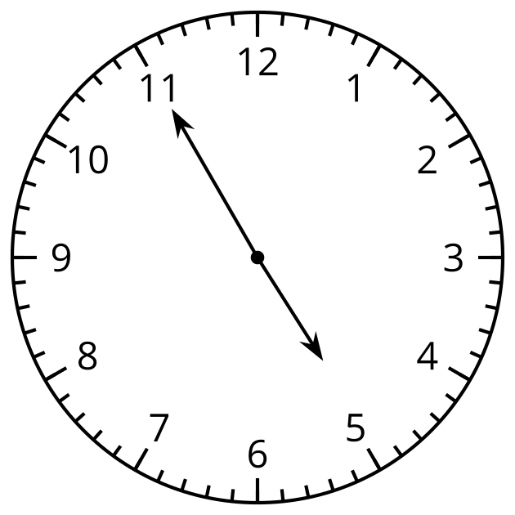
© CC BY 2021 Illustrative Mathematics®

