Lesson 17: Make 10 to Add

Standards Alignments
Addressing | 1.OA.A.1, 1.OA.B.3, 1.OA.C.6

Teacher-facing Learning Goals
- Analyze methods for adding within 20 that involve making a ten.
- Look for and use patterns in addition expressions to add within 20.

Student-facing Learning Goals
- Let’s look for patterns and think about making 10 as we add.

Lesson Purpose
The purpose of this lesson is for students to look for and use patterns to add within 20. Students see that they can decompose one addend in order to make a ten.
In previous lessons, students recognized the $10+n$ structure of teen numbers and used the structure to find the sum of three numbers. In this lesson, students use the structure of the 10-frame to find the sum of two addends when one addend is 9. Students come to see that when they find the sum of two addends, they can decompose one addend to make 10 with the other addend (associative property). For example, $9+5=9+1+4=10+4=14$. When students identify and use equivalent expressions, they look for and make use of structure (MP7) and here they repeatedly make a 10 to find the value of expressions (MP8).
Student methods are recorded with equations. It may also be helpful to represent how one addend is decomposed in order to make a ten.
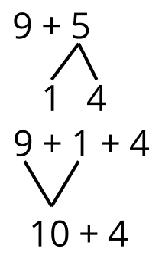

Access for:

Students with Disabilities
- Engagement (Activity 1)

English Learners
- MLR7 (Activity 2)

Instructional Routines
How Many Do You See? (Warm-up)

Materials to Gather
- Connecting cubes or two-color counters: Activity 1, Activity 2
- Double 10-frames: Activity 1, Activity 2
- Number cards 0–10: Activity 1

Lesson Timeline
Warm-up | 10 min
Activity 1 | 20 min
Activity 2 | 15 min
Lesson Synthesis | 10 min
Cool-down | 5 min

Teacher Reflection Question
What was the best question you asked students today? Why would you consider it the best one based on what students said or did?

Cool-down
(to be completed at the end of the lesson) 5min
Sitting Birds

Standards Alignments
Addressing | 1.OA.A.1, 1.OA.C.6

Student-facing Task Statement
8 birds are sitting in a tree.
6 birds are sitting on the grass.
How many birds are there all together?
Show your thinking using drawings, numbers, or words.
Equation: ________________________________

Student Responses
14. Sample response:
6 is the same as 2 and 4. $8+2=10$ and $10+4=14$

