Lesson 13: Problems with Missing Information
- Let’s find out what information is needed to solve problems about measurements at the fair.

Warm-up: Estimation Exploration: Giant Cantaloupe
A regular cantaloupe weighs between 1 and 5 kilograms.
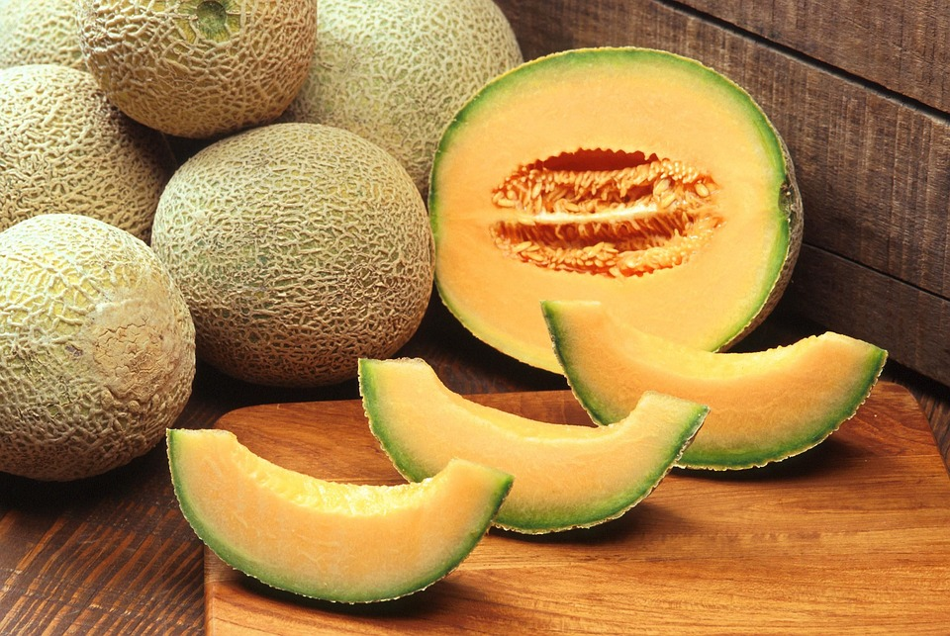
This cantaloupe melon was a winner at the 2010 Alaska State Fair. How many kilograms do you think it weighs?
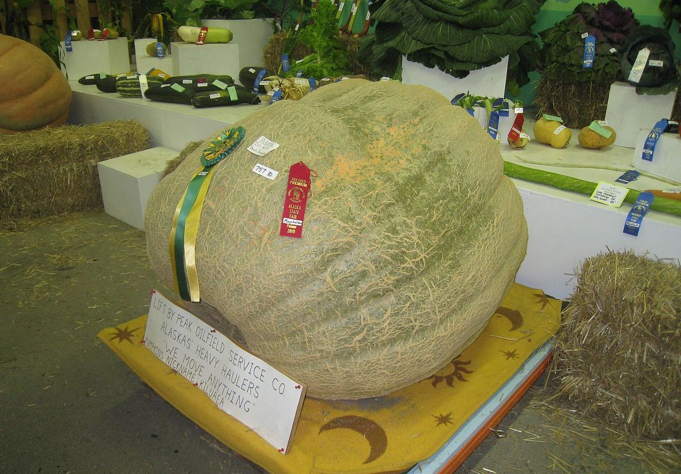
Record an estimate that is:
too low | about right | too high

13.1: Info Gap: Pumpkin Weigh-Off
Your teacher will give you either a problem card or a data card. Do not show or read your card to your partner.
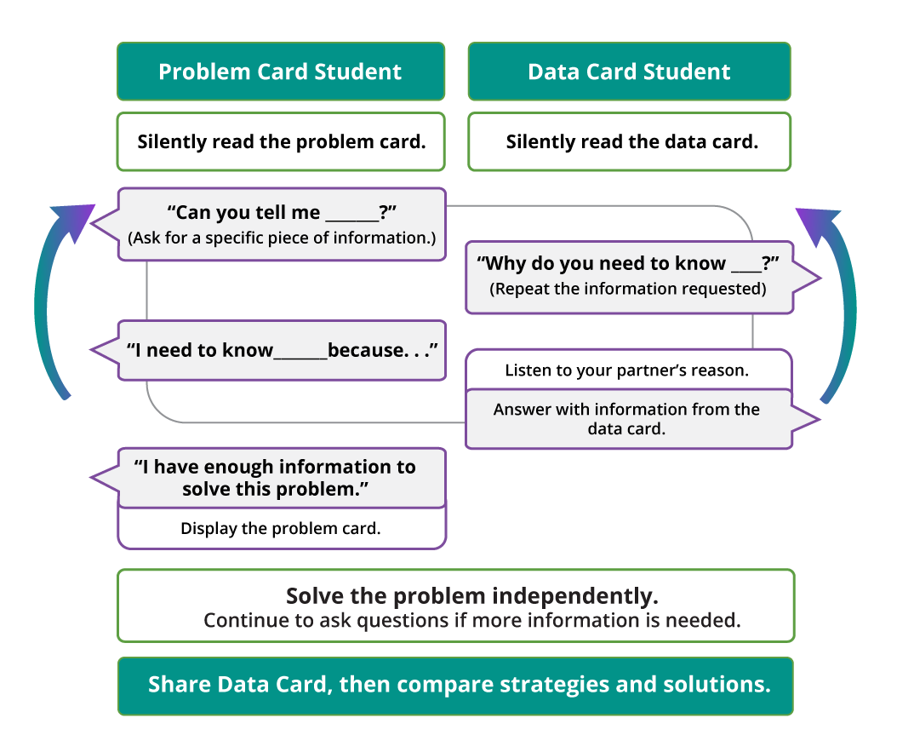
Pause here so your teacher can review your work.
Ask your teacher for a new set of cards and repeat the activity, trading roles with your partner.

13.2: Info Gap: Pig Weigh-Off
Your teacher will give you a new problem card or data card. Do not show or read your card to your partner.
Use the same information gap routine to solve the problem. Then, pause so your teacher can review your work.
Ask your teacher for a new set of cards and repeat the activity, trading roles with your partner.
© CC BY 2021 Illustrative Mathematics®

