Unit 1 Lesson 3: Prime and Composite Numbers

WU Choral Count: Twos and Fives (Warm up)

Student Task Statement

1 Card Sort: Area

Student Task Statement
Your teacher will give you a set of cards to sort.
- Sort the cards by area. Record your sorting results. Be prepared to explain your choices.
- For each group of sorted cards, think of at least one more rectangle. Name its length and width. Be prepared to explain your reasoning.
- 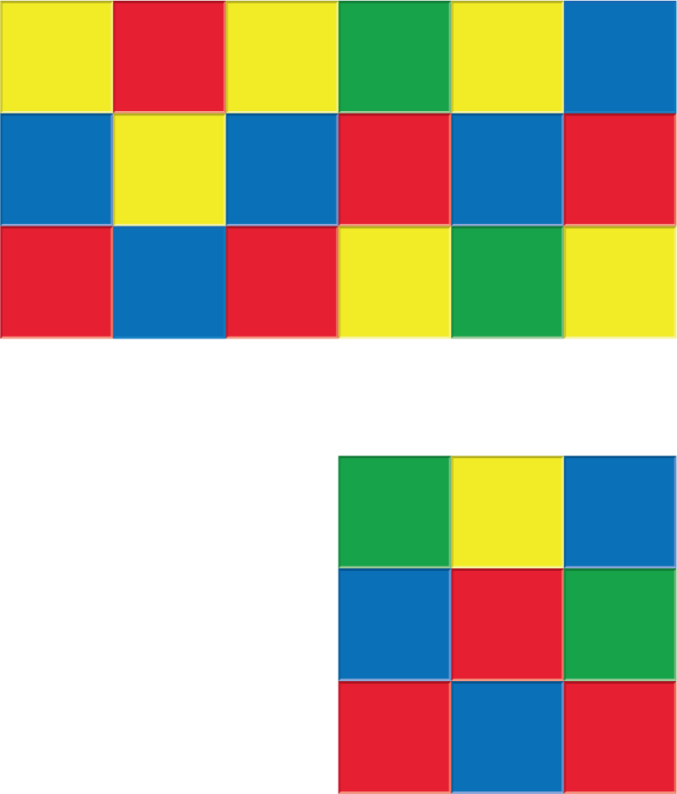

2 Prime or Composite?

Student Task Statement
The table shows different areas. How many rectangles can be made for each area?
Complete the table and be prepared to explain or show your reasoning.
Rectangles with the same pair of side lengths should be counted only once. For example, if you count a rectangle with 4 units across and 6 units down, you don’t need to also count a rectangle with 6 units across and 4 units down.
area | how many rectangles? | prime or composite?
2 square units
10 square units
48 square units
11 square units
21 square units
23 square units
60 square units
32 square units
42 square units
31 square units
56 square units
© CC BY 2021 Illustrative Mathematics®

