Lesson 16: Equivalent Exponential Expressions
Let's investigate expressions with variables and exponents.

16.1: Up or Down?
Find the values of $3^{x}$ and ${\left(\frac{1}{3}\right)}^{x}$ for different values of $x$. What patterns do you notice?
$x$ | $3^{x}$ | ${\left(\frac{1}{3}\right)}^{x}$
1
2
3
4

16.2: What's the Value?
Evaluate each expression for the given value of $x$.
- $3x^{2}$ when $x$ is 10
- $3x^{2}$ when $x$ is $\frac{1}{9}$
- $\frac{x^{3}}{4}$ when $x$ is 4
- $\frac{x^{3}}{4}$ when $x$ is $\frac{1}{2}$
- $9+x^{7}$ when $x$ is 1
- $9+x^{7}$ when $x$ is $\frac{1}{2}$

16.3: Exponent Experimentation
Find a solution to each equation in the list. (Numbers in the list may be a solution to more than one equation, and not all numbers in the list will be used.)
- $64=x^{2}$
- $64=x^{3}$
- $2^{x}=32$
- $x={\left(\frac{2}{5}\right)}^{3}$
- $\frac{16}{9}=x^{2}$
- $2⋅2^{5}=2^{x}$
- $2x=2^{4}$
- $4^{3}=8^{x}$
List:
$\frac{8}{125}$
$\frac{6}{15}$
$\frac{5}{8}$
$\frac{8}{9}$
1
$\frac{4}{3}$
2
3
4
5
6
8

Are you ready for more?
This fractal is called a Sierpinski Tetrahedron. A tetrahedron is a polyhedron that has four faces. (The plural of tetrahedron is tetrahedra.)
The small tetrahedra form four medium-sized tetrahedra: blue, red, yellow, and green. The medium-sized tetrahedra form one large tetrahedron.
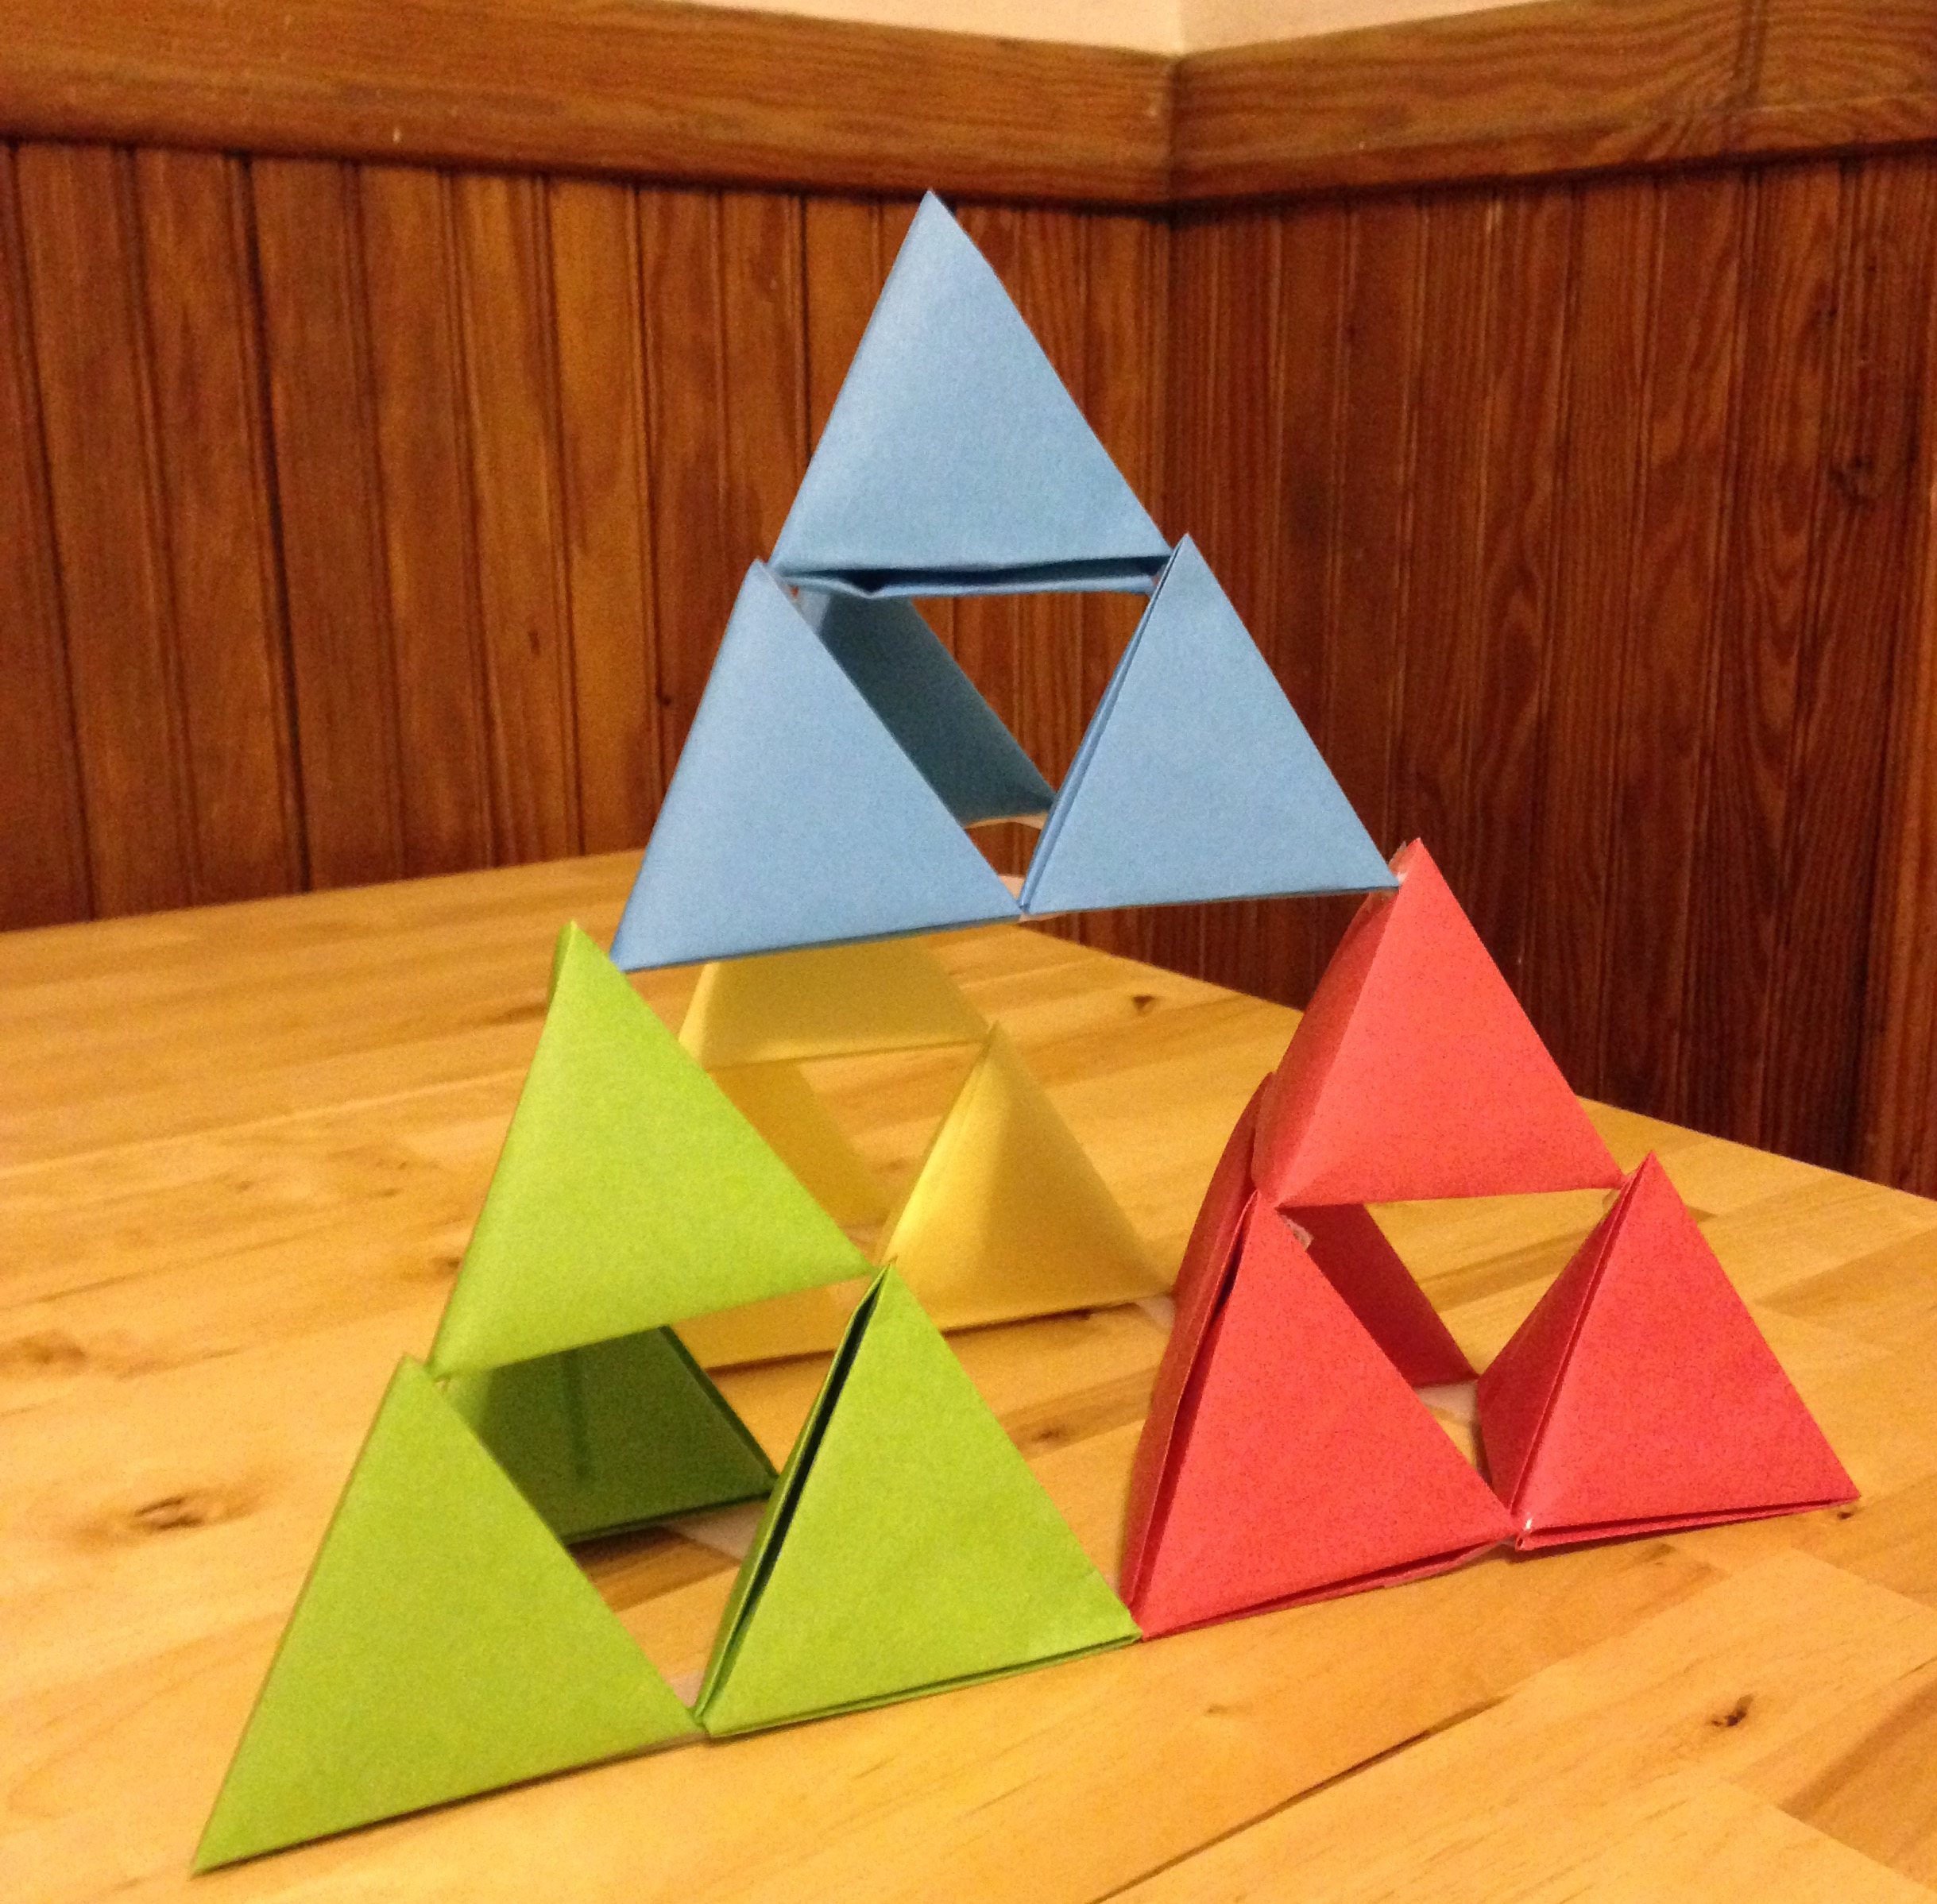
- How many small faces does this fractal have? Be sure to include faces you can’t see. Try to find a way to figure this out so that you don’t have to count every face.
- How many small tetrahedra are in the bottom layer, touching the table?
- To make an even bigger version of this fractal, you could take four fractals like the one pictured and put them together. Explain where you would attach the fractals to make a bigger tetrahedron.
- How many small faces would this bigger fractal have? How many small tetrahedra would be in the bottom layer?
- What other patterns can you find?

Lesson 16 Summary
In this lesson, we saw expressions that used the letter $x$ as a variable. We evaluated these expressions for different values of $x$.
- To evaluate the expression $2x^{3}$ when $x$ is 5, we replace the letter $x$ with 5 to get $2⋅5^{3}$. This is equal to $2⋅125$ or just 250. So the value of $2x^{3}$ is 250 when $x$ is 5.
- To evaluate $\frac{x^{2}}{8}$ when $x$ is 4, we replace the letter $x$ with 4 to get $\frac{4^{2}}{8}=\frac{16}{8}$, which equals 2. So $\frac{x^{2}}{8}$ has a value of 2 when $x$ is 4.
We also saw equations with the variable $x$ and had to decide what value of $x$ would make the equation true.
- Suppose we have an equation $10⋅3^{x}=90$ and a list of possible solutions: $1,2,3,9,11$. The only value of $x$ that makes the equation true is 2 because $10⋅3^{2}=10⋅3⋅3$, which equals 90. So 2 is the solution to the equation.
© CC BY Open Up Resources. Adaptations CC BY IM.

