Lesson 13: Describe and Match Shapes
- Let’s build shapes that match.

Warm-up: How Many Do You See: Add On and Rearrange
How many do you see?
How do you see them?

13.1: Where are the Pattern Blocks?
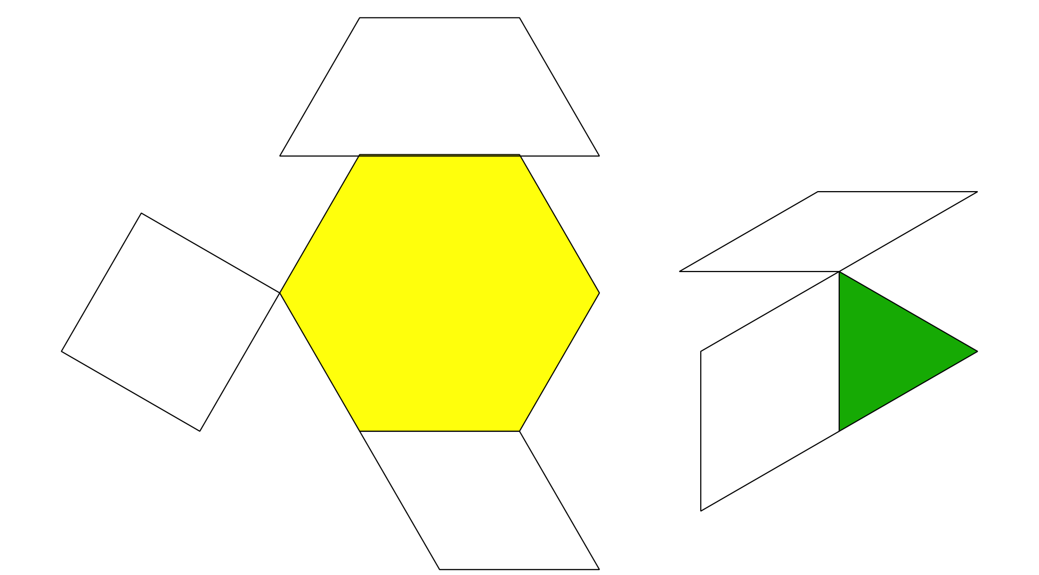
Synthesis:
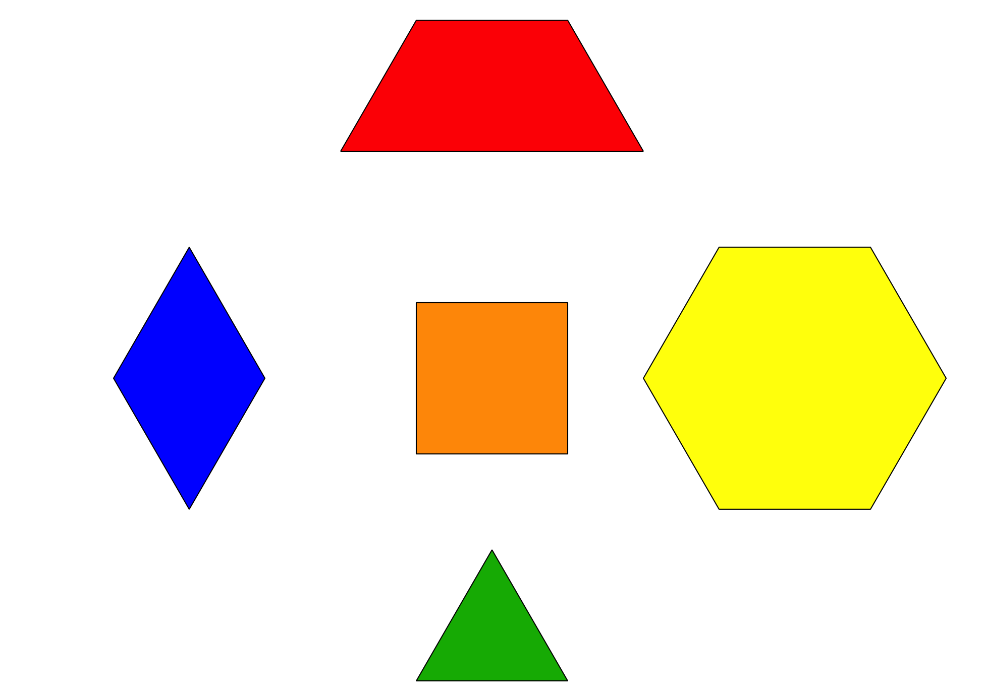

13.3: Centers: Choice Time
Choose a center.
Match Mine
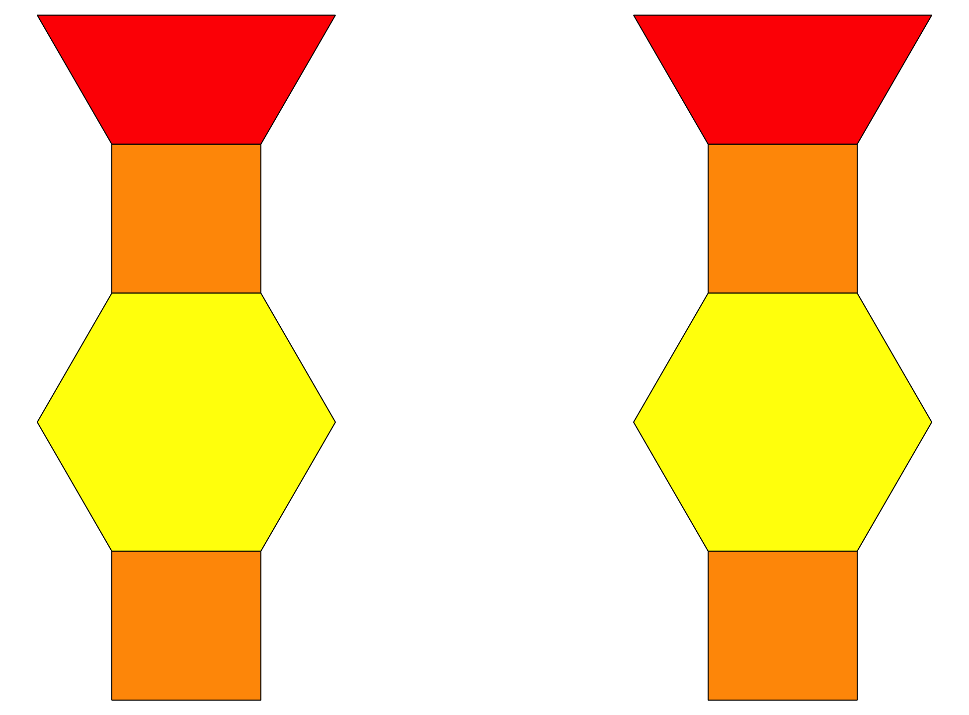
Geoblocks
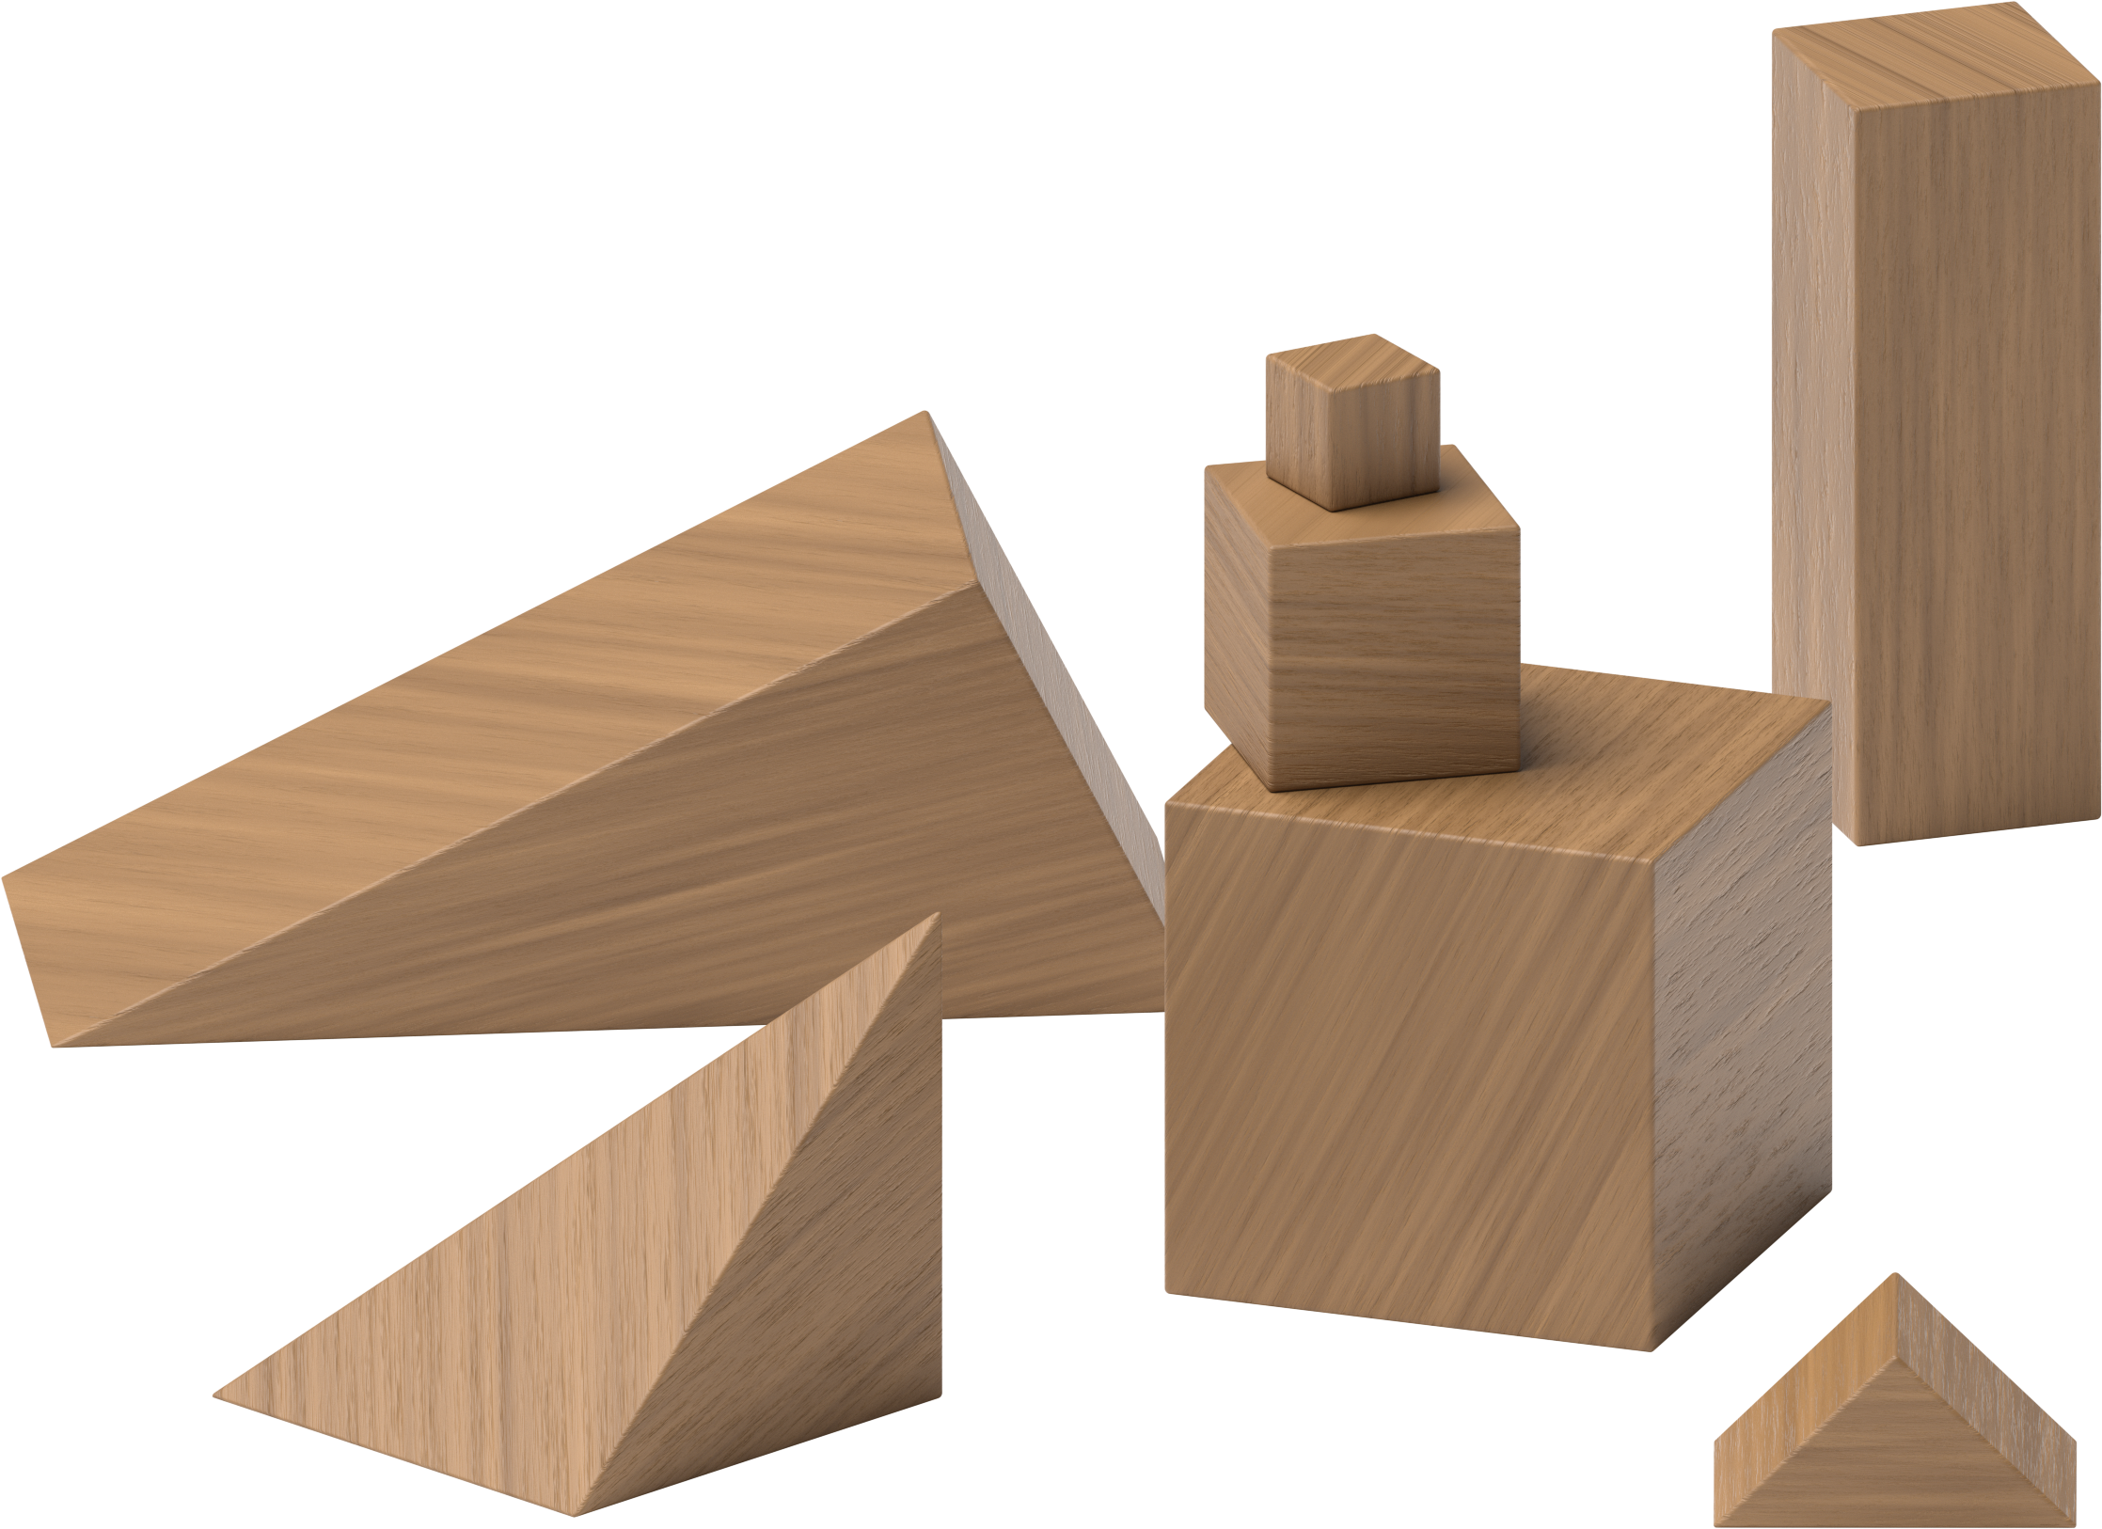
Build Shapes
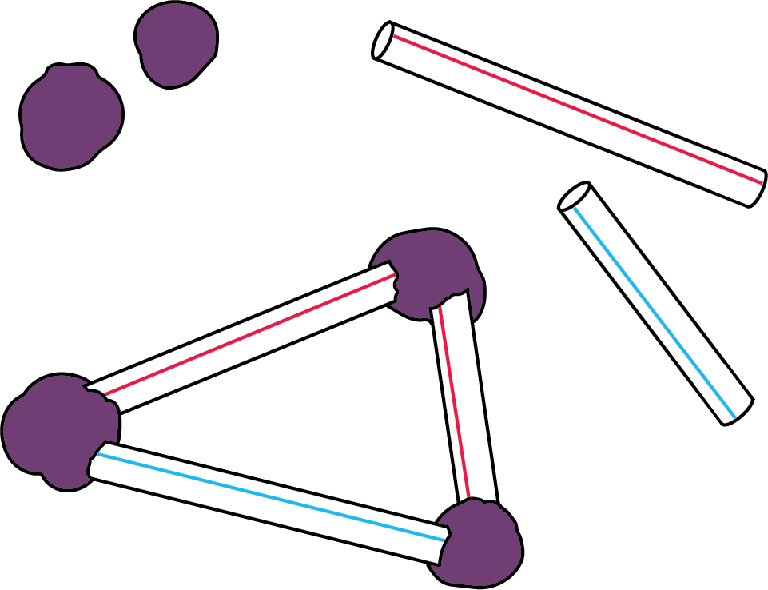
Pattern Blocks
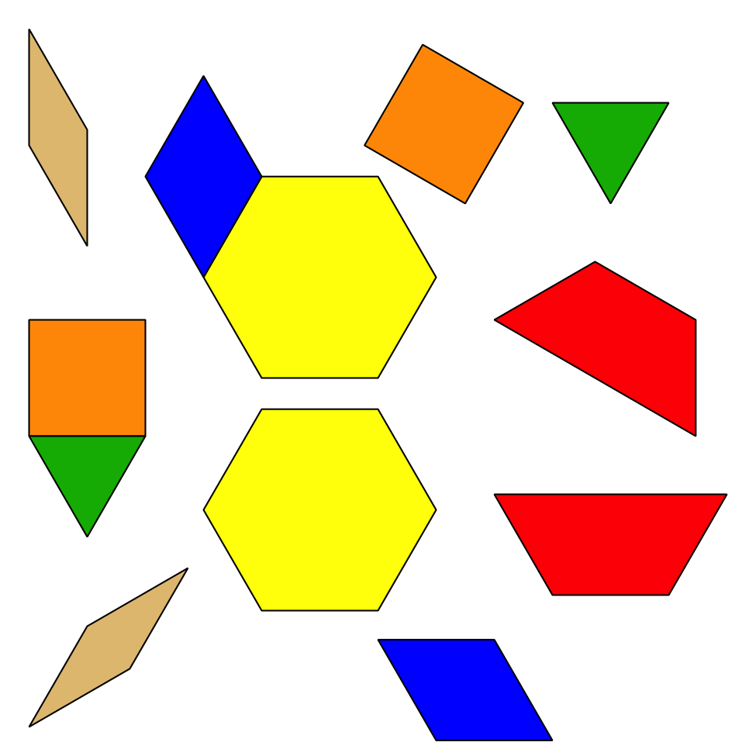
Less, Same, More
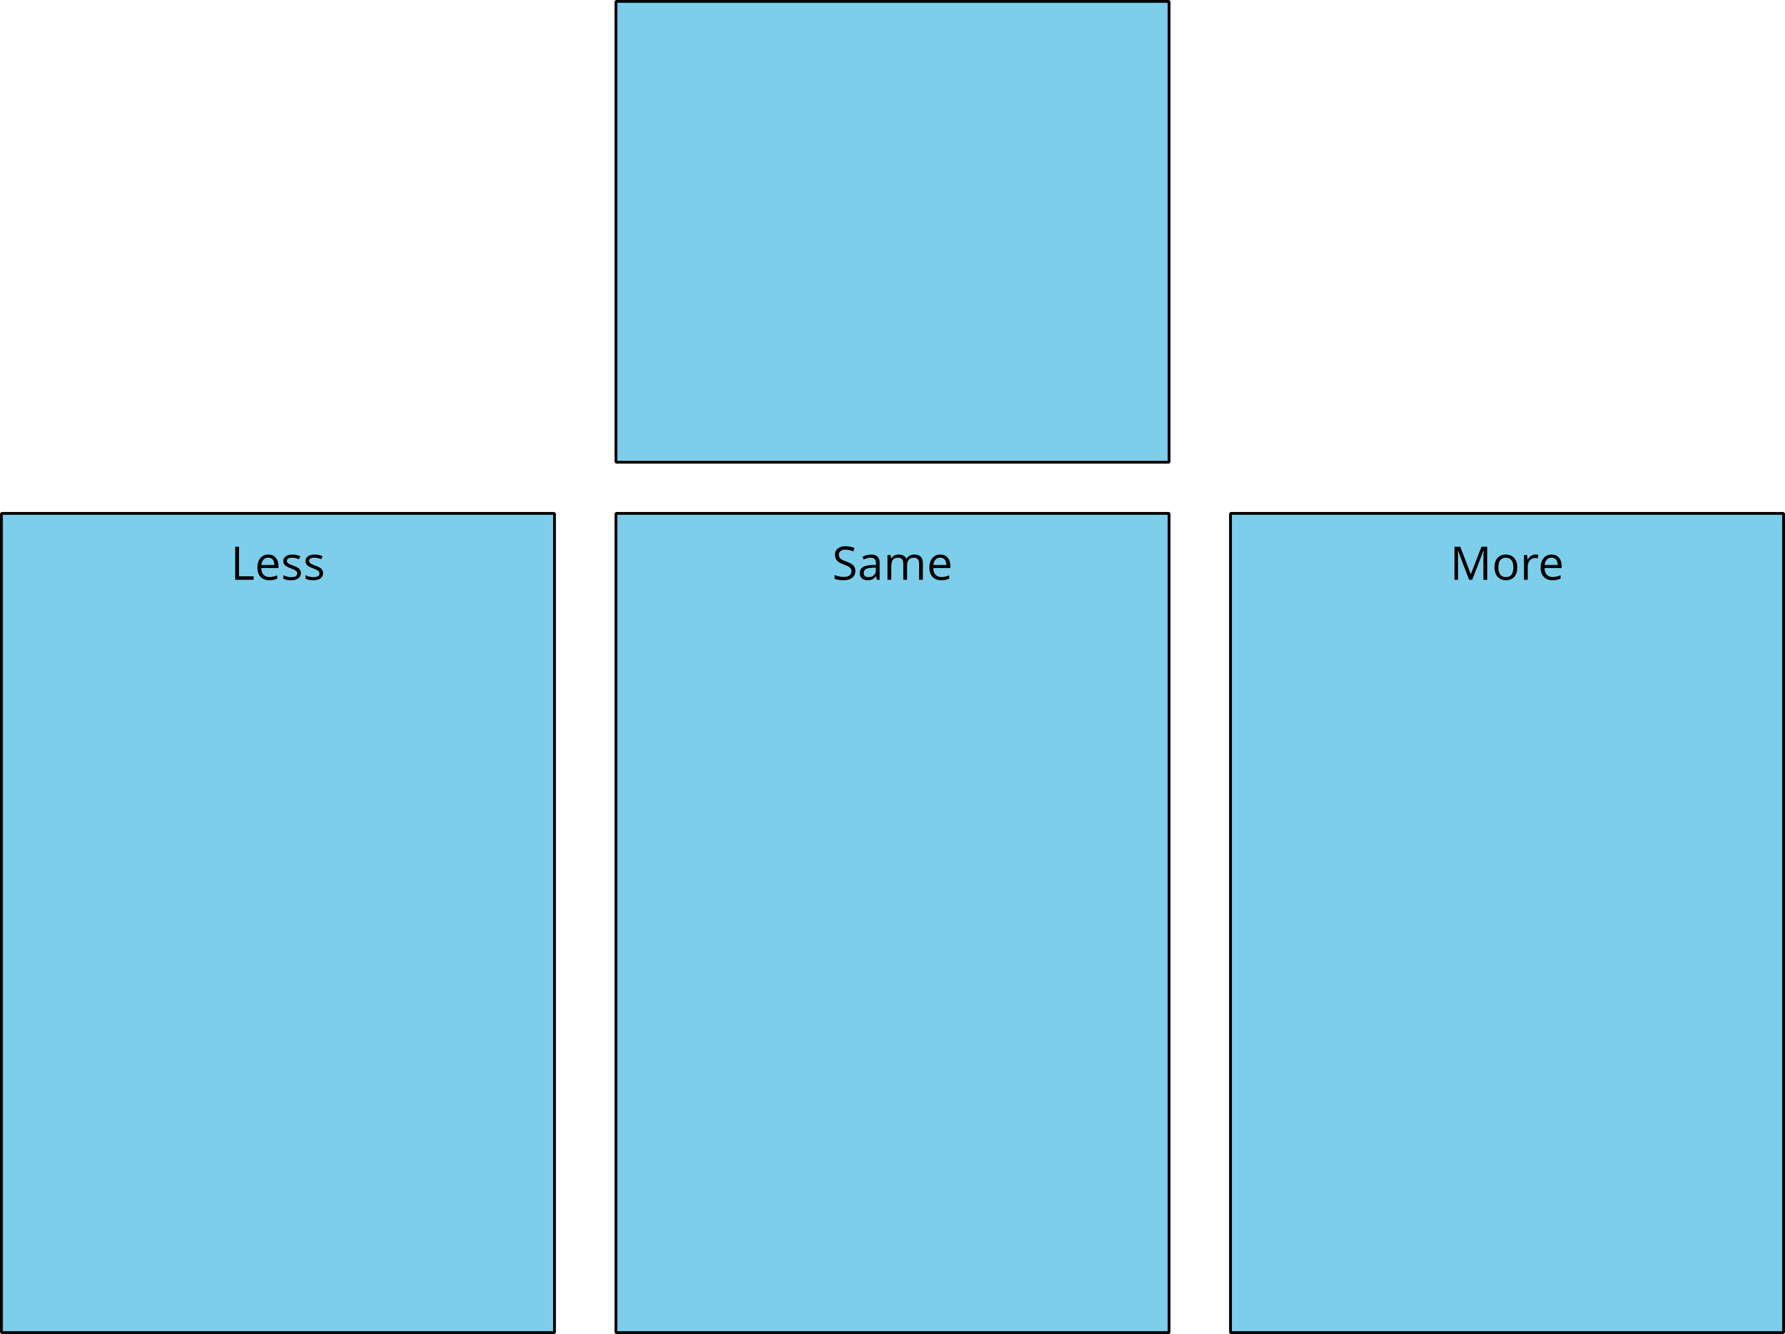
© CC BY 2021 Illustrative Mathematics®

