Lesson 9: Relate Area to Multiplication

Standards Alignments
Addressing | 5.NF.B.4.b

Teacher-facing Learning Goals
- Find the area of a rectangle with a unit fraction side length in a way that makes sense to them.

Student-facing Learning Goals
- Let’s explore the area of rectangles with one side length that is a unit fraction.

Lesson Purpose
The purpose of this lesson is for students to calculate the area of a rectangle whose side lengths are a unit fraction and a whole number in a way that makes sense to them.
Students build on their understanding of multiplication and area from grade 3 as they work with areas with fractional side lengths. Students may count the number of smaller parts within a rectangle and will need to recognize and consider the size of these parts, which is a fraction of a square unit. It is important to be precise in the units used to describe the area and teachers should make sure to refer to “square units” rather than “squares.”
As with the area work in grade 3, the commutative property may come up. The commutative property allows students to find products in a way that makes sense to them. For example a student might find the area of a rectangle with side lengths $\frac{1}{2}$ and 4 by thinking of 4 groups of $\frac{1}{2}$.
In Unit 6, students have another opportunity to interpret the product of a fraction and a whole number in the context of multiplication as scaling. This section is about area.

Access for:

Students with Disabilities
- Action and Expression (Activity 1)

English Learners
- MLR8 (Activity 1)

Instructional Routines
Which One Doesn’t Belong? (Warm-up)

Materials to Copy
- Grid Paper 5 (groups of 2): Activity 2

Lesson Timeline
Warm-up | 10 min
Activity 1 | 15 min
Activity 2 | 20 min
Lesson Synthesis | 10 min
Cool-down | 5 min

Teacher Reflection Question
As students shared their ideas today, how did you ensure all students’ voices were heard and valued as an important part of the collective learning?

Cool-down
(to be completed at the end of the lesson) 5min
Fractional Pieces

Standards Alignments
Addressing | 5.NF.B.4.b

Student-facing Task Statement
Find the area of the shaded region. Explain or show your reasoning.
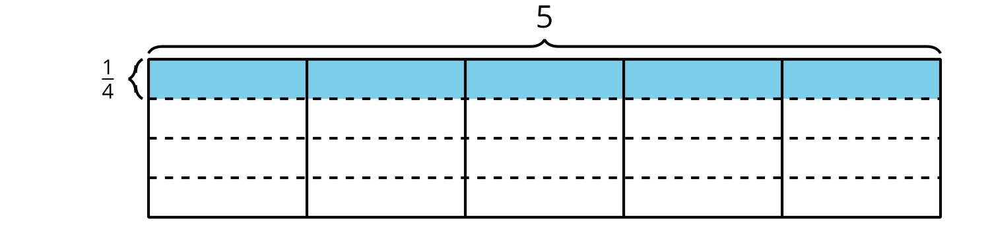

Student Responses
The area is $\frac{5}{4}$ or $1\frac{1}{4}$ square units.
Sample response: I counted the shaded pieces which are fourths and figured out that I had enough to fill one unit square and $\frac{1}{4}$ of a second unit square.

