Unit 2 Lesson 8: End Behavior (Part 1)

1 Notice and Wonder: A Different View (Warm up)

Student Task Statement
What do you notice? What do you wonder?

$y=x^{3}+4x^{2}−x−4$
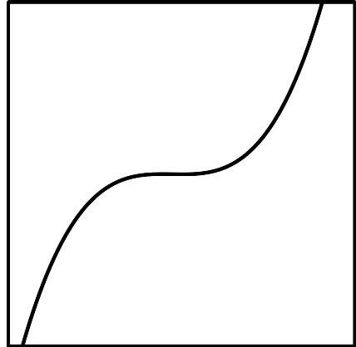

$y=x^{4}−10x^{2}+9$
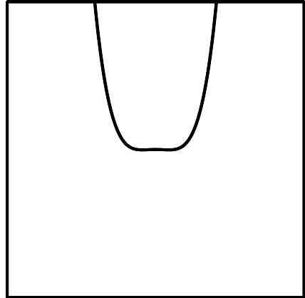

2 Polynomial End Behavior

Student Task Statement
- For your assigned polynomial, complete the column for the different values of $x$. Discuss with your group what you notice.
- $x$ | - $y=x^{2}+1$ | - $y=x^{3}+1$ | - $y=x^{4}+1$ | - $y=x^{5}+1$
- -1000
- -100
- -10
- -1
- 1
- 10
- 100
- 1000
- Sketch what you think the end behavior of your polynomial looks like, then check your work using graphing technology.

3 Two Polynomial Equations

Student Task Statement
Consider the polynomial $y=2x^{5}−5x^{4}−30x^{3}+5x^{2}+88x+60$.
- Identify the degree of the polynomial.
- Which of the 6 terms, $2x^{5}$, $5x^{4}$, $30x^{3}$, $5x^{2}$, $88x$, or $60$, is greatest when:
  - $x=0$
  - $x=1$
  - $x=3$
  - $x=5$
- Describe the end behavior of the polynomial.
© CC BY 2019 by Illustrative Mathematics®

