## Lesson 10: Place Value Comparisons (Part 1)

* Let’s use place value to compare three-digit numbers.

### Warm-up: Number Talk: Add Tens

Find the value of each expression mentally.

### 10.1: Compare by Place

Who has more? How do you know?

Mai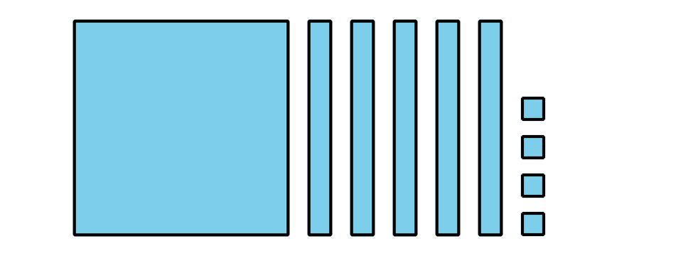

Tyler

Compare the base-ten diagrams.

Write each value as a three-digit number. Use the symbols , , or  to compare the numbers.

1. 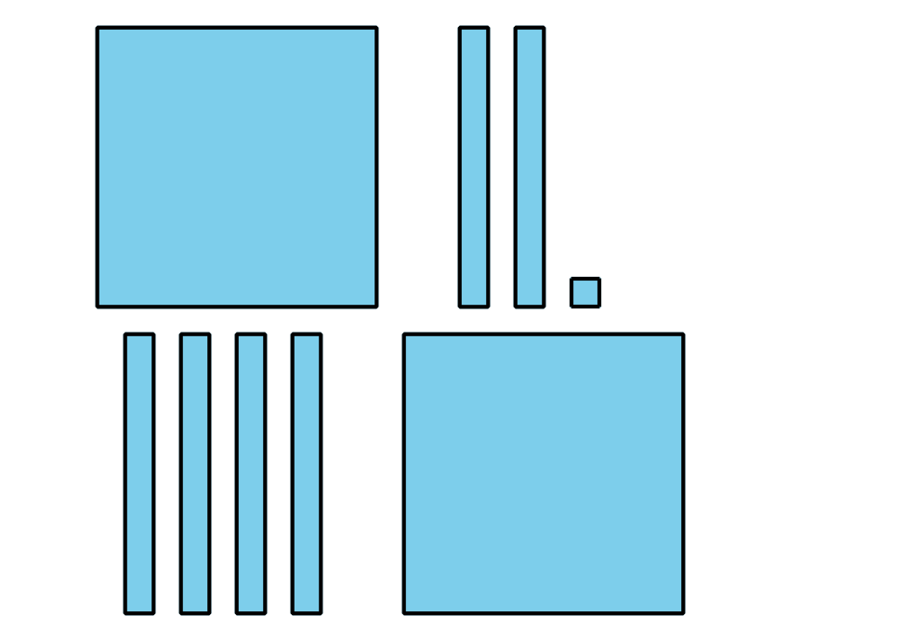

* 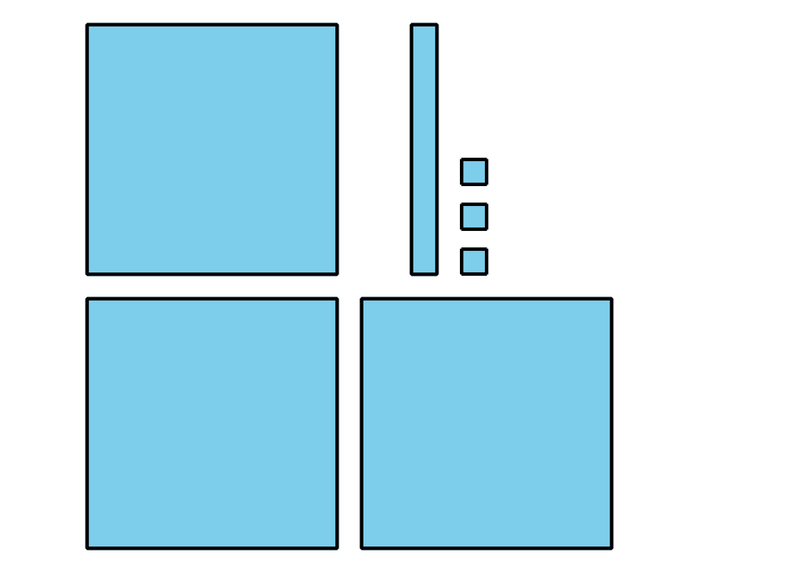

1. 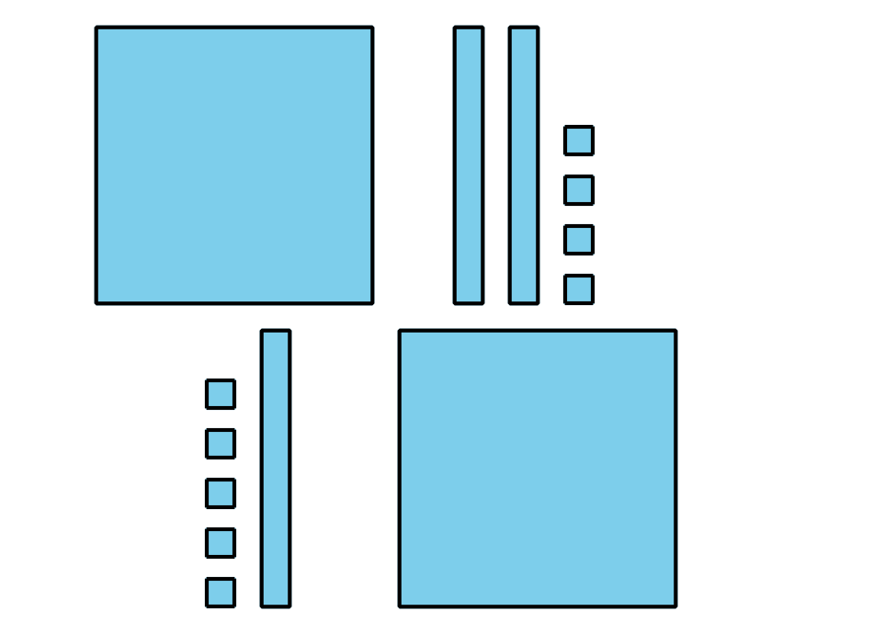

* 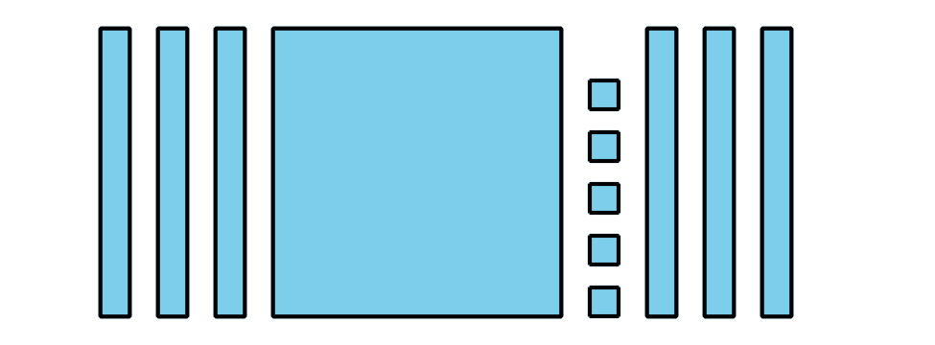

1. 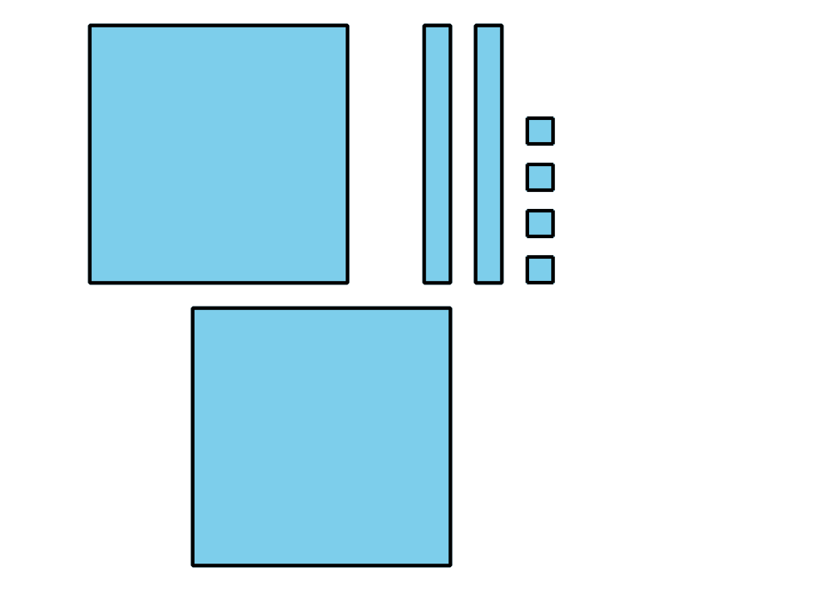

* 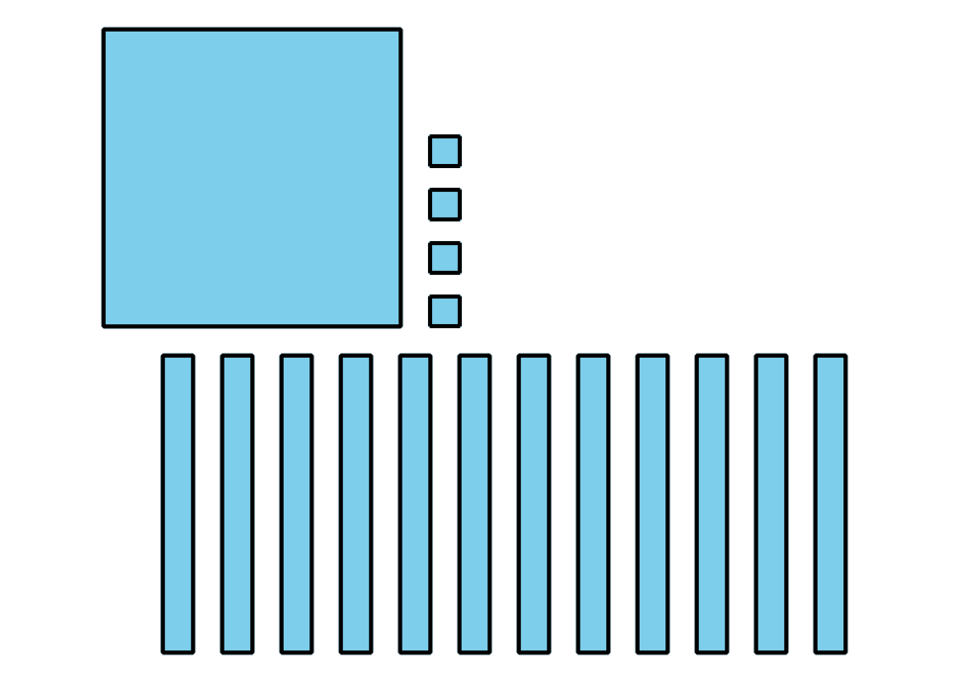

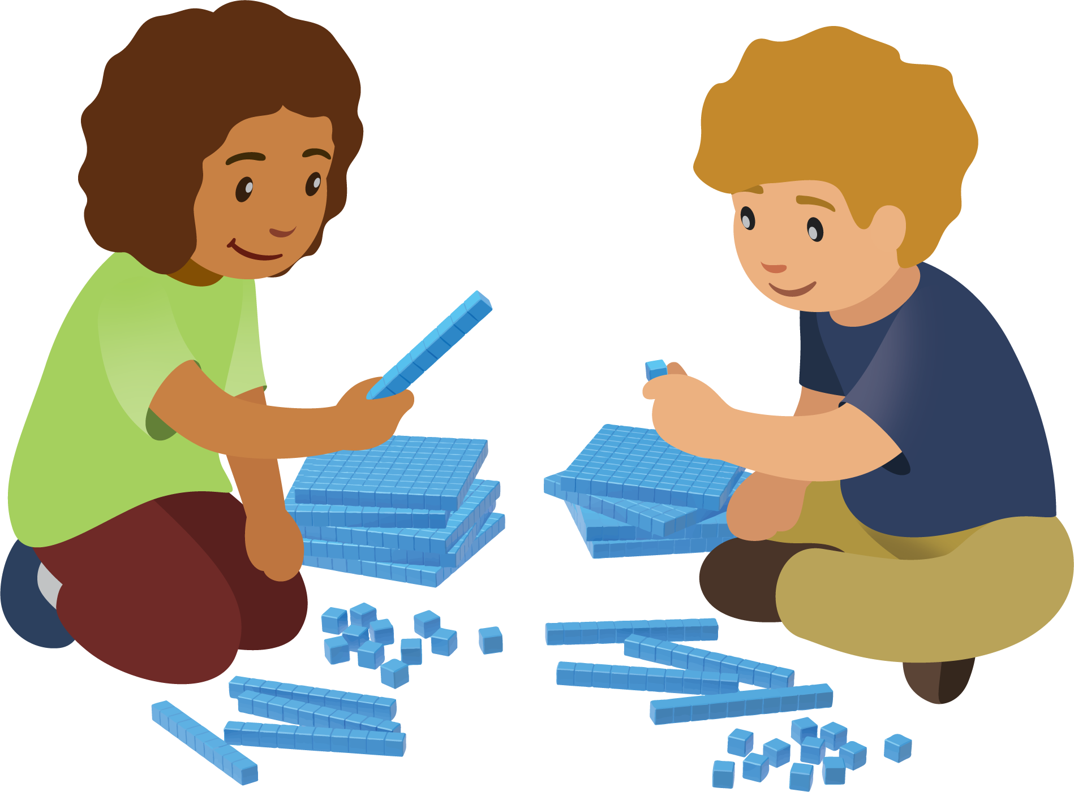

### 10.2: Compare Hundreds, Tens, and Ones

Compare the base-ten diagrams. Write each value as a three-digit number. Use the symbols , , or  to compare the numbers.

1. 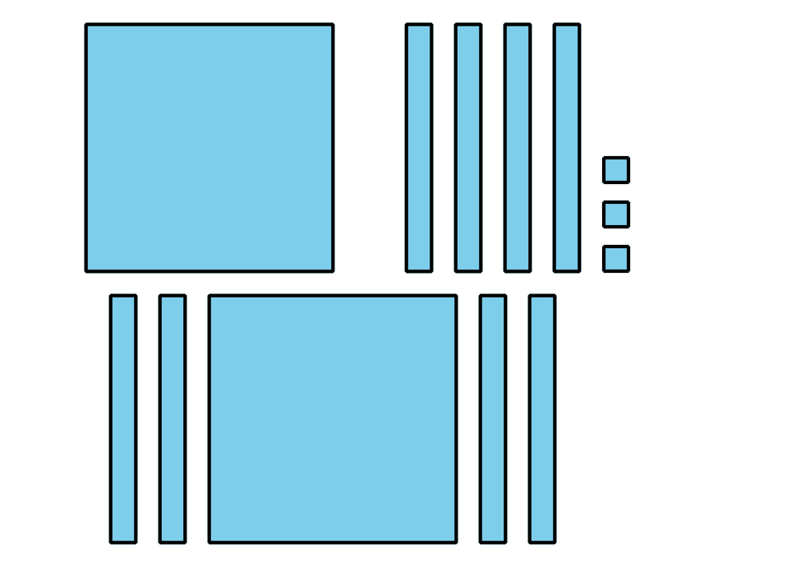

* 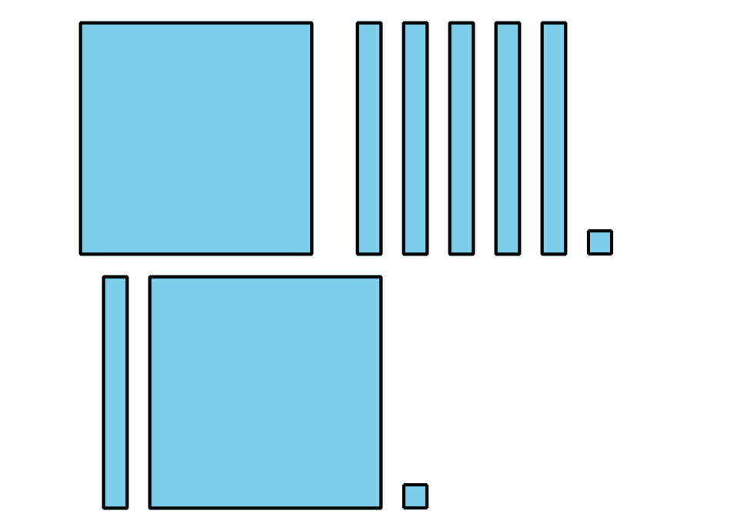

1. 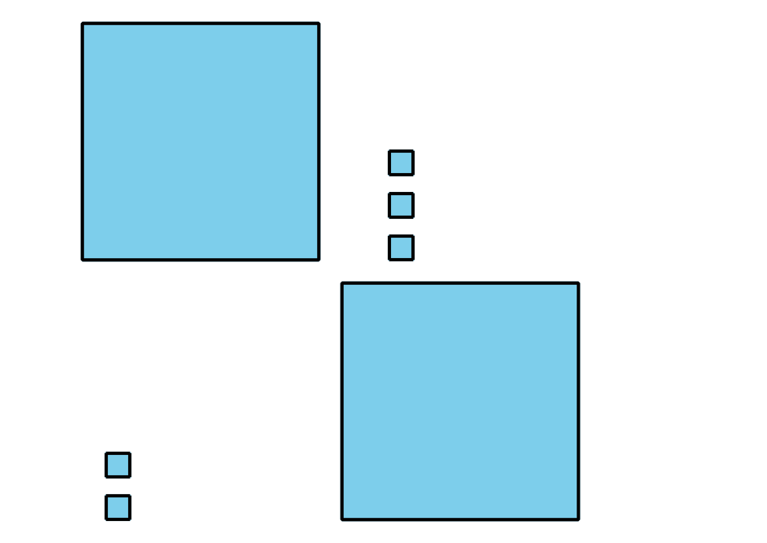

* 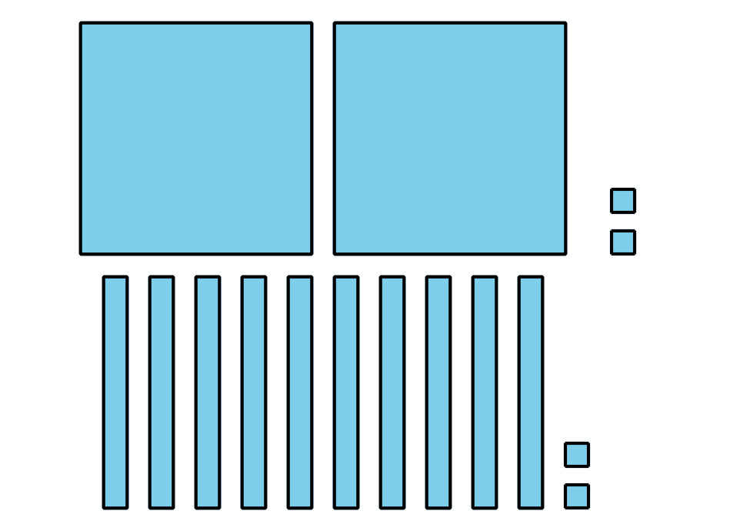

1. 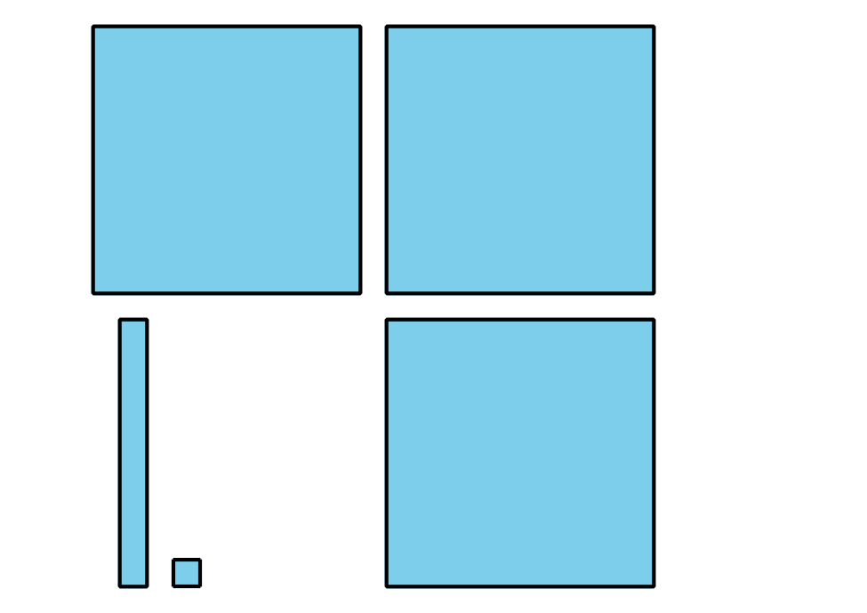

* 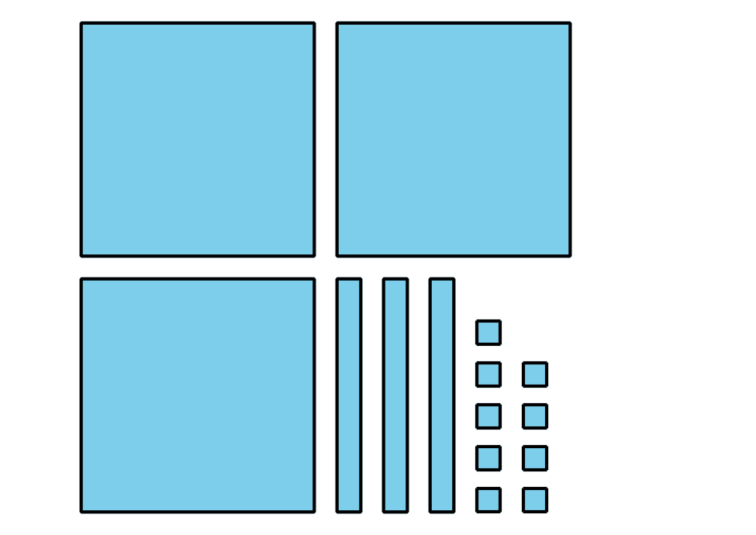

1. 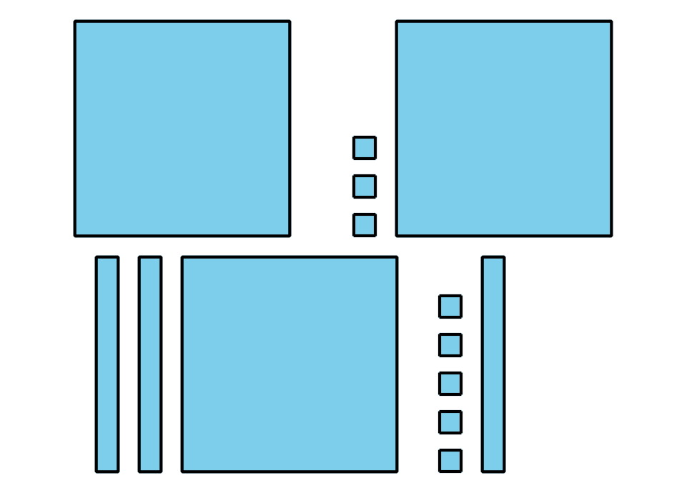

* 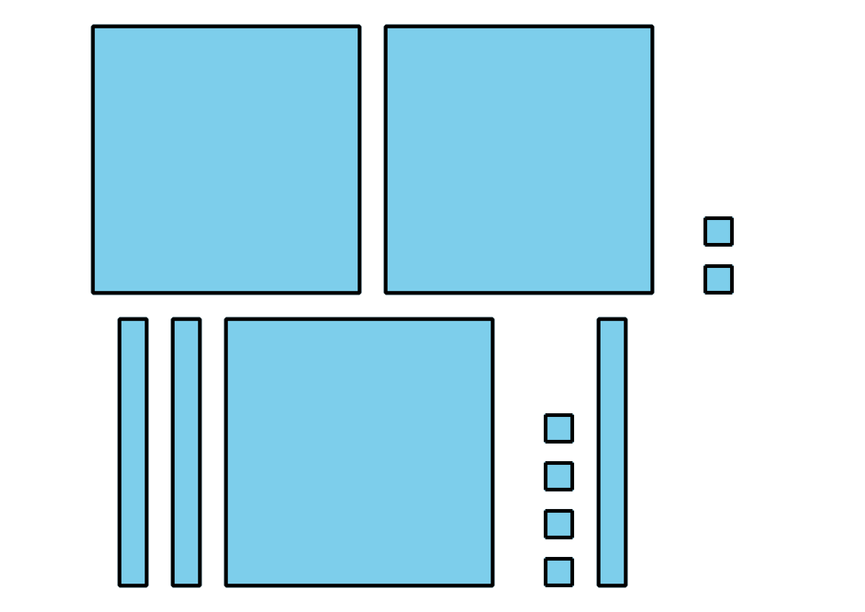

1. In the last problem, how do you know which value was greater?



© CC BY 2021 Illustrative Mathematics®