Unit 6 Lesson 13: Is It a.m. or p.m.?

WU Choral Count: Count Around the Clock (Warm up)

Student Task Statement

1 What is the Time of Day?

Student Task Statement
- Use the materials your teacher gives you to create your own representation for the hours in a day.
  - Circle and label when you eat breakfast, lunch, and dinner on the diagram.
  - Shade in when you might be sleeping.
- Fill in the blank with a.m. or p.m. to show the time of day for each activity. Explain your thinking to your partner.
  - Diego goes to baseball practice at 3:00 __________.
  - Mai eats breakfast at 7:00 __________.
  - Tyler eats lunch at 12:00 __________.
  - Elena walks her dog at 2:00 __________.
  - Han gets on the bus to go to school at 8:00 __________.
  - The second-grade class has a snack at 10:00 __________.

2 Tell Time with a.m. and p.m.

Student Task Statement
- Label each activity with a.m. or p.m.
- Draw a line to the time when the activity could take place.
- Draw the hands on the clock to show the time.
activity
do homework ____________
get ready for bed ____________
eat lunch ____________
on the way to school ____________
in bed sleeping ____________
time
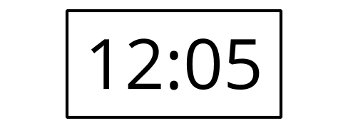
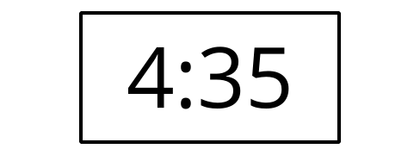
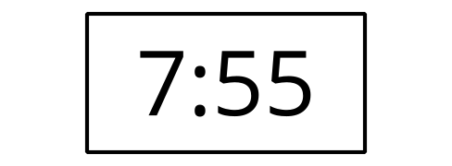
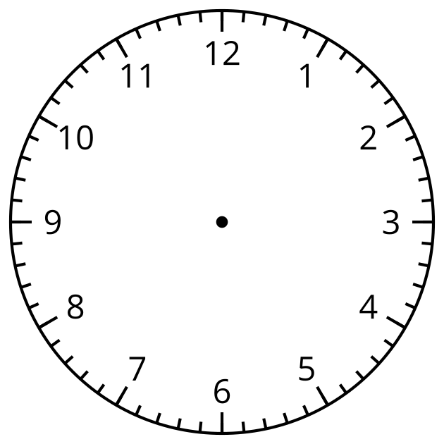
© CC BY 2021 Illustrative Mathematics®

