Lesson 14: What Makes Sense in the Problem?
- Let’s think about what numbers and questions make sense in problems.

Warm-up: Number Talk: Give and Take
Find the value of each expression mentally.
- $306+199$
- $318+297$
- $275+325$
- $275+329$

14.1: Carnival Time Number Choice
Here are three problems about time at the carnival. They are missing some information.
- In the blanks, write numbers or times that make sense for the situation in the problem assigned to you.
  - Clare waited for Tyler to ride the Ferris wheel. Tyler left at $\underset{_}{}$ and got back at $\underset{_}{}$. How long did Clare wait for Tyler?
  - When Tyler got back, he and Clare got in line to ride the roller coaster. They waited $\underset{_}{}$ minutes. At $\underset{_}{}$, they got on the ride. What time did they get in line?
  - Clare and Tyler got to the carnival at $\underset{_}{}$. After $\underset{_}{}$ minutes, they took a break to buy lemonade. What time did they take their lemonade break?
- Share the numbers and times you chose with your group and explain why they make sense.
- Work with your group to solve each problem. Be prepared to explain your reasoning.
- 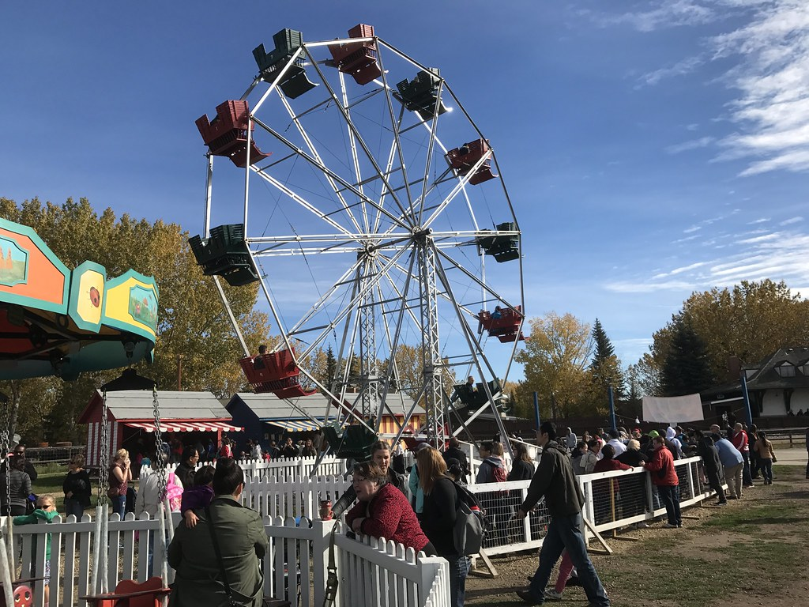

14.2: Lemonade Break
A lemonade stand at the fair makes 132 liters of lemonade a day. When Clare and Tyler stopped by the stand, there were 90 liters left.
At the end of the day, there were 56 liters of lemonade left, which the vendor put on sale in 4-liter jugs.
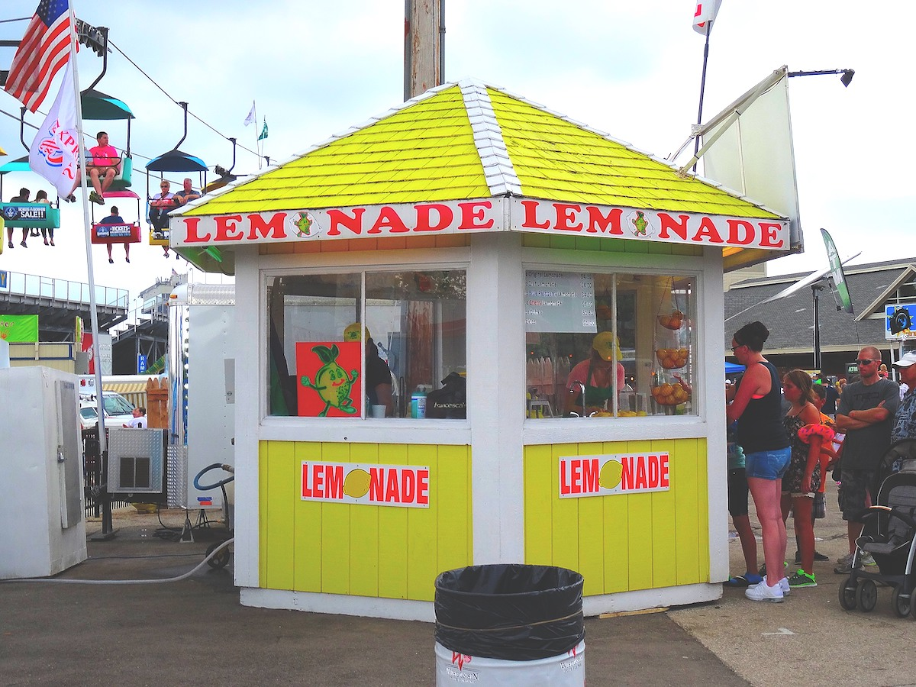
Use the information about the lemonade stand to write a question that could be answered with the mathematical work shown.
- $132−90=42$
- Question:

- 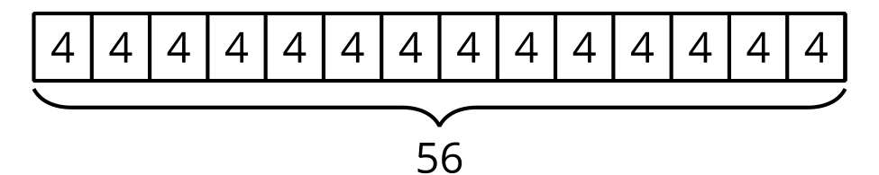
- Question:
© CC BY 2021 Illustrative Mathematics®

