Unit 4 Lesson 12: Compare Addition and Subtraction Story Problems

WU Choral Count: Count to 40 (Warm up)

Student Task Statement

1 Ducks in the Pond

Student Task Statement
There were 5 ducks in the pond.
4 more ducks came to the pond to swim.
How many ducks are in the pond now?

2 Ducks Swim Ashore

Student Task Statement
There were 9 ducks swimming in the pond.
Then 4 of the ducks waddled onto the grass.
How many ducks are swimming in the pond now?

3 Centers: Choice Time

Student Task Statement
Choose a center.
Bingo
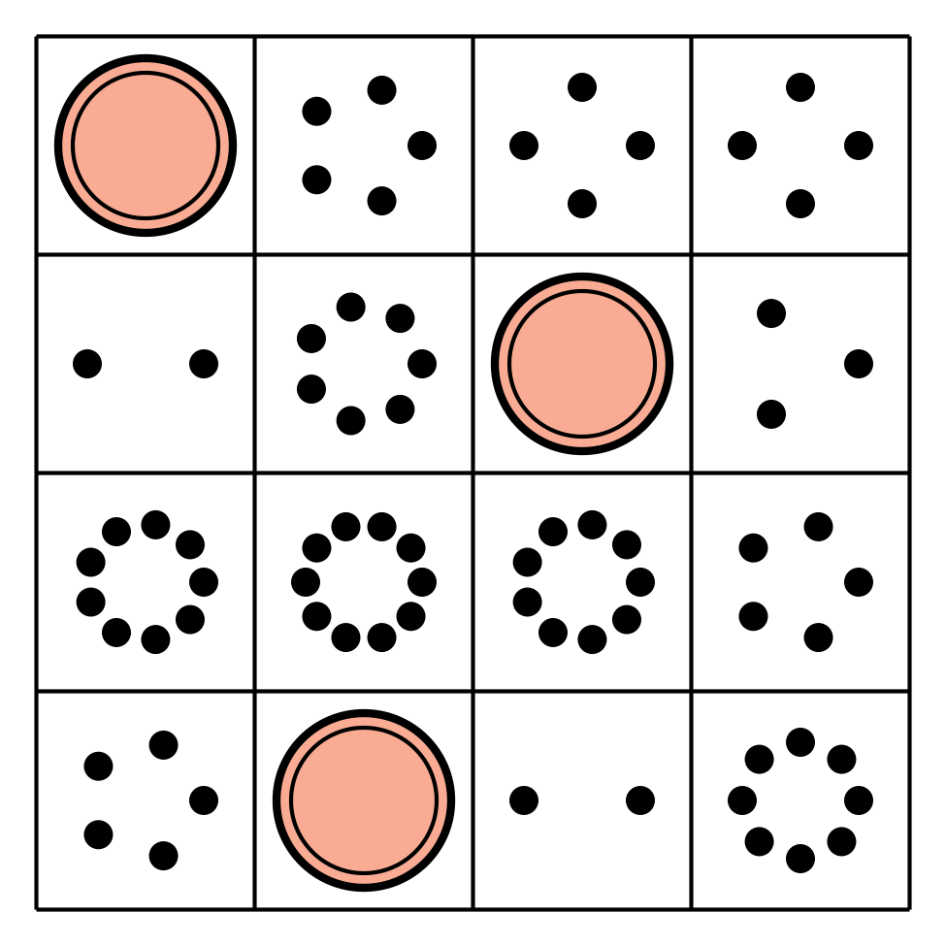
Math Fingers
Subtraction Towers
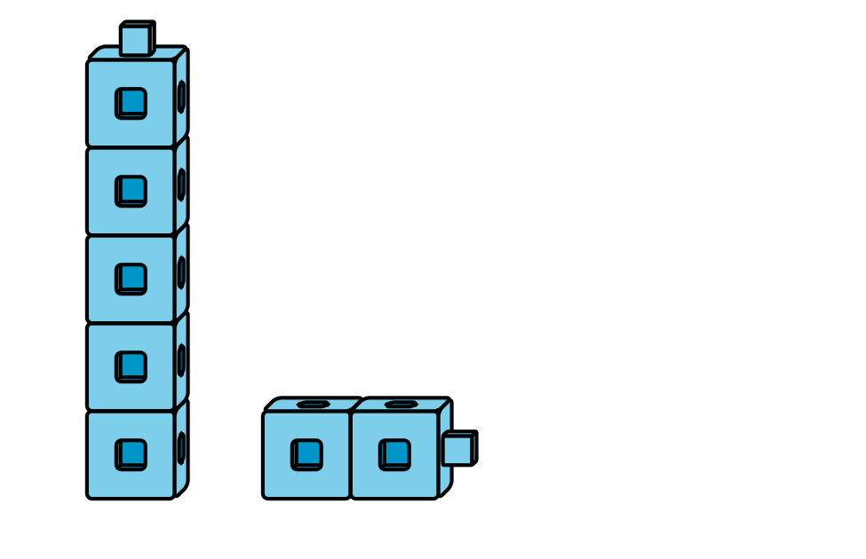
5-frames
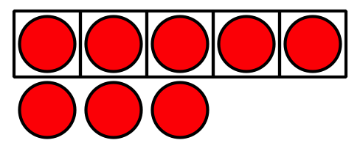
Math Stories
Counting Collections

Images for Activity Synthesis
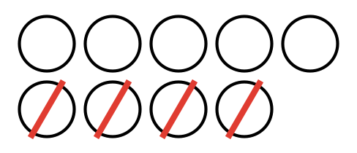
© CC BY 2021 Illustrative Mathematics®

