Lesson 11: Partial Products and the Standard Algorithm
- Let’s compare multiplication algorithms.

Warm-up: Number Talk: The Value of the Digits
Find the value of each expression mentally.
- $5×101$
- $5×102$
- $5×203$
- $5×404$

11.1: Two Algorithms to Multiply
- Here are two algorithms for finding the value of $3×713$.
- Kiran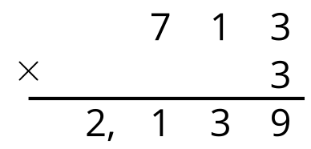
- Diego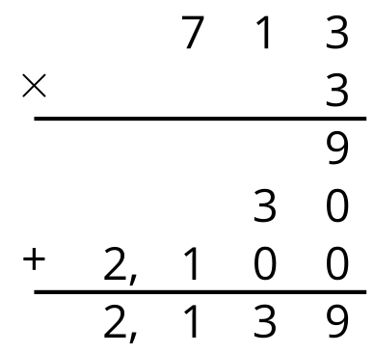
- Discuss with your partner:
  - How are Kiran’s algorithm and Diego’s algorithm alike? How are they different?
  - How do you think Kiran found the product 2,139?
- Find the value of each product.
  - $212×4$
  - $3×4,​132$

11.2: Algorithm Comparison
- Analyze the two algorithms used to find the value of $4×223$.
- Kiran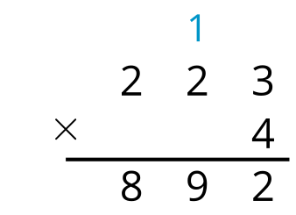
- Diego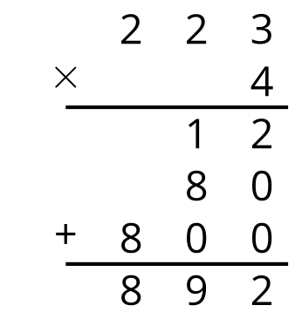
  - How are Kiran and Diego's algorithms alike? How are they different?
  - Where is the 12 in Kiran's algorithm?

  - Try using Kiran's algorithm to find the value of $512×3$.
  - Check your work using a different method.
© CC BY 2021 Illustrative Mathematics®

