Lesson 4: Does the Number Change?
- Let’s figure out how many objects there are when the objects are moved around.

Warm-up: Notice and Wonder: Lots of Dots
What do you notice?
What do you wonder?
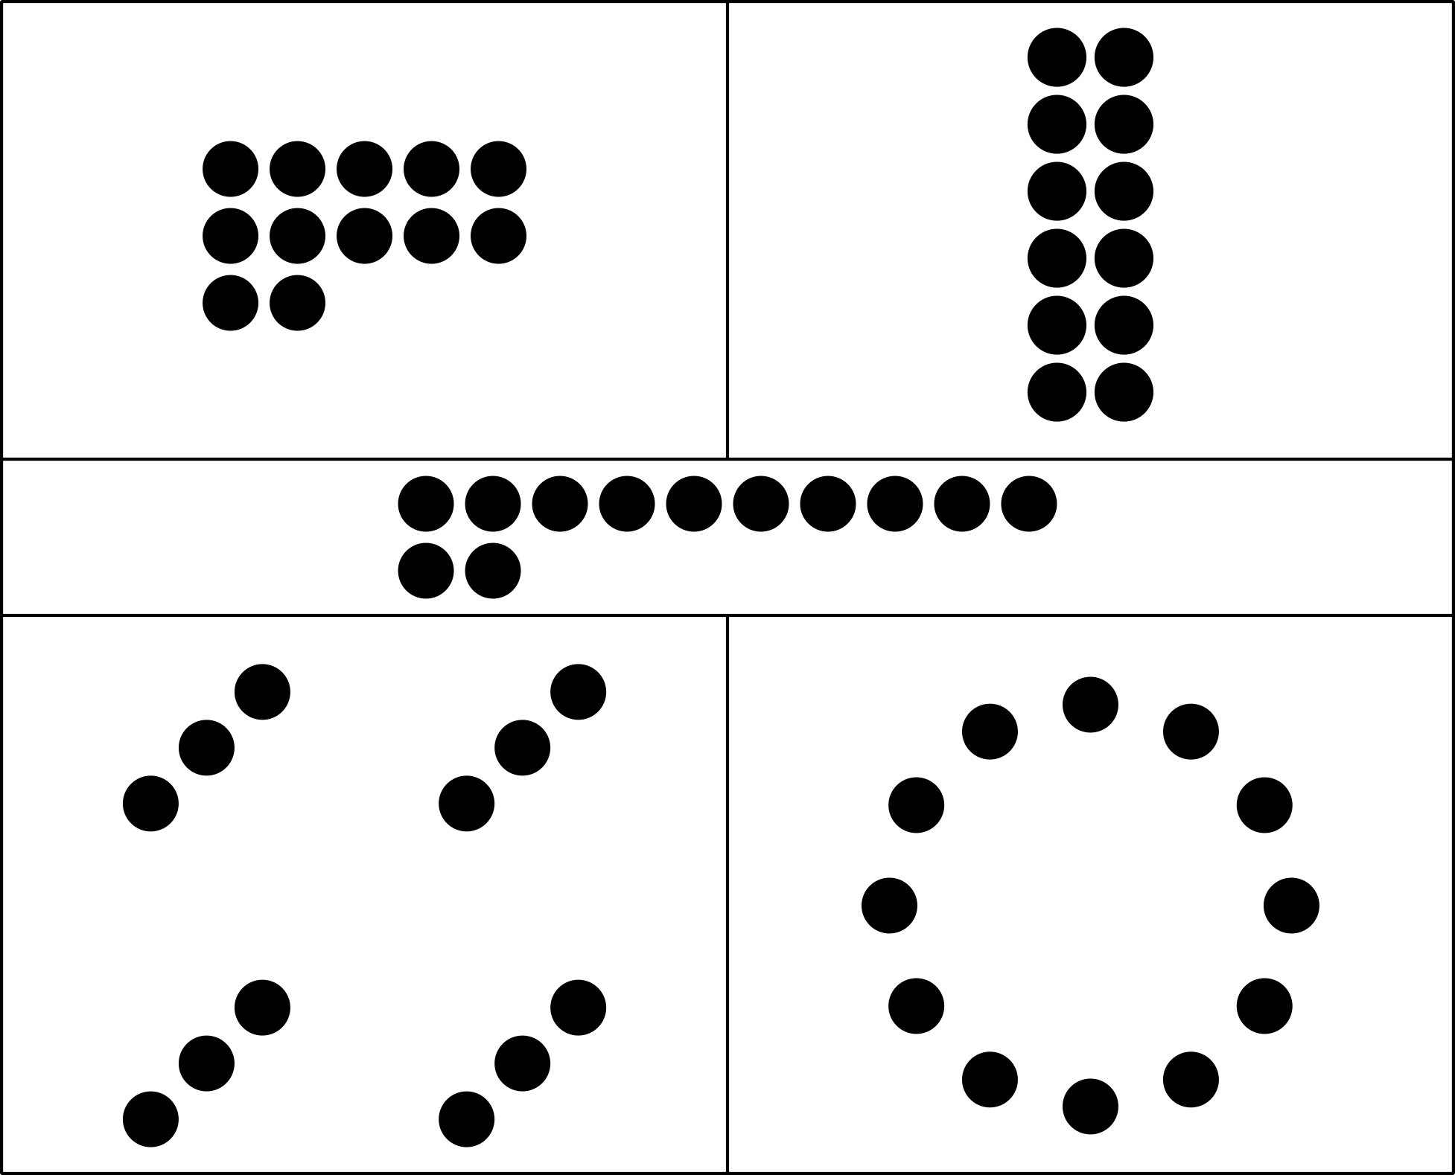

4.2: Count, Rearrange, Recount

4.3: Introduce Tower Build, Count and Build to 20
Choose a center.
Tower Build
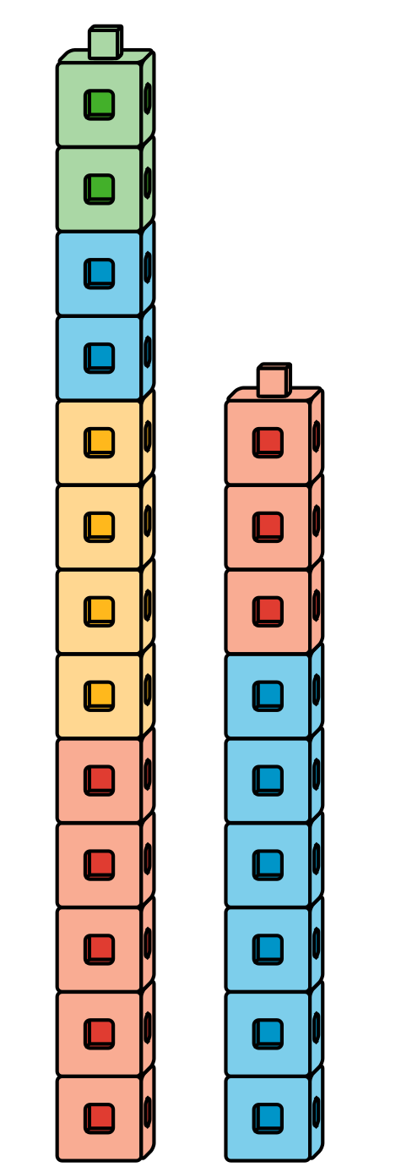
Find the Pair
Number Race
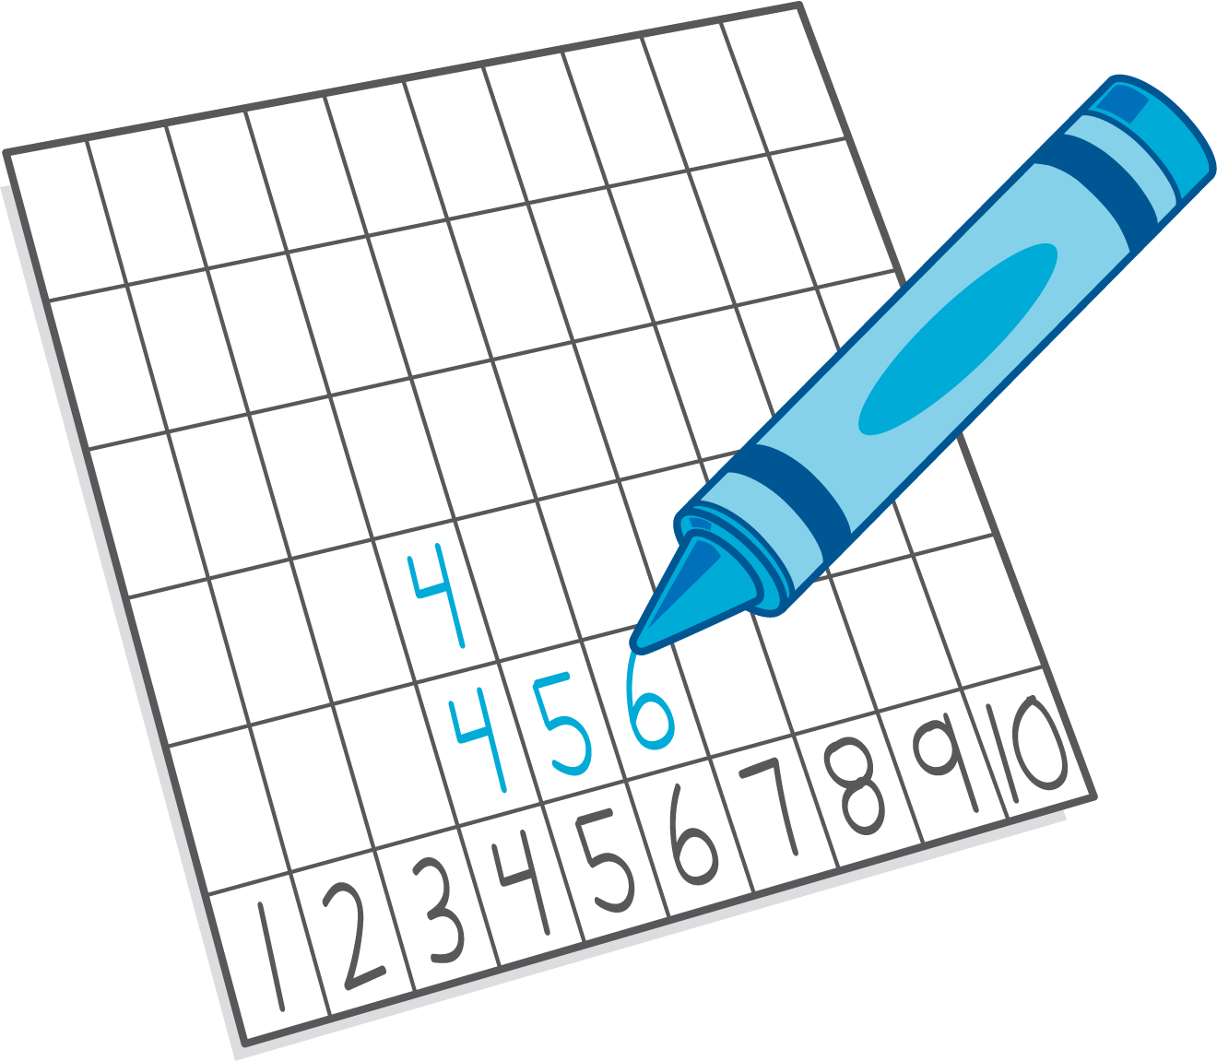
Subtraction Towers
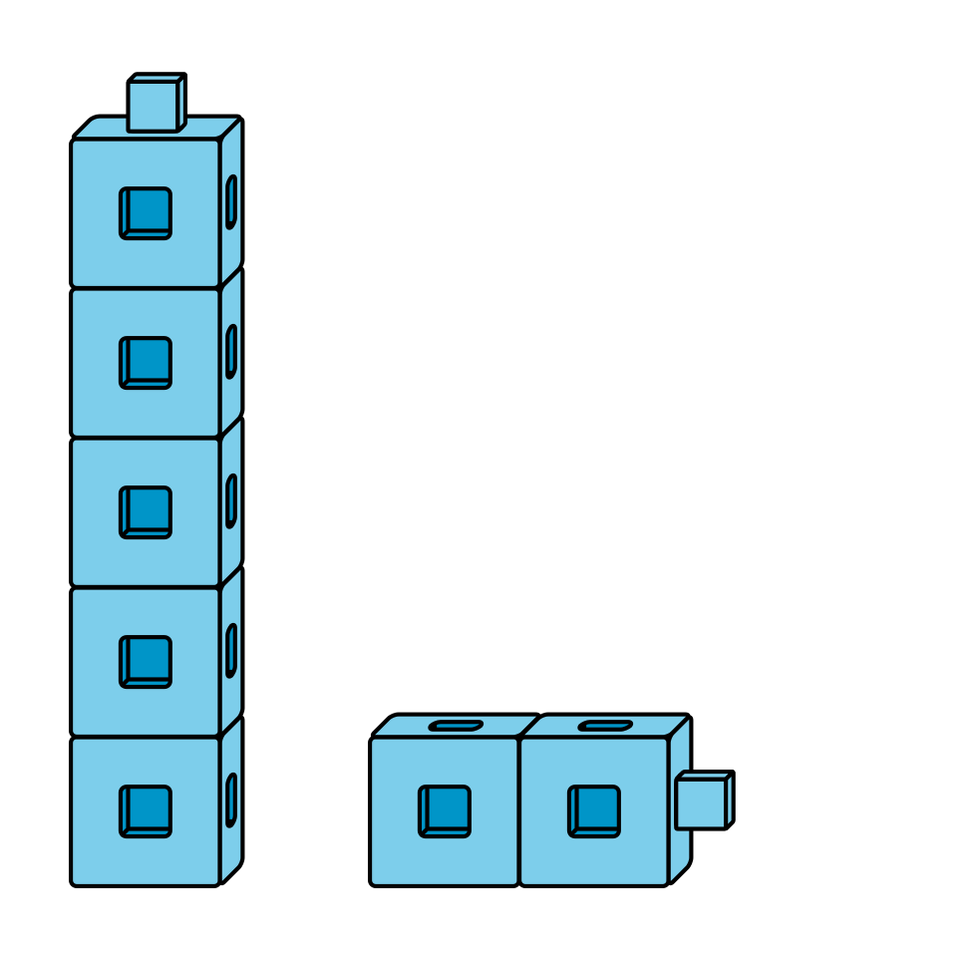
5-frames
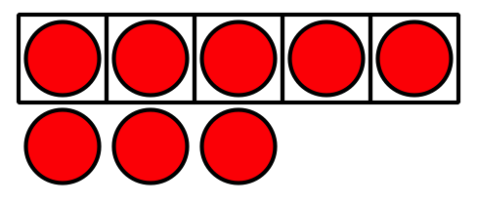

Section Summary
Section Summary
In this section, we counted groups of up to 20 objects.
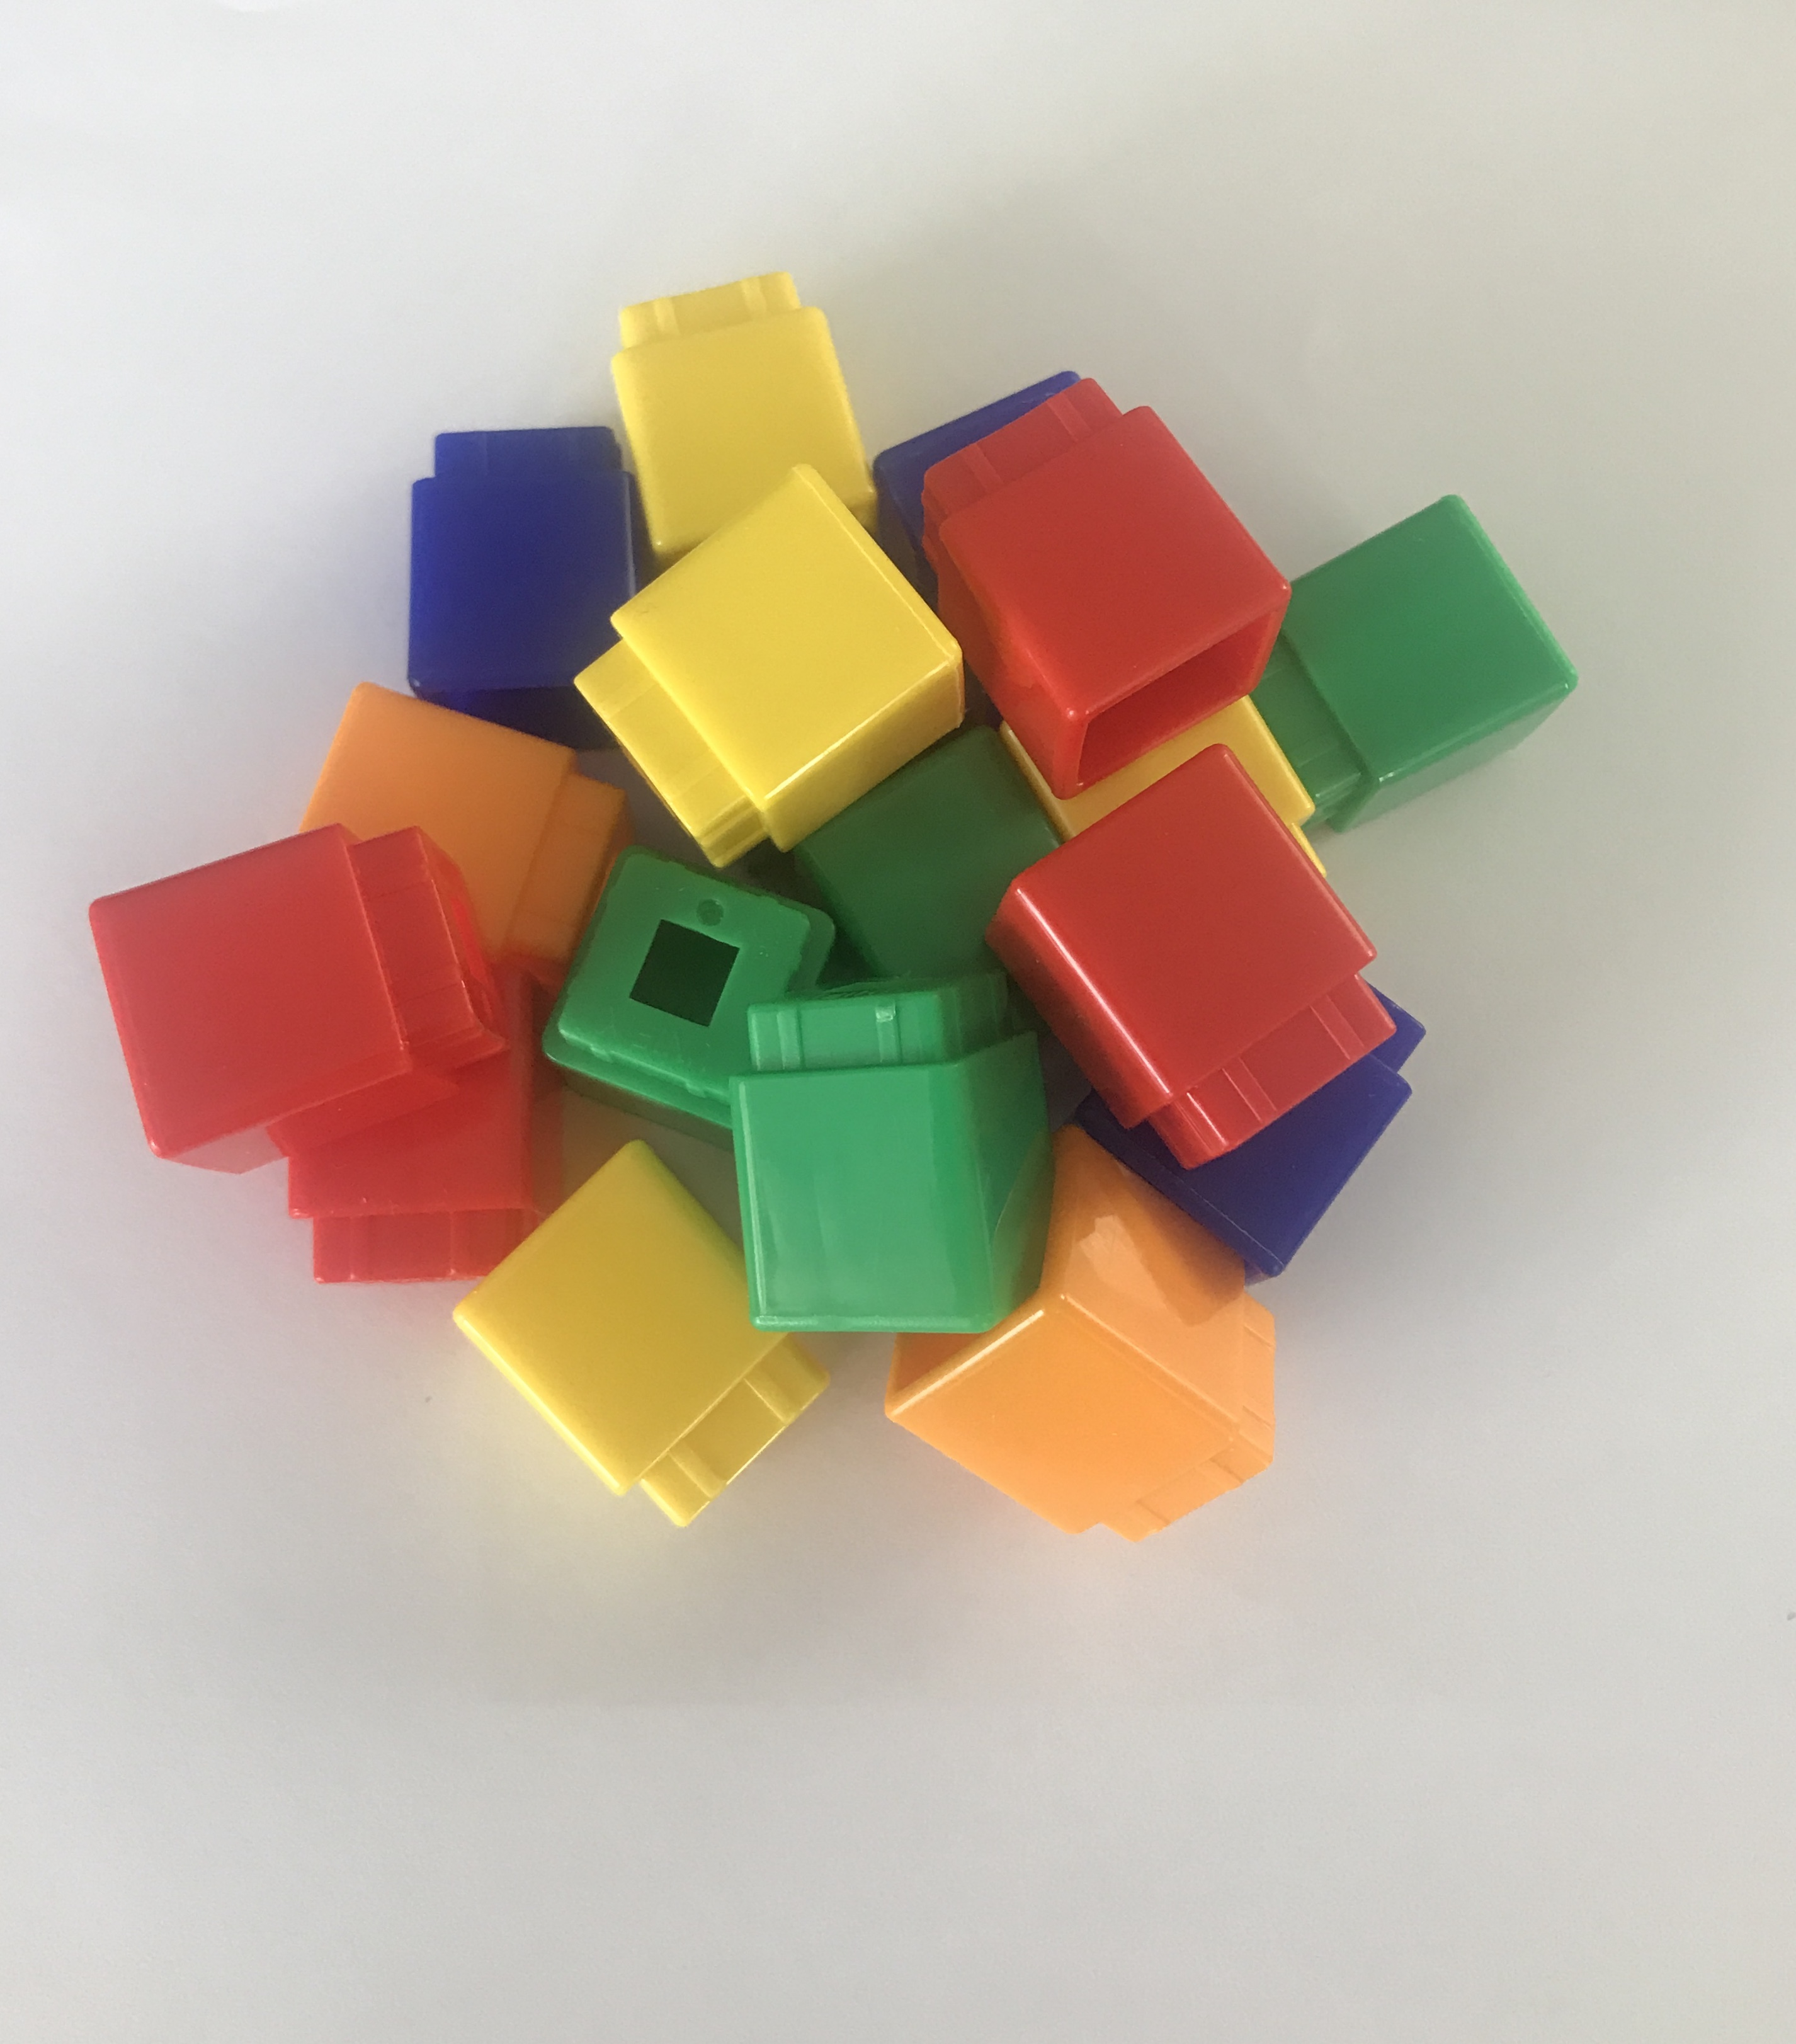
We kept track of the objects that we counted.
We used a 10-frame or a counting mat to help us.
We realized that the number of objects stayed the same even when we rearranged them.
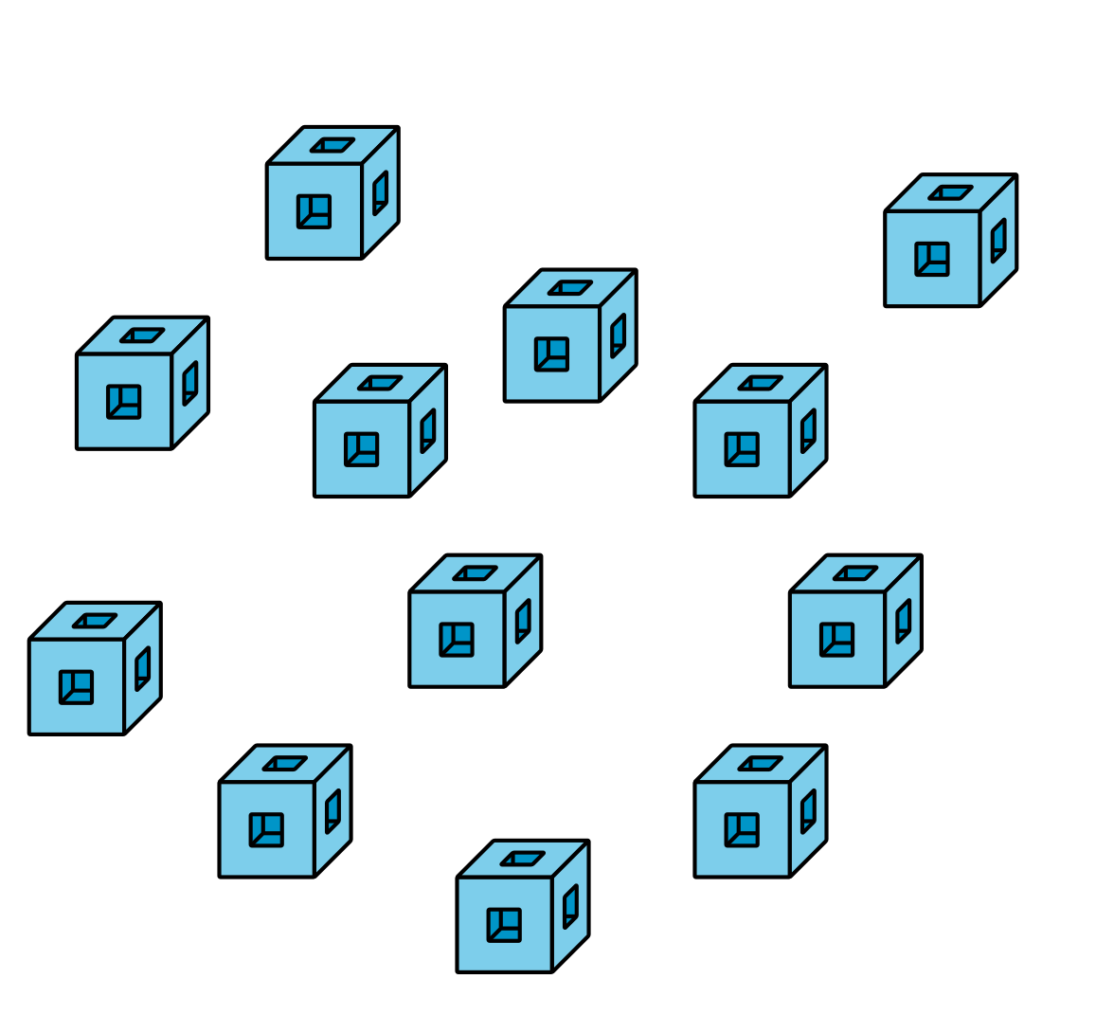
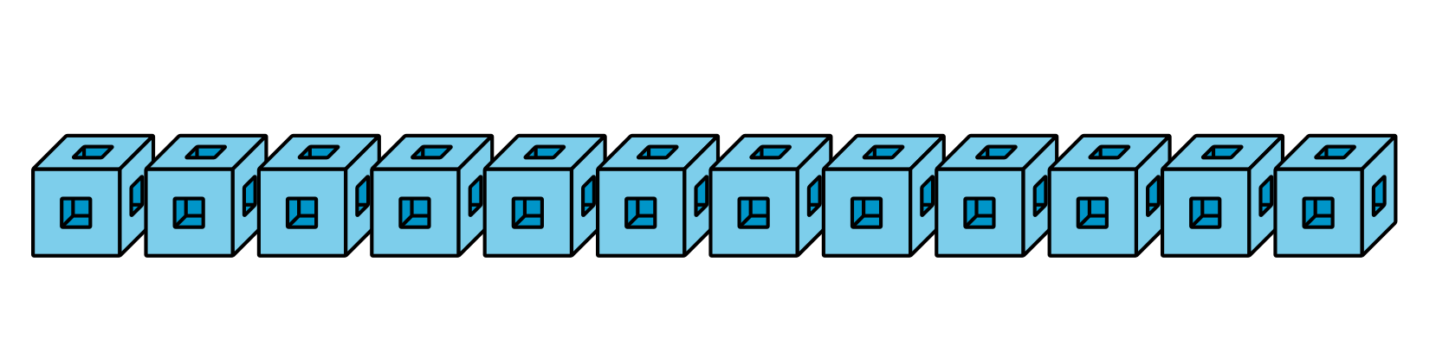
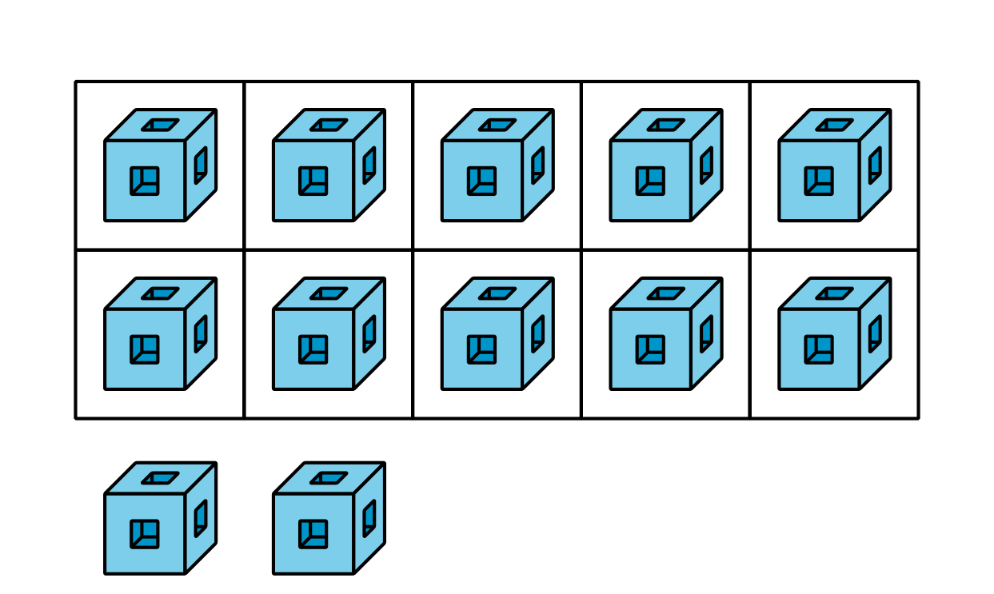
© CC BY 2021 Illustrative Mathematics®

