Lesson 22 Practice Problems
- To qualify for a loan from a bank, the total in someone’s checking and savings accounts together must be $500 or more.
  - Which of these inequalities best represents this situation?
    - $x+y<500$
    - $x+y≤500$
    - $x+y>500$
    - $x+y≥500$
  - Complete the graph so that it represents solutions to an inequality representing this situation.
  - (Be clear about whether you want to use a solid or dashed line.)
- The soccer team is selling bags of popcorn for $3 each and cups of lemonade for $2 each. To make a profit, they must collect a total of more than $120.
  - Write an inequality to represent the number of bags of popcorn sold, $p$, and the number of cups of lemonade sold, $c$, in order to make a profit.
  - Graph the solution set to the inequality on the coordinate plane.
  - Explain how we could check if the boundary is included or excluded from the solution region.
- Tickets to the aquarium are $11 for adults and $6 for children. An after-school program has a budget of $200 for a trip to the aquarium.
- If the boundary line in each graph represents the equation $11x+6y=200$, which graph represents the cost constraint in this situation?
- Tyler filled a small jar with quarters and dimes and donated it to his school's charity club. The club member receiving the jar asked, "Do you happen to know how much is in the jar?" Tyler said, "I know it's at least $8.50, but I don't know the exact amount."
  - Write an inequality to represent the relationship between the number of dimes, $d$, the number of quarters, $q$, and the dollar amount of the money in the jar.
  - Graph the solution set to the inequality and explain what a solution means in this situation.
  - Suppose Tyler knew there are 25 dimes in the jar. Write an inequality that represents how many quarters could be in the jar.
- Andre is solving the inequality $14x+3≤8x+3$. He first solves a related equation.
- $\begin{matrix}14x+3=8x+3 \\ 14x=8x \\ 8=14\end{matrix}$
- This seems strange to Andre. He thinks he probably made a mistake. What was his mistake?
- (From Unit 2, Lesson 20.)
- Kiran says, “I bought 2.5 pounds of red and yellow lentils. Both were $1.80 per pound. I spent a total of $4.05.”
  - Write a system of equations to describe the relationships between the quantities in Kiran's statement. Be sure to specify what each variable represents.
  - Elena says, “That can't be right.” Explain how Elena can tell that something is wrong with Kiran's statement.
  - Kiran says, “Oops, I meant to say I bought 2.25 pounds of lentils.” Revise your system of equations to reflect this correction.
  - Is it possible to tell for sure how many pounds of each kind of lentil Kiran might have bought? Explain your reasoning.
- (From Unit 2, Lesson 17.)
- Here is an inequality: $\text{-}7−(3x+2)<\text{-}8(x+1)$
- Select all the values of $x$ that are solutions to the inequality.
  - $x=\text{-}0.2$
  - $x=\text{-}0.1$
  - $x=0$
  - $x=0.1$
  - $x=0.2$
  - $x=0.3$
- (From Unit 2, Lesson 19.)
- Here is a graph of the equation $6x+2y=\text{-}8$.
- 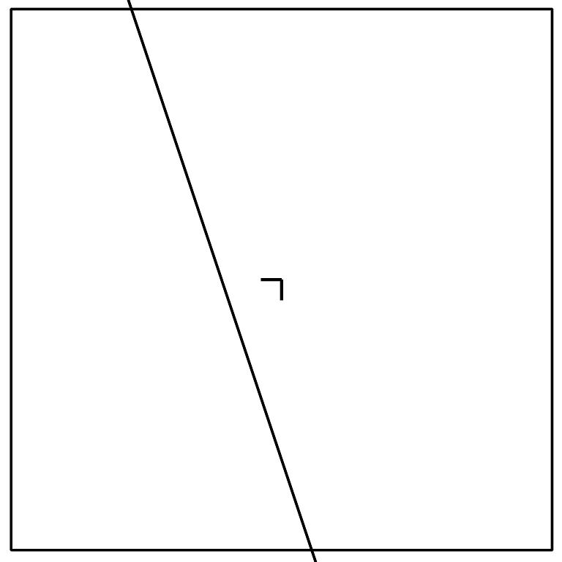
  - Are the points $(1.5,\text{-}4)$ and $(0,\text{-}4)$ solutions to the equation? Explain or show how you know.
  - Check if each of these points is a solution to the inequality $6x+2y≤\text{-}8$:
- $(\text{-}2,2)$ | - $(4,\text{-}2)$ | - $(0,0)$ | - $(\text{-}4,\text{-}4)$

  - Shade the solutions to the inequality.
  - Are the points on the line included in the solution region? Explain how you know.
- (From Unit 2, Lesson 21.)
© CC BY 2019 by Illustrative Mathematics®

