Teacher Presentation Materials

Unit 5 Lesson 6: Symmetry in Equations

1 Notice and Wonder: Same and Different (Warm up)

Student Task Statement
What do you notice? What do you wonder?

A. Graph of $g(x)=x^{5}+x$
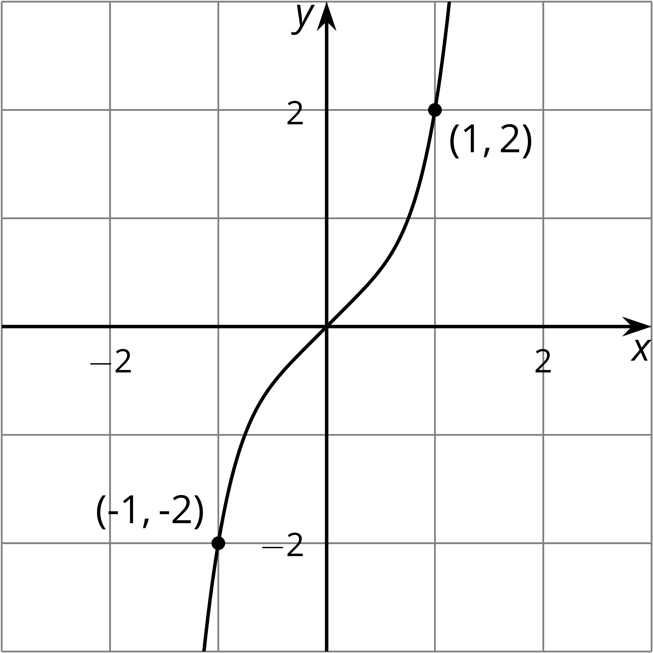

B. Graph of $\text{-}g(x)=\text{-}(x^{5}+x)$
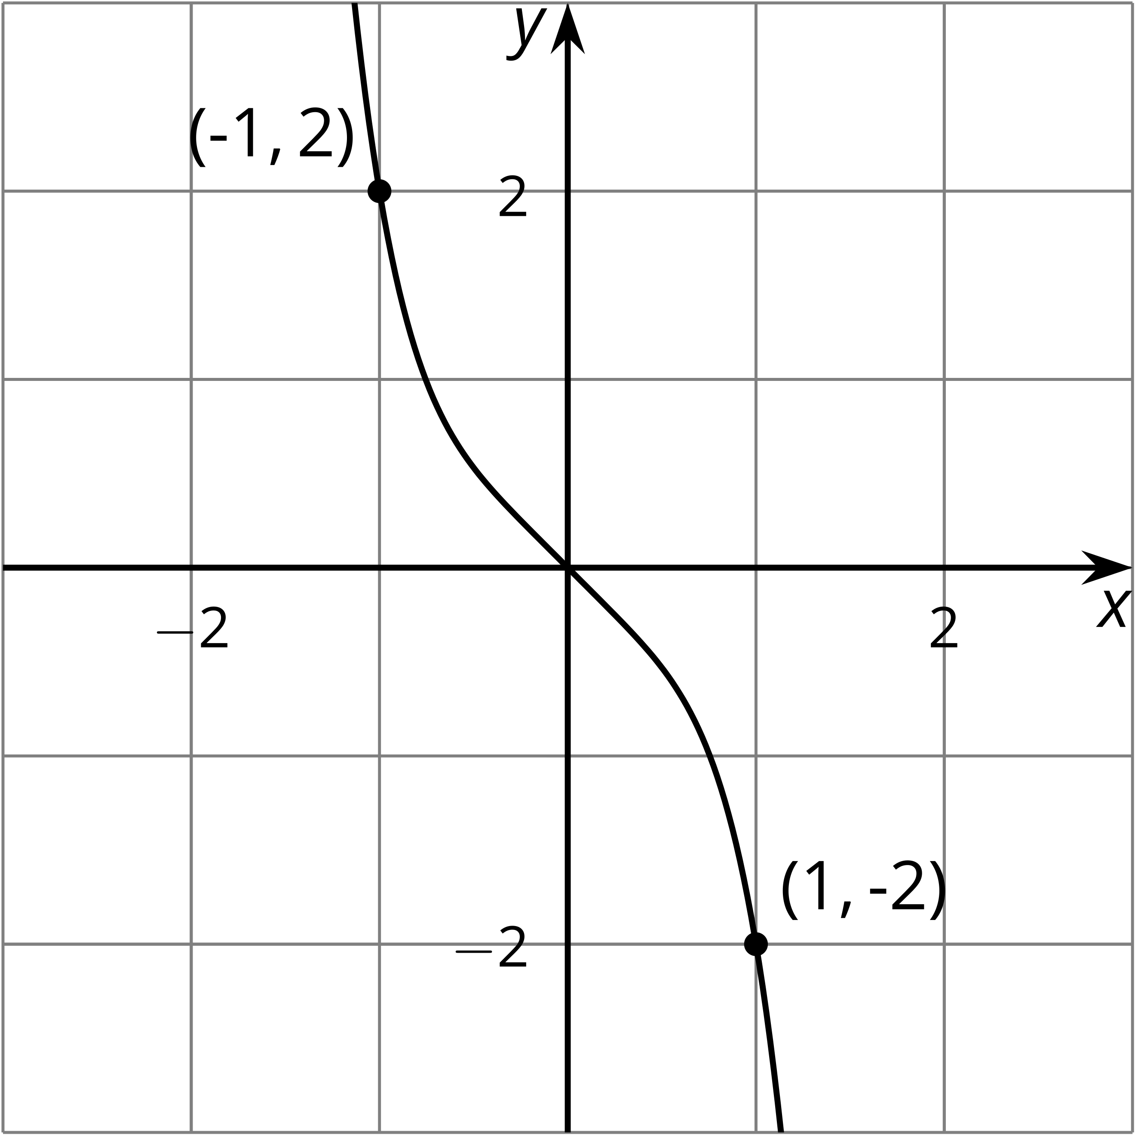

C. Graph of $g(\text{-}x)=(\text{-}x)^{5}+(\text{-}x)$
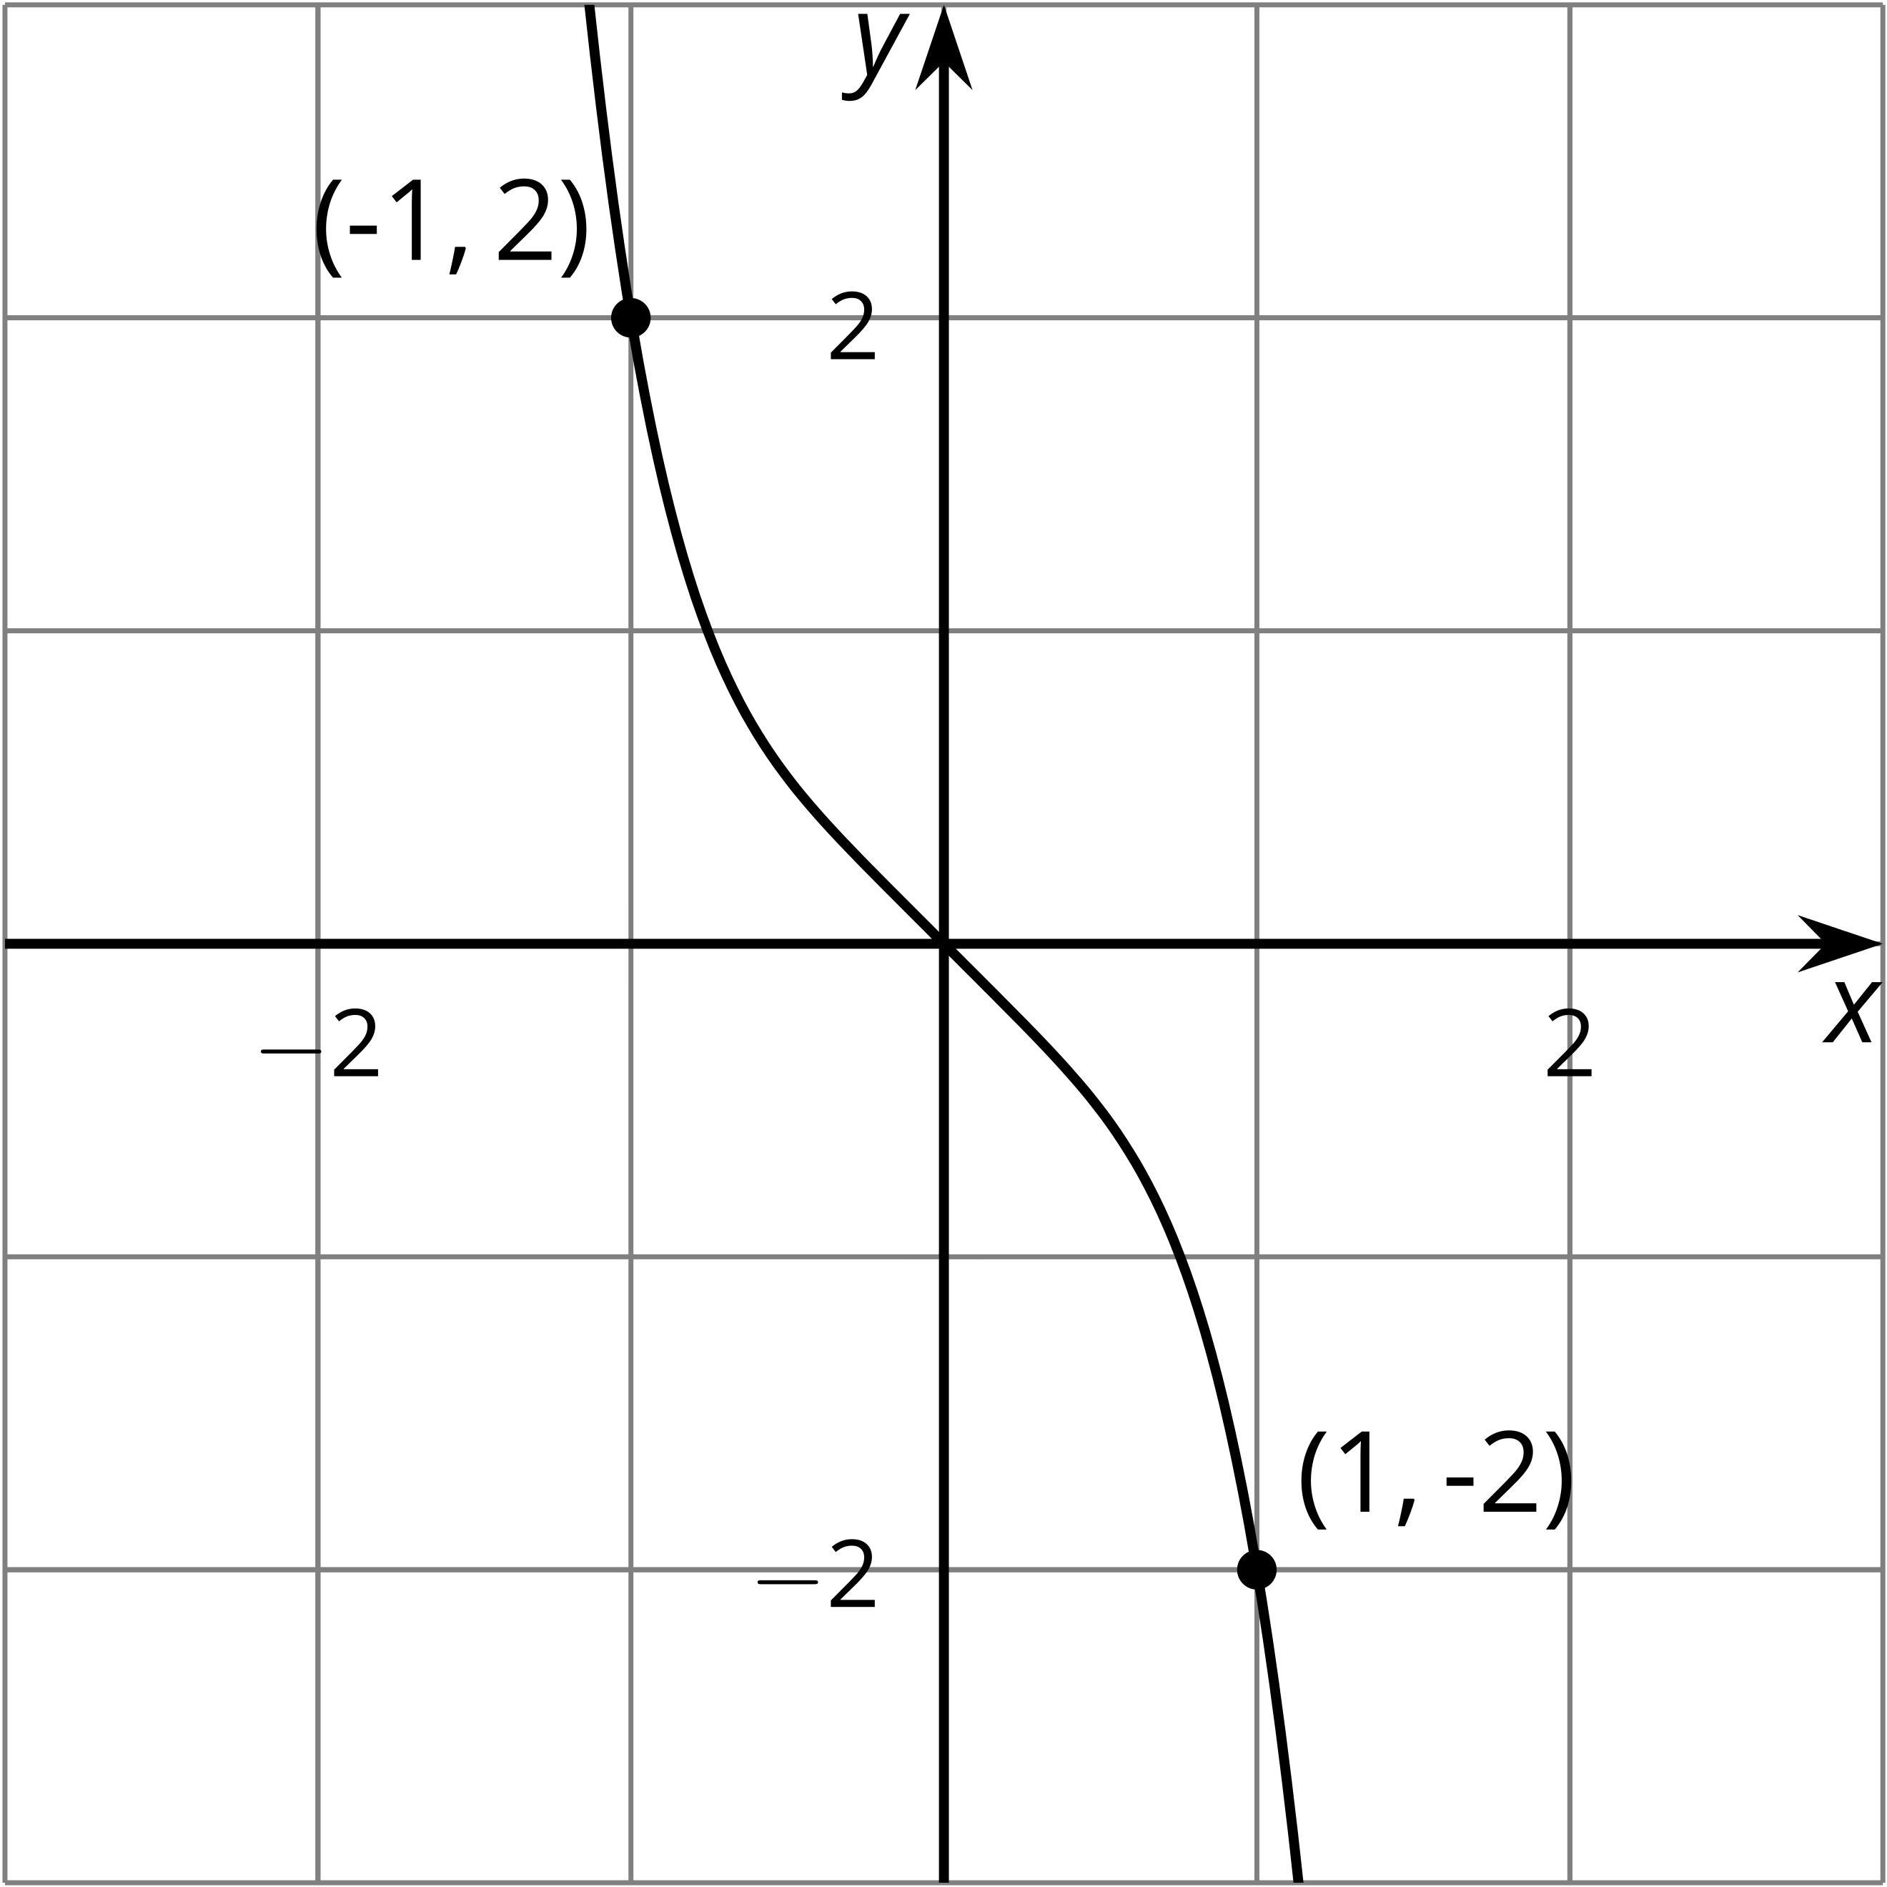

D. Graph of $\text{-}g(\text{-}x)=\text{-}\left((\text{-}x)^{5}+(\text{-}x)\right)$
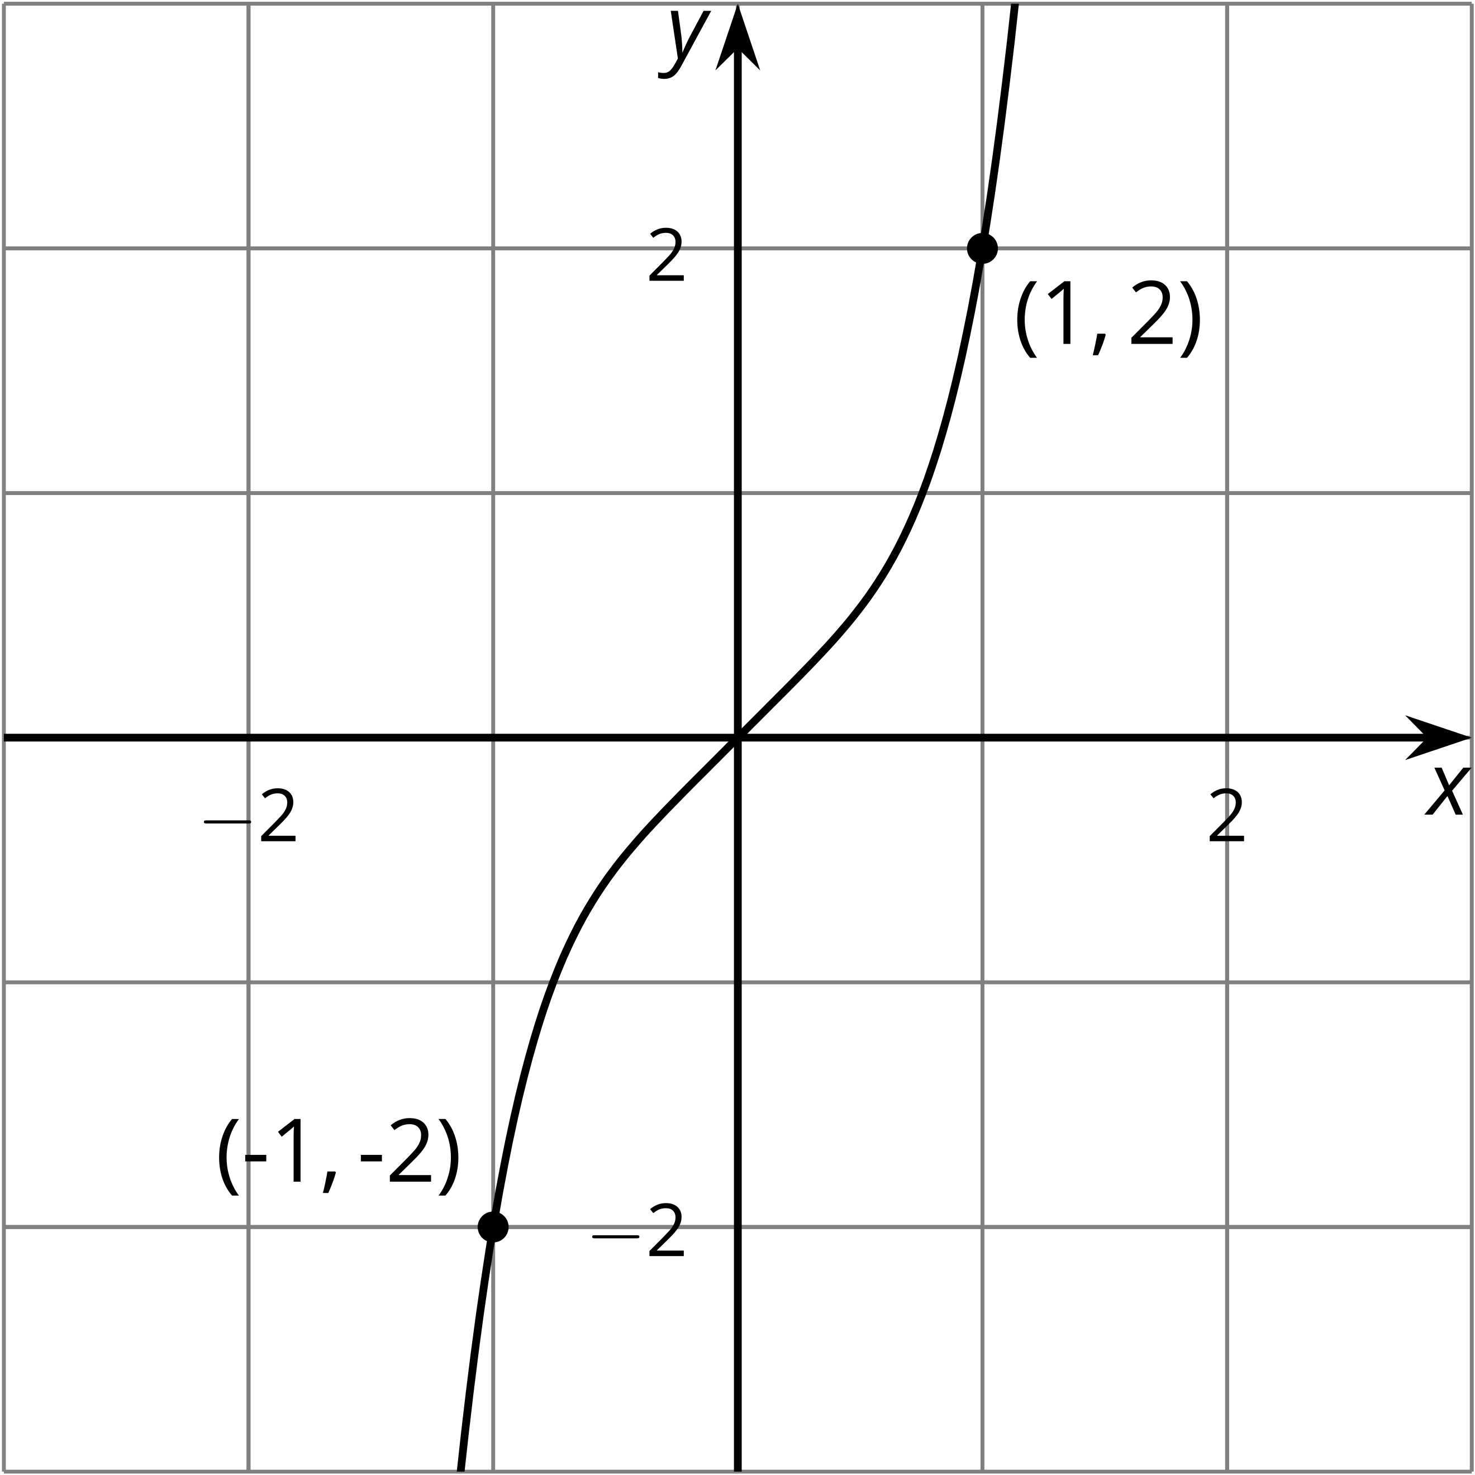

2 Finish the Graph

Student Task Statement
Here is a graph of $y=f(x)$ for $\text{-}5≤x≤0$. Draw the graph for $0≤x≤5$ and be prepared to explain your reasoning if:
- $f$ is even
- 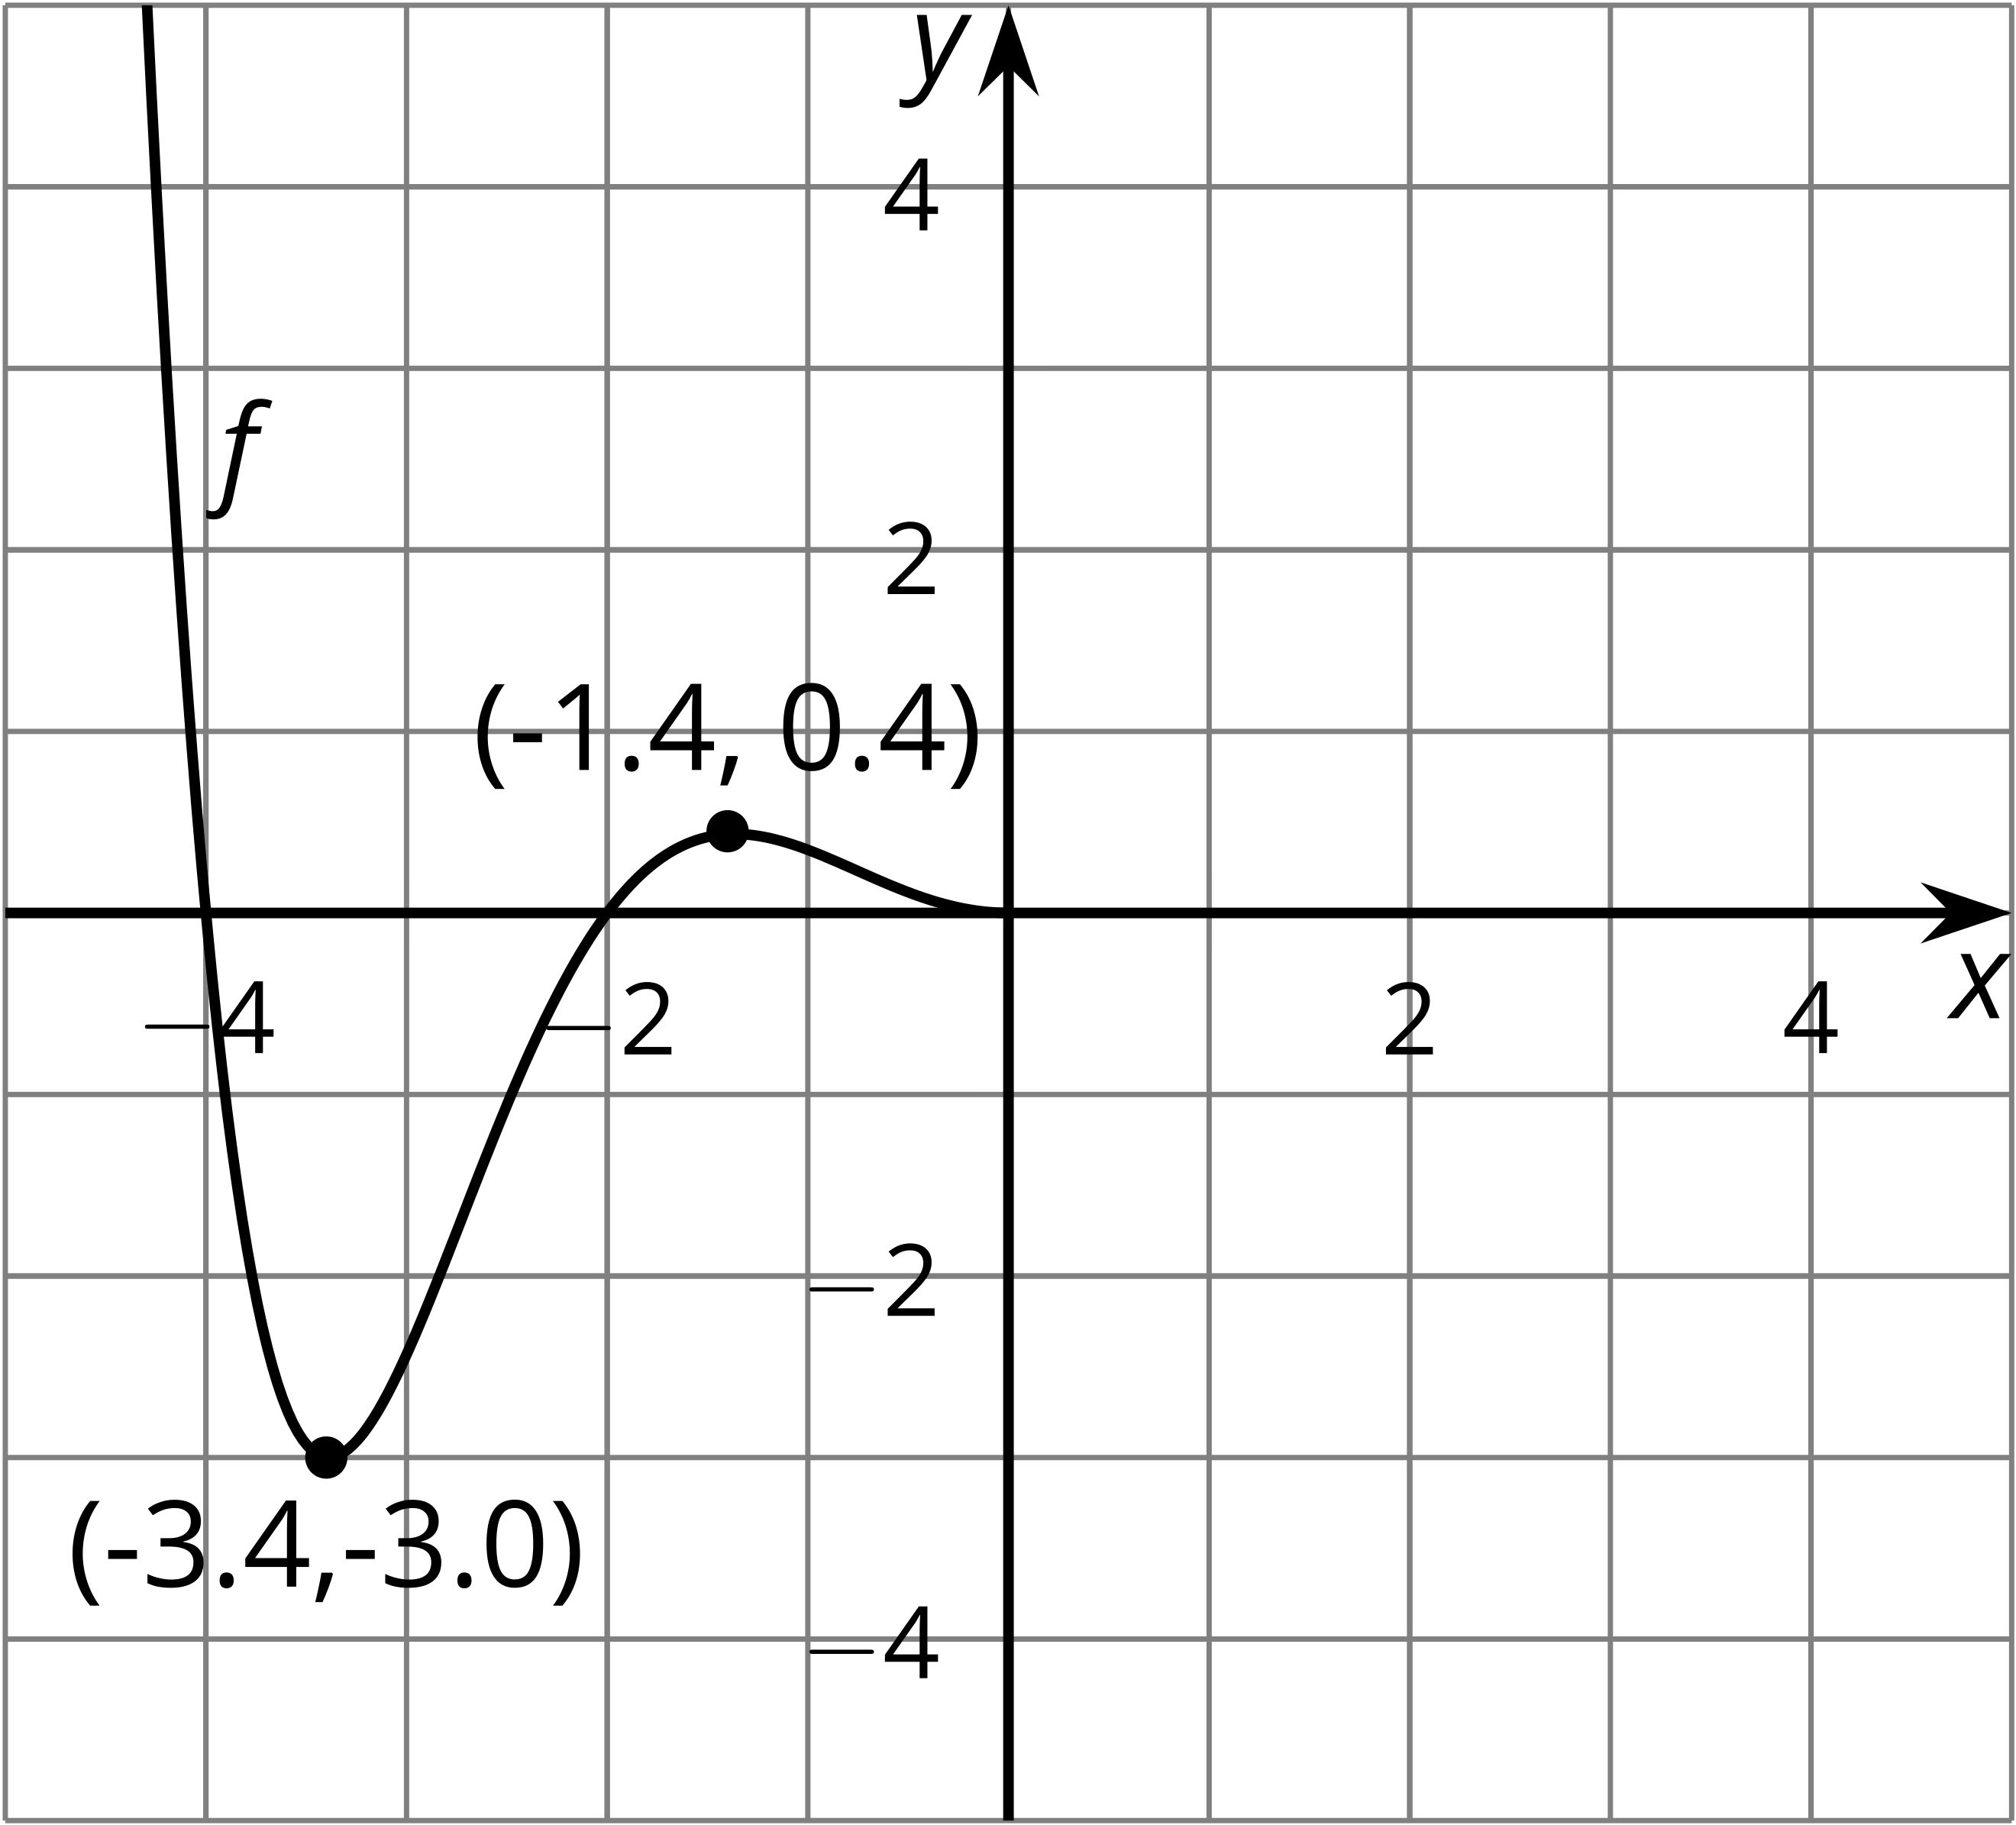
- $f$ is odd
- 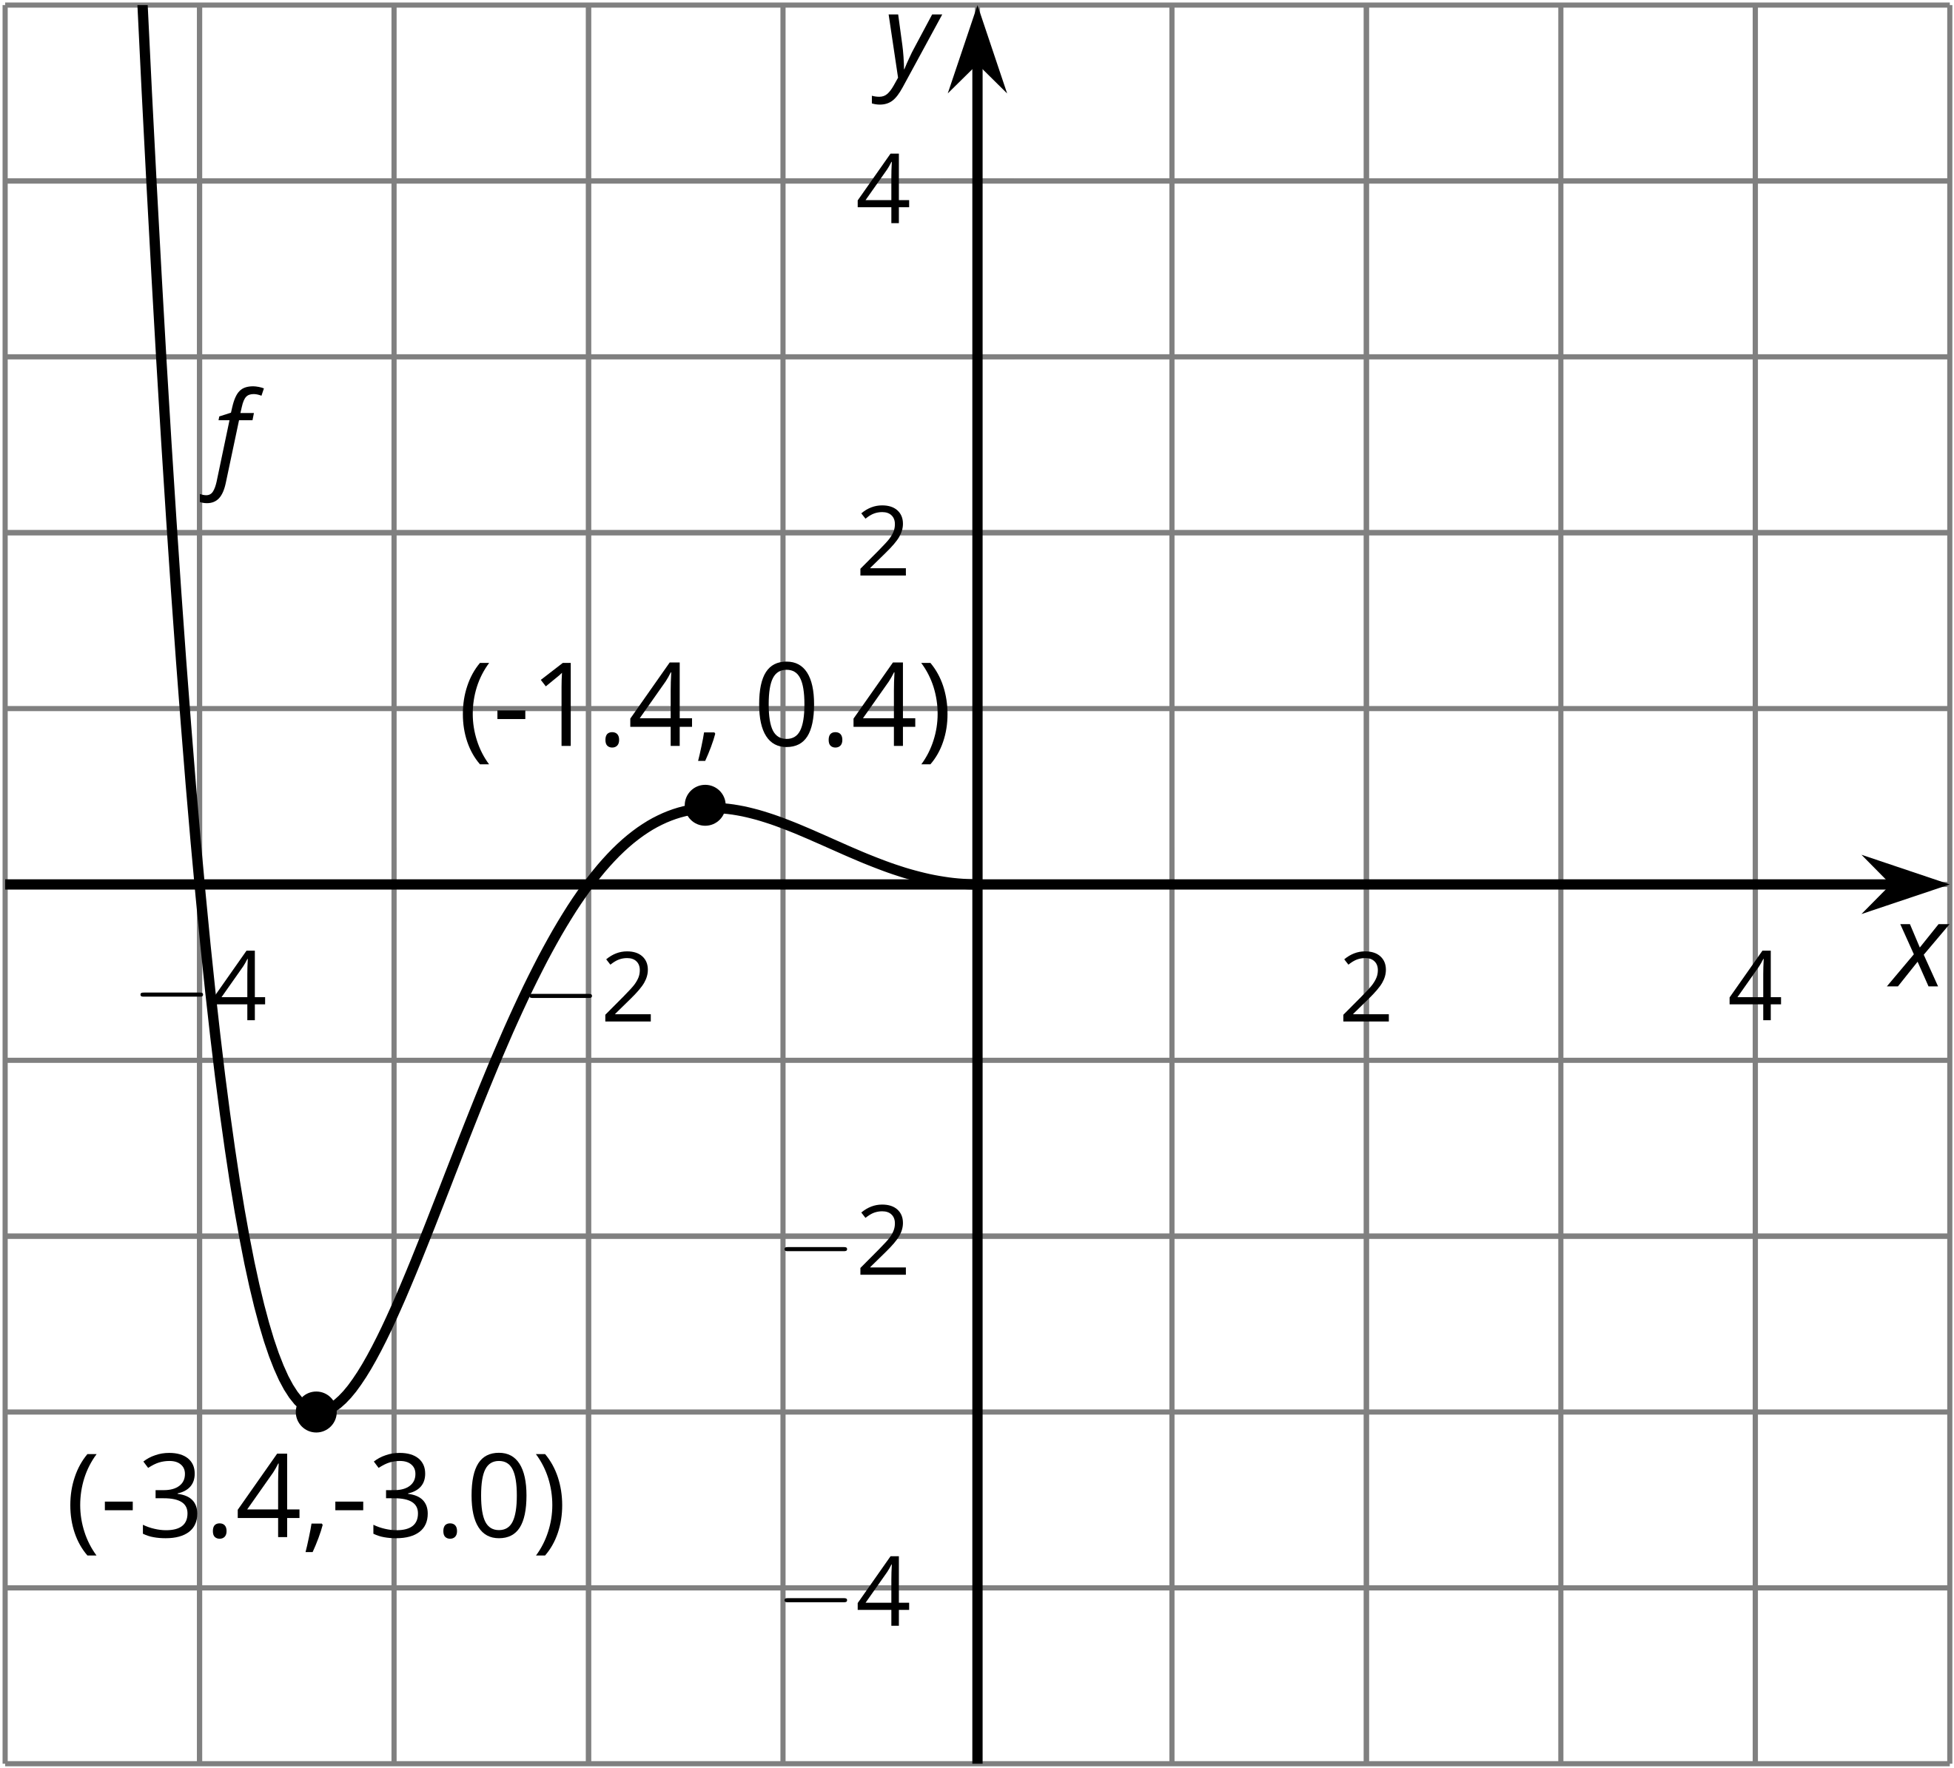
- $f$ is neither even nor odd
- 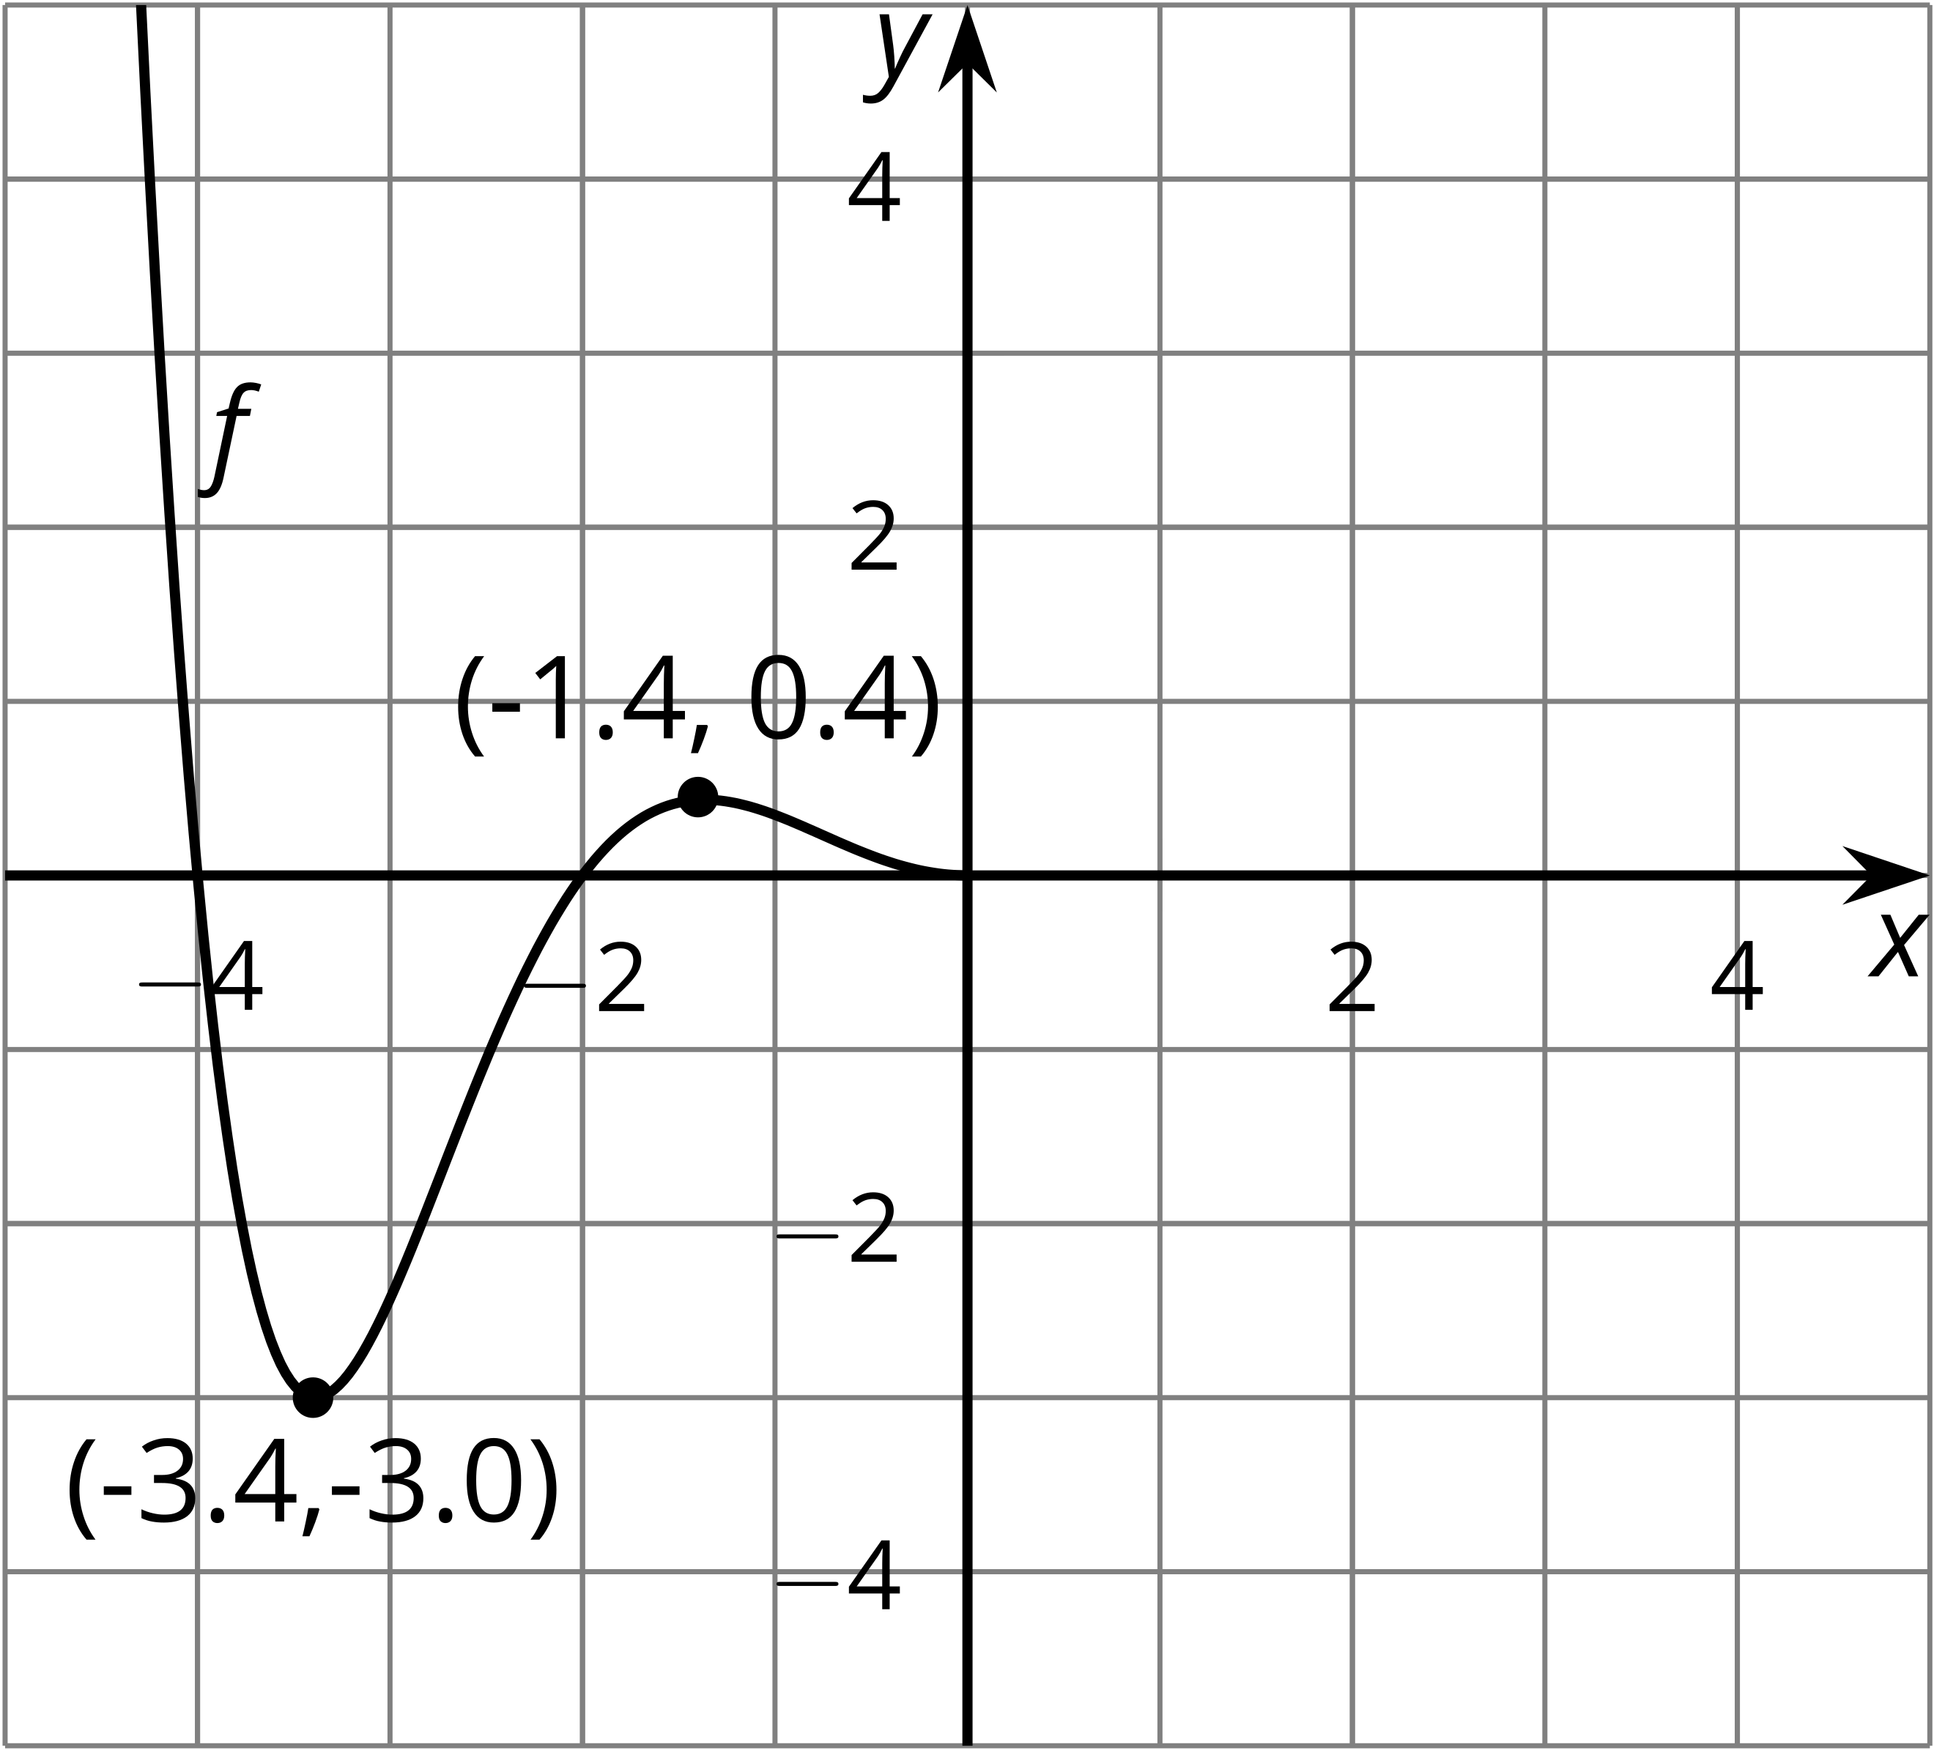

3 Odd and Even Equations

Student Task Statement
Take turns with your partner to decide if the function is even, odd, or neither. If it’s your turn, explain to your partner how you decided. If it’s your partner’s turn, listen carefully to their reasons and decide if you agree. If you disagree, discuss your thinking and work to reach an agreement.
- $f(x)=3x^{4}−2x^{2}+1$
- $g(x)=x^{3}−x$
- $h(x)=(x^{2}−1)(x^{2}−4)$
- $j(x)=2^{x}+2^{\text{-}x}$
- $k(x)=(x^{3}−1)x$
- $m(x)=(x−0.9)x(x+1.1)$
- $n(x)=x(x^{2}−1)(x^{2}−4)$
- $p(x)=(x^{2}+4)(x^{2}−3)$
- $q(x)=\frac{1}{x}+x$
- $r(x)=\frac{1}{x}−x$
© CC BY 2019 by Illustrative Mathematics

