Lesson 10: Looking at Rates of Change
Let's calculate average rates of change for exponential functions.

10.1: Falling Prices
Let $p$ be the function that gives the cost $p\left(t\right)$, in dollars, of producing 1 watt of solar energy $t$ years after 1977. Here is a table showing the values of $p$ from 1977 to 1987.
$t$ | $p\left(t\right)$
0 | 80
1 | 60
2 | 45
3 | 33.75
4 | 25.31
5 | 18.98
6 | 14.24
7 | 10.68
8 | 8.01
9 | 6.01
10 | 4.51
Which expression best represents the average rate of change in solar cost between 1977 and 1987?
- $p\left(10\right)−p\left(0\right)$
- $p\left(10\right)$
- $\frac{p\left(10\right)−p\left(0\right)}{10−0}$
- $\frac{p\left(10\right)}{p\left(0\right)}$

10.2: Coffee Shops
Here are a table and a graph that show the number of coffee shops worldwide that a company had in its first 10 years, between 1987 and 1997. The growth in the number of stores was roughly exponential.
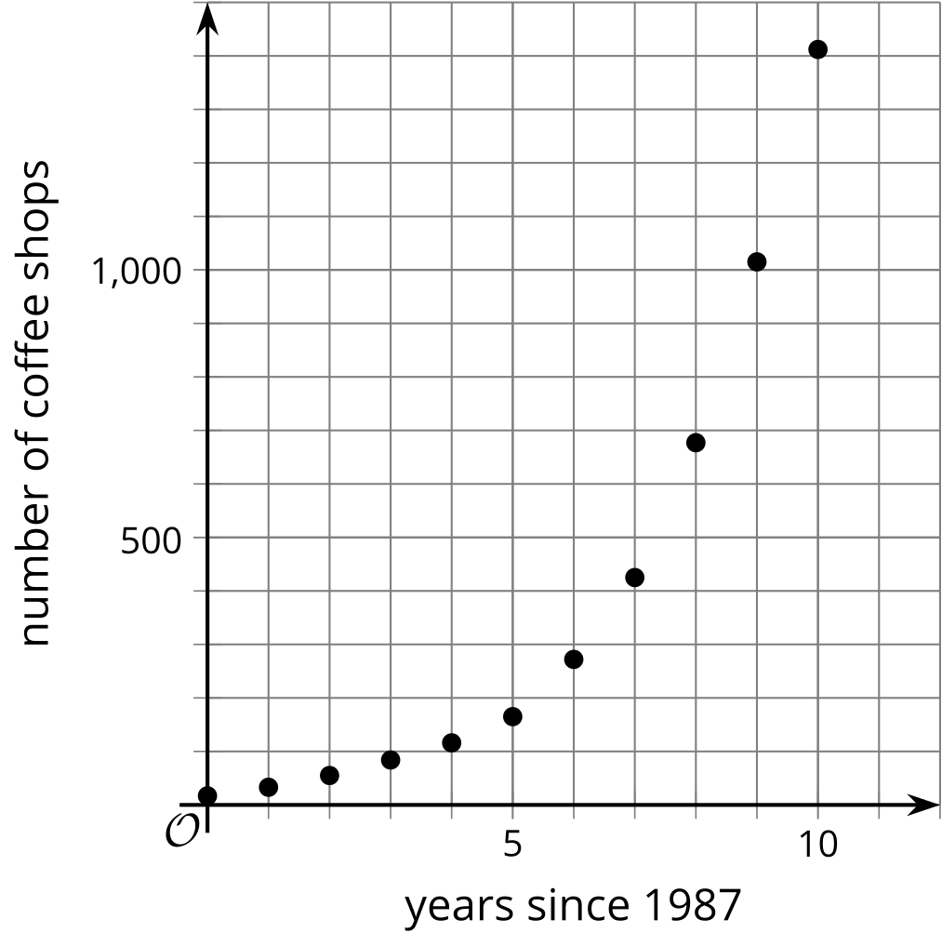
year | number of stores
1987 | 17
1988 | 33
1989 | 55
1990 | 84
1991 | 116
1992 | 165
1993 | 272
1994 | 425
1995 | 677
1996 | 1,015
1997 | 1,412
- Find the average rate of change for each period of time. Show your reasoning.
  - 1987 and 1990
  - 1987 and 1993
  - 1987 and 1997
- Make some observations about the rates of change you calculated. What do these average rates tell us about how the company was growing during this time period?
- Use the graph to support your answers to these questions. How well do the average rates of change describe the growth of the company in:
  - the first 3 years?
  - the first 6 years?
  - the entire 10 years?
- Let $f$ be the function so that$f\left(t\right)$ represents the number of stores $t$ years since 1987. The value of $f\left(20\right)$ is 15,011. Find $\frac{f\left(20\right)−f\left(10\right)}{20−10}$ and say what it tells us about the change in the number of stores.

10.3: Revisiting Cost of Solar Cells
Here is a graph you saw in an earlier lesson. It represents the exponential function $p$, which models the cost $p\left(t\right)$, in dollars, of producing 1 watt of solar energy, from 1977 to 1988 where $t$ is years since 1977.
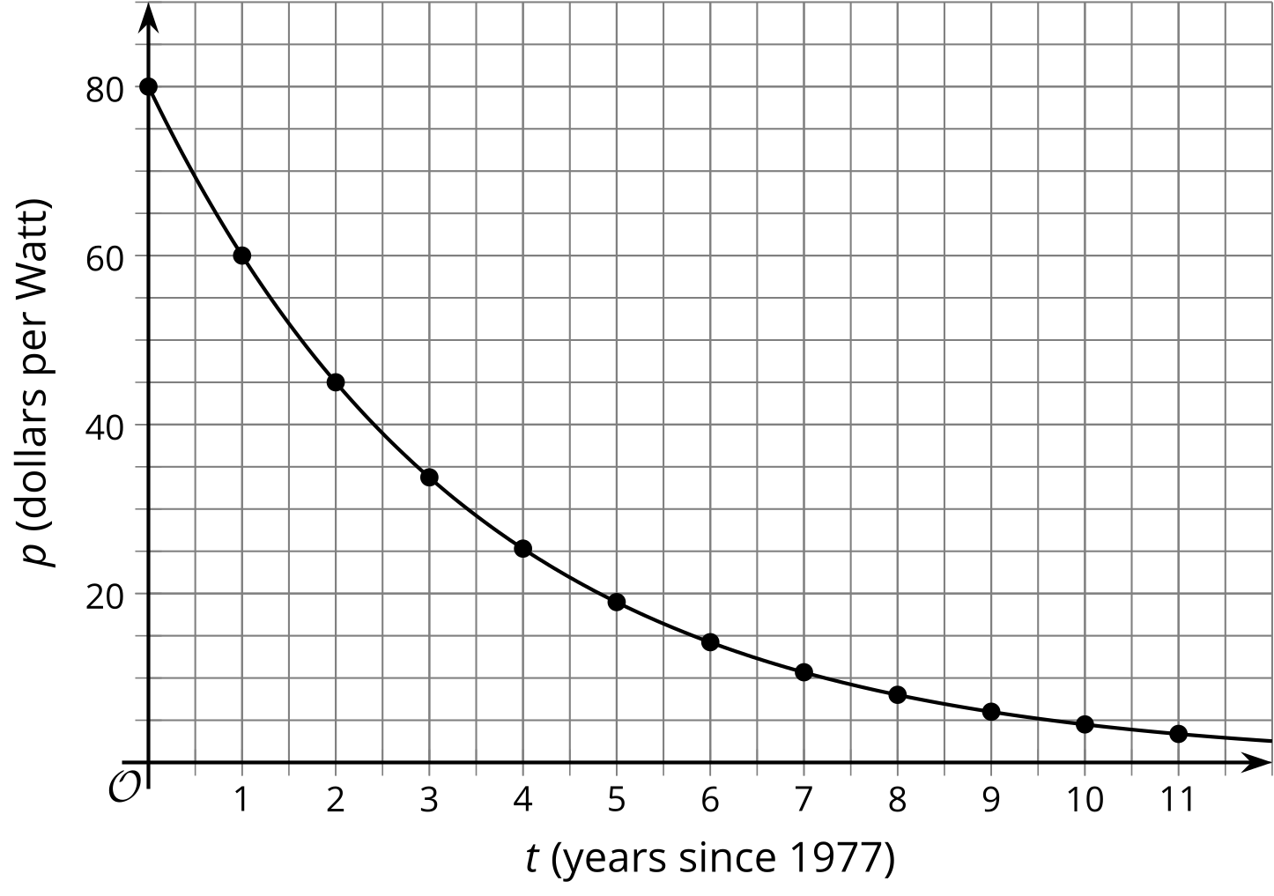
- Clare said, "In the first five years, between 1977 and 1982, the cost fell by about $12 per year. But in the second five years, between 1983 and 1988, the cost fell only by about $2 a year." Show that Clare is correct.
- If the trend continues, will the average decrease in price be more or less than $2 per year between 1987 and 1992? Explain your reasoning.

Are you ready for more?
Suppose the cost of producing 1 watt of solar energy had instead decreased by $12.20 each year between 1977 and 1982. Compute what the costs would be each year and plot them on the same graph shown in the activity. How do these alternate costs compare to the actual costs shown?

Lesson 10 Summary
When we calculate the average rate of change for a linear function, no matter what interval we pick, the value of the rate of change is the same. A constant rate of change is an important feature of linear functions! When a linear function is represented by a graph, the slope of the line is the rate of change of the function.
Exponential functions also have important features. We've learned about exponential growth and exponential decay, both of which are characterized by a constant quotient over equal intervals. But what does this mean for the value of the average rate of change for an exponential function over a specific interval?
Let's look at an exponential function we studied earlier. Let $A$ be the function that models the area $A\left(t\right)$, in square yards, of algae covering a pond $t$ weeks after beginning treatment to control the algae bloom. Here is a table showing about how many square yards of algae remain during the first 5 weeks of treatment.
$t$ | $A\left(t\right)$
0 | 240
1 | 80
2 | 27
3 | 9
4 | 3
The average rate of change of $A$ from the start of treatment to week 2 is about -107 square yards per week since $\frac{A\left(2\right)−A\left(0\right)}{2−0}≈\text{-}107$. The average rate of change of $A$ from week 2 to week 4, however, is only about -12 square yards per week since $\frac{A\left(4\right)−A\left(2\right)}{4−2}≈\text{-}12$.
These calculations show that $A$ is decreasing over both intervals, but the average rate of change is less from weeks 0 to 2 than from weeks 2 to 4, which is due to the effect of the decay factor. If we had looked at an exponential growth function instead, the values for the average rate of change of each interval would be positive with the second interval having a greater value than the first, which is due to the effect of the growth factor.
© CC BY 2019 by Illustrative Mathematics®

