Lesson 13 Practice Problems
- Here are four graphs. Match each graph with the quadratic equation that it represents.

- Graph A
- 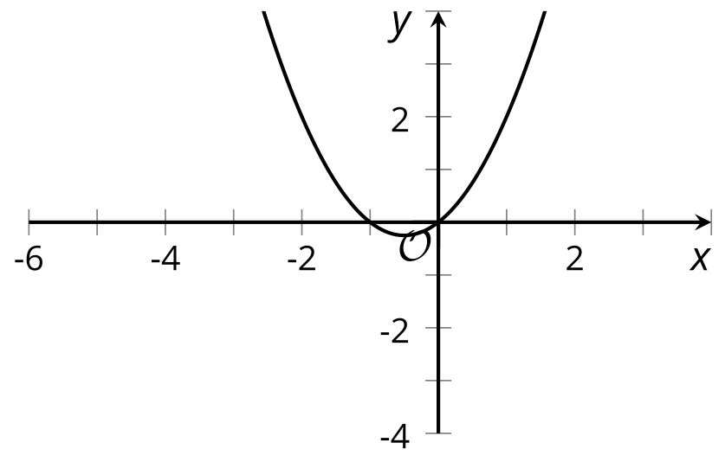

- Graph B
- 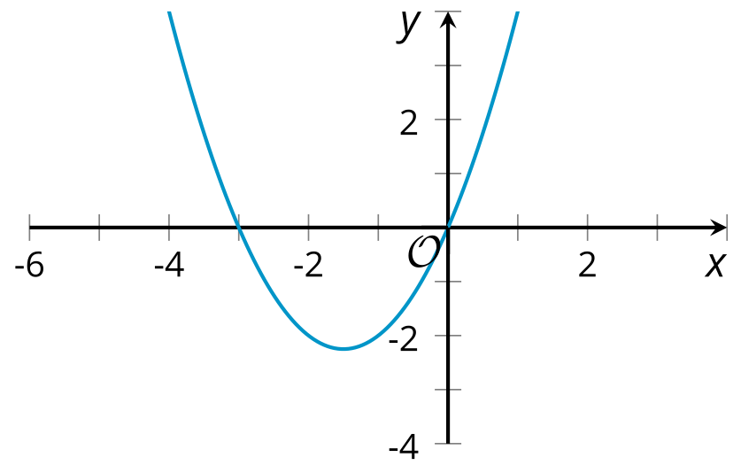

- Graph C
- 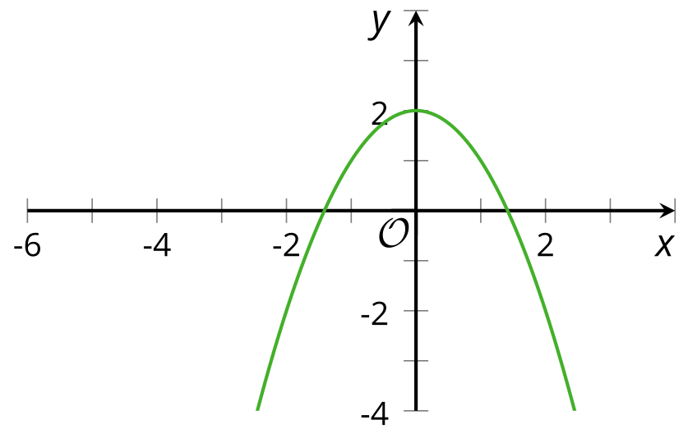

- Graph D
- 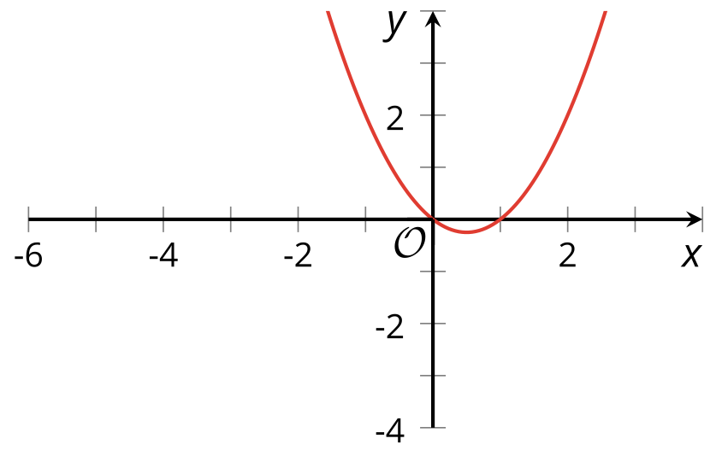
  - Graph A
  - Graph B
  - Graph C
  - Graph D
  - $y=x^{2}+x$
  - $y=\text{-}x^{2}+2$
  - $y=x^{2}−x$
  - $y=x^{2}+3x$
- Complete the table without graphing the equations.
- equation | - $x$-intercepts | - $x$-coordinate of the vertex
- $y=x^{2}+12x$
- $y=x^{2}−3x$
- $y=\text{-}x^{2}+16x$
- $y=\text{-}x^{2}−24x$
- Here is a graph that represents $y=x^{2}$.
  - Describe what would happen to the graph if the original equation were changed to $y=x^{2}−6x$. Predict the $x$- and $y$-intercepts of the graph and the quadrant where the vertex is located.

  - 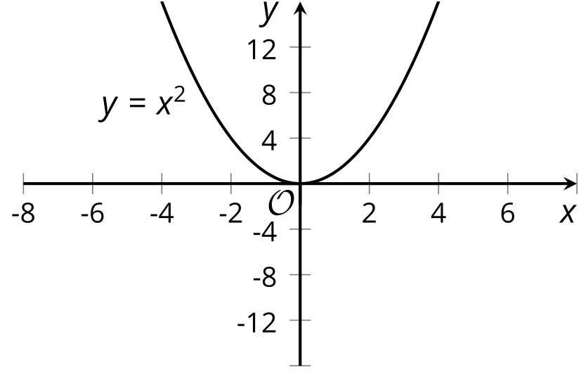
  - Sketch the graph of the equation $y=x^{2}−6x$ on the same coordinate plane as $y=x^{2}$.
- Select all equations whose graph opens upward.
  - $y=\text{-}x^{2}+9x$
  - $y=10x−5x^{2}$
  - $y={\left(2x−1\right)}^{2}$
  - $y=\left(1−x\right)\left(2+x\right)$
  - $y=x^{2}−8x−7$
- Technology required. Write an equation for a function that can be represented by each given graph. Then, use graphing technology to check each equation you wrote.

- Graph 1
- 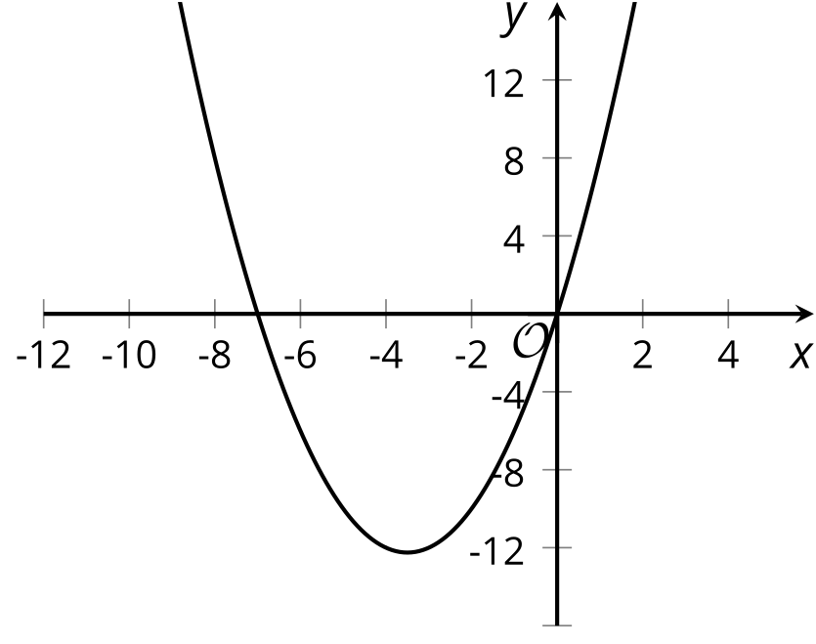

- Graph 2
- 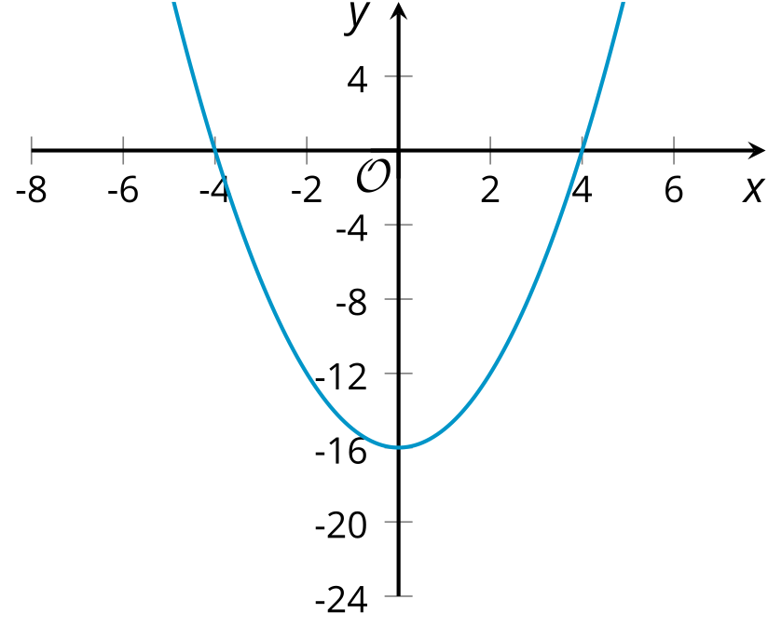

- Graph 3
- 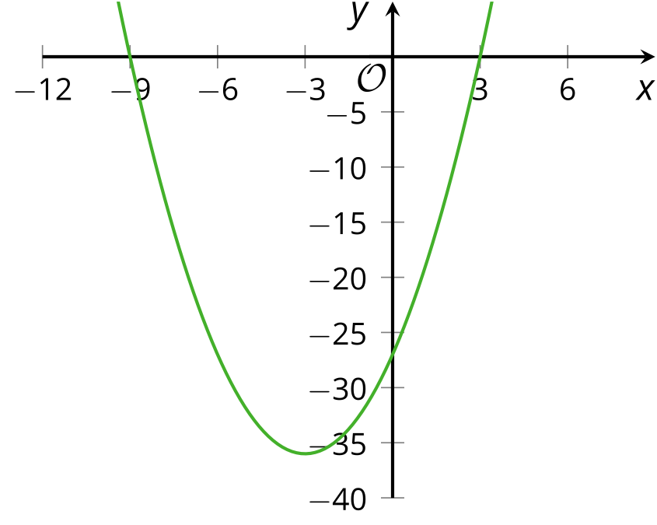

- Match each quadratic expression that is written as a product with an equivalent expression that is expanded.
  - $\left(x+3\right)\left(x+4\right)$
  - $\left(x+3\right)\left(x+7\right)$
  - $\left(3x+4\right)\left(x+3\right)$
  - $\left(x+7\right)\left(3x+1\right)$
  - $x^{2}+10x+21$
  - $3x^{2}+13x+12$
  - $3x^{2}+22x+7$
  - $x^{2}+7x+12$
- (From Unit 6, Lesson 8.)
- When buying a home, many mortgage companies require a down payment of 20% of the price of the house. What is the down payment on a $125,000 home?
- (From Unit 5, Lesson 14.)
- A bank loans $4,000 to a customer at a $9\frac{1}{2}\%$ annual interest rate.
- Write an expression to represent how much the customer will owe, in dollars, after 5 years without payment.
- (From Unit 5, Lesson 15.)
© CC BY 2019 by Illustrative Mathematics®

