Unit 7 Lesson 4 Cumulative Practice Problems
- Evaluate:
  - ${10}^{0}$
  - $\frac{{10}^{3}}{{10}^{3}}$
  - ${10}^{2}+{10}^{1}+{10}^{0}$
- Write each expression as a single power of 10.
  - $\frac{{10}^{3}⋅{10}^{4}}{{10}^{5}}$
  - $({10}^{4})⋅\frac{{10}^{12}}{{10}^{7}}$
  - ${\left(\frac{{10}^{5}}{{10}^{3}}\right)}^{4}$
  - $\frac{{10}^{4}⋅{10}^{5}⋅{10}^{6}}{{10}^{3}⋅{10}^{7}}$
  - $\frac{({10}^{5})^{2}}{({10}^{2})^{3}}$
- The Sun is roughly ${10}^{2}$ times as wide as Earth. The star KW Sagittarii is roughly ${10}^{5}$ times as wide as Earth. About how many times as wide as the Sun is KW Sagittarii? Explain how you know.
- Jada has a scale map of Kansas that fits on a page in her book. The page is 5 inches by 8 inches. Kansas is about 210 miles by 410 miles. Select all scales that could be a scale of the map. (There are 2.54 centimeters in an inch.)
  - 1 in to 1 mi
  - 1 cm to 1 km
  - 1 in to 10 mi
  - 1 ft to 100 mi
  - 1 cm to 200 km
  - 1 in to 100 mi
  - 1 cm to 1000 km
- (From Unit 2, Lesson 7.)
- Select all the expressions that are equivalent to $\text{-}36x+54y−90$.
  - $\text{-}9(4x−6y−10)$
  - $\text{-}18(2x−3y+5)$
  - $\text{-}6(6x+9y−15)$
  - $18(\text{-}2x+3y−5)$
  - $\text{-}2(18x−27y+45)$
  - $2(\text{-}18x+54y−90)$
- (From Unit 4, Lesson 8.)
- Bananas cost $1.50 per pound, and guavas cost $3.00 per pound. Kiran spends $12 on fruit for a breakfast his family is hosting. Let $b$ be the number of pounds of bananas Kiran buys and $g$ be the number of pounds of guavas he buys.
  - Write an equation relating the two variables.
  - Rearrange the equation so $b$ is the independent variable.
  - Rearrange the equation so $g$ is the independent variable.
- (From Unit 6, Lesson 3.)
- Lin’s mom bikes at a constant speed of 12 miles per hour. Lin walks at a constant speed $\frac{1}{3}$ of the speed her mom bikes. Sketch a graph of both of these relationships.
- 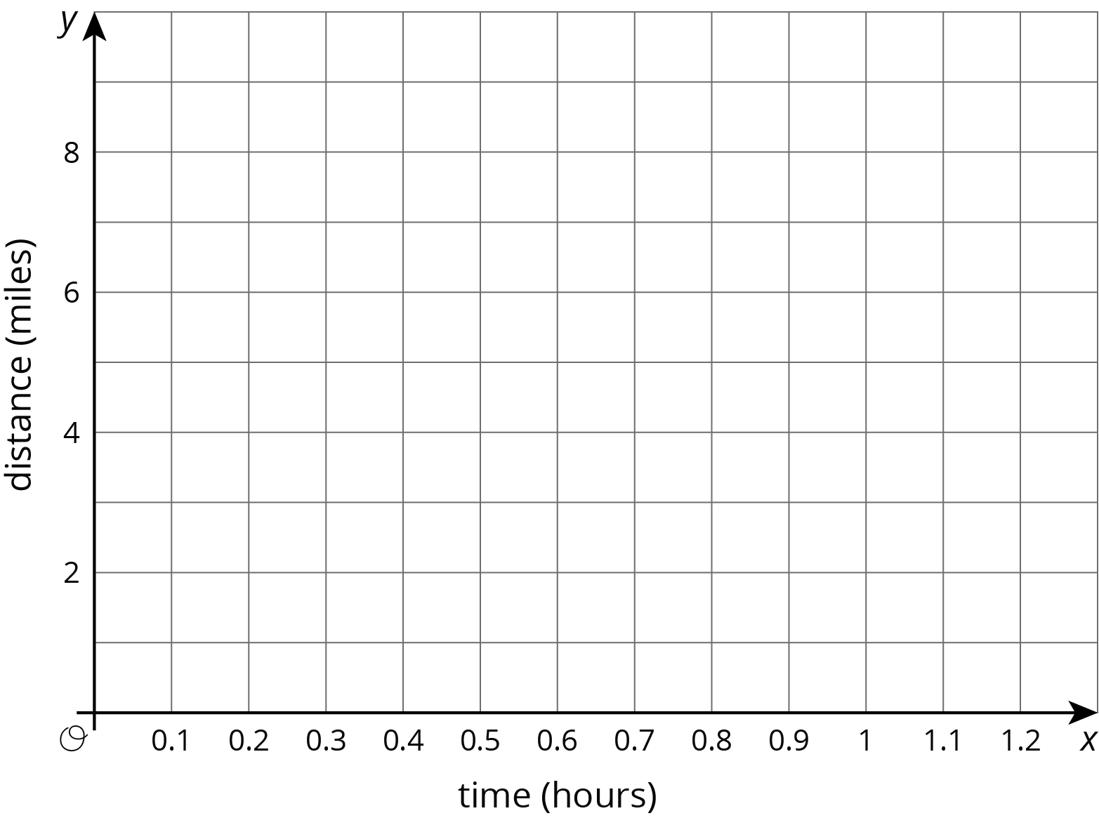
- (From Unit 5, Lesson 1.)
© CC BY Open Up Resources. Adaptations CC BY IM.

