Lesson 6: Building Polygons (Part 1)
Let’s build shapes.

6.1: True or False: Signed Numbers
Decide whether each equation is true or false. Be prepared to explain your reasoning.
$4⋅\left(\text{-}6\right)=\left(\text{-}6\right)+\left(\text{-}6\right)+\left(\text{-}6\right)+\left(\text{-}6\right)$
$\text{-}8⋅4=\left(\text{-}8⋅3\right)+4$
$6⋅\left(\text{-}7\right)=7⋅\left(\text{-}7\right)+7$
$\text{-}10−6=\text{-}10−\left(\text{-}6\right)$

6.2: What Can You Build?
Your teacher will give you some strips of different lengths and fasteners you can use to attach the corners.
- Use the pieces to build several polygons, including at least one triangle and one quadrilateral.
- After you finish building several polygons, select one triangle and one quadrilateral that you have made.
  - Measure all the angles in the two shapes you selected.
  - Using these measurements along with the side lengths as marked, draw your triangle and quadrilateral as accurately as possible.

6.3: Building Diego’s and Jada’s Shapes
- Diego built a quadrilateral using side lengths of 4 in, 5 in, 6 in, and 9 in.
  - Build such a shape.
  - Is your shape an identical copy of Diego’s shape? Explain your reasoning.
- Jada built a triangle using side lengths of 4 in, 5 in, and 8 in.
  - Build such a shape.
  - Is your shape an identical copy of Jada’s shape? Explain your reasoning.

6.4: Building Han’s Shape
Han built a polygon using side lengths of 3 in, 4 in, and 9 in.
- Build such a shape.
- What do you notice?

Lesson 6 Summary
Sometimes we are given a polygon and asked to find the lengths of the sides. What options do you have if you need to build a polygon with some side lengths? Sometimes, we can make lots of different figures. For example, if you have side lengths 5, 7, 11, and 14, here are some of the many, many quadrilaterals we can make with those side lengths:
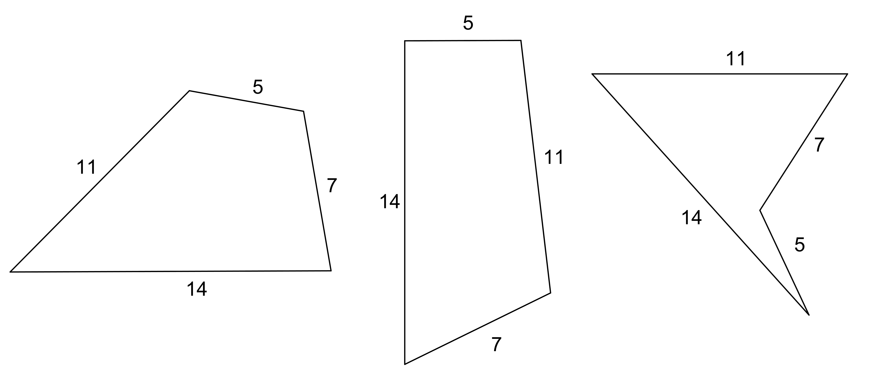
Sometimes, it is not possible to make a figure with certain side lengths. For example, 18, 1, 1, 1 (try it!).
We will continue to investigate the figures that can be made with given measures.
© CC BY Open Up Resources. Adaptations CC BY IM.

