Lesson 8 Practice Problems
- Two cars drive on the same highway in the same direction. The graphs show the distance, $d$, of each one as a function of time, $t$. Which car drives faster? Explain how you know.
- 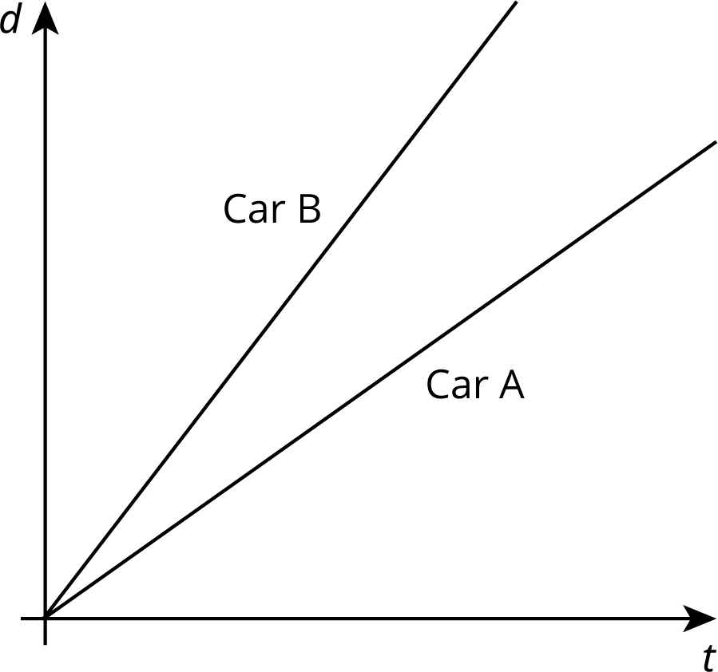
- Two car services offer to pick you up and take you to your destination. Service A charges 40 cents to pick you up and 30 cents for each mile of your trip. Service B charges $1.10 to pick you up and charges $c$ cents for each mile of your trip.
  - Match the services to the Lines $ℓ$ and $m$.
  - For Service B, is the additional
charge per mile greater or less than
30 cents per mile of the trip?
Explain your reasoning.
- 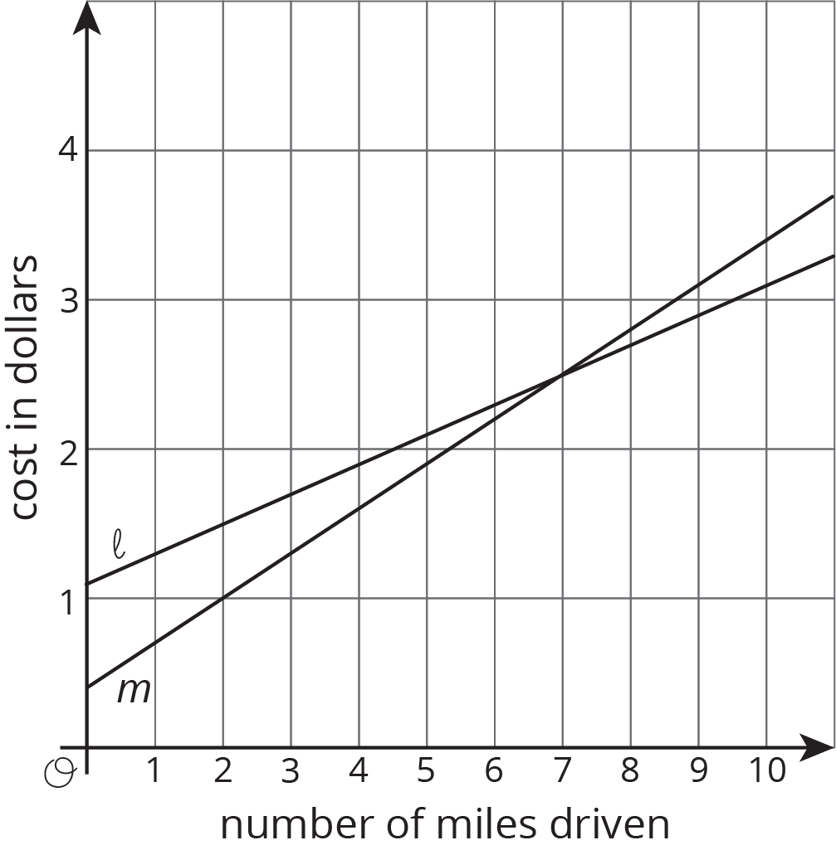
- Kiran and Clare like to race each other home from school. They run at the same speed, but Kiran's house is slightly closer to school than Clare's house. On a graph, their distance from their homes in meters is a function of the time from when they begin the race in seconds.
  - As you read the graphs left to right, would the lines go up or down?
  - What is different about the lines representing Kiran's run and Clare's run?
  - What is the same about the lines representing Kiran's run and Clare's run?
- Write an equation for each line.
- 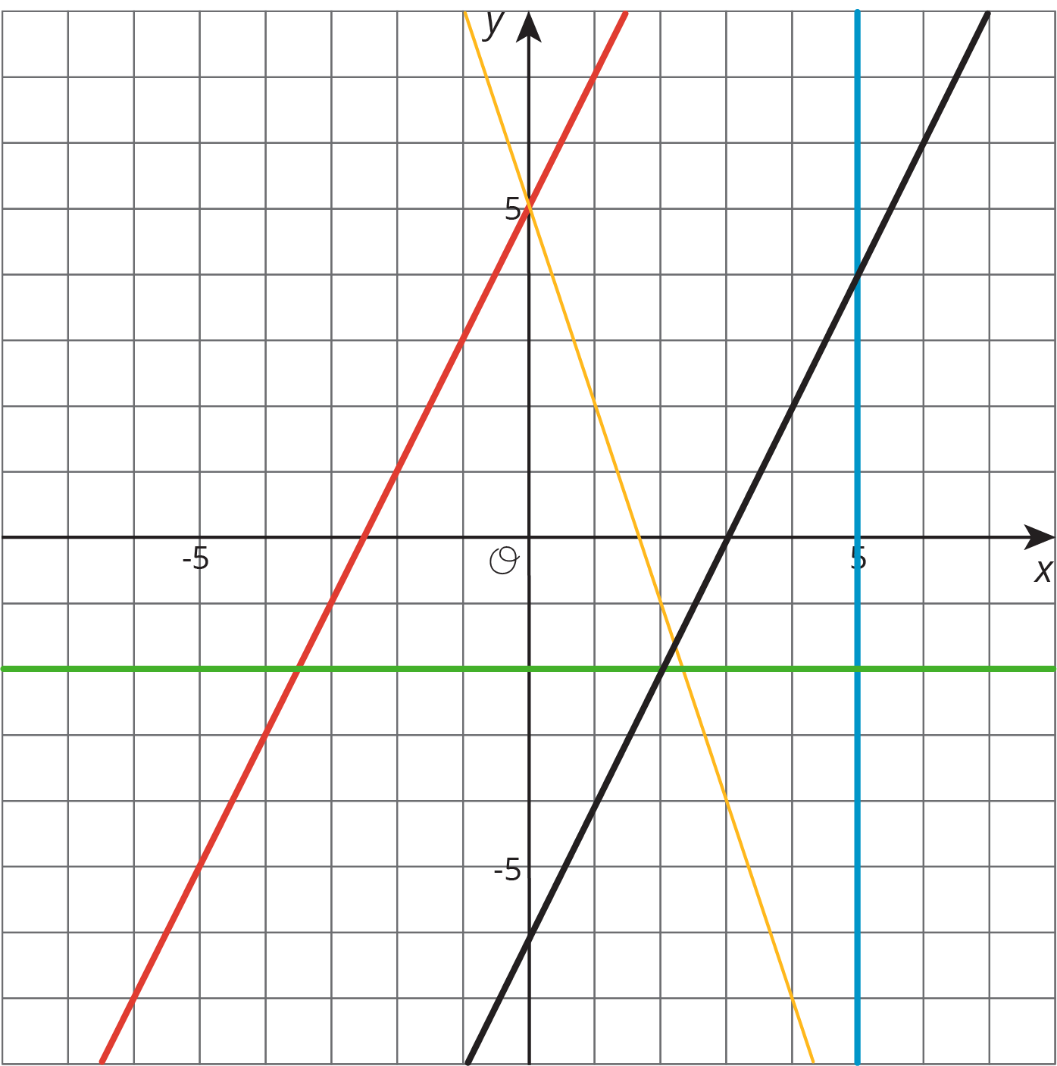
- (From Unit 5, Lesson 9.)
© CC BY Open Up Resources. Adaptations CC BY IM.

