Unit 1 Lesson 4: Explore Geoblocks

WU Notice and Wonder: Geoblocks (Warm up)

Student Task Statement
What do you notice?
What do you wonder?
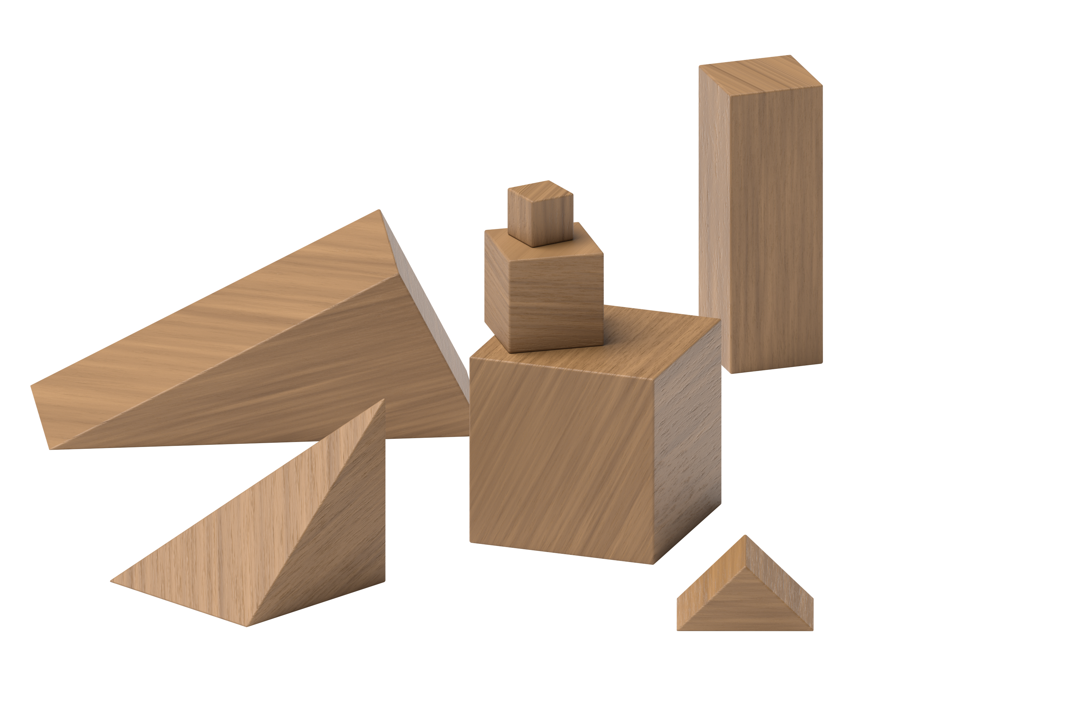

1 Introduce Geoblocks, Explore

Student Task Statement

2 Introduce Geoblocks, Build to Match

Student Task Statement
Use blocks to build a house.
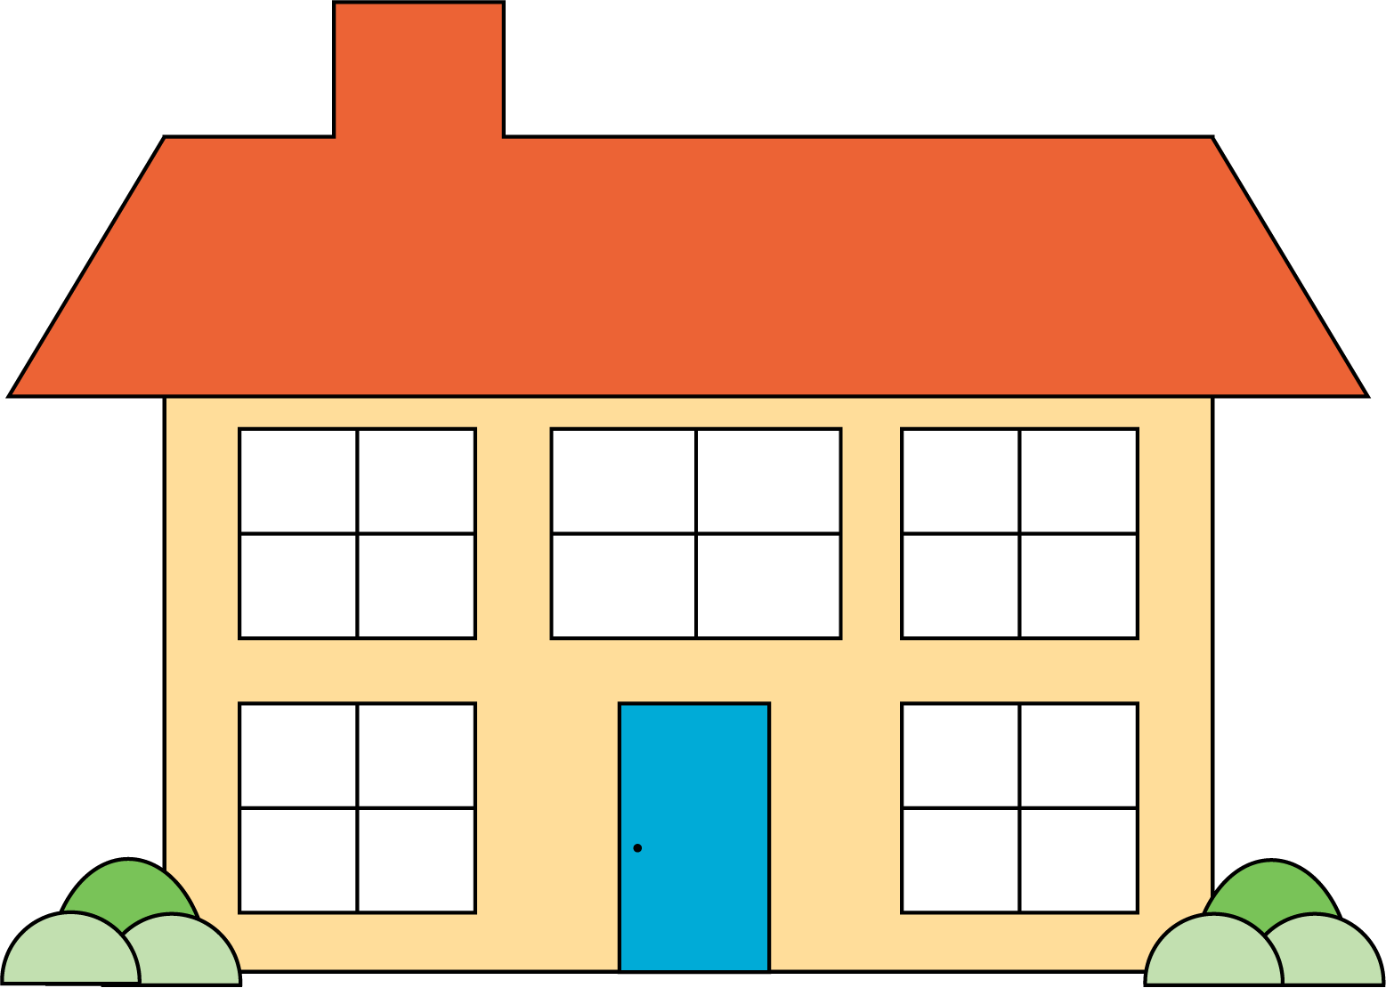
© CC BY 2021 Illustrative Mathematics®

