Lesson 2: Keep Track of Objects
- Let’s figure out how many objects are in our collections.

Warm-up: Number Talk: Add and Subtract 0 and 1
Find the value of each expression.
- $3+0$
- $3+1$
- $3−1$
- $2−0$

2.3: Centers: Choice Time
Choose a center.
Number Race
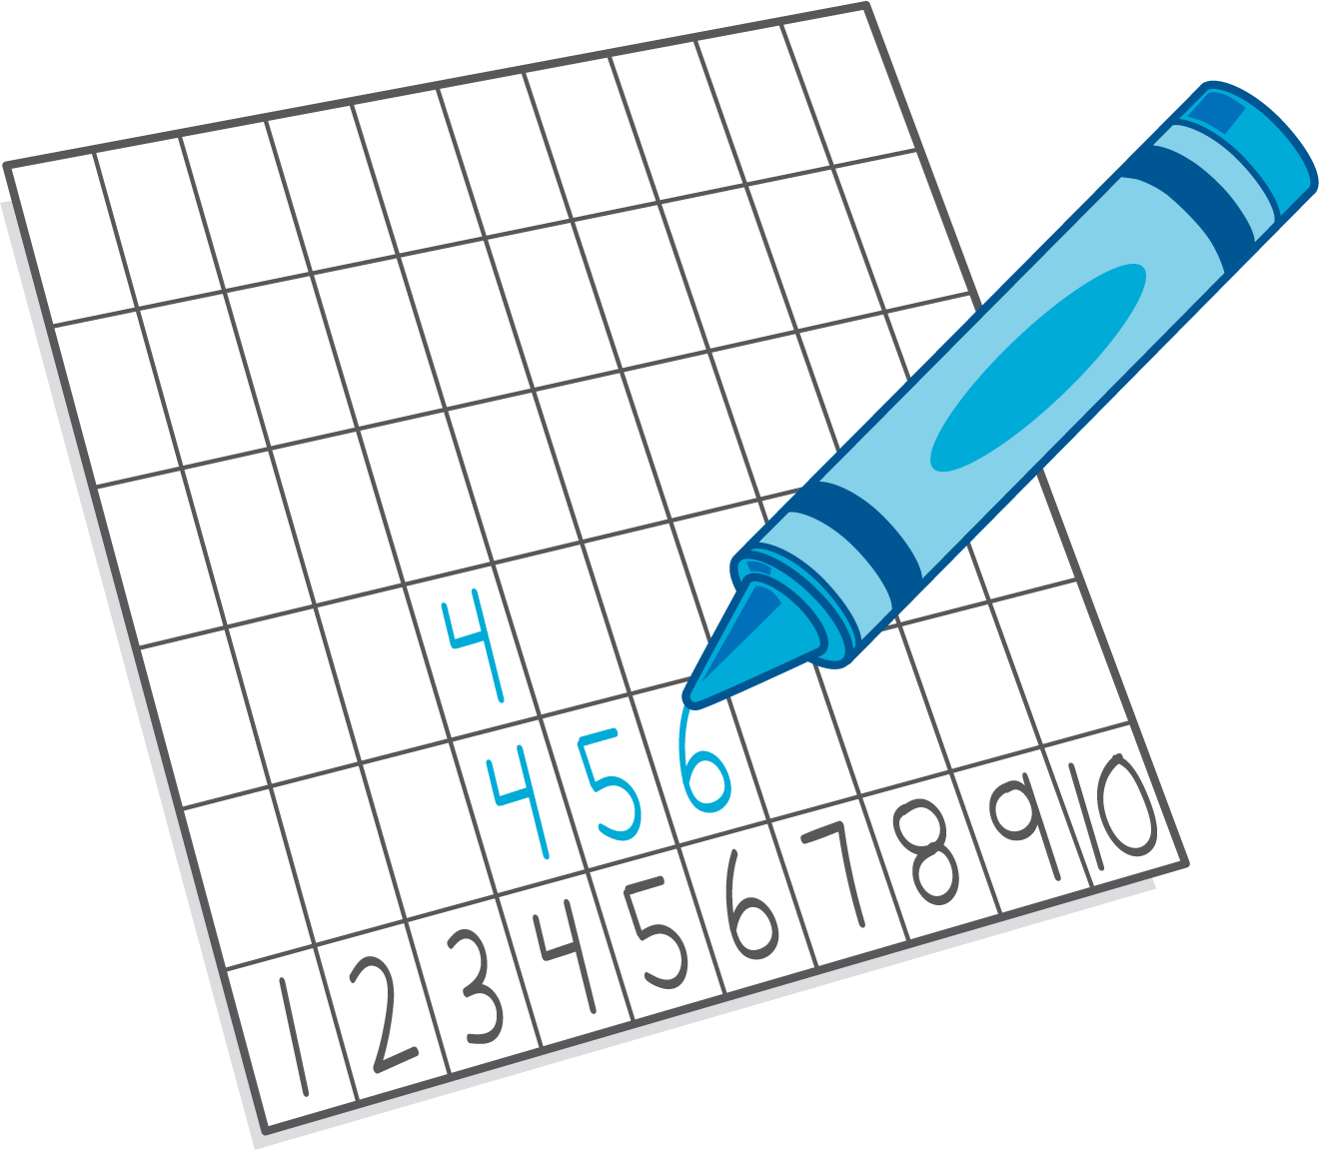
Subtraction Towers
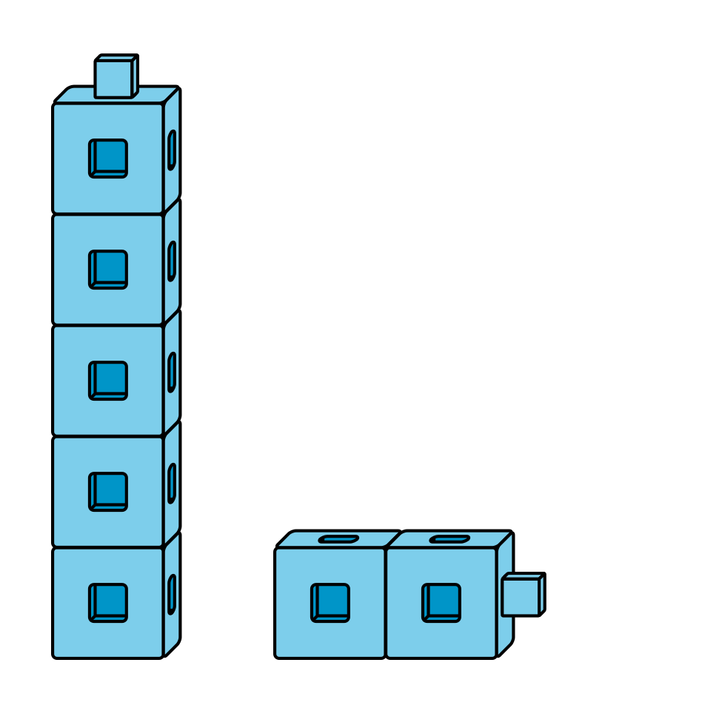
5-frames
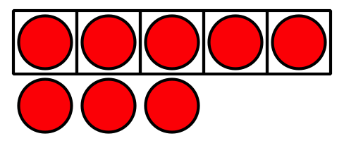
© CC BY 2021 Illustrative Mathematics®

