Lesson 7: Create Number Books (Part 2)
- Let’s make a number book about our school.

Warm-up: How Many Do You See: Different Dots
How many do you see?
How do you see them?
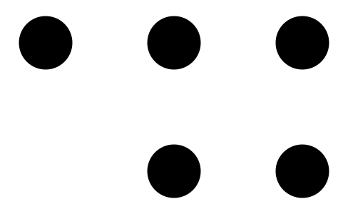
© CC BY 2021 Illustrative Mathematics®

