Lesson 7: Distances and Parabolas
- Let’s analyze the set of points that are the same distance from a given point and a given line.

7.1: Notice and Wonder: Distances
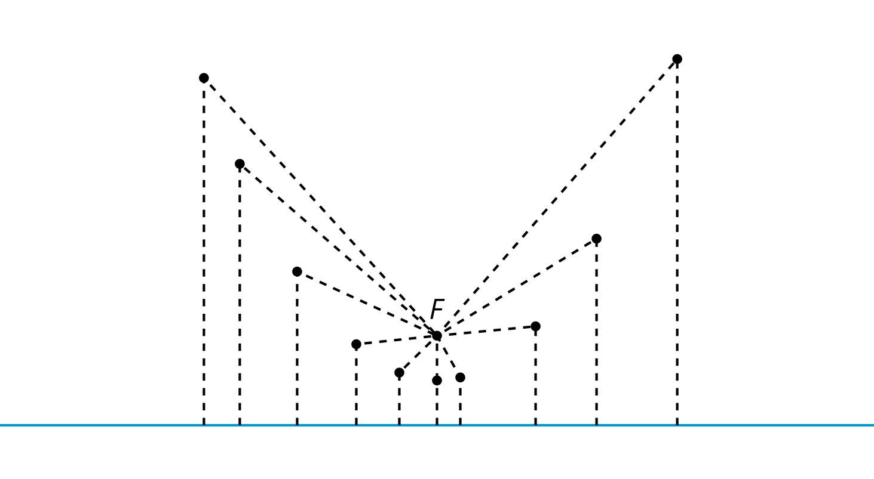
What do you notice? What do you wonder?

7.2: Into Focus
Here are several images of parabolas.
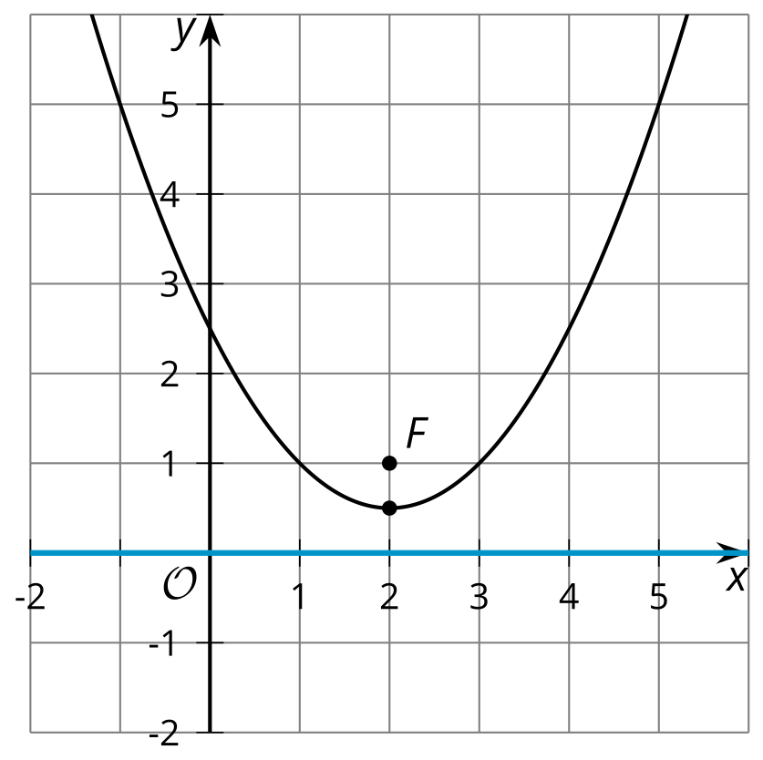
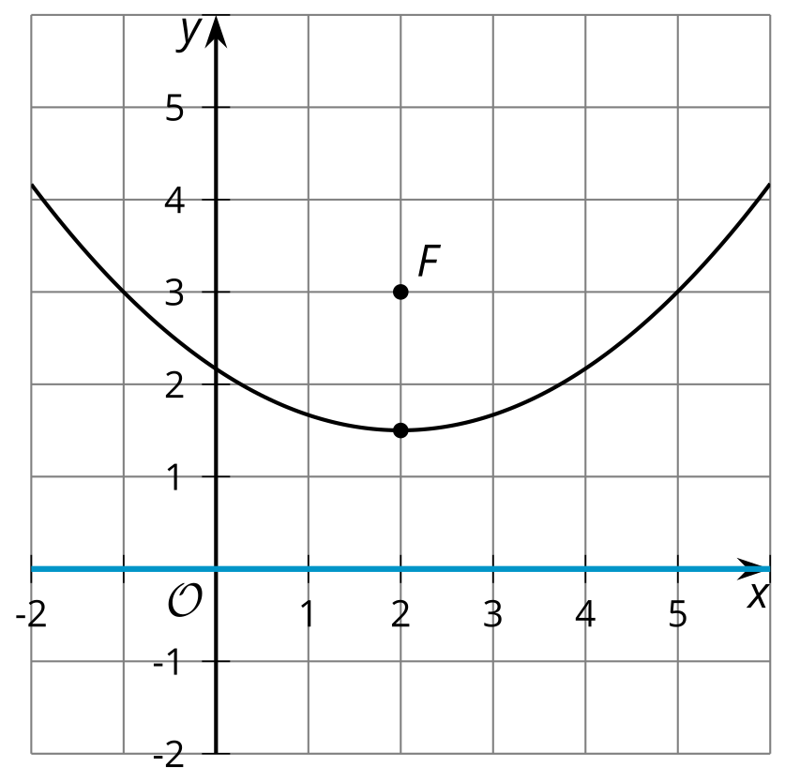
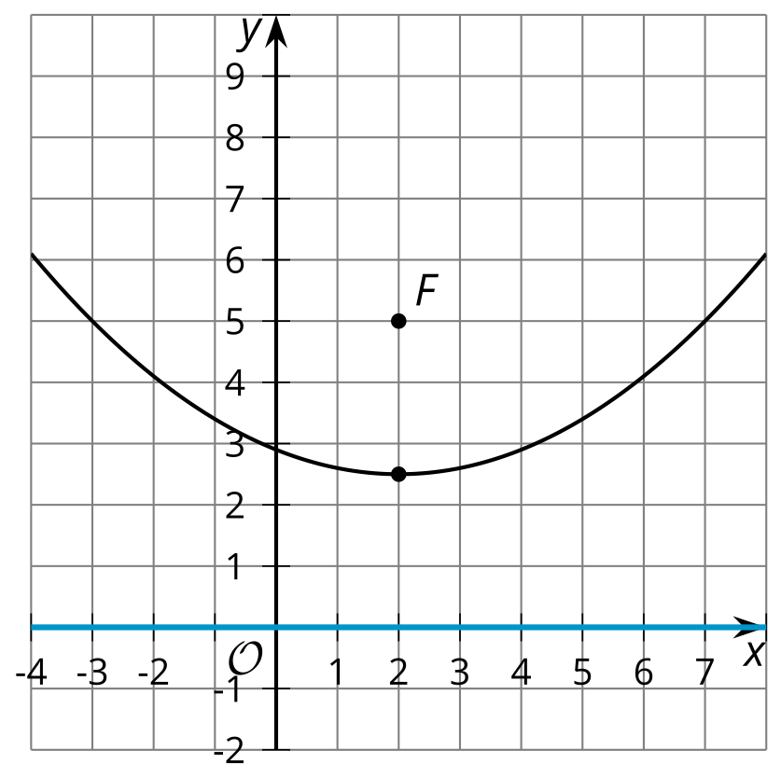
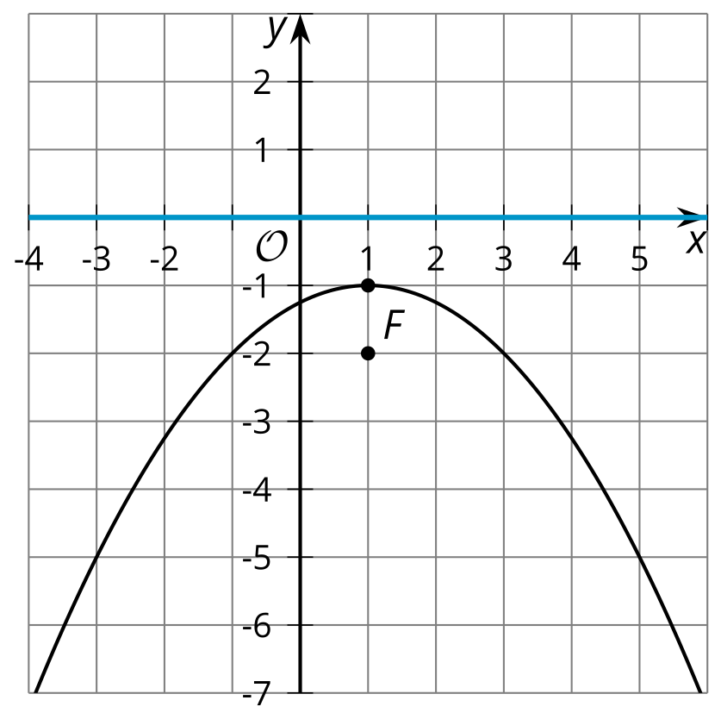
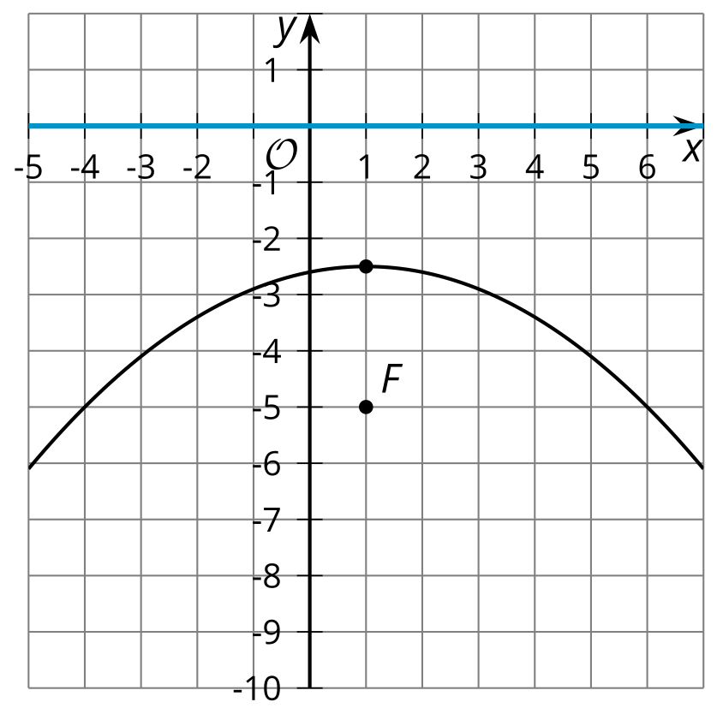
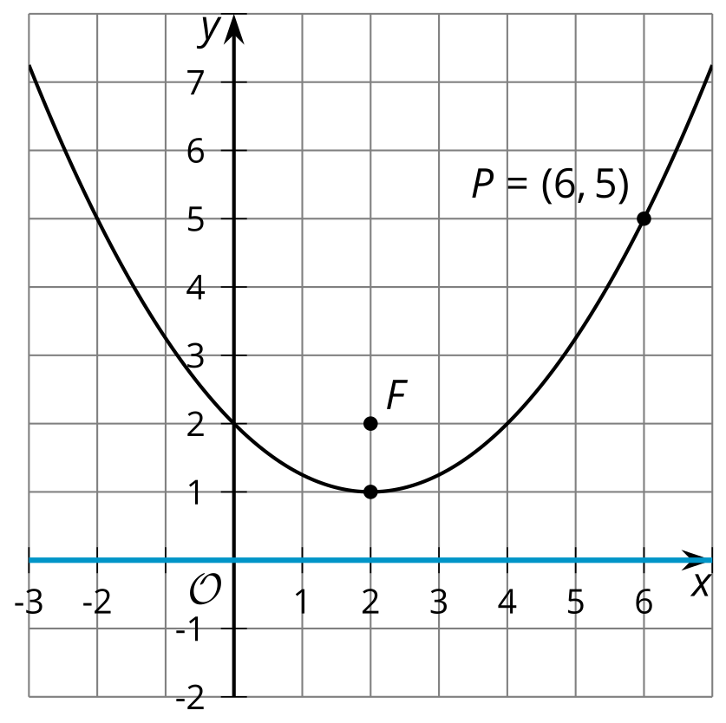
Look at the focus and directrix of each parabola. In each case, the directrix is the $x$-axis.
- How does the distance between the focus and the directrix affect the shape of the parabola?
- What seems to need to be true in order for the parabola to open downward (that is, to be shaped like a hill instead of a valley)?
- The vertex of the parabola is the lowest point on the curve if it opens upward, or the highest if it opens downward. Where is the vertex located in relationship to the focus and the directrix?
- In the final image, the directrix is on the $x$-axis and the focus is the point $\left(2,2\right)$. Point $P$ on the parabola is plotted.
  - What is the distance between point $P$ and the directrix?
  - What does this tell you about the distance between $P$ and $F$?

7.3: On Point
The image shows a parabola with focus $\left(6,4\right)$ and directrix $y=0$ (the $x$-axis).
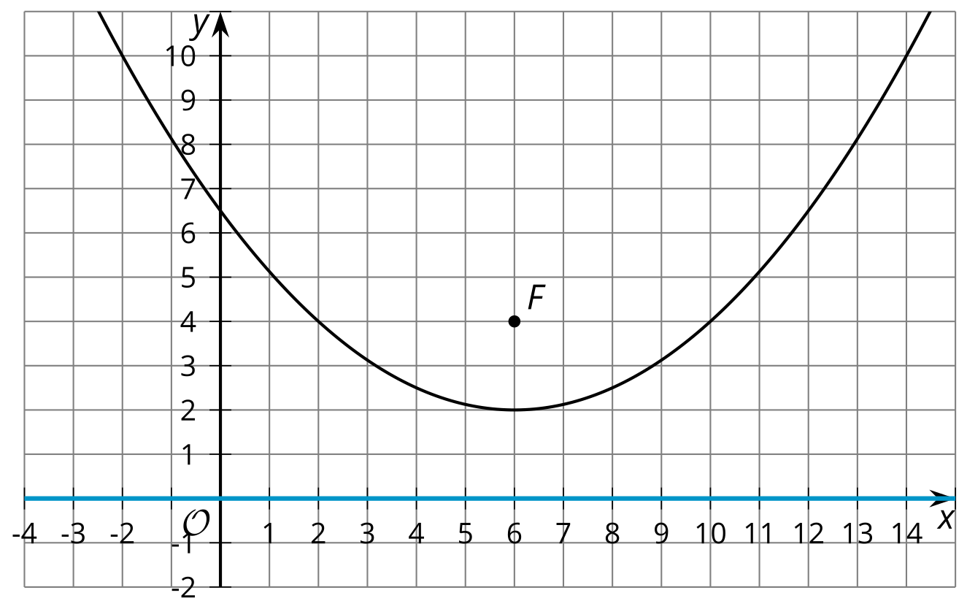
- The point $\left(11,5\right)$ looks like it might be on the parabola. Determine if it really is on the parabola. Explain or show your reasoning.
- The point $\left(14,10\right)$ looks like it might be on the parabola. Determine if it really is on the parabola. Explain or show your reasoning.
- In general, how can you determine if a particular point $\left(x,y\right)$ is on the parabola?

Are you ready for more?
The image shows a parabola with directrix $y=0$ and focus at $F=\left(2,5\right)$.
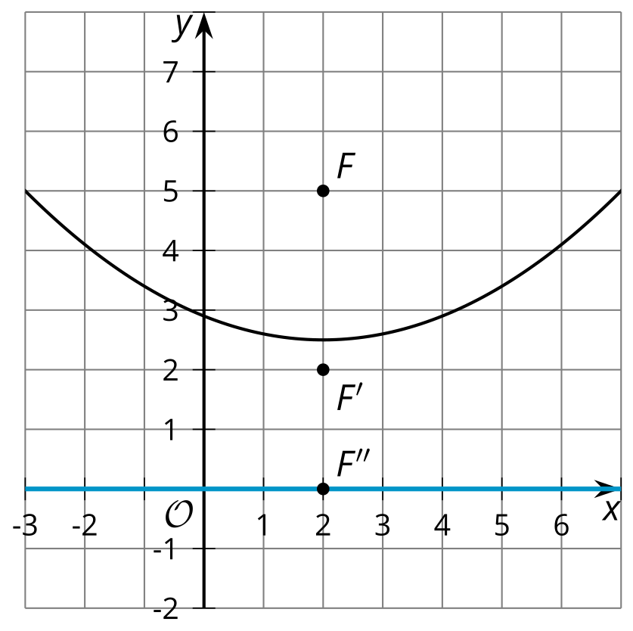
Imagine you moved the focus from $F$ to $F^{′}=\left(2,2\right)$.
- Sketch the new parabola.
- How does decreasing the distance between the focus and the directrix change the shape of the parabola?
- Suppose the focus were at $F^{″}$, on the directrix. What would happen?

Lesson 7 Summary
The diagram shows several points that are the same distance from the point $\left(2,1\right)$ as they are from the line $y=\text{-}3$​​​. (Distance is measured from each point to the line ​​along a segment perpendicular to the line.) The set of all points that are the same distance from a given point and a given line form a parabola. The given point is called the parabola’s focus and the line is called its directrix.
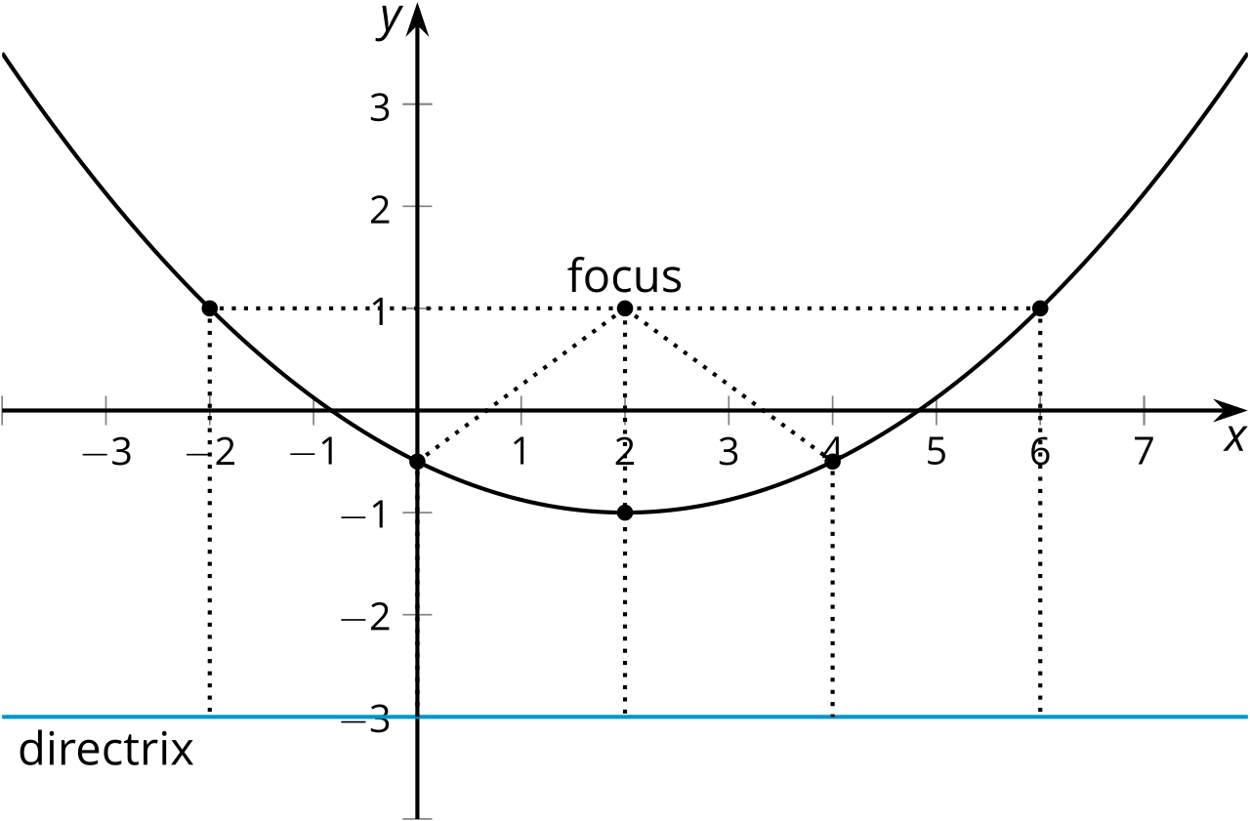
We can use this definition to test if points are on a parabola. The image shows the parabola with focus $\left(2,3\right)$ and directrix $y=1$. The point $\left(\text{-}2,6\right)$ appears to be on the parabola. Counting downwards, the distance between $\left(\text{-}2,6\right)$ and the directrix is 5 units.
Now use the Pythagorean Theorem to find the distance $d$ between $\left(\text{-}2,6\right)$ and the focus, $\left(2,3\right)$. Imagine drawing a right triangle whose hypotenuse is the segment connecting $\left(\text{-}2,6\right)$ and $\left(2,3\right)$. The lengths of the triangle’s legs can be found by subtracting the corresponding coordinates of the points.
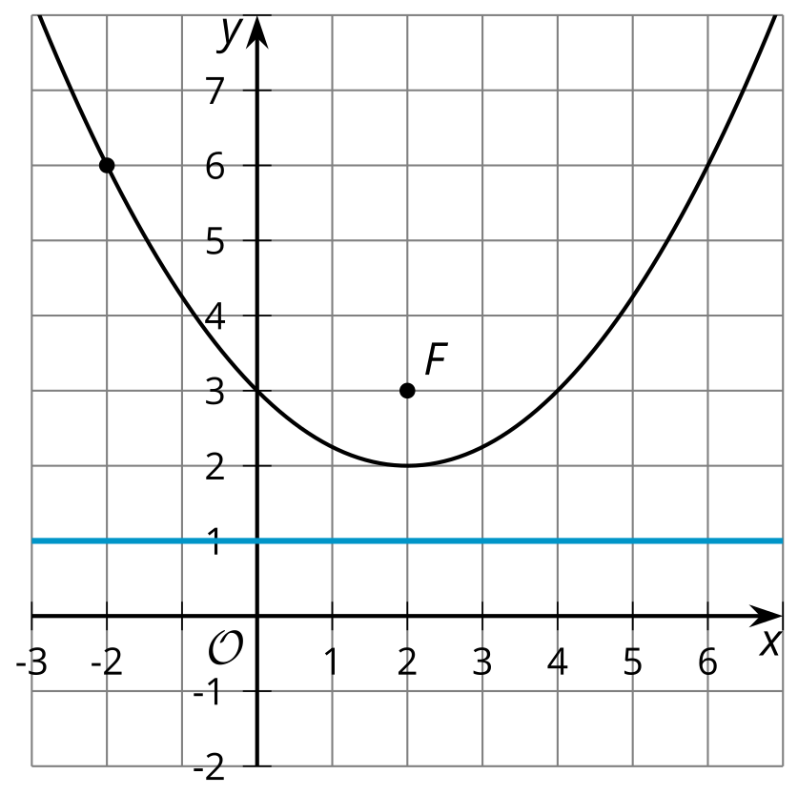
Use those lengths in the Pythagorean Theorem to get ${\left(\text{-}2−2\right)}^{2}+{\left(6−3\right)}^{2}=d^{2}$. Evaluate the left side of the equation to find that $25=d^{2}$. The distance, then, is 5 units because 5 is the positive number that squares to make 25. Now we know the point $\left(\text{-}2,6\right)$ really is on the parabola, because it’s 5 units away from both the focus and the directrix.
© CC BY 2019 by Illustrative Mathematics®

