Unit 4 Lesson 2: Keeping the Equation Balanced

1 Notice and Wonder: Hanging Socks (Warm up)

Student Task Statement
What do you notice? What do you wonder?
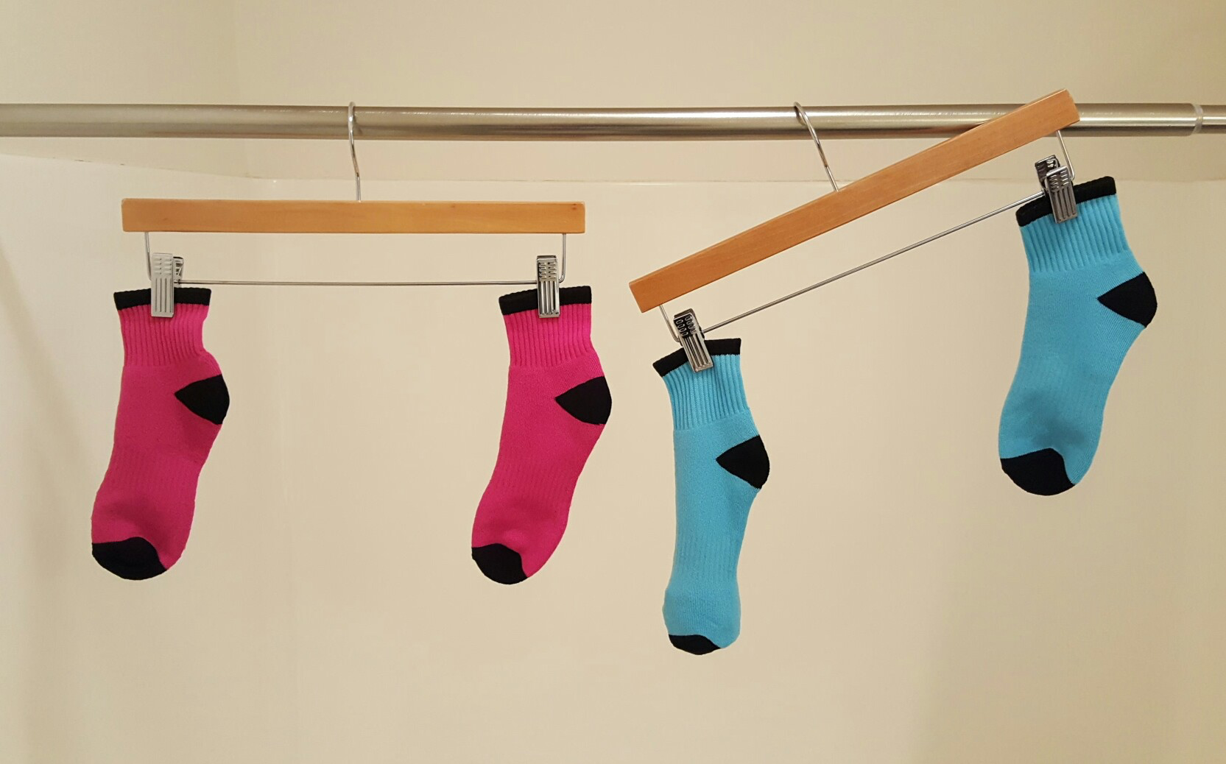

2 Hanging Blocks

Student Task Statement
This picture represents a hanger that is balanced because the weight on each side is the same.
- Elena takes two triangles off of the left side and three triangles off of the right side. Will the hanger still be in balance, or will it tip to one side? Which side? Explain how you know.
- If a triangle weighs 1 gram, how much does a square weigh?
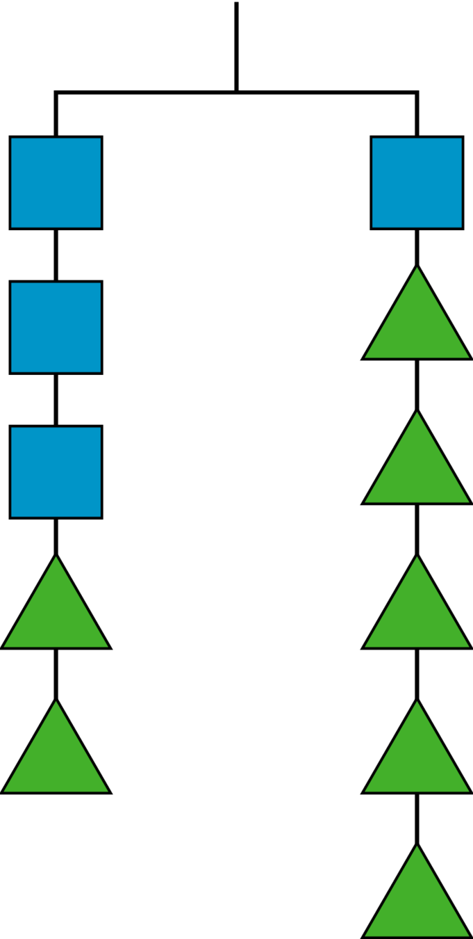

3 More Hanging Blocks

Student Task Statement
A triangle weighs 3 grams and a circle weighs 6 grams.
- Find the weight of a square in Hanger A and the weight of a pentagon in
Hanger B.
- Write an equation to represent
each hanger.
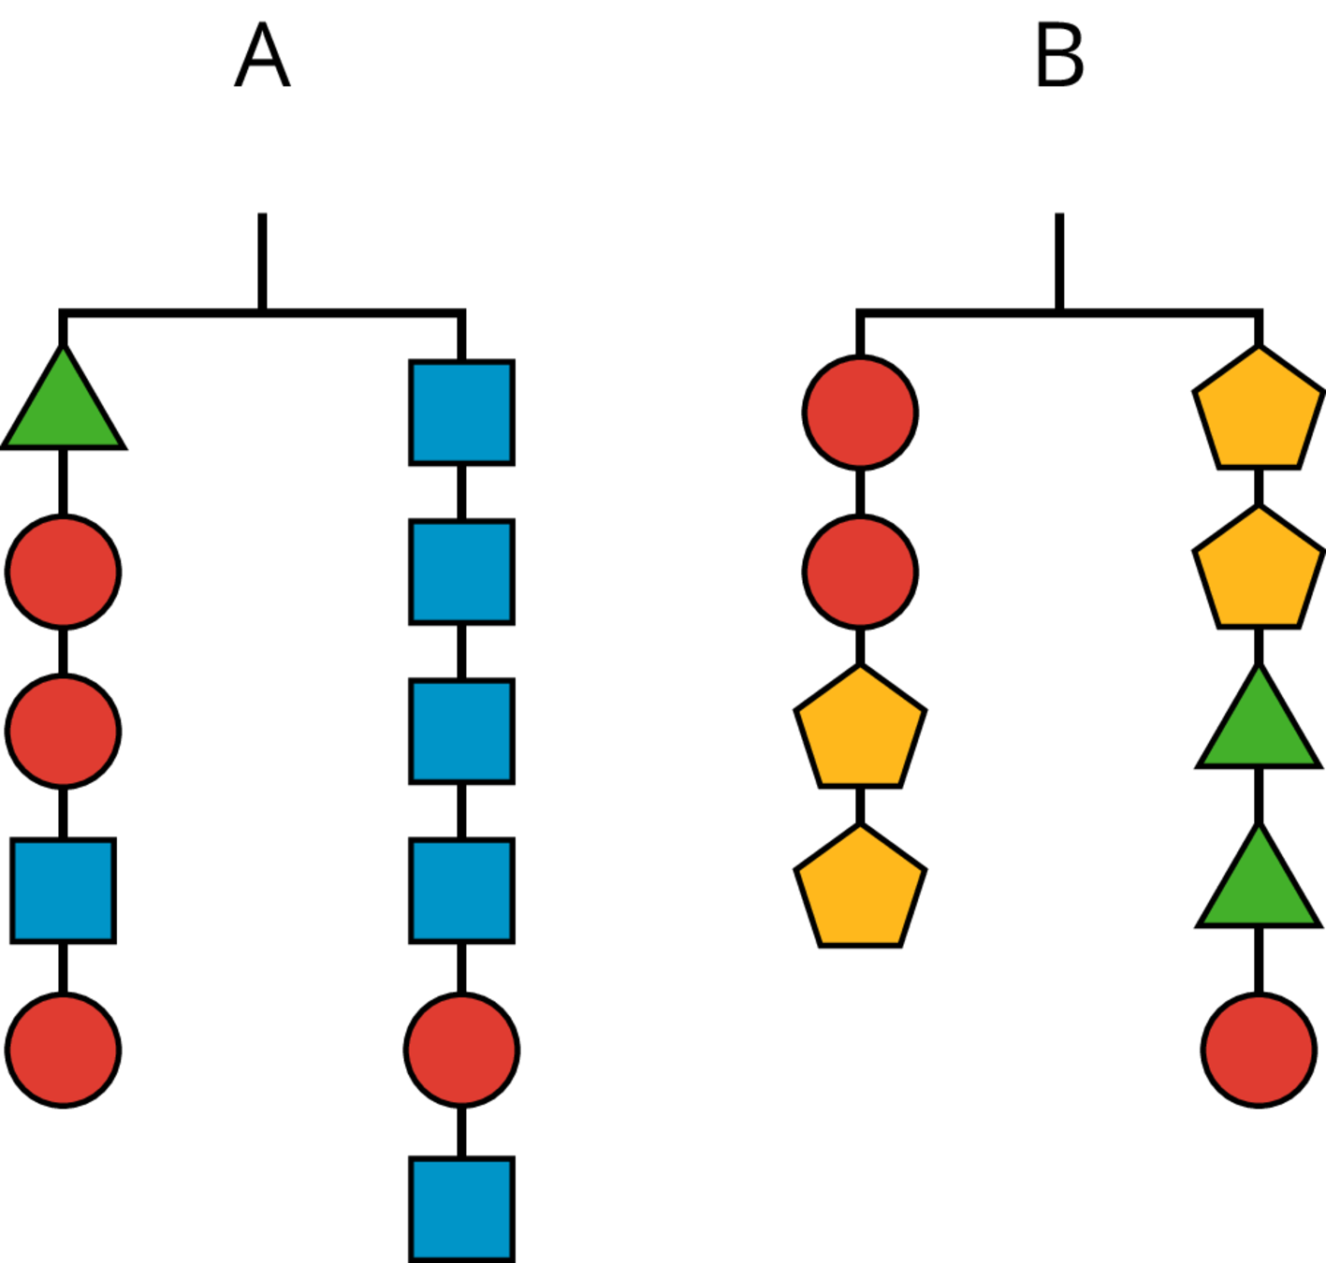
© CC BY Open Up Resources. Adaptations CC BY IM.

