Unit 1 Lesson 14: Center Day 3

WU Number Talk: Plus or Minus 2 (Warm up)

Student Task Statement
Find the value of each expression mentally.
- $4+2$
- $7−2$
- $9−2$
- $8+2$

1 Introduce Sort and Display, Any Way

Student Task Statement

2 Centers: Choice Time

Student Task Statement
Choose a center.
Five in a Row: Addition and Subtraction
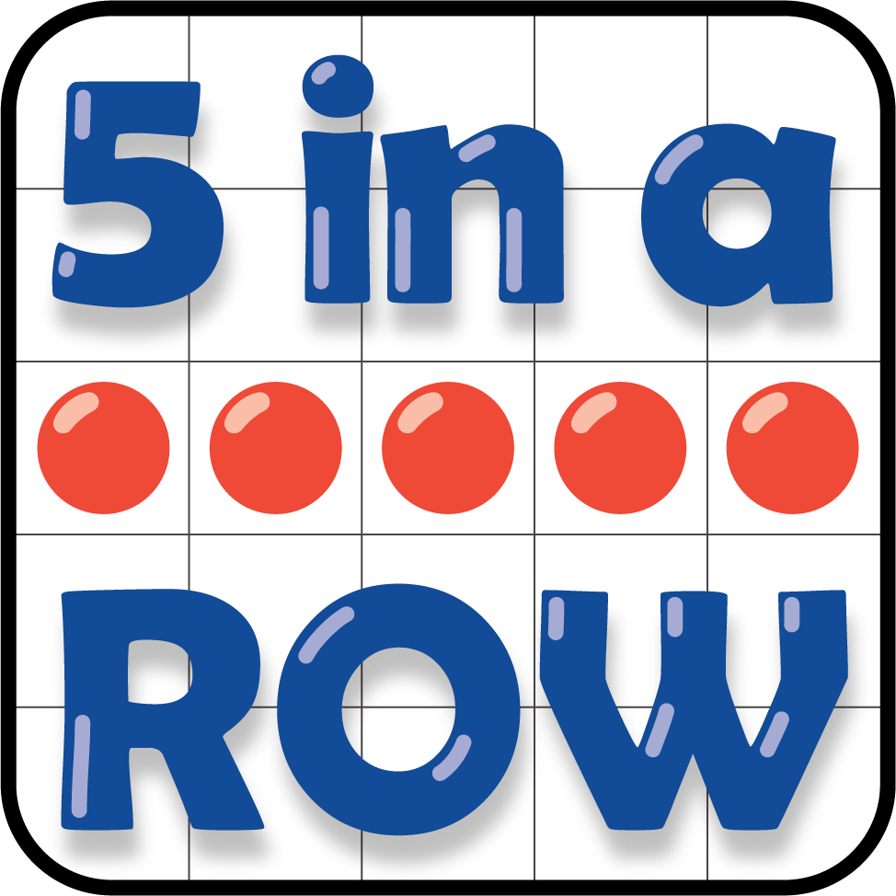
Check it Off
Find the Pair
What's Behind My Back
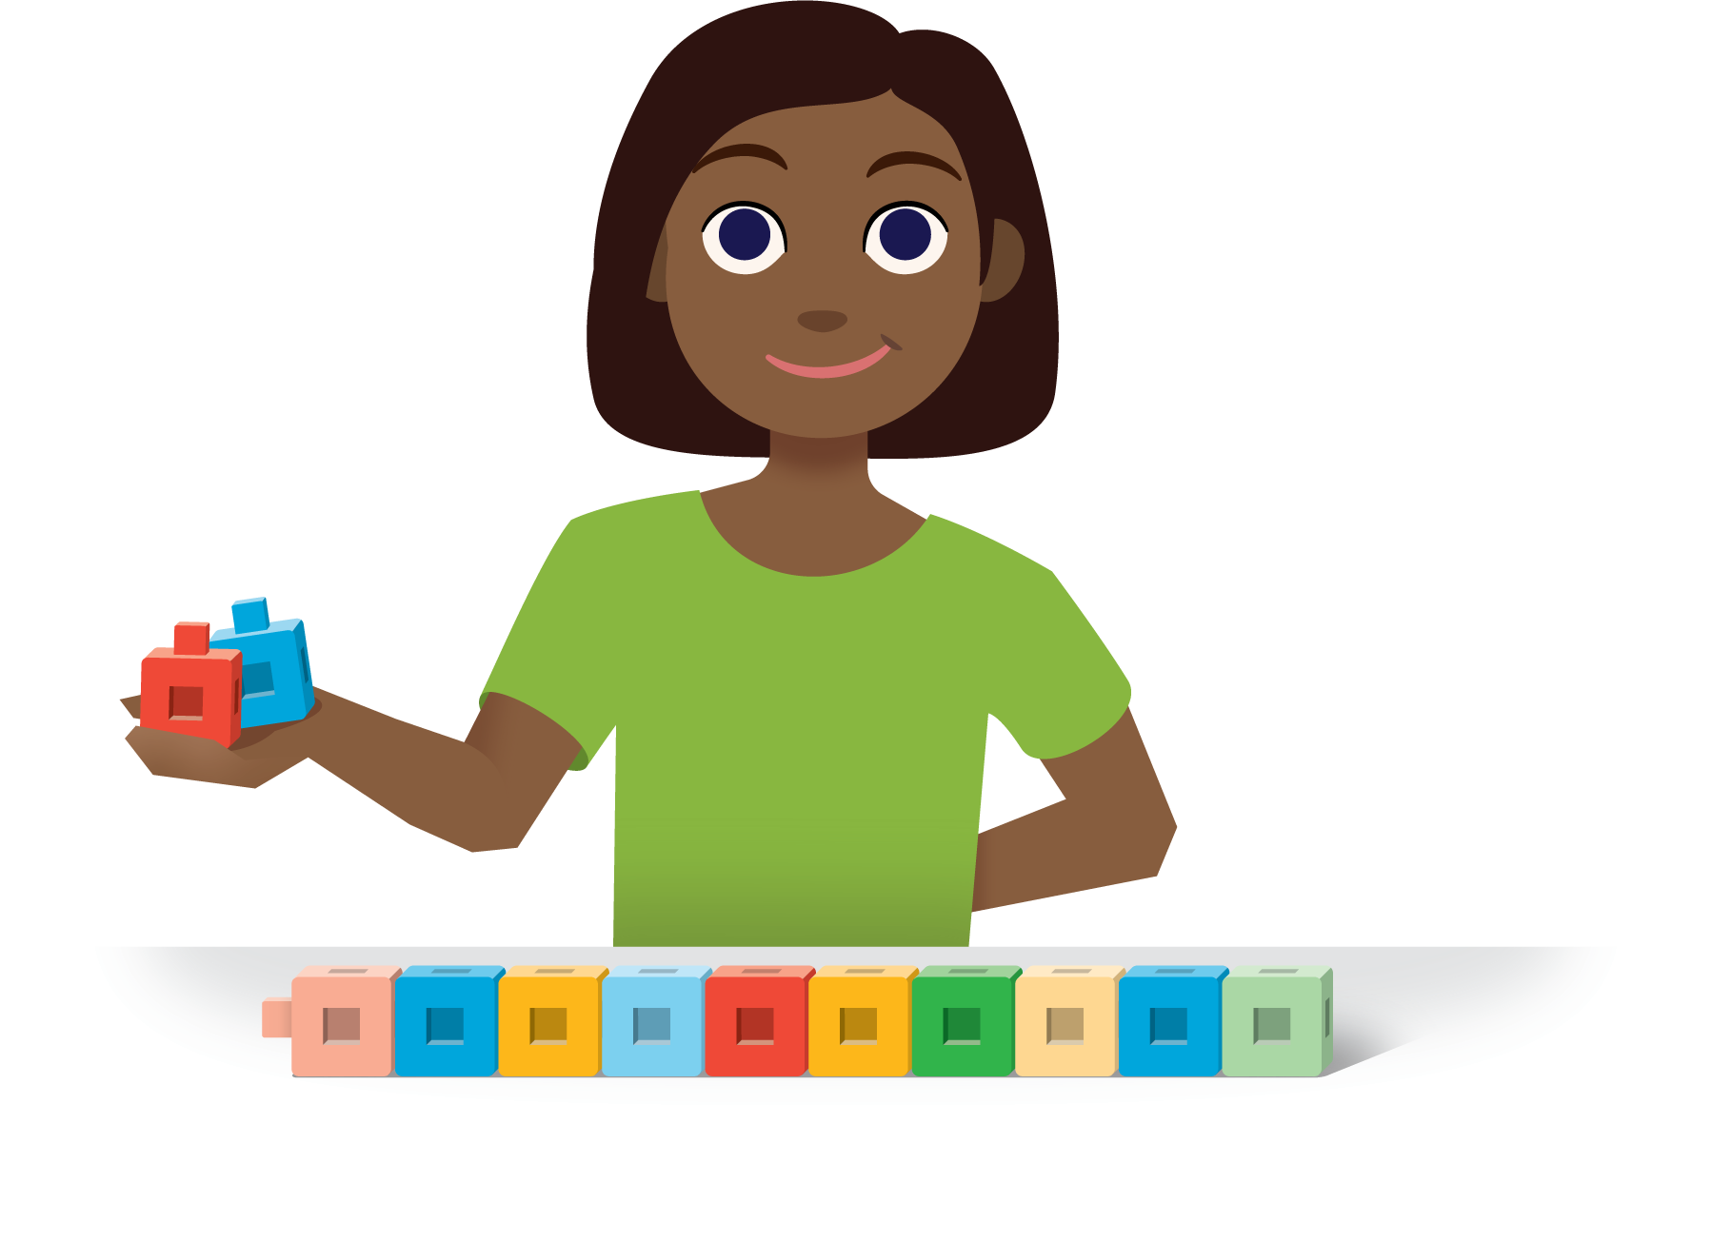
Number Race
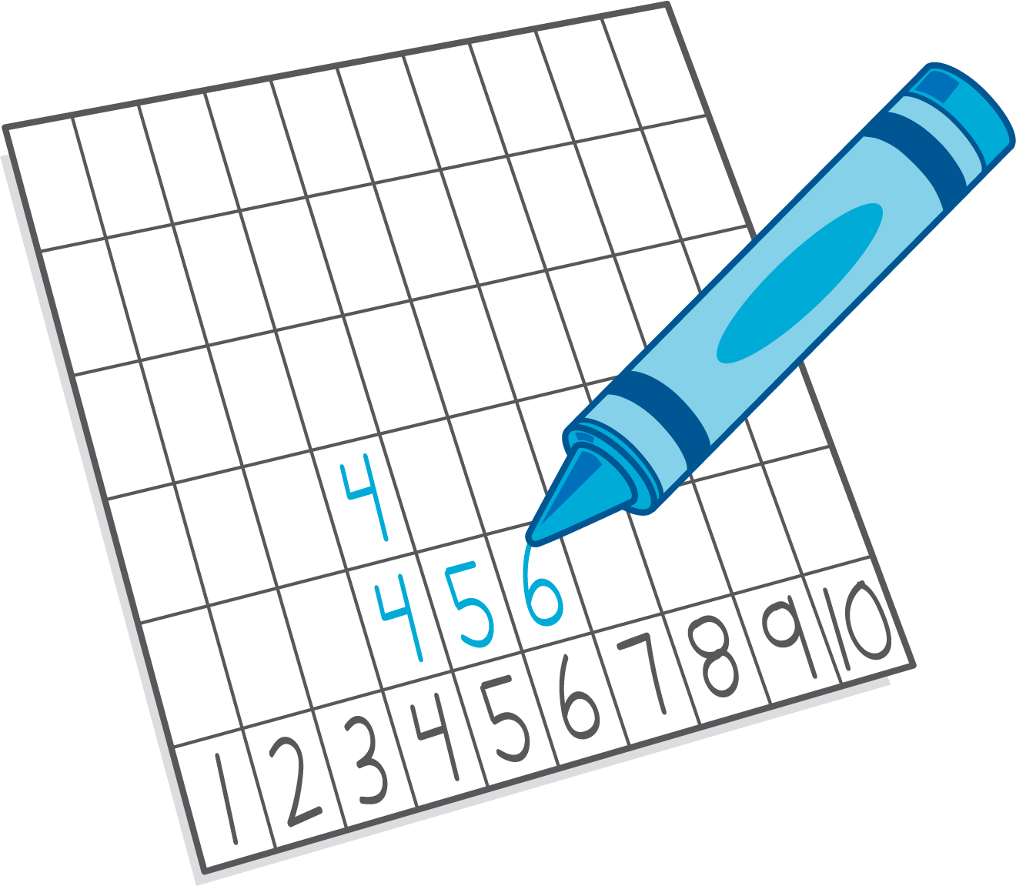
© CC BY 2021 Illustrative Mathematics®

